NAME…………………………………………………… INDEX NO……………………........................
SCHOOL………………………………………………… DATE…………………………………………
SIGNATURE……………………………………………..
BIOLOGY
231/3
(PRACTICAL)
JULY/AUGUST, 2017
TIME: 1¾ HOURS
JULY/AUGUST EVALUATION TEST - 2017
FORM FOUR EXAMINATION

INSTRUCTIONS TO CANDIDATES:
(a) Write your name and index number in the spaces provided above.
(b) Sign and write the date of examination in the spaces provided above.
(c) Answer all the questions in the spaces provided.
(d) You are required to spend the first 15 minutes of the 1¾ hours allowed for
this paper reading the whole paper carefully before commencing your work.
(f) This paper has three questions. Students should check the question paper to ascertain that all the papers are printed as indicated and that no questions are missing.
FOR EXAMINER’S USE ONLY:
Question | Maximum  Score | Candidate’s  Score
1 | 14
2 | 15
3 | 11
Total Score | 40

1. a) You are provided with substances labeled M, N, V, U and X and a filter paper. M and N are food substances, while V is Benedict’s solution, U is 10% Sodium Hydroxide solution and X is 1% Copper Sulphate solution. Using the reagents provided, carry out tests to determine the food substance(s) in M and N (10 marks)

Substance | Food Substance Being Tested For | Procedure | Observation | Conclusion
M
N

b).State the functions of the food substances found in both M and N. (4marks)
…………………………………………………………………………………………………………………………………………………………………………………………………………………………………………………………………………………………………………………………………………………………………………………………………………..………………………………………………………………………………………………………………………………………………………………………………………………………………………………………………….
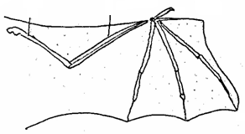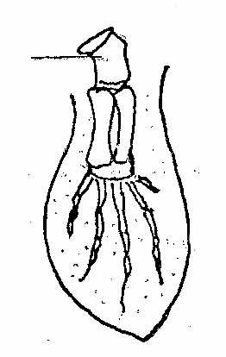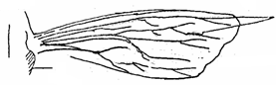2. Figure 1 represents a bat wing, Figure 2 a whale paddle and Figure 3 an insect wing. Study the diagrams and answer the questions that follow.
Figure 1
H
E
Figure 2
F
Figure 3
G
S

(i) Name parts labeled E and F. (2 marks)

E ………………………………………………………………………………………………

F ………………………………………………………………………………………………
(ii)Suggest the type of structures represented in Fig 1 and 2. Give a reason for your answer (2 marks)

………………………………………………………………………………………………

…………………………………………………………………………………………….…
(iii)Name the type of joint found at proximal end of bone marked H. (1 mark)

………………………………………………………………………………………………
iv) What type of evolution is represented by existence of bat and insect wings? Explain your answer. (3marks)

………………………………………………………………………………………………………………………………………………………………………………………………………………………………………………………………………………………………v) The wings of a kiwi unlike those of a bat are greatly reduced.
- Name the type of structures represented by wings of a kiwi ( 1mark)

……………………………………………………………………………………….
- Why are wings of kiwi greatly reduced? (1mark)

……………………………………………………………………………………….
- State the type of skeleton found on the part labeled S (1mark)

………………………………………………………………………………………

3. You are provided with photographs of the specimen labelled J₁, J₂, K₁, K₂ examine them.
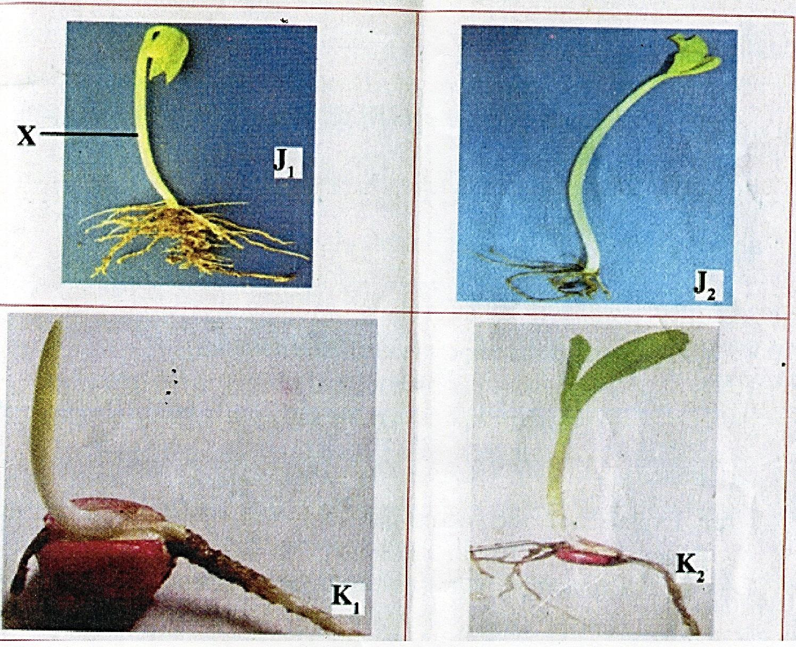

a) With a reason name the class to which specimens J₁ and K₁ belong. (4mks)
J₁ ……………………………………………………………………………………………………
Class: ………………………………………………………………………………………………..
Reason: ……………………………………………………………………………………………...

K₁ ……………………………………………………………………………………………………
Class: ………………………………………………………………………………………………..
Reason: ……………………………………………………………………………………………...
b) i) Name the part labelled X in specimen J₁. (1mk)
……………………………………………………………………………………………………………………………………………………………………………………………………………….
ii) What is the importance of the curvature? (1mk) ……………………………………………………………………………………………………………………………………………………………………………………………………………….

c) Name the part that protects the plumule in specimen K₁ and K₂. (1mk) ……………………………………………………………………………………………………………………………………………………………………………………………………………….
d)i) Which of the two types of seedlings may form swellings on the root later in its life?
(1mk) ……………………………………………………………………………………………………………………………………………………………………………………………………………….

ii) Give the name of the swelling in e(i) above. (1mk) ……………………………………………………………………………………………………………………………………………………………………………………………………………….
iii) Name the organism that would be found in the swellings. (1mk) ……………………………………………………………………………………………………………………………………………………………………………………………………………….
iv) Name the relationship that exist between the named organism and the plant. (1mk) ……………………………………………………………………………………………………………………………………………………………………………………………………………….
e) i) Name the structure found on the stem just below the leaves of specimen J₂. (1mk) ……………………………………………………………………………………………………………………………………………………………………………………………………………….
ii) State one function of the structure named in e (i) above. (1mk) ……………………………………………………………………………………………………………………………………………………………………………………………………………….
f) Name the root system found in specimens (2mks)
i) J₁ and J₂.
……………………………………………………………………………………………………………………………………………………………………………………………………………….
ii) K₁ and K₂.
……………………………………………………………………………………………………………………………………………………………………………………………………………….

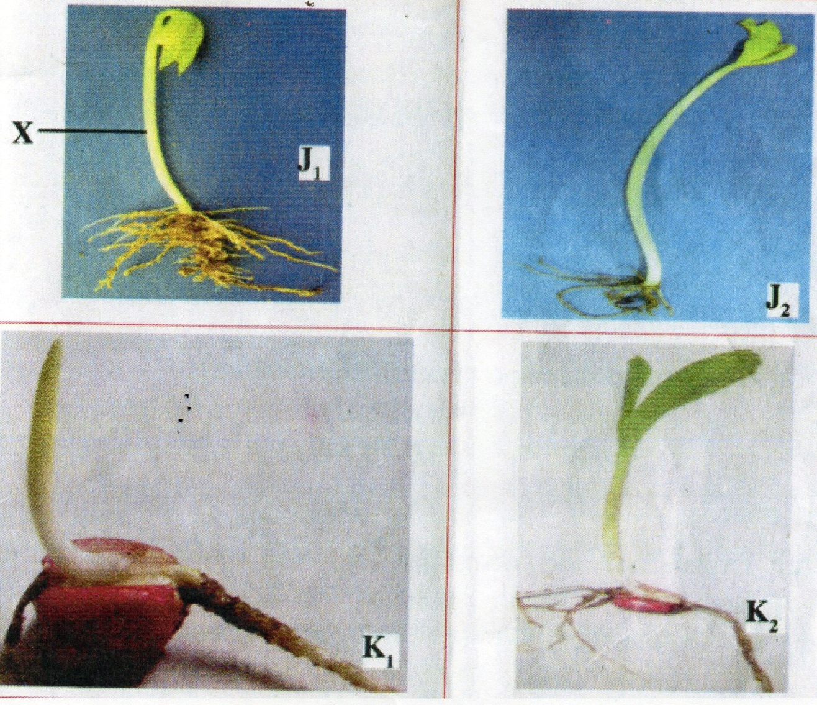

JULY/AUGUST
BIOLOGY PAPER 3
MARKING SCHEME 231/3 2017
1.

SUBSTANCE | FOOD SUBSTANCE BEING TESTED FOR | PROCEDURE | OBSERVATION | CONCLUSION
M | Reducing Sugars√ | To M,  Add equal amount of Benedict’s solution; and / heat to boil; (2mks) | Co colour changes from blue to green and yellow. / colour changes from blue to green. (½ mk)  ( | Reducing sugars present / little reducing sugar is present;√ (½ mk)
 | Proteins√ | (To M)  Add (10%) sodium hydroxide solution then (1%) copper sulphate solution√ (drop wise)(1mk) | Colour changes to purple  (½ mk) | Proteins present √(½ mk)
 | Lipids√ | Pour a drop of M onto the filter paper and dry√(1mk) | No permanent translucent spot formed√.(½ mk) | Lipids absent;√ (½ mk)
N | Reducing sugars | (To N) add Benedict’s solution and / heat to boil / boil | Colour changes from blue to green;√ (½ mk) | Little / traces reducing sugars present √(½ mk)
 | Proteins | (To N) add (10%) sodium hydroxide solution then (1%) copper sulphate solution ( drop wise) | Colour changes to purple  (½ mk) | Proteins present;√(½ mk)
 | Lipids | Pour a drop of N onto the filter paper and dry. | A permanent translucent spot forms √(½ mk) | Lipids present;√(½ mk)
b) Reducing sugars;
- Source of energy when oxidized
- Are condensed to form starch for storage in plants / glycogen for storage in animals
(2 x 1 = 2 marks)
Proteins
- Forms structures in living organisms
- Forms metabolic regulators / enzyme / hormones
- Source of energy during starvation; (Any 2 x1 = 2 marks)

2.(i) E-Radius; (1mk)
F-Humerus;( 1mk)
ii)Homologous structures; reason-presence of pentadactyl structure/similar bone anatomy;( 2mks)
iii)Ball and socket joint;( 1mk)
iv)Convergent evolution;reason-Both have different embryonic origin but serve similar function/used for flight; ( 3mks)
v) i) vestigial structures; (1mk)
ii)Ceased to function/lack a particular function;(1mk)
iii)Exoskeleton;( 1mk)

3. a) J₁
Class: Dicotyledonae (1mk)
Rj Dicot/ Dicotyledeon
Reason: leaf net-veined/ net venation/reticulate/ two cotyledons/taproot system (1mk)
K₁ Class: Monotyledonae Rj; monocot/ monocotyledon (1mk)
Reason: Parallel veins/ parallel venation/ one cotyledon/ fibrous root system.(1mk)
b) i) X- Hypocotyl (1mk)
ii) – Protects the plumule/ shoot tip/ first foliage leaves. (1 mk)
- Penetrates through the soil/Pulls the cotyledons out of the soil.
c) Coleoptile/ plumule sheath (1mk)
d) i) J₁ and J₂ (1mk)
ii) Root nodules. NB tied to d(i) (1mk)
iii) Rhizobium spp (1mk)
iv) Symbiotic relationship/symbiosis; (1 mark)
e) i) Cotyledons/ seed leaves
ii) – Carry out photosynthesis to provide food for the germinating seedling.
- Food reserve/ stores food/ provide food for the germinating seed. Tied to e (i)
any 1x1 (1 mk)

f) J₁ and J₂ – Tap root system/ Tap roots. (1mk)
K₁ and K₂- fibrous roots/ Fibrous root system (1mk)

