NAME:…………………………………………………Index No:…………………
Candidate’s Signature…………………
Date…………………………
233/2
Chemistry
Paper 2
(THEORY)
July 2017
2 hours

CHEMISTRY
THEORY
Paper 2
2 Hours
INSTRUCTIONS TO CANDIDATES
- Write your name and index number in the spaces provided above.
- Sign and write the date of examination in the space provided above.
- Answer all the questions in the space provided.
- KNEC Mathematical tables and silent non-programmable electronic calculators may be used.
- All workingMUST be clearly shown where necessary.
- This paper consists of 16 printed pages.
- Candidates should check the question paper to ascertain that all the pages are printed as indicated and that no questions are missing.
- Candidate should answer the questions in English
FOREXAMINER’S USE ONLY
QUESTION | MAXIMUM SCORE | CANDIDATE’S SCORE
1 | 10
2 | 12
3 | 09
4 | 14
5 | 13
6 | 12
7 | 10
TOTAL SCORE | 80

- a) Other than their location in the atom, name two other differences between an electron and a proton (2mks)

b) The table below gives the number of electrons, protons and neutrons in particles A,B,C,D,E,F and G.
Particle | Protons | Electrons | Neutrons
A | 6 | 6 | 6
B | 10 | 10 | 12
C | 12 | 10 | 12
D | 6 | 6 | 8
E | 13 | 10 | 14
F | 17 | 17 | 18
G | 8 | 10 | 8

- Which particle is likely to be a halogen? (1mk)

- What is the mass number of E? (1 mk)

- Write the formula of the compound formed when E combines with G (1 mk)

- Name the type of bond formed in (iii) above (1 mk)

- How does the atomic radii of C and E compare? Give a reason (2mks)

- Draw a dot( ● ) and cross (x) diagram for the compound formed between A and F (1mk)

- Why would particle B not react with particle D (1 mk)

- Study the following table and then use it to answer the questions that follow
Hydrocarbon | Boiling point K
CH4 | 112
C2H6 | 184
C3 H8 | 231
C4 H10 | 273
C5 H12 | 309
C6 H14 | 342
- These organic compounds belong to the same homologous series
- What is meant by the term homologous series (1mk)

- To which homologous series do the above hydrocarbons belong? (1mk)

- Select one hydrocarbon that would be a liquid at room temperature (1mk)

- Compare the boiling point of CH4 and C6 H14? Explain your answer (2mks)

- Give one chemical test to distinguish between C2 H6 and C2 H4 (2mks)

- Study the scheme below and answer the questions that follow.

C2 H5COONa
Step IV
Step V Step I
CH ≡CH C2 H6
Step II
CH2=CHCl
Step III

-(CH2-CHCl)-^{n-}
- Name the reagents used in :- (1 mk)
Step I

Step II

- Write an equation for the combustion of CH≡CH (1mk)

- Name the reagent and condition required for step (IV) (2mks)
Reagent-
Condition-
- Explain one disadvantage of the continued use of items made from the compound formed in step III (1mk)

- The diagram below shows how hydrogen gas is prepared in the laboratory and its reaction with lead (II)oxide
Lead (II) oxide
Solution A
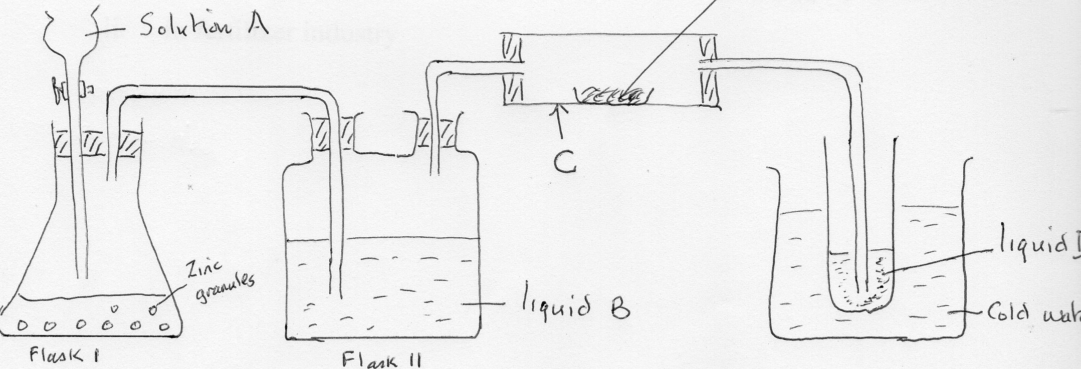
Zinc
granules

Liquid B
Liquid D
Flash II
Flask I
Cold water

- Identify a suitable reagent that can be used as solution A (1mk)

- Write an ionic equation for the reaction in flask I (1mk)

- Name liquid B and state its purpose in the experiment (2mks)

- State and explain the observation made in the apparatus labeled C
(2mks)

- State one test that can be used to determine the purity of liquid D (1mk)

b. State any two uses of hydrogen gas:- (2mks)
- in the food industry

- in fertilizer industry

- Study the flow chart diagram below and answer the questions that follow:-

Acidified Air
Water
Electrolysis Step I Step 2
M N

Step 3
Ammonia

Rh/Pt Step 4
900⁰C
Colourles gas Q
Step 5
Nitrogen (IV Oxide
Step 6
Nitric Acid
Step 7
Ammonium Nitrate

a. (i) Name element M and N (2mks)
M
N
(ii) Describe briefly how N is obtained from air (3mks)

(iii) Name a catalyst that is used in step 2 (1 mk)

b. (i) Explain why it is necessary to use excess air in step 4 (1mk)

(ii) Write a balanced equation for the reaction in step 6 (1mk)

c. (i) Explain why nitric (V) acid reacts with copper metal whereas hydrochloric acid does not (2mks)

(ii) State the observation made when a sample of sulphur is heated in concentrated nitric (v) acid (2mks)

d. State two uses of ammonia gas (2mks)

- a. (i) What is meant by the term ‘Enthalpy of formation’? (1mk)

(ii) The enthalpies of combustion of carbon, methane and hydrogen are indicated below
Cs + O2 (g) CO2(g) ∆H = -393 kJmol⁻¹

H2( g) + ^{½} O2 (g) H2Ol(l) ∆H = -286 kJmol^{—1}

Enthalpy of combustion of CH4 = ⁻890 kJmoI⁻¹

- Draw an energy cycle diagram that links the enthalpy of formation of methane to enthalpy of combustion of carbon, hydrogen and methane. (2mks)

- Determine the enthalpy of formation of methane (2mks)

b. An experiment was carried out where different volumes of dilute hydrochloric and aqueous sodium hydroxide both at 25⁰C were mixed and stirred with a thermometer. The highest temperatures reached by each mixture was recorded in the table below.
Volume of hydrochloric acid (cm³) | 5 | 10 | 15 | 20 | 25 | 30 | 35 | 40 | 45
Volume of sodium hydroxide (cm³) | 45 | 40 | 35 | 30 | 25 | 20 | 15 | 10 | 5
Highest temperature of mixture (^{O}C) | 27.2 | 29.4 | 31.6 | 33.8 | 33.6 | 31.8 | 30.0 | 28.4 | 26.6

On the grid provided, plot a graph of highest temperature (vertical axis) against volume of hydrochloric acid (horizontal axis) (3mks)

(i)Using your graph, determine the;
- highest temperature reached; (1/2 mk)

- Volume of acid and base reacting when highest temperature is reached; (1/2mks)

(iii) Calculate the amount of heat liberated during the neutralization process.
(Specify heat capacity is 4.2J⁻¹K⁻¹ and the density of solution is 1.0g cm⁻³)
(2mks)

c. The molar enthalpy of neutralization between hydrochloric acid and ammonia solution was found to be -52.2kJmol⁻¹ while that of hydrochloric acid and sodium hydroxide was -57.1 kjmol^{-1.} Explain the difference in these values (2mks)

- Use the standard electrode potentials for the elements P, Q, R, S and T to answer the questions that follow
E^{ᵨ} (volts)
P ²⁺ + 2e⁻ P(s) -2.92
Q²⁺ + 2e⁻ Q(s) -2.38
R⁺ + e- ½ R2(g) 0.00
S⁺ +e⁻ S (s) +0.80
½ T2 +e⁻ T- (g) +1.37
- Identify the species that is the strongest reducing agent (1mk)

- Which element is likely to be hydrogen? Explain (2mks)

- (i) Draw a labelled diagram of the electrochemical cell that would be obtained when the half cell of element Q and S are combined (3mks)

(ii) Calculate the E^{ᵨ}value for the cell constructed in c(i) above (2 mks)

- During the electrolysis of aqueous copper(II) sulphate using copper electrodes, a current of 4 amperes was passed through the cell for 18 minutes and 15 seconds (2mks)
- Write an ionic equation for the reaction that took place at;-
- Anode

- Cathode

- Determine the change in mass at the cathode which occurred as a result of the electrolysis. (3mks)
(IF = 96 500C, Cu = 63.5)

- The factors which affect the rate of reaction between Zinc and dilute sulphuric (VI)acid were investigated by carrying out these experiments
Experiment number | Zinc metal | Concentration of H2SO4
1 | Granules | 4M
2 | Powder | 4M
3 | Granules | 2M
- Other than concentration, name the other factor that was investigated in the experiments (1mk)

- For each of the experiments, the same volume of acid (excess) and mass of zinc metal were used and the volume of gas liberated measured with time
- Draw a set up that can be used to investigate the rate of reaction for one of the experiments (3mks)

- On the grid provided, sketch the curves obtained when the volume of gas produced was plotted against time for each of the three experiments and label each as 1,2, and 3. (3mks)

Volume of
Gas (cm³)

Time(seconds)
III. Write an equation for the reaction that took place (1mk)

C. A solution of chromate (VI)is yellow in colour but turns orange in acid solution due to the formation of dichromate (VI)
The reaction is represented by the equation
2 CrO4²⁻⁽aq) + 2H⁺(ag) Cr2O7²⁻ (aq) + H20
Yellow orange
State and explain the observation made when sodium hydroxide is added to the mixture when at equilibrium (2mks)

