NAME:…………………………………………………Index No:…………………
Candidate’s Signature…………………
Date…………………………

233/1
CHEMISTRY
PAPER 1
JULY /AUGUST
2HOURS

Chemistry
Paper 1
2 hours

INSTRUCTIONS TO CANDIDATES
- Write your name and index number in the spaces provided above.
- Sign and write the date of examination in the space provided above.
- Answer all the questions in the space provided.
- KNEC Mathematical tables and silent non-programmable electronic calculators may be used.
- All working MUST be clearly shown where necessary.
- This paper consists of 16 printed pages.
- Candidates should check the question paper to ascertain that all the pages are printed as indicated and that no questions are missing.
- Candidate should answer the questions in English
FOREXAMINER’S USE ONLY

QUESTION | MAXIMUM SCORE | CANDIDATE’S SCORE
1-30 | 80

- Distinguish between the terms deliquescent and efflorescent as used in Chemistry.(2mks)
________________________________________________________________________________________________________________________________________________________________________________________________________________________________________________________________________________________________________________________________________________________________
- (a) Using an equation, explain the observation made when concentrated sulphuric (iv) acid is added to sugar crystals (2mks)
________________________________________________________________________________________________________________________________________________________________________________________________________________________________________________________________________________________________________________________________________________________________________________________________________________________________________________________
(b) What property is displayed by the acid in (a) above (1mk)
________________________________________________________________________________________________________________________________________________________________________________________________________________________________________________________________________
- Carbon (II) oxide was passed over heated copper (II) oxide in a combustion tube as shown in the diagram below
Copper (II)oxide
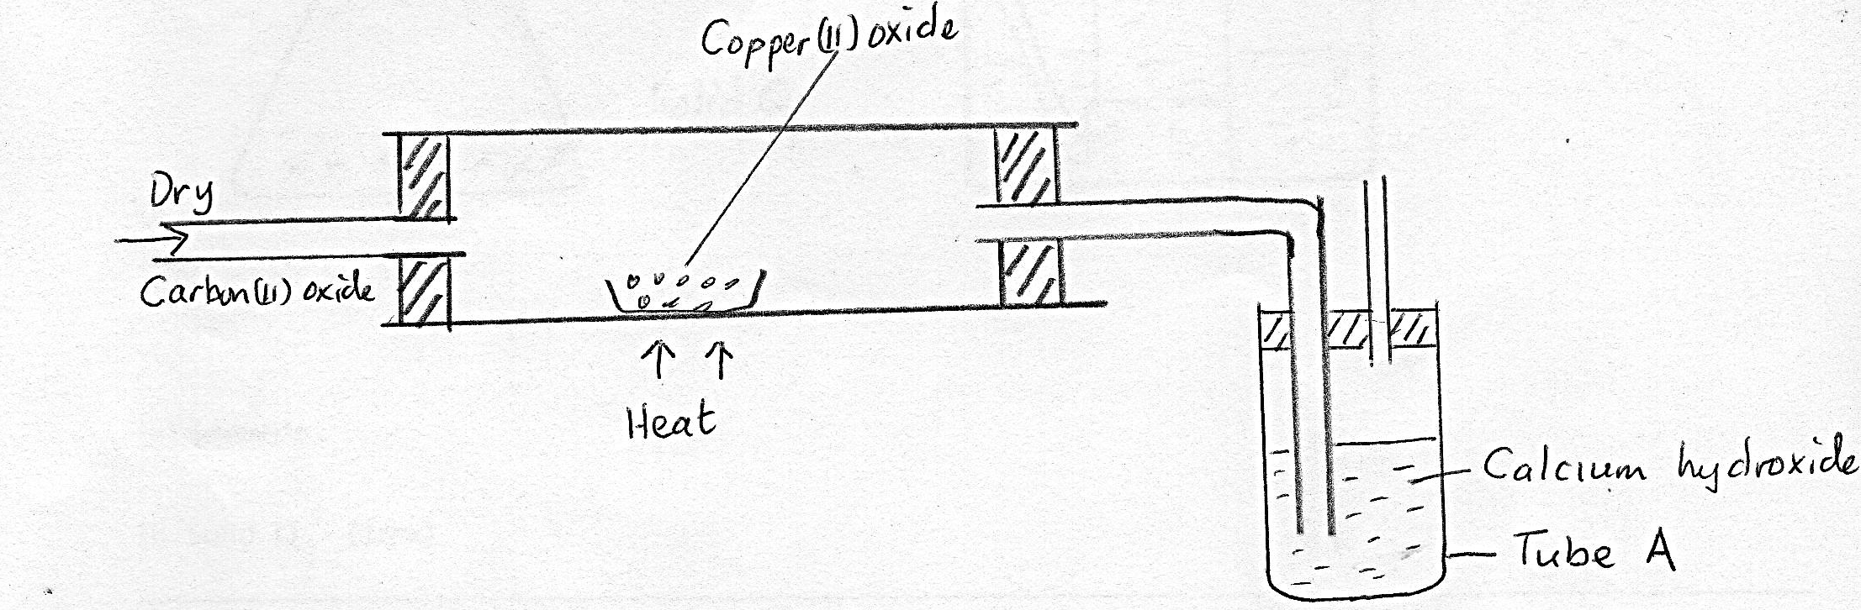
Dry

Carbon (II)oxide
Heat
Calcium Hydroxide
Tube A

- State the observation made in tube A (1mk)
_______________________________________________________________________________________________________________________________________________________________________________________________________________________________________________________________
- Write a chemical equation for the reaction that took place in the combustion tube (1mk)
_______________________________________________________________________________________________________________________________________________________________________________________________________________________________________________________________

- (a) What is isomerism ? (1mk)
________________________________________________________________________________________________________________________________________________________________________________________________________________________________________________________________________
(b) Draw and name any two isomers of C₄ H₈ (2mks)
____________________________________________________________________________________________________________________________________________________________________________________________________________________________________________________________________________________________________________________________________________________

- Below is a set up used to prepare and collect hydrogen gas in the laboratory. Study it and answer the questions that follow
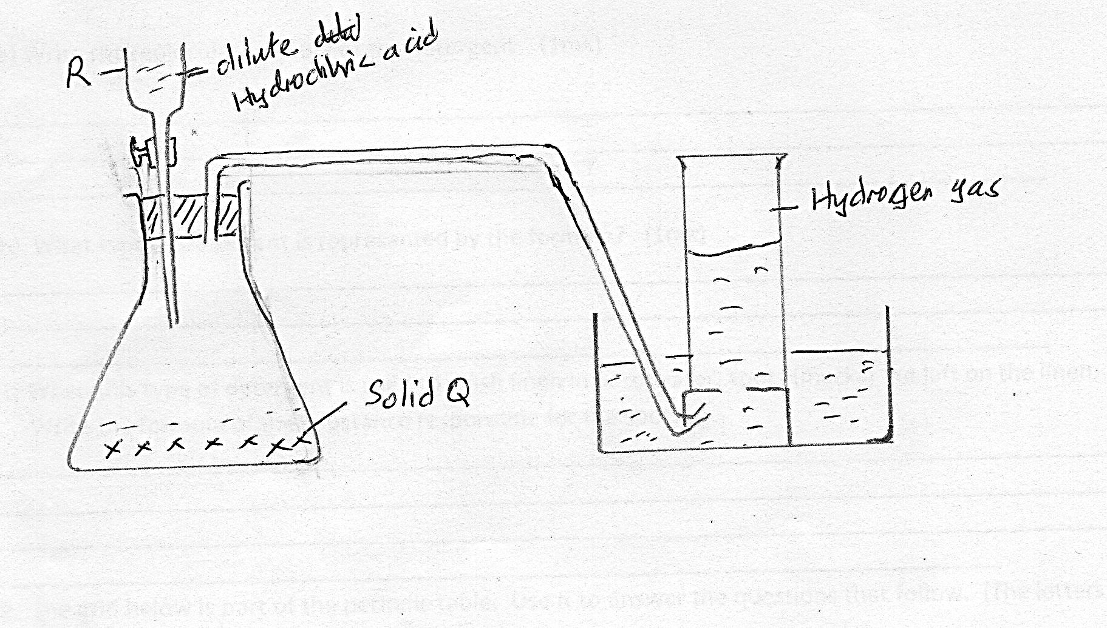
Dilute hydrochloric acid

Hydrogen gas

Solid Q

- Identify:
- Solid Q (1mk)
____________________________________________________________________________________________________________________________________________________________
- Apparatus R (1mk)
____________________________________________________________________________________________________________________________________________________________
- If the gas was to be collected dry, name a suitable drying agent that you would use to dry the gas. (1mk)

- A mixture contains ammonium chloride, copper (II) oxide and sodium chloride. Describe how each of the substances can be obtained from the mixture. (3mks)
________________________________________________________________________________________________________________________________________________________________________________________________________________________________________________________________________________________________________________________________________________________________________________________________________________________________________________________________________________________________________________________________________________________________________________________________________________________________________
- The structure of the detergent is

- Write the molecular formula of the detergent (1mk)
_______________________________________________________________________________________________________________________________________________________________________________________________________________________________________________________________
- What type of detergent is represented by the formula? (1mk)
_______________________________________________________________________________________________________________________________________________________________________________________________________________________________________________________________
- When this type of detergent is used to wash linen in hard water, spots (marks) are left on the linen.
Write the formula of the substance responsible for the spots.

- The grid below is part of the periodic table. Use it to answer the questions that follow. (the letters are not the actual symbols of the elements.)

 |  |  |  |  | R | S
N | Q |  |  |  |  | T | U
P

- Indicate on the grid the position of an element represented by letter V whose atomic number is 14 (1mk)
__________________________________________________________________________________________________________________________________________________________________________
- Select an element which represents a monatomic gas (1mk)
__________________________________________________________________________________________________________________________________________________________________________
- (a) A radioactive substance emits three different particles. Give the symbol of the particles with the highest mass. (1mk)
________________________________________________________________________________________________________________________________________________________________________________________________________________________________________________________________________
(b) (i) Find the value of Z₁ and Z₂ in the nuclear equation below
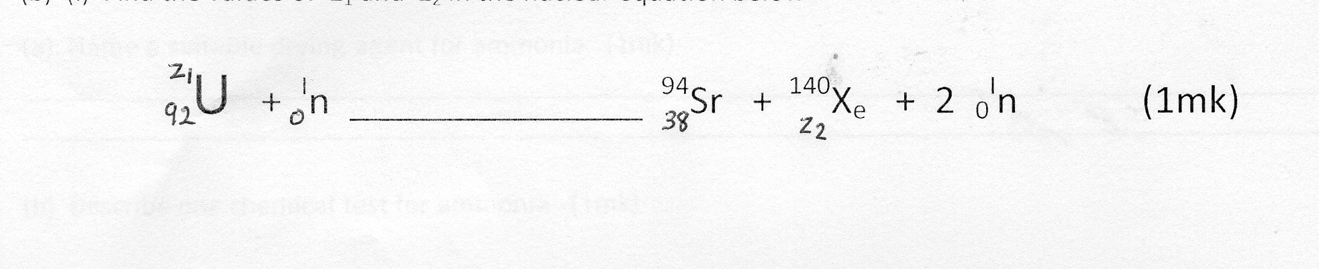

- What type of nuclear reaction is represented in b(i) above ? (1mk)
__________________________________________________________________________________________________________________________________________________________________________________________________________________________________________

- A solution was made by dissolving 8.2g of calcium nitrate to give 2 liters of solution
(Ca=40.0, N=14.0, O=16.0)

Determine the concentration of nitrate ions in moles per litres (3mks)

- Study the flow chart below and answer the questions that follow.
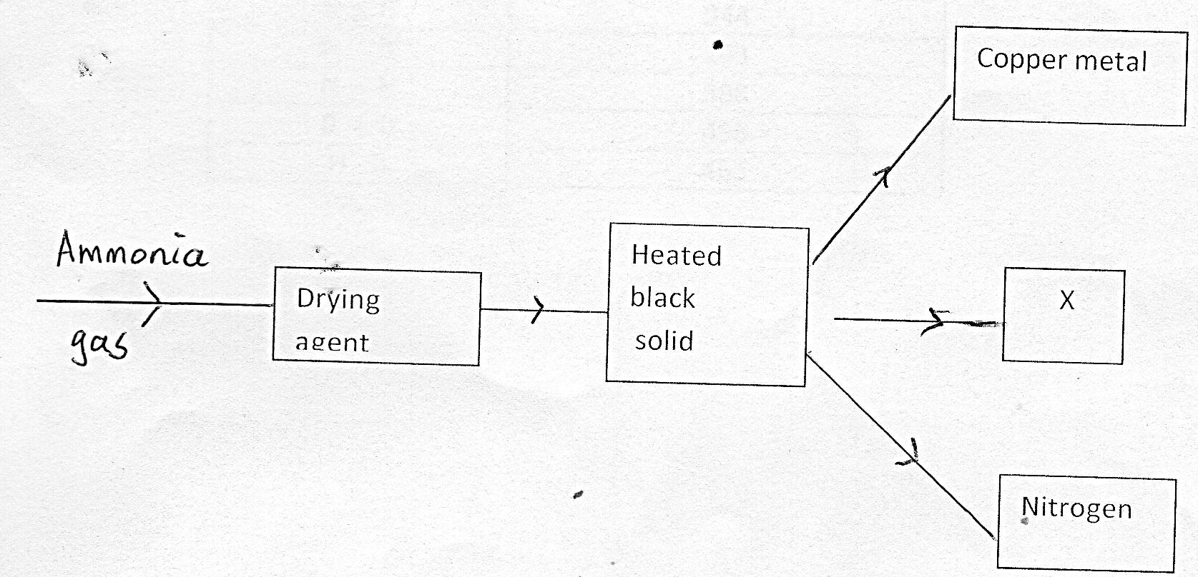

- Name a suitable drying agent for ammonia (1mk)
_________________________________________________________________________________________________________________________________________________________________________
- Describe one chemical test for ammonia (1mk)
____________________________________________________________________________________________________________________________________________________________________________________________________________________________________________________________________________________________________________________________________________________
- Name substance X (1mk)
________________________________________________________________________________________________________________________________________________________________________________________________________________________________________________________________________________________________________________________________________________________________________________________________________________________________________

- The melting point of phosphorous trichloride is -91 ºc and that of sodium chloride is 801ºc. Explain the huge difference in their melting points.
________________________________________________________________________________________________________________________________________________________________________________________________________________________________________________________________________________________________________________________________________________________________________________________________________________________________________________________________________________________________________________________________________________________________________________________________________________________________________________________________________________________________________________________________
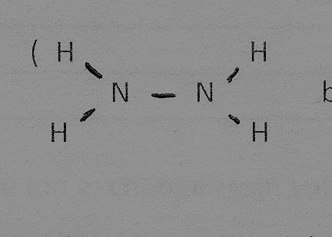
- Hydrazine gas burn in oxygen to form nitrogen gas and steam

- Write an equation for the reaction (1mk)
__________________________________________________________________________________________________________________________________________________________________________
- Using the bond energies given below, calculate the enthalpy change for the reaction in (a) above. (2mks)
Bond | Bond energy (k/per mole)
N=N | 944
N-N | 163
N-H | 388
O=O | 496
H-O | 463

- The following are half- cell reaction and their reduction potentials

E (Volt)
Zn²+(_{aq}+ 2_{e} -
Zn _{(s)} - 0.76
Pb²⁺_{(aq)} +2^{e-}pb_{(g)} - 0.13
Ag⁺_{(aq)} + e- Ag _{(s)} + 0.80
Cu²⁺_{(aq)}+2e- ` Cu²⁺_{(s)} +0.34

- Write the cell representation for the electrochemical cell that would give the highest E⁰value (I mark)
__________________________________________________________________________________________________________________________________________________________________________
- State and explain the observation made when a copper rod is placed in a beaker containing silver nitrate solution (2mks)

- (a) Name two cations that are present in hard water (1mk)
________________________________________________________________________________________________________________________________________________________________________________________________________________________________________________________________________
(b)Explain how the ion exchange resin softens hard water (2mk)
____________________________________________________________________________________________________________________________________________________________________________________________________________________________________________________________________________________________________________________________________________________
- Under certain conditions, chlorine gas reacts with sodium hydroxide to form sodium hyochlorite.

- Name the condition under which sodium hydroxide reacts with chlorine to form sodium hypochlorite (1mk)
____________________________________________________________________________________________________________________________________________________________________________________________________________________________________________________________________________________________________________________________________________________
- State two uses of sodium hypochlorite (2mk)
____________________________________________________________________________________________________________________________________________________________________________________________________________________________________________________________________________________________________________________________________________________
- The flow chart below shows some processes involved in the industrial extraction of zinc metal
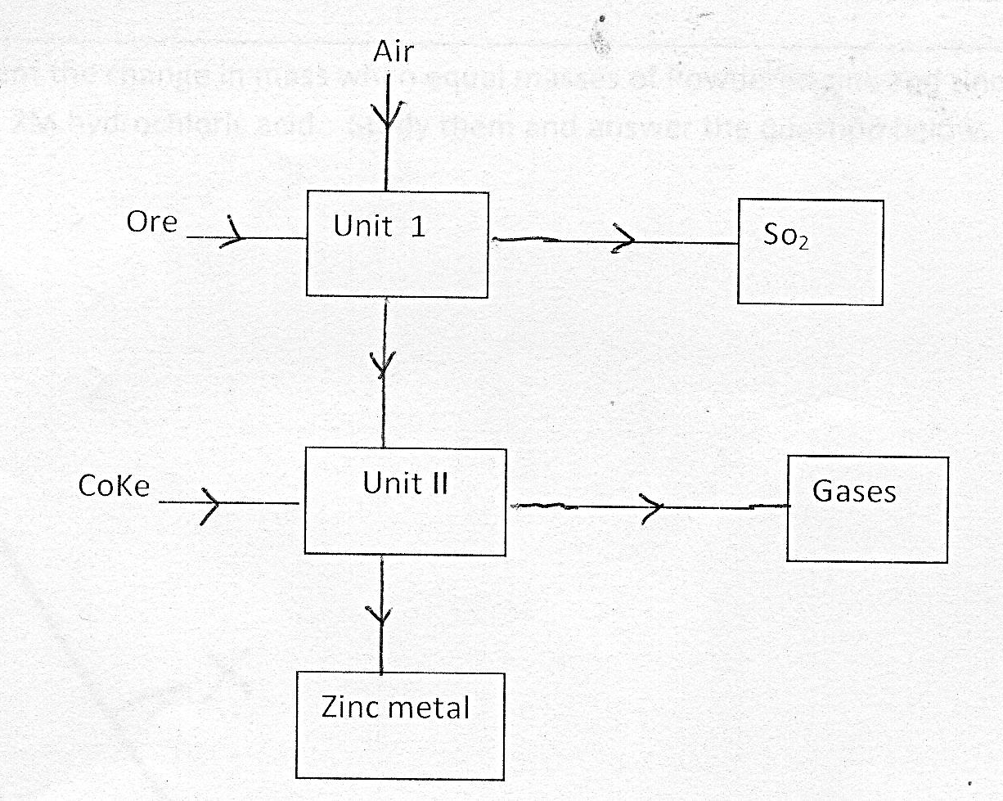

SO₂

- Name one ore from which zinc is extracted (1mk)
__________________________________________________________________________________________________________________________________________________________________________

- Write the equation of the reaction taking place in unit II (1mk)
__________________________________________________________________________________________________________________________________________________________________________
- Name two uses of zinc metal (1mk)
__________________________________________________________________________________________________________________________________________________________________________
- (a) State Boyle’s Law (1mk)
________________________________________________________________________________________________________________________________________________________________________________________________________________________________________________________________________
(b)A gas occupies 650cm³ at a pressure of 760 mmHg if the pressure is raised to 1220mmHg, What volume would the gas occupy.(2mk)
_______________________________________________________________________________________________________________________________________________________________________________________________________________________________________________________________
- Describe two chemical tests that can be used to distinguish butane from butane. (2mk)
________________________________________________________________________________________________________________________________________________________________________________________________________________________________________________________________________________________________________________________________________________________________________________________________________________________________________________________
- The curves below represent the change in mass when equal masses of powdered zinc and zinc granules were reacted with excess 2M hydrochloric acid. Study them and answer the question below.
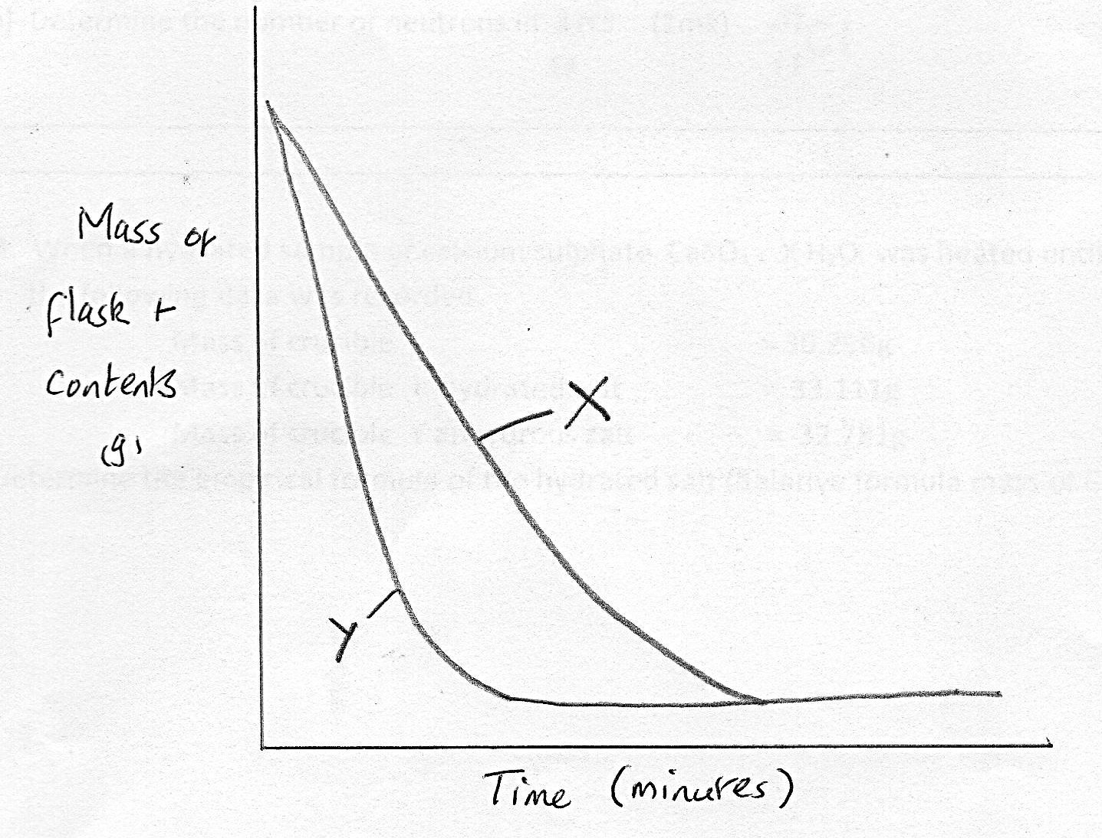

Which curve represents the reaction with zinc granules? Explain your answer. (3mks)
____________________________________________________________________________________________________________________________________________________________________________________________________

- Chlorine , Bromine and iodine belong to the group VII of the periodic table.
- What name is given to this elements (1mk)
__________________________________________________________________________________________________________________________________________________________________________
- Explain how the reactivity of these elements compares
____________________________________________________________________________________________________________________________________________________________________________________________________________________________________________________________________________________________________________________________________________________
- Oxygen gas can be prepared in the laboratory by decomposition of hydrogen peroxide
- Write an equation to show the decomposition of hydrogen peroxide to produce oxygen gas. (1mk)
__________________________________________________________________________________________________________________________________________________________________________
- Name the catalyst used in the above reaction(1mk)
__________________________________________________________________________________________________________________________________________________________________________
- Explain why oxygen gas is collected over water (1mk)
_______________________________________________________________________________________________________________________________________________________________________________________________________________________________________________________________
- (a) What are isotopes (1mk)
________________________________________________________________________________________________________________________________________________________________________________
(b) Determine the number of neutrons in $37 Cl$
17
________________________________________________________________________________________________________________________________________________________________________________
- When a hydrated sample of calcium sulphate C_{a}SO₄, X H₂O was heated until all the water was lost, the following data was recorded.

Mass of crucible | = 30.296g
Mass of crucible + hydrated salt | =33.111g
Mass of crucible + anhydrous salt | =32.781g
Determine the empirical formula of the hydrated salt (relative formula mass of C_{a}SO₄ =136, H+O=18) (3mks)

- An organic compound P reacts with sodium metal to produce a gas that burns with a pop sound. Compound P reacts with acidified potassium dichromate (IV) to form a green solution.

- To which homologous series does compound P belong (1mk)
__________________________________________________________________________________________________________________________________________________________________________
- Write an equation for the reaction of the second member of the series with sodium metal (1mk)
__________________________________________________________________________________________________________________________________________________________________________
- Draw a dot(.) and cross (x) diagram to show bonding in a molecule of carbon (II) oxide(atomic number of C=6 and O=8)(2mks)

- The tale below shows the pH values of solution P, Q, R and S

Solution | P^{H} value
P | 1.0
Q | 4.0
R | 11.0
S | 13.0

- Which solution represents:
- A weak acid (½mk)
____________________________________________________________________________________________________________________________________________________________
- A strong base (½mk)
____________________________________________________________________________________________________________________________________________________________

- Identify two solutions that react with aluminum (III) oxide (1mk)

_________________________________________________________________________________________________________________________________________________________________________
- Copper sulphate solution forms a pale blue precipitate when reacted with aqueous ammonia. The precipate dissolves in excess ammonia to form a deep blue solution
- Identify the pale blue precipitate (1mk)
__________________________________________________________________________________________________________________________________________________________________________
- Write an ionic equation for the formation of the deep blue solution
_______________________________________________________________________________________________________________________________________________________________________________________________________________________________________________________________
- Describe how a pure sample of lead chloride can be obtained starting with lead (II) carbonate (3mks)
________________________________________________________________________________________________________________________________________________________________________________________________________________________________________________________________________________________________________________________________________________________________
- State two applications of electrolysis (2mks)
________________________________________________________________________________________________________________________________________________________________________________________________________________________________________________________________________

