NAME………………………………………………………….…. INDEX NO…………………………

CANDIDATE’S SIGNATURE……………….
DATE………..………………………………

232/1
PHYSICS
PAPER 1
(THEORY)
JULY AUGUST 2016
TIME: 2 HOURS

LUGARI REGION KSCE TRIAL EXAMINATION-2016
Kenya Certificate of Secondary Education(KSCE)

232/1
PHYSICS
PAPER 1

Instructions to candidates
- Write your name, index number, class and admission number in the spaces provided above.
- Sign and write the date of examination in the spaces provided above.
• This paper consist of TWO sections; A and B.
• Answer ALL the questions in section A and B in the spaces provided.
• ALL working MUST be clearly shown.
• Mathematical tables, electronic calculators and slide rules may be used.
Take acceleration due to gravity = 10m/s⁻²
Density of water 1000kg/m³

For Examiner’s Use Only
SECTION | Question | Maximum  Score | Candidate’s  Score
A | 1-12 | 25
B | 13 | 11
 | 14 | 13
 | 15 | 9
 | 16 | 10
 | 17 | 12
TOTAL |  | 80

SECTION A (25 MARKS)
1 The water level in a burette is 40.6cm³. 50 drops of water each of volume 0.2cm³ are
added to the water in the burette. What is the final reading of the burette? `(2marks)
……………………………………………………………………………………………………… ……………………………………………………………………………………………………… ………………………………………………………………………………………………………
2. The springs in figure 2 are identical.
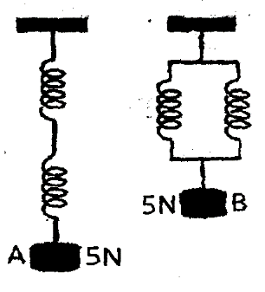
Figure 2
The extension produced in A is 4cm. What is the extension in B? (3marks)
……………………………………………………………………………………………………… ……………………………………………………………………………………………………… ………………………………………………………………………………………………………
3. Why are the tanks for storage of fuel by the Kenya pipeline company painted silvery? (1mark)
………………………………………………………………………………………
4. A dripless candle is weighted slightly on the bottom so that it floats upright in a container filled with water as shown in figure 4.
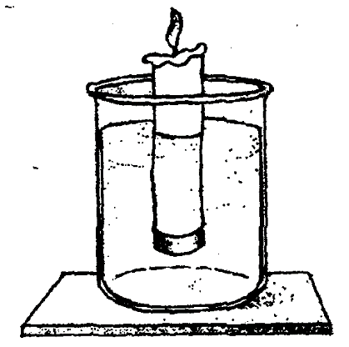
Figure 4
Explain what happens to the candle as it bums. (2marks)
……………………………………………………………………………………………………… ……………………………………………………………………………………………………… ………………………………………………………………………………………………………
5. In an experiment to estimate the size of an oil molecule, a spherical oil drop is introduced on a clean water surface. It spreads to form a circular oil film. State one assumption made in this experiment. (1mark)
……………………………………………………………………………………………………… ………………………………………………………………………………………………………
6. On the axes provided sketch a graph of mechanical advantage (MA) against load for a pulley system. (1mark)
7. State and explain how the motion of the smoke particles changes when the temperature inside the smoke cell is lowered. (2marks)
………………………………………………………………………………………………………. ……………………………………………………………………………………………………….
8. Sketch on the axis provided below a velocity – time graph of a motion of a stone thrown vertically upward from the edge of a platform and eventually the stone lands without bouncing on the ground below the platform. (1mark)
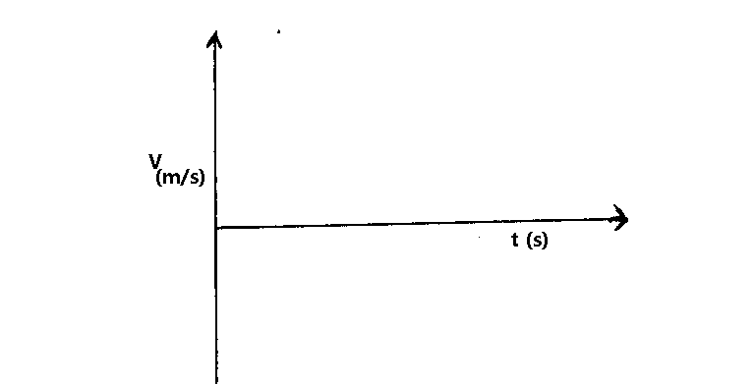

9. The barometric height at sea level is 76cm of mercury while that at a point on a highland is 74cm of mercury. What is the altitude of the point? Take g = 10m/s², density of mercury = 13600 Kg/m³ and density of air as 1.25Kg/m³. (3marks)

10. Oil is injected at a coastal town with a speed of 12m/s where the diameter of the pipe is 7cm,flows at some point inland where the radius of the pipe is 10.5cm. Determine the speed of the oil at this point. (3marks)

11. A student inverted a rounded flask with a glass tube and inserted it into water as shown in figure 6.0 below;
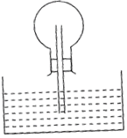
Fig.6
(a) When the student warmed the flask by rubbing it with his hands he noticed some
bubbles escaping from the end of the tube into the water. Explain. (1mark)
…………..………………………………………………………………………………………… ………………..……………………………………………………………………………………
(b) What happens in the glass tube when the student stops rubbing and lets the flask to cool? (1mark)
……………………………………………………………………………………………………… ……………………………………………………………………………………………………….

12. The figure below show a smooth spherical marble of mass 0.2kg released from height of 80m from the ground into a smooth circular pipe curved to a radius of 4m. The pipe is placed vertically on the ground surface.
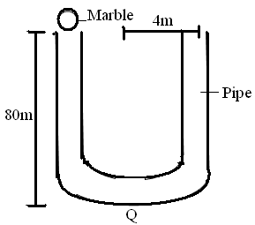
(a) What is the velocity of marble at point Q. (2 marks)

(b) What is the angular velocity at point Q. (2 marks)

SECTION B
13. (a) Define impulse and state its SI units. (2marks)
……………………………………………………………………………………………………… ……………………………………………………………………………………………………….
(b) A policeman fires a bullet of mass 20g from a gun of mass 2kg, if the bullet emerges at a velocity of 300m/s from the muzzle, calculate the force the gun exerts on the policeman. (4marks)

(c) The diagram below shows a spherical object falling through a fluid
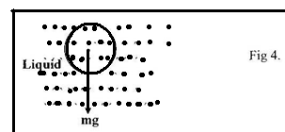
(i) on the diagram bellow shows two other forces acting on the object (2marks)
(d) If a graph of velocity against time for the object above is plotted for various fluids, the
sketch below is obtained.
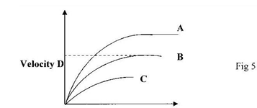
(i) Name the part D (1mark)
………………………………………………………………………………………..
(ii) Arrange the fluids A,B, & C in order of decreasing density (1mark)
…………………………………………………………………………………………..
(iii) State one factor that affects the resultant force of the body above as it falls through the fluid. (1mark)
……………………………………………………………………………………………………
14. (a) Distinguish between latent heat of fusion and specific latent of fusion. (1mark)
……………………………………………………………………………………………………… ……………………………………………………………………………………………..
b) Figure 8 shows a block of ice. A thin copper wire with two heavy weights hanging from its ends-passes over the block. The copper wire is observed to pass through the block of ice without cutting it in a process known as regelation.
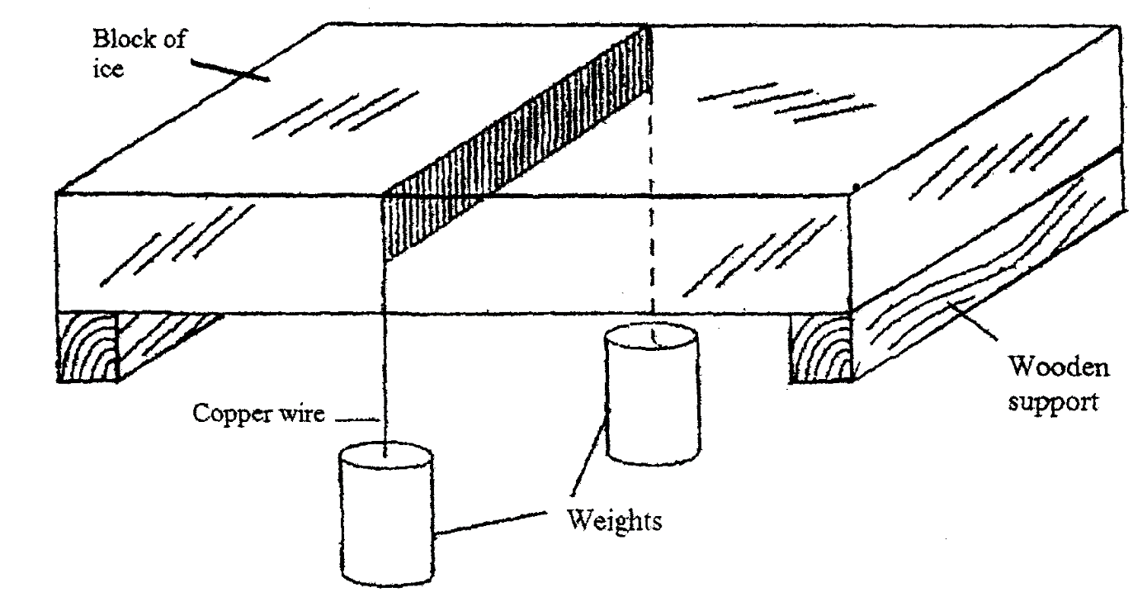
(i) Explain this observation, (3marks)
…………………………………………………………………………………………………….. …………………………………………………………………………………………………….. …………………………………………………………………………………………………….. ……………………………………………………………………………………………………..
(ii) What would be the effect of replacing the copper wire with a cotton thread?
Explain. (2marks)
……………………………………………………………………………………………………..……………………………………………………………………………………………………..
c) Figure 9 shows one method of measuring the specific latent heat of fusion of ice. Two funnels A and B, contain crushed ice at 0°C.
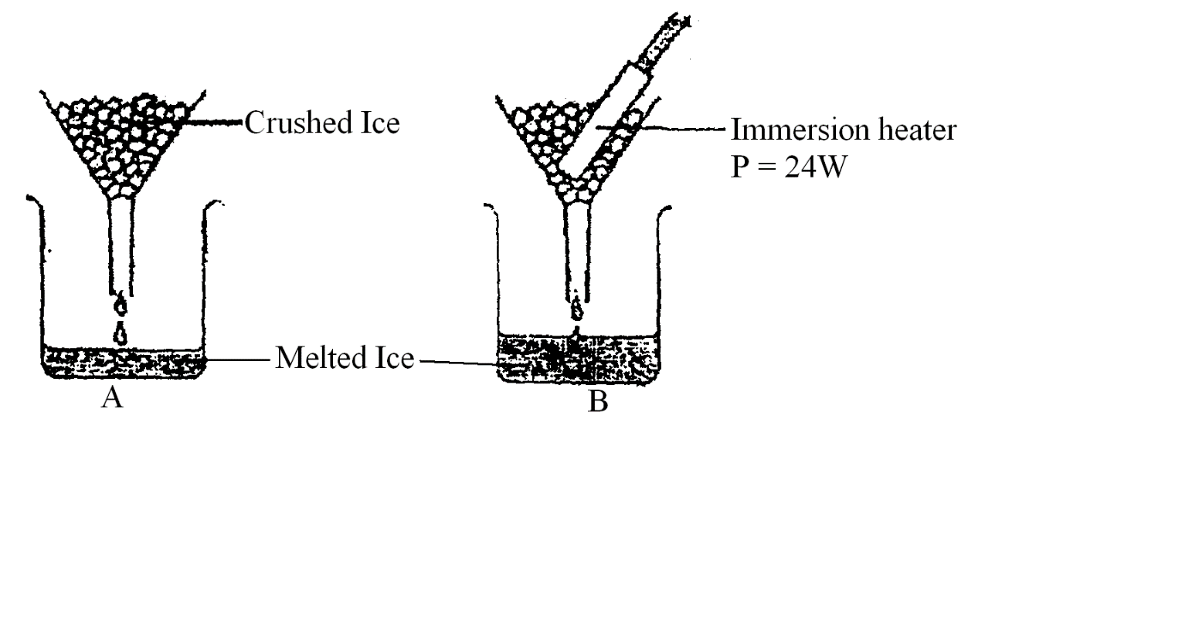
Figure 9
The mass of melted ice from each funnel is measured after 11 minutes. The results are shown below.
Mass of melted ice in A = 24g
Mass of melted ice in B = 63g
(i) What is the reason for setting up funnel A? (1mark)
……………………………………………………………………………………………………….

(ii) Determine the:
I. quantity of heat supplied by the heater. (2marks)

II. mass of ice melted by the heater. (1mark)

III. specific latent heat of fusion of ice. (3marks)

15. (a) Fig 8 below shows a stone moving with uniform speed in a horizontal circle.
Stone (2kg)
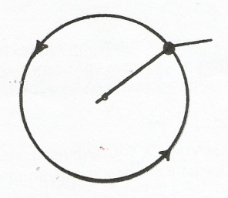
10cm
Fig.8

Indicate on the figure the centripetal force (T). (1 mark)
(b) If the stone takes 15 seconds to describe an arc length of 5 cm. Calculate:-
(i) The angle it subtends at the centre. (2 marks)

(ii) The angular velocity, ω (2 marks)

(iii) The linear velocity V of the stone (2 marks)

(iv) The centripetal force (T) (2 mks)

16. (a) The figure below shows an inclined plane placed at 30⁰ to the horizontal so that it can be used to raise a load through a height ‘h’. The efficiency is 76%.
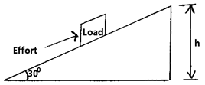
(i) Determine Velocity Ratio of the machine (2marks)

(ii) the efforts needed to move a load of 800N along the plane at a constant velocity. (3 marks)

(b) (i) Draw a block and tackle pulley system of velocity ratio 4. In your diagram, Show the effort and load position. (2marks)

(ii) If the pulley system raises a load of 100N at steady rate. Calculate the efforts required to raise the load if it is 80% efficient. (3 marks)

17. (a) State the law of flotation (1mark)
…………..………………………………………………………………………………………… ………………..…………………………………………………………………………………… (b) The figure below shows a rectangular metal block of density 10500Kg/m³ and dimensions 30cm by 20cm by 20cm suspended inside a liquid of density 1200Kg/m³ by a string attached to a point above the liquid. The three forces acting on the block are the tension T, on the string, the weight, W, of the block, and the upthrust, U, due to the liquid.
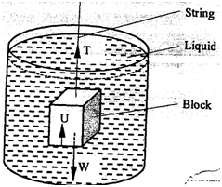
(i) Write the expression relating, T, W, and U when the block is in equilibrium inside
the liquid. (1mark)
…………..………………………………………………………………………………………… ………………..……………………………………………………………………………………
(ii) Determine the weight, W, of the block (3marks)

(iii) Determine the weight of the liquid displaced by the fully submerged block. (2marks)

(iv) Hence determine the tension T, in the string (2marks)

(c) A certain solid of volume 50cm³ displaces 10cm³ of kerosene (density 800Kg/m³) when floating. Determine the density of the solid (3marks)

End

