565/1.
BUSINESS STUDIES.
PAPER 1.
JULYIAUGUST.201 6.
2 ½ HOURS.

KIRINYAGA EAST SUB-COUNTY
CENTRAL ZONE STRATEGIC ALLIANCE EXAMINATIONS 2016
(Kenya Certificate of Secondary Education –K.C.P.E)

565/1.
BUSINESS STUDIES.
PAPER 1

Instructions to candidates
(a)Write your name and Adm. Number in the spaces provided above
(b) Answer all the questions
(c) All answers must be written in the spaces provided.
(d) Candidates should check the questions paper to ascertain that all the pages are printed as indicated and no questions are missing.
(e) This paper consists of 8 printed pages.
(f Candidates should check the questions paper to ascertain that all the pages are printed as indicated and that no questions are missing.
(g) Candidates should answer all the questions in English.

For examiners use only
Questions marks | 1 | 2 | 3 | 4 | 5 | 6 | 7 | 8 | 9 | 10 | 11 | 12
Questions marks | 13 | 14 | 15 | 16 | 17 | 18 | 19 | 20 | 21 | 22 | 23 | 24

This paper consists of 8 printed pages. Candidates should check the question paper to ensure that all pages are printed as indicated and no questions are missing

1. Highlight four reasons why people engage in business activities (4mks)
i)…………………………………………………………………………………………………
ii)………………………………………………………………………………………………..
iii)……………………………………………………………………………………………….
iv……………………………………………………………………………………………….
2. Outline four types of resources that are important in Business. (4mks)
i)…………………………………………………………………………………………………
ii)………………………………………………………………………………………………..
iii)……………………………………………………………………………………………….
iv……………………………………………………………………………………………….
3. State four functions of an entrepreneur in the production of goods and services. (4mks)
i)…………………………………………………………………………………………………
ii)………………………………………………………………………………………………..
iii)……………………………………………………………………………………………….
iv……………………………………………………………………………………………….
4. Identify the machine used to perform the following tasks. ( 4mks)

Statement | The machine
- To count coins and notes
- To trim papers into required size and shapes
(c ) to fold documents,place them in envelopes and seal the envelope
(d)To print postage impression on envelope

5. Outline four differences between chain stores and departmental store (4mks)
Chain store | Department store

6. State four statistics that are associated with the measurement of National income.(4mks)
i)…………………………………………………………………………………………………
ii)………………………………………………………………………………………………..
iii)……………………………………………………………………………………………….
iv……………………………………………………………………………………………….
7. Prepare Sunshine Traders Balance sheet from the following list of balances extracted from
his books as 31st December 2013. ( 4mks)
Capital 357.000
Stock 40.000
Machines 150,000
Furniture 7,000
Motor vehicles 200.000
Bank 20,000
Creditors 25.000
Cash 5.000
Debtors 60,000
Loan from KCB 100.000

8. Outline four characteristics of a good filing system. ( 4mks)
i)…………………………………………………………………………………………………
ii)………………………………………………………………………………………………..
iii)……………………………………………………………………………………………….
iv……………………………………………………………………………………………….
9 Highlight four methods that government uses to protect consumers. ( 4mks)
i)…………………………………………………………………………………………………
ii)………………………………………………………………………………………………..
iii)……………………………………………………………………………………………….
iv………………………………………………………………………………………………
10. State four factors that a manager should bear in mind to ensure that he/she effectively communicate with the employees (4mks)
i)…………………………………………………………………………………………………
ii)………………………………………………………………………………………………..
iii)……………………………………………………………………………………………….
iv………………………………………………………………………………………………
11. State the meaning of the following principles of insurance.
a) Subrogation…………………………………………………………………………………
b) Contribution………………………………………………………………………………….
c) Insurable interest…………………………………………………………………………….
d) Indemnity…………………………………………………………………………………..
12. High light four characteristics of underdevelopment. (4mks
i)…………………………………………………………………………………………………
ii)………………………………………………………………………………………………..
iii)……………………………………………………………………………………………….
iv………………………………………………………………………………………………
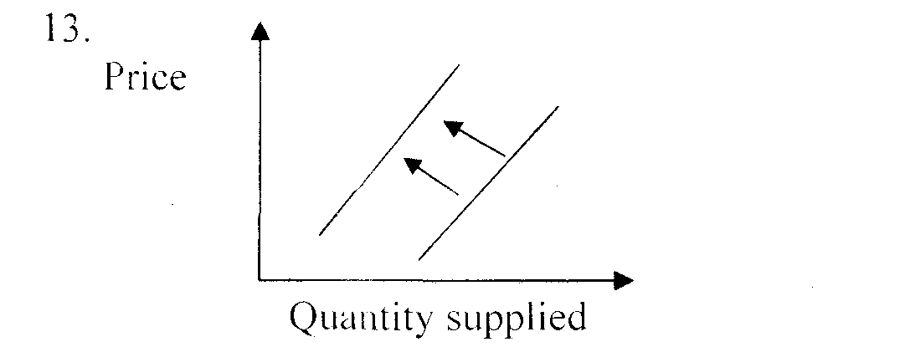
13.

State four factors that may have caused the changes shown in the diagram above
i)…………………………………………………………………………………………………
ii)………………………………………………………………………………………………..
iii)……………………………………………………………………………………………….
iv)………………………………………………………………………………………………..
14. Highlight four causes of unemployment in Kenya (4mks)
i)…………………………………………………………………………………………………
ii)………………………………………………………………………………………………..
iii)……………………………………………………………………………………………….
iv)………………………………………………………………………………………………..
15. Outline four circumstances under which Mr. Ondieki ( a farmer ) may distribute his products directly to his customers ( 4mks)
i)…………………………………………………………………………………………………
ii)………………………………………………………………………………………………..
iii)……………………………………………………………………………………………….
iv)………………………………………………………………………………………………..

16. Triple S Wholesalers had the following information as at 31 December 2013
Closing 70. 00
Total expenses 5.000
Drawings of goods 6.000
Total incomes 3.000
Calculate the capital at the beginning of the year.

17. Highlight four advantages of localization of firms. (4mks)
i)…………………………………………………………………………………………………
ii)………………………………………………………………………………………………..
iii)……………………………………………………………………………………………….
iv)………………………………………………………………………………………………..
18. State four characteristics of good money. (4rnks)
i)…………………………………………………………………………………………………
ii)………………………………………………………………………………………………..
iii)……………………………………………………………………………………………….
iv)………………………………………………………………………………………………..
19. Identify the day book associated with the following source documents given below. (4mks)
Source document | Day book
Invoice received
Credit note received
Receipt issued
Debit not received

20. Highlight four purposes of public finance. (4mks)
i)…………………………………………………………………………………………………
ii)………………………………………………………………………………………………..
iii)……………………………………………………………………………………………….
iv)………………………………………………………………………………………………..
21. The following balances were extracted from the books of Okinda wholesalers on 3 l December. (4mks)
Sh
Capital 800,000
Sale 250,000
Debtors 70,000
Purchases 1 60,000
Creditors 45,000
Opening stock ( I . I .2006) 40,000
Closing stock (31.12.2006) 20,000
General expenses 50,000
5 years bank loan 200,000
Insurance expenses 20,000
22. Salaries and wages 80,000
Required, calculate
i) Mark up ( lrnk)
ii) Current ratio (1 rnk)
iii) Rate of stock turnover ( lmk)
iv) Rate of return on capital ( lrnk)

23. Highlight four uses of a proforma invoice. (4mks)
i)…………………………………………………………………………………………………
ii)………………………………………………………………………………………………..
iii)……………………………………………………………………………………………….
iv)……………………………………………………………………………………………….
24. State four factors that affect the productivity of an office worker. (4msk)
i)…………………………………………………………………………………………………
ii)………………………………………………………………………………………………..
iii)……………………………………………………………………………………………….
iv)………………………………………………………………………………………………..
25. In each of the following cases, state the types of inflation described. (4mks)
(a) The unrest in Libya has resulted to an increase in the price of oil
(b)The price of bread has gone up to sh.60 due to increase in the price of wheat
(c )A lot of money in circulation has led to the general increase of price
(e)A rise in price due to uneven growth in some sectors of the economy.

