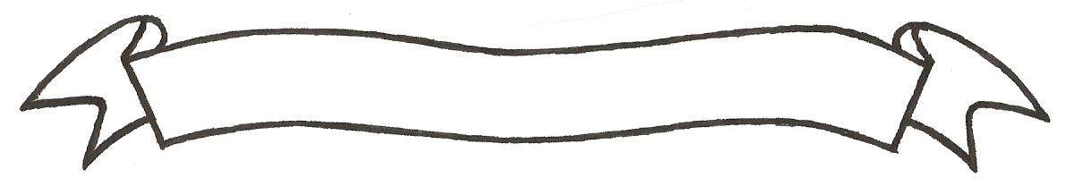

MERU UNIVERSITY OF SCIENCE AND TECHNOLOGY
P.O. Box 972-60200 – Meru-Kenya.
Tel: 020-2069349, 061-2309217. 064-30320 Cell phone: +254 712524293, +254 789151411
Fax: 064-30321
Website: www.must.ac.ke Email: info@mucst.ac.ke

University Examinations 2015/2016
THIRD YEAR FIRST SEMESTER EXAMINATION FOR THE DEGREE OF BACHELOR OF SCIENCE IN PUBLIC HEALTH
HPP 3204: LAW, ETHICS AND PUBLIC HEALTH
DATE: NOVEMBER 2015 TIME: 2 HOURS
INSTRUCTIONS: Answer question one and any other two questions

QUESTION ONE (30 MARKS)
- Define the following terms as applied in law:
- Nuisance (1 Mark)
- Civil wrong or legal wrong. (1 Mark)
- By-laws. (1 Mark)
- Explain the Layman’s general understanding of law. (4 Marks)
- Under the Public Health Act Cap 242 Section 123, who is expressly mandated to have power of entry into premises for inspection? (3 Marks)
- State three components of an ideal food control program under Cap 254. (3 Marks)
- Name four key issues in Public Health ethics. (4 Marks)
- Explain the purpose of the Meat Control Act Cap 356. (4 Marks)
- State the objective of Malaria Control Act Cap 246 of Laws of Kenya. (2 Marks)
- Explain the reasons why the Human Tissue Act Cap 252 allow for harvesting of human body organs. (4 Marks)
- What are the functions of the Medical Officer of Health under the Employment Act? (3 Marks)

QUESTION TWO (20 MARKS)
Discuss the functions of Medical Officer of Health as stipulated under the Prison’s Act. (20 Marks)
QUESTION THREE (20 MARKS)
Discuss the requirements and relevance of the Births and Deaths Registration Act Cap 149 (20 Marks)
QUESTION FOUR (20 MARKS)
Discuss the provisions for food that should be met under the Hotels and Restaurant Act Cap 494 in order that an application for hotel business is approved by the Medical Officer of Health.
(20 Marks)

