Name: ………………………………………………………….. Index No. ……………………………………

Date: …………………………………………………………. Candidate’s Sign. …………................................

443/1
AGRICULTURE
Paper 1
OCT/NOV 2017
Time: 2 Hours

Kenya Certificate of Secondary Education (K.C.S.E.)
FORM THREE

INSTRUCTIONS TO THE CANDIDATES:
- Write your name, index number and school in the spaces provided above.
- Sign and write the date of examination in the spaces provided.
- This paper consists of Three Sections: A, B and C.
- Answer ALL the questions in section A and B and any TWO questions from section C.
- Answers should be written in the spaces provided.
- This paper consists of 11printed pages.
- Candidates should check the questions paper to ascertain that all the pages are printed as indicated and that no questions are missing.

For Examiners’ Use Only
SECTION | QUESTIONS | MAXIMUM SCORE | CANDIDATE’S SCORE
A |  | 30
B |  | 20
C |  | 20
 |  | 20
 |  | 90

This paper consists of 11 printed pages. Candidates should check to ascertain that all pages are printed as indicated and that no questions are missing.

SECTION A (30 MARKS)
Answer ALL the questions in this section in the spaces provided
1. State four ways by which plant nutrients may be lost from the soil (2mks)
……………………………………………………………………………………………………….
……………………………………………………………………………………………………….
……………………………………………………………………………………………………….
……………………………………………………………………………………………………….
2. State two characteristics of a good root stock for grafting (1mk)
……………………………………………………………………………………………………….
……………………………………………………………………………………………………….
3. Give two factors which characterize small scale farming (1mk)
……………………………………………………………………………………………………….
……………………………………………………………………………………………………….
4. State two limitations of mixed farming (1mk)
……………………………………………………………………………………………………….
……………………………………………………………………………………………………….
5. Name two basic economic concepts (1mk)
……………………………………………………………………………………………………….
……………………………………………………………………………………………………….
6. State four advantages of keeping farm records (2mks)
……………………………………………………………………………………………………….
……………………………………………………………………………………………………….
……………………………………………………………………………………………………….
……………………………………………………………………………………………………….
7. Outline four pieces of information contained in a land title deed (2mks)
……………………………………………………………………………………………………….
……………………………………………………………………………………………………….
……………………………………………………………………………………………………….
……………………………………………………………………………………………………….
8. Give two ways in which land consolidation help to promote sound farm management (1mk)
……………………………………………………………………………………………………….
……………………………………………………………………………………………………….
9. Mention four aspects of rainfall that influence agriculture (2mks)
……………………………………………………………………………………………………….
……………………………………………………………………………………………………….
……………………………………………………………………………………………………….
……………………………………………………………………………………………………….
10. State four effects of HIV/AIDS and ill health on Agricultural production (2mks)
……………………………………………………………………………………………………….
……………………………………………………………………………………………………….
……………………………………………………………………………………………………….
……………………………………………………………………………………………………….
11. State factors to consider when designing acrop rotation programme (2mks)
……………………………………………………………………………………………………….
……………………………………………………………………………………………………….
12. Mention two forms in which nitrogen is taken by plants (1mk)
……………………………………………………………………………………………………….
……………………………………………………………………………………………………….
13. Name two field practices carried out to obtain optimum plant population in a crop field (1mk)
……………………………………………………………………………………………………….
……………………………………………………………………………………………………….
14. Give four factors that would determine the number of tillage operations when preparing a seed bed (2mks)
……………………………………………………………………………………………………….
……………………………………………………………………………………………………….
……………………………………………………………………………………………………….
……………………………………………………………………………………………………….
15. What causes late blight in tomatoes (1mk) ……………………………………………………………………………………………………….
16. Give two factors that would influence the time of planting beans (1mk)
……………………………………………………………………………………………………….
……………………………………………………………………………………………………….
17. Name the vegetative parts each of the following crops which is propagated
(i) Sweet potatoes…………………… ½ mk
(ii) Cassava………………………….. ½ mk
(iii) Bananas………………………….. ½ mk
18. State four advantages of drainage as a method of land reclamation (2mks)
……………………………………………………………………………………………………….
……………………………………………………………………………………………………….
……………………………………………………………………………………………………….
……………………………………………………………………………………………………….
19. Name a chemical used to achieve the following during water treatment
(a) Coagulation of solid particles…………………. (1mk)
(b) Softening of water…………………………. (1mk)
(c) Killing of pathogens……………………….. (1mk)
SECTION B (20 MARKS)
Answer ALL the questions in this section in the spaces provided.
20. The illustration below shows a method of making compost manure. Study it and answer the questions that follow.
Field
D
B
C
A

(a) By use of arrows show how the decomposed materials should be transferred (1mk)
……………………………………………………………………………………………………….
(b) Identify the above shown method (1mk)
……………………………………………………………………………………………………….
(c) Give one reason for turning the materials regularly (1mk)
……………………………………………………………………………………………………….
(d) Give one reason for sprinkling water on the structure (1mk)
……………………………………………………………………………………………………….
(e) Outline three characteristics of plants used for green manuring (3mks)
……………………………………………………………………………………………………….
……………………………………………………………………………………………………….
……………………………………………………………………………………………………….
21. The diagram below represents a ground surface after a tertiary operation
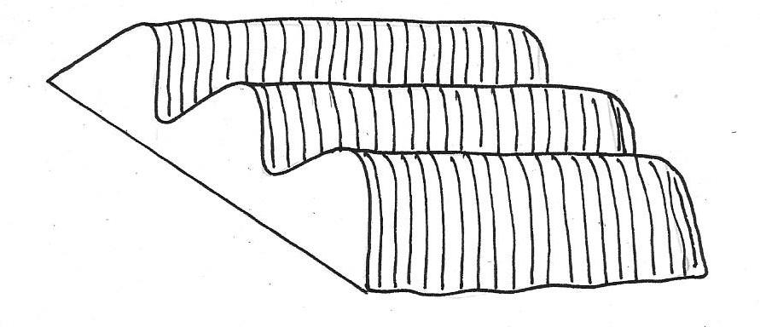

(a) Identify the tertiary operation (1mk)
……………………………………………………………………………………………………….
(b) Give two types of crops that can be established on the structure above (2mks)
……………………………………………………………………………………………………….
……………………………………………………………………………………………………….
(c) State three advantages of using the above for growth of crops (3mks)
……………………………………………………………………………………………………….
……………………………………………………………………………………………………….
……………………………………………………………………………………………………….

22. The diagram below illustrates a field management practice. Study it carefully and answer the
questions that follow
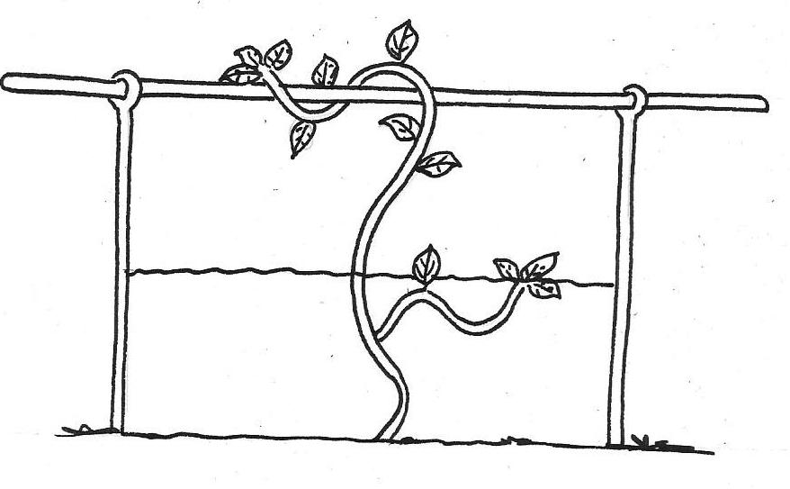

(a) Identify the field practice above (1mk)
……………………………………………………………………………………………………….
(b) Name one type of crop trained using above methods (1mk)
……………………………………………………………………………………………………….
(c) Give two reasons for carrying out the practice above (2mks)
……………………………………………………………………………………………………….
……………………………………………………………………………………………………….
23. A farmer was adviced to apply compound a fertilizer 20:30:10 on a plot measuring 5m by 4m at the rate of 200kg/ha
(a) Calculate the amount of fertilizer the farmer would require for the plot (2mks)

(b) What do the figures 30, and 10 in the fertilizer stand for? (1mk)
……………………………………………………………………………………………………….
SECTION C (40 MARKS)
Answer any two questions in this section in the spaces provided at the end of the section.
24. (a) Explain cultural methods used in controlling crop diseases (10mks)
(b) Describe the production of dry beans under the following sub headings
(i) weed control (3mks)
(ii) Harvesting (3mks)
(iii) Marketing (4mks)
25. (a) Explain the factors that influence spacing in crops (10mks)
(b) Describe the practices that a farmer should carry out to ensure uniform germination of seeds(10mks)
26. (a) Explain ten farming practices which help to conserve soil on the farm (10mks)
(b) Explain the factors that influence the type of irrigation to the farm (10mks)
……………………………………………………………………………………………………….
……………………………………………………………………………………………………….
……………………………………………………………………………………………………….
……………………………………………………………………………………………………….
……………………………………………………………………………………………………….
……………………………………………………………………………………………………….
……………………………………………………………………………………………………….
……………………………………………………………………………………………………….
……………………………………………………………………………………………………….
……………………………………………………………………………………………………….
……………………………………………………………………………………………………….
……………………………………………………………………………………………………….
……………………………………………………………………………………………………….
……………………………………………………………………………………………………….
……………………………………………………………………………………………………….
……………………………………………………………………………………………………….
……………………………………………………………………………………………………….
……………………………………………………………………………………………………….
……………………………………………………………………………………………………….
……………………………………………………………………………………………………….
……………………………………………………………………………………………………….
……………………………………………………………………………………………………….
……………………………………………………………………………………………………….
……………………………………………………………………………………………………….
……………………………………………………………………………………………………….
……………………………………………………………………………………………………….
……………………………………………………………………………………………………….
……………………………………………………………………………………………………….
……………………………………………………………………………………………………….
……………………………………………………………………………………………………….
……………………………………………………………………………………………………….
……………………………………………………………………………………………………….
……………………………………………………………………………………………………….
……………………………………………………………………………………………………….
……………………………………………………………………………………………………….
……………………………………………………………………………………………………….
……………………………………………………………………………………………………….
……………………………………………………………………………………………………….
……………………………………………………………………………………………………….
……………………………………………………………………………………………………….
……………………………………………………………………………………………………….
……………………………………………………………………………………………………….
……………………………………………………………………………………………………….
……………………………………………………………………………………………………….
……………………………………………………………………………………………………….
……………………………………………………………………………………………………….
……………………………………………………………………………………………………….
……………………………………………………………………………………………………….
……………………………………………………………………………………………………….
……………………………………………………………………………………………………….
……………………………………………………………………………………………………….
……………………………………………………………………………………………………….
BUTERE EAST DISTRICT JOINT EXAMS
AGRICULTURE 443/12
MARKING SCHEME
OCT/NOV 2013
1. Ways by which plant nutrients may be lost
- Leaching
- Soil erosion
- Volatilization
- Burning
- Denitrification
- Plant uptake (4x ½=2mks)
2. Characteristics of a good root stock
Healthy/free from pests and diseases.
Resistant /tolerant to soil born diseases and pests
Adaptable to different soil condition (2 x ½ =1mk)
3. Factors which characterizes small scale farming
Small size of land
Limited capital
Limited tools/equipment
Less labour is required
Maximum use of available labour ( 2 x ½ =1mk)
4. Limitation of mixed farming
High initial labour is required to start various farming enterprise
Limited area for each enterprise
Inadequate technical know how and labour to run enterprises ( 4 x ½ =2mks)
5. Name two basic economic concepts
Scarcity
Opportunity cost
Preference and choice
6. Four advantages of keeping farm records
- Determines the value of the farm in terms of assets and liabilities
- Used in income tax assessment
- Used in future reference
- Helps in planning and budgeting
- Determines the credit worthiness of the farmer
- Determines losses and detects theft on the farm
- Important when sharing profits and losses in partnership
- Helps to settle disputes among the heirs
- Helps to support insurance claims
- Provides labour information like terminal benefits NSSF remittances and SACCO dues
- Help in proper management of routine livestock and crop production practices
- Used to compare the performance of different enterprises on the farm (4x ½ =2mks)
7. Pieces of information contained in a land title deed land certificates
- Title deed number/land parcel number /location
- Size of land
- Name and identify number of the owner
- Type of ownership (absolute, lease hold or free hold)
- Condition of ownership if any
- Seal and the signature of the issuing officer
- Date of registration (4x ½ =2mks)

8. Saves time and money
Make it easy to have sound farm plan
Make supervision easy
Facilitate mechanization
Makes it easy to carry out soil, conservation measures (2x1=2mks)
9. For aspects of rainfall influencing agriculture (2mks)
Rainfall distribution (pattern)
Rainfall reliability
Rainfall amount
Rainfall intensity ( 4x ½ =2mks)
10. Effects of HIV/AIDS and ill health on agriculture production
- Shortage of labour
- A lot of money is spent on treatment and hospitalization of people with HIV/AIDS
- Leads to low food supply and poverty due to loss of market for agricultural products
- Resources used in treatment of HIV and AIDS could be used in agriculture production
- Less time is spent in farming activities because a lot of time is spent looking after people with HIV/AIDS (2x1=2mks)
11. Factors to consider when designing a crop rotation programmed
- Include grass ley to give land rest
- Legume crops to be included to fix nitrogen
- Heavy feeders should come first in a newly opened land
- Crops from same family should not follow each other
- Deep rooted crops should alternate with shallow rooted crops (4x ½ =2mks)
17. Forms in which nitrogen is taken by plants
Nitrate ion (NO3-)
Ammonium (NH4+) ( ½ x 1=1mk)
13. Field practices carried out to obtain optimum plant population
Thinning
Gapping ( 2 x ½=1mk)
14. Factors determining number of tillage operations
Topography/ liability to soil erosion
Type of implement used
Crop to be planted /size of the seed/type of seeds
Soil moisture
Initial condition of the land/type of weeds
Soil texture
Available capital
Skill of the operator
15. Cause of late blight
Fungus/ phytopthera infections (2 ½ =1mk)
16. Factors that could influence time of planting beans
- Variety of beans
- Rainfall pattern/ availability of irrigation facilities /onset of rains/rainfall reliability
- Diseases and pest incidences
- Expected harvesting time/marketability/light of suitable weather
17 . Vegetative parts
- Sweet potatoes-stem cutting/vine tuber ( ½ mk)
- Cassava- stem cutting ( ½ mk)
- Bananas -suckers ( ½ mk)
- Orange- Budwoods/buds ( ½ mk)
18. Advantages of drainage as a method of land reclamation
Improves soil aeration
Raises soil temperature
Increases soil volume
Prevents accumulation of poisonous substances ( ½ x 4=2mks)
19. Chemicals used to achieve the following during water treatment
(a) Coagulation of solid particles- alum(aluminium sulphate)
(b) Softening of water-soda ash (sodium bicarbonate)
(c) Killling of pathogens-chlorine
SECTION B
20(a)
fieldd
C
A
B
A

1mk

(b) Four heap system ( 1x1=1mk)
(c) To enhance uniform decomposition (1mk)
(d) To improve microbial activities /moderates the temperature (1mk)
(e)should be leafy
Faster rate of decomposition
Have high nitrogen content
Should be hardy (3mks)
21. (a) Ridging
(b) Irish potatoes, sweet potatoes yams (any tube crop)
Sugar cane and bananas (on the furrows) (2x1=2mks)
(c) Proper drainage
Easy harvesting
Good soil aeration
Facilitates tuber expansion
Section c
24 (a) Cultural methods used in controlling crop diseases
Healthy planting materials/certified seeds/clean planting material
Field hygiene/burning crop residues
Proper spacing to control rosette virus and damping off disease
Rouging uprooting and burning infected plants
Early planting
Timely harvesting to avoid attack by storage pests/disease
Use of resistant varieties
Practice crop rotation
Enhanced plant nutrition to enable plants resist opportunities infections
Close season to break life cycle of pathogens
Pruning to create favourable micro-climate (10x1=10mks)
(b) Weed control
Control perennial weeds by cultivation during dry spell
Plant early for crops to establish in time before weeds
Uproot the weeds by hand
Use of selective herbicides occasionally (3x1=3mks)
(iii) Harvesting
Harvest 3 months after planting
Harvest brown pods by uprooting the whole stalk
Harvest early in the morning or late in the evening to avoid shattering of grains (3x1=3mks)
(iii) market through National cereal produce board
Market locally by selling to individuals and hotels
Selling in open air market
Bidding for tenders in schools (4x1=4mks)
25. Factors that influence spacing in crops
Soil fertility- a fertile soil allows for closer spacing compared to poor soils
Moisture content/amount of rainfall-allows closer spacing but low rainfall may necessitate wide spacing
Interplanted crops- crops planted with others in rows mill require wider spacing
Pest control- Rosette virus in groundnuts is controlled by close spacing
Number of seeds/plants per hole-where more than one seed/plant a wider spacing is used (5x2=10mks)
(b) Practices a farmer should carry out to ensure uniform germination of seeds
Select seeds of the same size
Seeds .. of pests and diseases
Plant seeds at the same time
Prepare the field to the required uniform tilth
Plant at the right moisture content
Treat seeds before planting
Plant at the correct depth (5x2=10mks)
26. (a) Farming practices that help to conserve soil on the farm
Mulching-mulches reduces speed of run off
Cover cropping-protect the soil against splash erosion
Use of filter strips-heaped along contours trap soil
Cut off drains-direct water run off from cultivated fields
Gabions- build across slopes reduce speed of run off
Planting of trees-protect the soil from splash erosion by reducing the force of rain drops reaching the ground
Stonelines-stones heaped along contours to trap soil that is being washed away.
Terraces- constructed on hilly areas to slow down surface flow of water it reduces its erosive power
Bunds- heaps of soil on sloping land along contours. They stop the water rushing down the hill
Ridging –Ridges for establishing crops are constructed along the contours of the field. Ridges slow down run off and trap eroded soil
Dams (10x1=10mks)
(b) Factors that influence the type of irrigation to be used on the farm
- Naure of the land
- Type of soil
- Availability of water
- Type of crop
- Technology available
- Cost of the irrigation system
- Availability of skilled manpower
- Distance from the source of water to the field
- Climate of the area. (8x1=8mks)

