Name: …………………………………………………………… Index No …......…................................

Candidate’s Sign …………………………………. Date: …………………………………

443/2
AGRICULTURE
Paper 2
OCT/NOV 2017
Time: 2 Hours

Kenya Certificate of Secondary Education (K.C.S.E)

Agriculture
Paper 2
2 Hours

INSTRUCTIONS TO CANDIDATES:

- Write your name, index number and school in the spaces provided.
- Sign and write the date of the examination in the spaces provided.
- This paper consists of three sections; A, B and C.
- Answer all questions in section A and B.
- In section C answer any two questions in the spaces provided
- All answers must be written in the spaces provided.

For Examiner’s Use Only;
SECTION | QUESTION | MAXIMUM SCORE | CANDIDATES’ SCORE
A | 1 - 20 | 30
B | 16 – 19 | 20
C |  | 20
 |  | 20
 | Total | 90
This paper consists of 8 printed pages. Candidates should check the question paper to ascertain that all pages are printed as indicated and that no questions are missing

SECTION A (30 MARKS)
Answer all the questions in this section in the spaces provided.
1. What characteristics of gizzard of a cork enable it to digest food? (1mk)
…………………………………………………………………………………………………………..
…………………………………………………………………………………………………………..
2. Differentiate between an essex saddle back and Wessex saddle back (1mk)
…………………………………………………………………………………………………………..
…………………………………………………………………………………………………………..
3. State four factors that determine quality of honey (2mks)
…………………………………………………………………………………………………………..
…………………………………………………………………………………………………………..
…………………………………………………………………………………………………………..
…………………………………………………………………………………………………………..
4. (a) Give fours ways of restoring a sick animal to good health (2mks)
…………………………………………………………………………………………………………..
…………………………………………………………………………………………………………..
…………………………………………………………………………………………………………..
…………………………………………………………………………………………………………..
(b) Differentiate between pen and daft camping in sheep management (2mks)
…………………………………………………………………………………………………………..
…………………………………………………………………………………………………………..
5. What the difference between making gauge and mortise gauge (1mk)
…………………………………………………………………………………………………………..
…………………………………………………………………………………………………………..
6. Give two examples of light breeds of poulrty (1mk)
…………………………………………………………………………………………………………..
…………………………………………………………………………………………………………..
7. (a) State four signs of heat in pigs (2mks)
…………………………………………………………………………………………………………..
…………………………………………………………………………………………………………..
…………………………………………………………………………………………………………..
…………………………………………………………………………………………………………..
(b) Give two reasons why teaser rams are introduced to a flock of ewes some weeks before tupping (1mk)
…………………………………………………………………………………………………………..
…………………………………………………………………………………………………………..
8. Name two livestock diseases controlled through artificial insemination (1mk)
…………………………………………………………………………………………………………..
…………………………………………………………………………………………………………..
9. State two factors which determine amount of feeds given to an animal (1mk)
…………………………………………………………………………………………………………..
…………………………………………………………………………………………………………..
10. Name the tool used together with each of the following tools
(a) Canula
…………………………………………………………………………………………………………..
(b) Brace
…………………………………………………………………………………………………………..
(c) Elastrator
…………………………………………………………………………………………………………..
11. Name four plumbing tools used for installing galvanized water pipes (2mks)
…………………………………………………………………………………………………………..
…………………………………………………………………………………………………………..
…………………………………………………………………………………………………………..
…………………………………………………………………………………………………………..
12. Give two reasons for seasoning timber before it is used for construction (1mk)
…………………………………………………………………………………………………………..
…………………………………………………………………………………………………………..
13. State two factors that lower quality of concrete (1mk)
…………………………………………………………………………………………………………..
…………………………………………………………………………………………………………..
14. Give two maintenance practices in a green house (1mk)
…………………………………………………………………………………………………………..
…………………………………………………………………………………………………………..
15. Highlight three functions of ventilation in an animal house (1 ½ mks)
…………………………………………………………………………………………………………..
…………………………………………………………………………………………………………..
…………………………………………………………………………………………………………..
16. Name the type of breeding system represented below
(a) Ayrshire sue x Boran Dam F1 heifer x Hereford ( ½ mk)
…………………………………………………………………………………………………………..
(b) Outline two characteristics of livestock that are used in mass selection (1mk)
…………………………………………………………………………………………………………..
…………………………………………………………………………………………………………..
17 (a) Name four properties of a good vaccine (2mks)
…………………………………………………………………………………………………………..
…………………………………………………………………………………………………………..
…………………………………………………………………………………………………………..
…………………………………………………………………………………………………………..
(b) What is the function of spillway in a fish pond? (1mk)
…………………………………………………………………………………………………………..
SECTION B (20MARKS)
Answer all the questions in the spaces provided
18. Below is a diagram of a farm structure it to answer the questions that follow
A
B
C
D
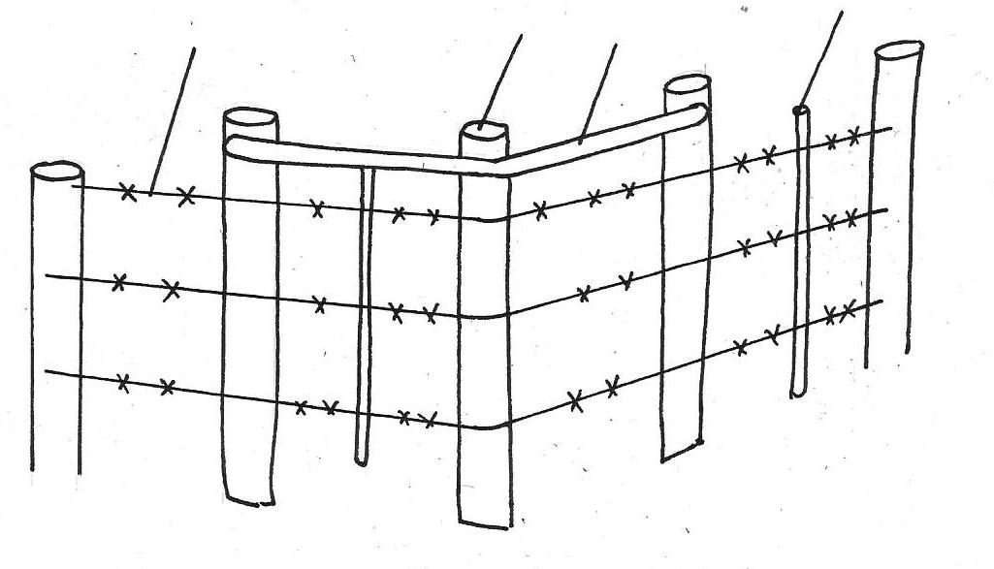

(a) Identify the structure ( ½ mk)
…………………………………………………………………………………………………………..
(b) Name the parts labeled B,C,D,E and F (2 ½ mks)
…………………………………………………………………………………………………………..
…………………………………………………………………………………………………………..
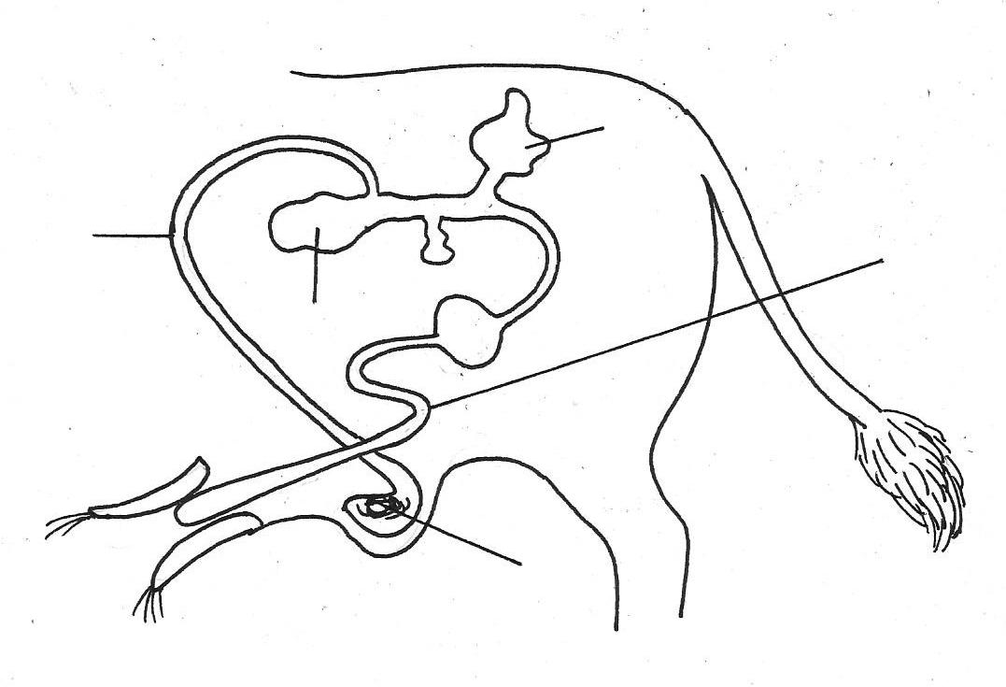
19. Study the illustration below and use to to answer the questions below
Urethra
A
C
D
B

(a) Label the parts
A…………………….
B……………………..
C……………………
D…………………
(b) Give the functions of parts B and C (2mks)
B……………………………………………………………………………………………….
C…………………………………………………………………………………………………
(c) Give the name of the part in the animal affected when the animal is attacked by brucellosis(1mk)
…………………………………………………………………………………………………………..
20. Diagram G,H and J illustrate some livestock parasites
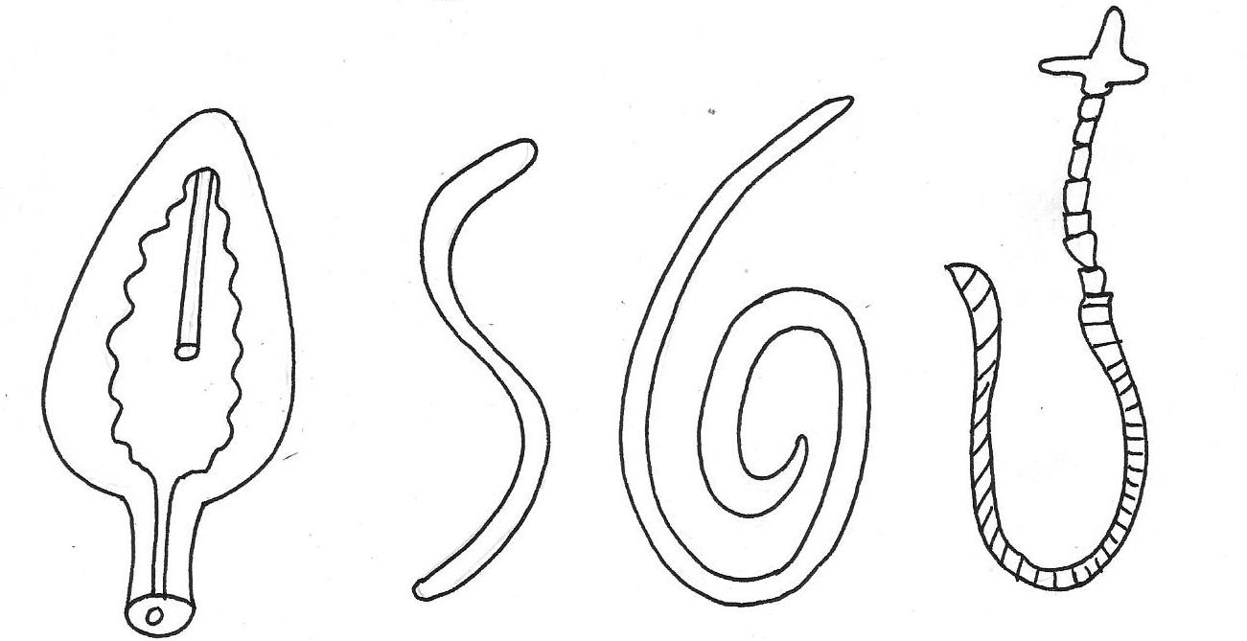

G
H
J

(a) Identify parasites G,H and J ( 1 ½ mks)
…………………………………………………………………………………………………………..

(b) State the category of parasites G, H and J (1 ½ mks)
…………………………………………………………………………………………………………..
…………………………………………………………………………………………………………..
(c) Name the parts of the hosts body where parasites G and J are found (2mks)
…………………………………………………………………………………………………………..
(d) Name the intermediate horsts of parasites G and H (1mk)
…………………………………………………………………………………………………………..
21. Below is a breeding cycle of an ewe in relation to feeding region accompanying it it.
TUPPING
LAMBING
WEANING
iii
i
ii

(a) Which stages are represented by:-
(i) ……………………………………
(ii)…………………………………….
(iii)…………………………………….
(b) Give two importance of (i) (2mks)
…………………………………………………………………………………………………………..
…………………………………………………………………………………………………………..
22. Below are farm tools, study them and answer the questions below

O
N
M
L

(a) Identify the tools M, N (1mk)
M …………………………………………………………………………………………………………..

N …………………………………………………………………………………………………………..
(b) Give one functional advantage of O over tool L (1mk)
…………………………………………………………………………………………………………..
SECTION C: (40MARKS)
Answer TWO questions from this section.
23. (a)Describe five design requirement of a calf pen (10mks)
(b) Describe milk fever disease under the following sub-headings
(i) Animals affected (2mks)
(ii) Symptoms (5mks)
(iii) Control and treatment (3mks)
24. Give the routine practices and explain an appropriate method of handling livestock during the routine practice (20mks)
25. (a) Describe the digestion of grass in the rumen of a ruminant (6mks)
(b) Describe the life-cycle of a three host tick (7mks)
(c) Which precautions should be observed when using farm tools and equipment (6mks)
…………………………………………………………………………………………………………..
…………………………………………………………………………………………………………..
…………………………………………………………………………………………………………..
…………………………………………………………………………………………………………..
…………………………………………………………………………………………………………..
…………………………………………………………………………………………………………..
…………………………………………………………………………………………………………..
…………………………………………………………………………………………………………..
…………………………………………………………………………………………………………..
…………………………………………………………………………………………………………..
…………………………………………………………………………………………………………..
…………………………………………………………………………………………………………..
…………………………………………………………………………………………………………..
…………………………………………………………………………………………………………..
…………………………………………………………………………………………………………..
…………………………………………………………………………………………………………..
…………………………………………………………………………………………………………..
…………………………………………………………………………………………………………..
…………………………………………………………………………………………………………..
…………………………………………………………………………………………………………..
…………………………………………………………………………………………………………..
…………………………………………………………………………………………………………..
…………………………………………………………………………………………………………..
…………………………………………………………………………………………………………..
BUTERE EAST DISTRICT JOINT EXAMS
AGRICULTURE 443/2
MARKING SCHEME
OCT/NOV 2013
1 .(a) Contains grit for grinding food
Has tough muscles on each side to enable crushing of food into powder/smaller particles (2x ½ =1mk)
(b) Essex has black body with shoulders and all four legs white while wessex saddle back has a black body with shoulders and only the front legs white (1 mk as a whole)
2. Reduced growth rate
Anaemia
Blockage of intestines
Diarrhoea
Loss of weight
Presence of worms in fieces
Malnourishment
Pot bellies
Coughing as larvae migrate from the lungs to the trachea ( ½ x5= 2 ½ msk)
3. Factors that influence quality of honey
Presence of impurities
Source of nector/type of flowers
Season of the year the honey is harvested
Oversmocking during harvesting which give honey bad smell
Method of harvesting
Method of processing the flowers ( ½ x4= 2mks)
4 (a) Ways of restoring a sick animal to good health
Good feeding
Provision of clean environment
Provision of clean environment
Neutralizing the ill effects produced by the disease
Relieving discomfort on injury to the animals
Preventing further spread of the disease.
(b) Pen and drift lambing
Lambing-process where the pregnant ewes are separated from the others after showing signs of lambing while drift lambing is where pregnant ewes are put together in one paddock and separated as they lamb down.
5. Difference between marking gauge and mortise gauge
6. Light breeds of poultry
Leghorns, Minorca, Ancona, Sykes ( 2 x ½ =1mk)
7 (a) Signs of heat in pigs
Restlessness
Frequent urination
Swelling and reddening of vulva
Respond positively to riding test
Frequent mounting on others
Clear/shiny mucus from the vulva
(b) Reasons why teaser rams are introduced
Stimulates ewes to be on heat
Helps in detection of ewes that are on heat/oestrus
Helps in determining the most appropriate time for tupping (2x ½ =1mk)
8. Vaginitis
Orchitis
Brucellosis/contagious abortion (2x ½ =1mk)
9. Factors which determine amount of feeds
Level of production of the animal
Activity performed by the animal
Age of the animal
Body weight/body size
Type /species of th e animal
Weather conditions /temp
Physiological conditions of the animal (2x ½ =1mk)
10. (a) Canula-Trocar
(b) Brace-bit
(c) Elastrator-rubber ring (3 x ½ =1 ½ mks)
11. Plumbing tools
Stock and die
Pipe wrench /adjustable
Pipe cutter/hacksaw
Screw driver
Pipe chump
Drill
Wall punch
Plumb bob
12. Prevent warping
Prevent rotting due to fungal attack
Prevent insect damage (2x ½ =1mk)
13. Factors that lower quality of concrete
Impurities/foreign materials
Wrong ratio used
Quick drying /premature drying
Large sizes of individuals aggregates
Poor mixing
Expiry of cement (2 x ½ =1mk)
14. Maintenance in a green house
Broken frames should be repaired or replaced
Torn polythene materials should be cleaned
Dirty polythene sheets should be cleaned ( 2 x ½ =1mk)
15. Functions of ventilation
Allow sufficient air circulation
Prevent dampness
Controls temp in the house (3x ½ = 3½ mks)
16 (a) Upgrading/grading up
(b) Observable characteristics e.g colour, size, shape
Measurable characteristics e.g body, weight, milk, yield etc (2x ½ =1mk)
17. (a) Properties of a good vaccine
Should produce immunity
Have a long keeping life
Easy to administer
Be compatible with other vaccines given to the animal
Have no side effects
Single dose should produce life long immunity
(b) Drains away excess water from the fish pond
SECTION B
18. (a) Barbed wire fence
b) B- corner post
C-Brace
D- Dropper
E-post/strandard
F-Strainer
19. (a)A-seminal vesicles
B- Epidydymis
C-Prostrate gland
D- Sperm duct
(b) B- storage of sperms
C-Produces a neutral fluid that neutralizes acidity of urine in urethra
(c) Testes/testicles/epidydimis
20. (a) G- Liverfluke
H-Round worm
J- Tapeworm
(b) Internal parasite
(c) G-bile duct/gall bladder/liver
J- attached on the walls of small intestines
(d) G- Water snail J- cattle, sheep, goat, pig
(i) Steaming up
(ii) lactation/milk production
(iii) Flushing
(b) Flushing
(b) Give the ewe good condition for parturition
Facilitates rapid foetal development
22. (a) M- Adjustable specimen
N- mattock
(b) Tool label O can be used to open bolts and nuts or various sizes but L can only open bolts and nuts of only of particular size (1mK)
23. Routine practices and appropriate method of handling
(1) Vaccination
Animals should be in to restrict it from running away
Young animals should be tied properly in the crush
Birds should be hold by a helper as the vet officer administer the vaccine
(ii) wool shearing
Sheep is made to sit on its rump and then turned as shearing goes on.
(iii) Ploughing
Animal should be properly harnessed by a yoke. The yoke should be made by a soft material to prevent direct injury on livestock
(iv) Livestock exhibition
Bulls should be paraded by an aid of lead stick and bull rings, cows and heifers held by a halter
(vi) Transportation
Small animals i.e rabbit should be transported in cages, mature chicken in coops and chicks in perforated cartons
For large animals should be restricted in a vehicle by use of ropes and floor of vehicle spread with sow dust or straws to prevent skidding
(vi) Milking
Lactating cow should be put in the milk parlour and if necessary tied at the near legs tightly
(vii)castration- restrain the animals well-use the appropriate tool
(iii) Deworming
Correct equipment should be used
The drug should be given in small amount until the whole dose is given to prevent chocking the animal. The restraining should be applied to avoid stressing the animals
(ix) Debeaking
Restrain the chicken by tying the legs. Hold the chicken under the armpit and debeak
(ix) Ear notching
Identification put the animal in crush. Hold the ear and punch the ear appropriately
(x) Treatment
(xi) Dehorning
24 (a) Digestion of grass in rumen
Cow picks up material very fast, chews mixing with saliva and swallows
Later it chews’ cud mixing the food with more saliva
There is no enzymatic digestion in the mouth as cattle do not have ptyalin enzymes in their saliva
After the food is mechanically broken in the mouth it is passed onto the rumen
The rumen stores the food temporarily and during this time it is churmed mixed and soften with water
Micro organisms break down the carbohydrates cellulose, starch and simple sugars
The results of microbial proteins gases such as methane and vitamin B2 and K lost of the volatile fatty acids are absorbed through the rumen wall and what remains goes into the reticulum (1x7=7mks)
(b) Life cycle of the lost tick
The eggs are laid on the ground
They hutch into larva which attach of the first host
It sucks blood become engorged and then fall down to moult
It moulds into nymph
The nymph’s look for second host
Feed on blood, become engorged and fall down to moult
It moults into adult
© Precautions observed when using farm tools and equipment
- Handle tools carefully and correctly
- Use a tool for the right job designed for
- Maintain the tool in good working condition
- Dress properly when using farm tools and equipments
- The work should be firmly secured where possible
- Avoid wearing loose clothes especially when operating workshop tools and equipments
- Avoid working on dangerous grounds such as on slippery floors
- Learn how to use a tool on operate a piece of equipment before using it
- Store farm tools in safe places such as tool racks
25. (a) Concreter or slatted floors for away cleaning
Dry litter to provide warm and dry conditions
Dry and warm to discourage infections
Spacious to provide room for exercise, feeding and placement of waters
Well lit to enhance synthesis of vitamin D for strong bones development
Well drained to avoid dampness which may encourage infections
Draught free to avoid chilly conditions that may include infections
Well ventilated to drive away bad smell
Simple hosing to avoid spread of worms and diseases
Movable –move to fresh grounds to reduce fresh infections
(b)(i) Cows that have recently calved
Goats and pigs that have recently calved
(ii) Dullness
Mascular twitching
Staggering
Falls down and becomes unconscious
Animal lies down on the side and the whole body stiffens.
Stomach contents are drawn into the mouth (lungs)
Complete loss of appetite
Sudden death
(iii) Intravenous infections of calcium boroghiconate salt
Partial milking for first 10 days
Provide heavy nutrition with ratio containing calcium and phosphorous
Give doses of vitamin D/Parathyroid extractions
Keep sick animals in a comfortable position
Give fresh water
Mechanical removal of urine

