312/1
GEOGRAPHY
Paper 1
2 ¾ Hours

NAKURU SUB COUNTY SEC. SCHOOLS K.C.S.E TRIAL EXAMINATIONS-2016
Kenya Certificate of Secondary Education (K.C.S.E)
313/1
GEOGRAPHY
Paper 1
July 2016
2 ¾ Hours

INSTRUCTIONS TO CANDIDATES

- This paper consists of TWO Sections A and B.
- Answer all questions in section A.
- Answer 6 and any other TWO questions from section B.
- All questions must be written in the answer sheets provided
- This paper consists of 5 printed pages.
- Candidates should check the question papers to ensure that all pages are printed as indicated and no questions are missing.

SECTION A
ANSWER ALL QUESTIONS IN THIS SECTION
1. (a) Define the term solar system (2 marks)
(b) The diagram below shows the solar system. Study it and answer the questions that follows.
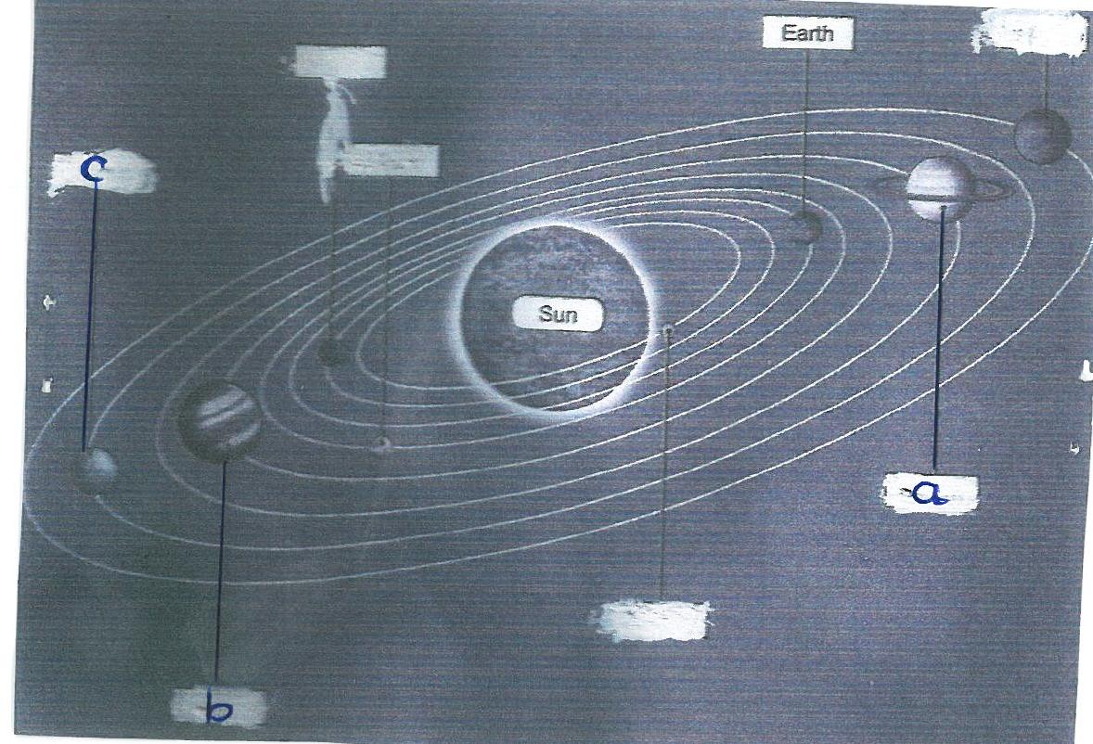
Name the planets marked a, b, and c. (3 marks)
2 (a) Differentiate between a plug dome volcano and a volcanic plug (2 marks)
(b) State three effects of earthquakes (3 marks)
3 (a) Describe five characteristics of savannah vegetation (5 marks)
4 (a) Name three glacial erosional features on highland region (3 marks)
(b) The diagram below shows moraine deposits. Name the moraines labelled E and F (2 marks)

5 (a) Name three processes of wind erosion in hot deserts (3 marks)
(b) Differentiate between a Zeugen and a Yardang (2 marks)

SECTION B:
Answer question 6 and any other two questions from this section
6. Study the map of Busia 1:50,000 (sheet 101/1) provided and answer the following questions.

(a) Give the location of the South East corner of the map by longitude and latitude (2 marks)

(b)(i) Identify two relief features found in grid square 2934 (2 marks)
(ii) Calculate the bearing of a market at Odiado from Chief’s house (2marks)

(c)(i) Draw a cross-section along Northing 35 from 290350 to 360350 (4 marks)
(ii) On your cross-section mark and label the following (3 marks)
- River Kawuoda
- Riverine trees
- All weather road, loose surface
(iii) Calculate vertical exaggeration of your cross-section (2 marks)

(d) Describe four characteristics of river Sio (4 marks)

(e) Citing evidence from the map. Identify three economic activities carried out in the area.
6marks)

7 (a) (i) Name one meteorite crater lake in Africa (1 mark)
(ii) Explain two reasons why LakeMagadi is salty (4 marks)

(b) Using a diagram, describe how Lake Victoria was formed (5 marks)

The diagram above shows a hydrological cycle
(c) (i) Give the processes taking place at P, S and T (3 marks)
(ii) Explain two factors that influence occurrence of surface run off (4 marks)

(d) (i) Explain three significance of lakes with reference to specific lakes in East Africa(6 Marks)
(ii) Name the man-made lakes behind the following rivers (2 marks)
- River Volta
- River Zambezi

8 (a) (i) what is a mineral? (2 marks)
(ii) Rocks are classified according to their mode of formation into three categories namely
(3 marks)

(b) (i) The diagram below shows different types of rocks. Identify the rocks marked G, H and J.
(3 marks)
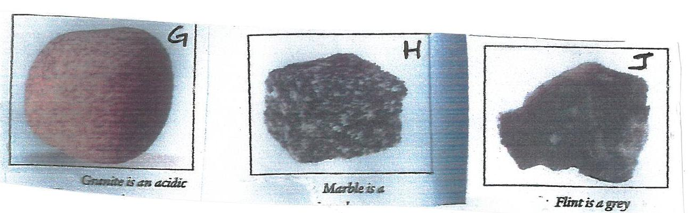
(ii) Briefly describe the formation of mechanically formed sedimentary rocks (5 marks)
(iii) State any five significance of rocks to man (5 marks)

(c) Students from Bonyunyu Sec. School in Nyamira County set out for a field study on rocks
within Nakuru county.
(i) List down any four preparations they will make for that study ( 4 marks)
(ii) Give three reasons why it is necessary to make a reconnaissance survey (3 marks)

9 (i) What is internal earth movement? (2 marks)
(ii) Give three forces that are responsible for lateral earth movement (3 marks)

(c) The map below shows distribution of Fold Mountains in the world. Study it and answer the
questions that follows.
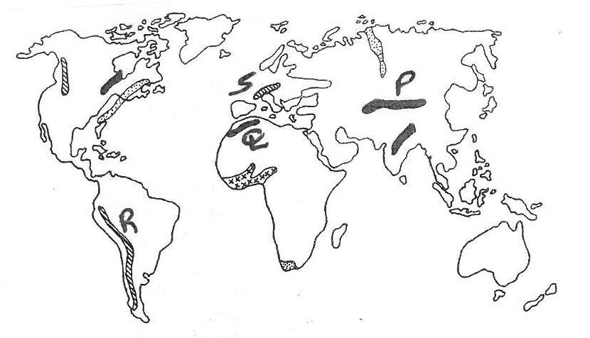
(i) Identify the Fold Mountains marked Q, P, R and S (4 marks)
(ii) Name three orogenies you know (3 marks)

(c) Describe how inter-montane plateau is formed (5 marks)

(d) Explain four positive effects of folding to human activities (8 marks)

10 (i) Draw a well labelled soil profile (4 marks)
(ii) State three components of soil apart from humus (3 marks)

(b) Explain how the following factors influence soil formation
(i) Topography (4 marks)
(ii) Climate

(c) Describe how sheet erosion occur (2 marks)

(d) Students from Flamingo Academy carried out a field study on the soils of farms around their
School
- State two methods of data collection they could have used (2 marks)
- Name two equipments they carried. (2 marks)
- Give four recommendations they gave to the agricultural officers in the area resulting from these findings. (4 marks)

