NAME................................................................ .INDEX NO......................
SIGN............................................................... DATE......................
232/1
PHYSICS
PAPER 1
(THEORY)
JULY/AUGUST 2016
TIME: 2 HOURS
KENYA CERTIFICATE OF SECONDARY EDUCATION
NAKURU SUB-COUNTY EVALUATION EXAM

INSTRUCTIONS TO CANDIDATES
- Write your name and index number in the spaces provided above.
- Answer ALL questions in section A and B in the spaces provided.
- All working must be clearly shown.
- Non programmable silent electronic calculators and KNEC mathematical tables may be used.
- Take g = 10m/s²
Specific heat capacity of water is 4200Jkg⁻¹K⁻¹
Density of water = 1000kgm⁻³
Density of mercury = 1.36 x 10⁴kgm³
For Examiners Use only
Section | Question | Maximum score | Candidate’s Score
A | 1 – 11 | 25
B | 12 | 8
 | 13 | 7
 | 14 | 10
 | 15 | 15
 | 16 | 15
 |  | 80

SECTION A (25 MARKS)
Answer ALL the questions in this section in the spaces provided
- The diagram below shows a section of a micrometer screw gauge containing an initial error.
40

35
0
Figure 1
  - State the zero error in the micrometer screw gauge in the diagram above. (1 mark)

………………………………………………………………………………………
  - The thimble of the micrometer screw gauge in figure 1 is rotated through 2 ½ revolutions in the anticlockwise direction in order to measure the diameter of a marble. State the reading obtained on the micrometer screw gauge . (2 mark)
………………………………………………………………………………………
………………………………………………………………………………………
………………………………………………………………………………………
………………………………………………………………………………………
- The figure below shows a measuring cylinder with a fluid to the level shown.
Find the new level when a solid of mass 13.6g and a density 1250kgm⁻³ is fully immersed into the cylinder. (3mks)
………………………………………………………………………………………
………………………………………………………………………………………
………………………………………………………………………………………
………………………………………………………………………………………
- The figure below shows some forces acting on an object.
5N

3N
5N

2N

4N
9N
2N
On the figure below draw the resultant force acting on the object (1mks)

- The figure below shows two identical containers A and B containing hot water and ice block.
Hot Water
Ice block wrapped in wire gauze
Floating ice block
A
B
State with reason which water cools faster assuming that the wire gauge absorbs negligible heat
(2 marks)
………………………………………………………………………………………
………………………………………………………………………………………
………………………………………………………………………………………
- A bus that carries goods in the under seats carrier is more stable than one that carries goods in the carrier at the top. Explain why this is so. (1 mark)
………………………………………………………………………………………
………………………………………………………………………………………
………………………………………………………………………………………
- A turntable of radius 16cm is rotating at 960 revolutions per minute. Determine the angular speed of the turntable. (3 marks)
………………………………………………………………………………………
………………………………………………………………………………………
………………………………………………………………………………………
………………………………………………………………………………………
………………………………………………………………………………………

- A cork enclosing steam in a boiler is held down by the system shown below.

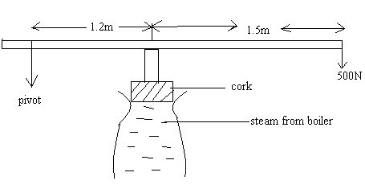
If the area of the cork is 15cm² and a force of 500N is needed to keep the cork in place, determine the pressure of the steam in the boiler. (3 marks)
………………………………………………………………………………………
………………………………………………………………………………………
………………………………………………………………………………………
………………………………………………………………………………………
………………………………………………………………………………………
………………………………………………………………………………………
- In an experiment a crystal of potassium permanganate was placed in water as shown below.

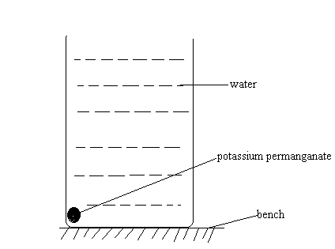

After sometime, it was observed that the water turned purple. Explain this observation. (1 marks)
………………………………………………………………………………………
………………………………………………………………………………………
………………………………………………………………………………………

- An aircraft 300m from the ground traveling horizontally at 400m/s releases a parcel.
Calculate the horizontal distance covered by the parcel from the point of release
(Ignore air resistance). (3 marks)
………………………………………………………………………………………
………………………………………………………………………………………
………………………………………………………………………………………
………………………………………………………………………………………
………………………………………………………………………………………
- A 20kw immersion water heater is used to heat 5.0 x 10⁻³m³ of water from 23ºC to 100ºC. Given that 30% of heat is lost to the surroundings, determine the time used in heating the water. Take specific heat capacity of water= 4200J/kg⁰C (3 marks)
………………………………………………………………………………………
………………………………………………………………………………………
………………………………………………………………………………………
………………………………………………………………………………………
………………………………………………………………………………………
- State two features that make the clinical thermometer more sensitive (2mrks)
………………………………………………………………………………………
………………………………………………………………………………………

SECTION B (55 MARKS)
Answer ALL the questions in this section in the spaces provided
- The graph below show the variation of force against extension (cm) of two spiral springs of same material and same length but of different diameters. Identify which graph (A or B) represents which spring. (2 marks)
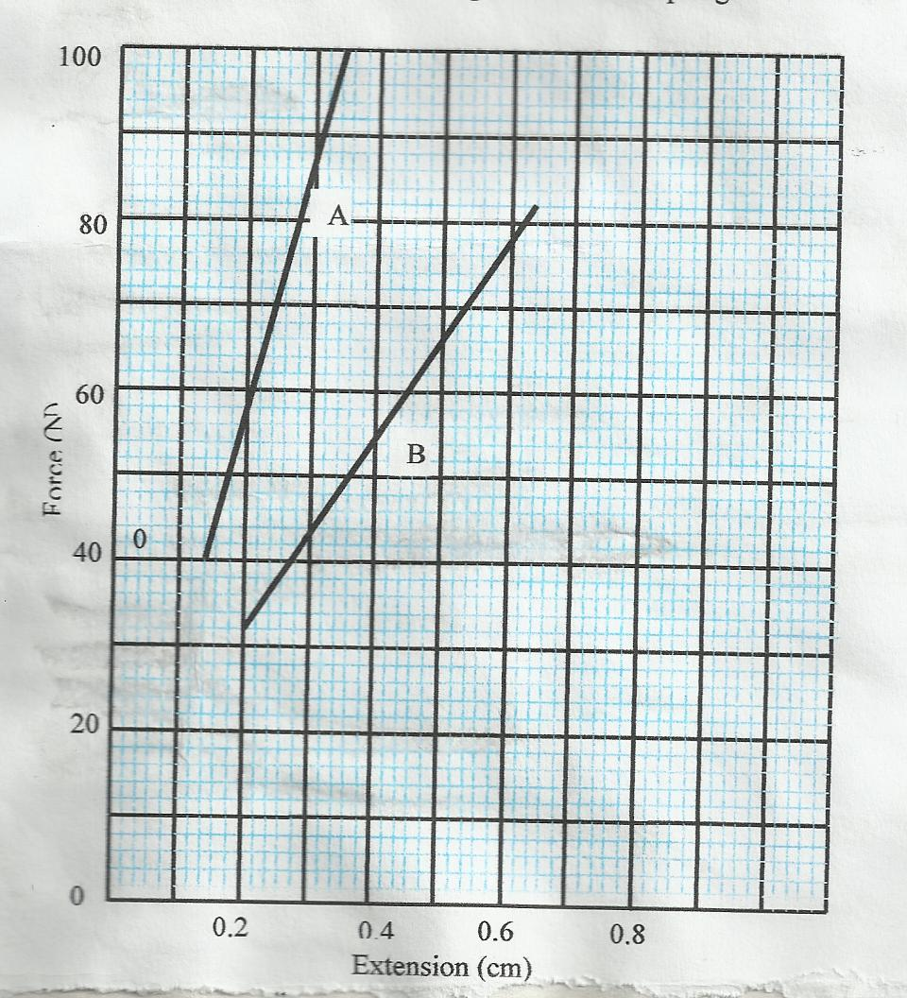
………………………………………………………………………………………
………………………………………………………………………………………
………………………………………………………………………………………
………………………………………………………………………………………
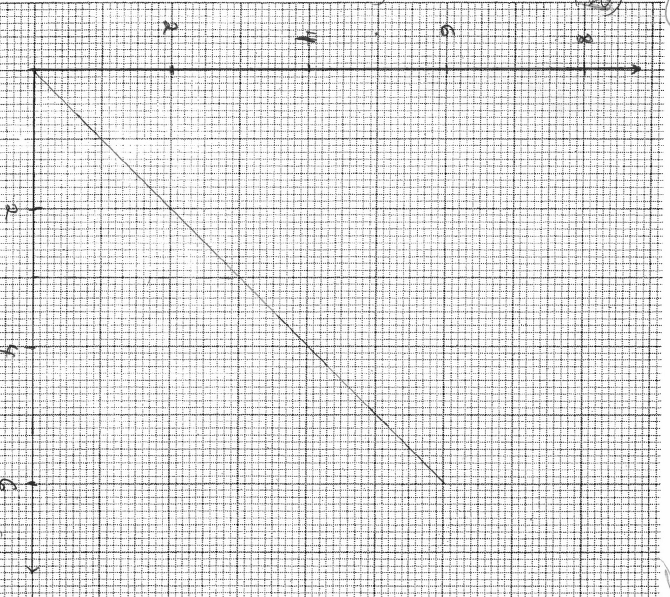
(b) The graph provided is of force (y-axis) against extension.

8

6
Extension (cm)
Force (N)

4

2

6
4
2

- From the graph determine the work done in stretching spring by 3cm (3mks)
………………………………………………………………………………………
………………………………………………………………………………………
………………………………………………………………………………………
………………………………………………………………………………………

(ii) Use the graph to determine the spring constant. Give your answer in SI units (3mks)
………………………………………………………………………………………
………………………………………………………………………………………
………………………………………………………………………………………
………………………………………………………………………………………
………………………………………………………………………………………
- a) State the principle of moments. (1 mark)
………………………………………………………………………………………
………………………………………………………………………………………
………………………………………………………………………………………
b)A uniform metal strip is 3.0cm wide 0.6cm thick and 100cm long. The density of the metal is 2.7g/cm³.
    - Determine the weight of the metal strip. (3 marks)
………………………………………………………………………………………
………………………………………………………………………………………
………………………………………………………………………………………
………………………………………………………………………………………
The strip is placed on a pivot and kept in equilibrium by forces as shown.
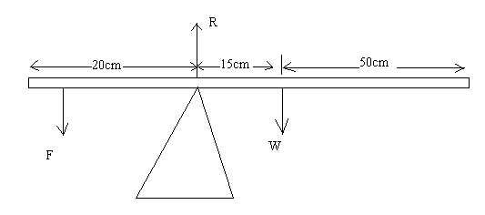

Determine the value of F and R. (3 marks)

………………………………………………………………………………………
………………………………………………………………………………………
………………………………………………………………………………………
………………………………………………………………………………………
- The figure below shows an inclined plane of length 82.7m, a trolley of mass 60kg being pulled up the slope by a force of 200N parallel to the slope. The trolley is moved from X to Y.

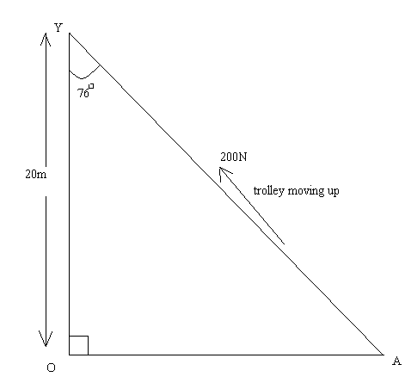
X
200N
Determine the
- Work output of the system. (2 marks)
………………………………………………………………………………………
………………………………………………………………………………………
………………………………………………………………………………………
- Work input of the system. (3 marks)
………………………………………………………………………………………
……………………………………………………………………………………… ………………………………………………………………………………………
………………………………………………………………………………………
- The frictional force between the wheels of the trolley and the inclined plane. (2 marks)
………………………………………………………………………………………
………………………………………………………………………………………
………………………………………………………………………………………
………………………………………………………………………………………
- The efficiency of the system. (3 marks)
………………………………………………………………………………………
………………………………………………………………………………………
………………………………………………………………………………………
………………………………………………………………………………………
- The velocity ratio of the system. (2 marks)
………………………………………………………………………………………
………………………………………………………………………………………
………………………………………………………………………………………
………………………………………………………………………………………
- (a) A glass capillary contains enclosed air by a thread of mercury 15cm long when the tube is horizontal, the length of the enclosed air column is 24cm as shown.
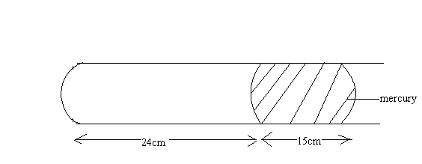

- What is the length of the enclosed air column when the tube is vertical with the open end uppermost if the atmospheric pressure is 750mmHg? (2 marks)
………………………………………………………………………………………
……………………………………………………………………………………… ………………………………………………………………………………………
- What is the length of the enclosed air column when the tube is vertical with the open end facing down if the atmospheric pressure is 750mmHg? (2 marks)
………………………………………………………………………………………
………………………………………………………………………………………
………………………………………………………………………………………
………………………………………………………………………………………
- Explain why the mercury does not run out when the tube is vertical with the closed end uppermost. (1 mark)
………………………………………………………………………………………
………………………………………………………………………………………
………………………………………………………………………………………
iv. Explain why an air bubble increase in volume as it rises from the bottom of a lake to the surface. (2 marks)
………………………………………………………………………………………
………………………………………………………………………………………
………………………………………………………………………………………
- When an inflated balloon is placed in a refrigerator it is noted that its volume reduces. using the kinetic theory of gases, explain the observation. (2 marks)
………………………………………………………………………………………
………………………………………………………………………………………
………………………………………………………………………………………
- A certain mass of hydrogen gas occupies a volume of 1.6m³ at a pressure of 1.5 x 10⁵ N/m² and a temperature of 27º C. Determine the volume when the temperature is 0ºC at a pressure of 8.0 10⁴ N/m². (3 marks)
………………………………………………………………………………………
………………………………………………………………………………………
………………………………………………………………………………………
………………………………………………………………………………………
- State the pressure law. (1 mark)
………………………………………………………………………………………
………………………………………………………………………………………
………………………………………………………………………………………
- a) State Archimedes principle. (1 mark)
………………………………………………………………………………………
………………………………………………………………………………………
………………………………………………………………………………………
b) A block of wood measuring 0.8m by 0.5m by 2m floats in water. 1.2m of the block is submerged. (density of water = 1000kg/m³)
    - Determine the weight of the water displaced. (3 marks)
………………………………………………………………………………………
………………………………………………………………………………………
………………………………………………………………………………………
    - Find the force required to just make the block fully submerged. (4 marks)
………………………………………………………………………………………
………………………………………………………………………………………
………………………………………………………………………………………
………………………………………………………………………………………
………………………………………………………………………………………
c) A block of glass of mass 250g floats in mercury. What volume of the glass lies under the surface of mercury (density of mercury =13600kg/m³ ) (3 marks)
………………………………………………………………………………………
………………………………………………………………………………………
………………………………………………………………………………………
………………………………………………………………………………………
………………………………………………………………………………………
d) A piece of sealing wax, weight 3N in air and 0.22N when immersed in water, calculate the density of the wax. (4 marks)
………………………………………………………………………………………
………………………………………………………………………………………
………………………………………………………………………………………
………………………………………………………………………………………
………………………………………………………………………………………

