Name:….….……………………………………………... Adm. No: …………………………………….

School:…….……………………………………………. Candidate’s Sign:……………………..….……

Date: ……………………………………………………...

121/1
PAPER 1
MATHEMATICS
OCT/NOV 2017
TIME: 2 ½ HOURS

Kenya Certificate of Secondary Education (K.C.S.E)

Mathematics
Paper 1
2 ½ hours

INSTRUCTIONS TO THE CANDIDATES:-
- Write your name and index number in the spaces provided above.
- Sign and write the date in the space provided above.
- This paper consists two sections: Section I and Section II.
- Answer all the questions in Section 1 and any five questions from Section II.
- All working and answers must be written on the question paper in the spaces provided below each question.
- Show all the steps in your calculations, giving your answers at each stage in the spaces provided below each question.
- Non-programmable silent electronic calculators and KNEC mathematical tables may be used, except where stated otherwise.
- Marks may be given for correct working even if the answer is wrong.
- Candidates should check the question paper for error and omissions.

For Examiners’ Use Only.
Section I
Questions | 1 | 2 | 3 | 4 | 5 | 6 | 7 | 8 | 9 | 10 | 11 | 12 | 13 | 14 | 15 | 16 | Total
Marks

Section II
GRAND TOTAL
Questions | 17 | 18 | 19 | 20 | 21 | 22 | 23 | 24 | Total
Marks

This paper consists of 15 printed pages. Candidates should check to ascertain that all pages are printed as indicated and that no questions are missing.

SECTION A (50 MARKS)
Answer all questions in this section

1. Solve the equation x+1 - x-3 = 4 (3mks)
2 3

2. Find the equation of a line which passes through (-1,-4) and is perpendicular to the line
y+2x-4=0 (3mks)

3. Given that Cos A = $\frac{5}{13}$ and A is acute angle. Find tan (90-A) (2mks)

4. Simplify 12x²- 16x (4mks)
20-11x-3x²

5. The figure below shows triangle PQR. PR=12cm TR=4cm and ST is parallel to QR
P
S
T
Q
R

If the area of triangle PQR is 336cm² find the area of the quadrilateral QRTS. (4mks)

6. The internal radius of a pipe is 0.35m. Water flows through the pipe at a rate of 45cm per second. Calculate the amount of water that passes through the pipe in 2¼ hours in m³. (3mks)

7. A car moves with a constant acceleration of 8m/s² for 5 seconds. If the final velocity is 40m/s. calculate the initial velocity. (2mks)

8. Simplify without using a calculator (3mks)
$$\frac{2\frac{1}{3}- 1\frac{2}{3} ÷\frac{5}{9}}{\frac{4}{7} of 2\frac{1}{3}- 2\frac{2}{7}}$$

9. Given that 4:5:8 is equivalent to 1:n:bn. Find the ratio of n:b only. (3mks)

10. Solve ${ 32}^{2x}x 4^{x+3}=128÷{ 2}^{x}$ (3mks)

11. John bought 3 books and 4 pens while Peter bought 4 books and 5 pens of the same type if Peter paid sh. 525 while John paid sh. 125 less than what Peter paid. Calculate the cost of each item. (3mks)

12. A kenyan company received US dollars 100,000. The money was converted into Ksh. in a bank which buys and sells foreign currency as follows
Buying Ksh selling Ksh
1 US dollar 77.24 77.44
1 sterling pound 121.93 122.27
(a) Calculate amount of money in Ksh. The company received (2mks)

(b) The Company exchanged the Ksh above into sterling pounds. Calculate how much it received to the nearest pound. (2mks)

13. (a) Use reciprocal tables to find the value of $=\frac{1}{0.325}$ (1mk)

(b) Hence,evaluate 3 0.000125 (2mks)
0.325

14. A point (2,3) is mapped onto onto (0,5) when rotated through angle of rotation 180º about centre (x,y). Find the coordinates of the centre. (3mks)

15. A square room is covered by a number of whole rectangular slabs of sides 60cm by 42cm. Calculate the least possible area of the room in square metres (3mks)

16. Using a ruler and pair of compasses only
(a) Construct a parallelogram PQRS in which PQ =6cm QR=4cm and ∠SPQ =75º (3mks)

(b) Determine the perpendicular distance between PQ and SR (1mk)

SECTION II (50 MARKS)
Answer any five questions in this section in the spaces provided
17. A solid consists of a cone and a hemisphere. The common diameter of the cone and hemisphere is 12cm and the slanting height of the cone is 10cm
(a) Calculate the
(i) surface of the solid to 2 d.p (3mks)
(ii) the volume of the solid to 2 d.p (4mks)
(b) If the density of the material used to make the solid is 1.3g/cm3, calculate its mass in kilograms. (3mks)

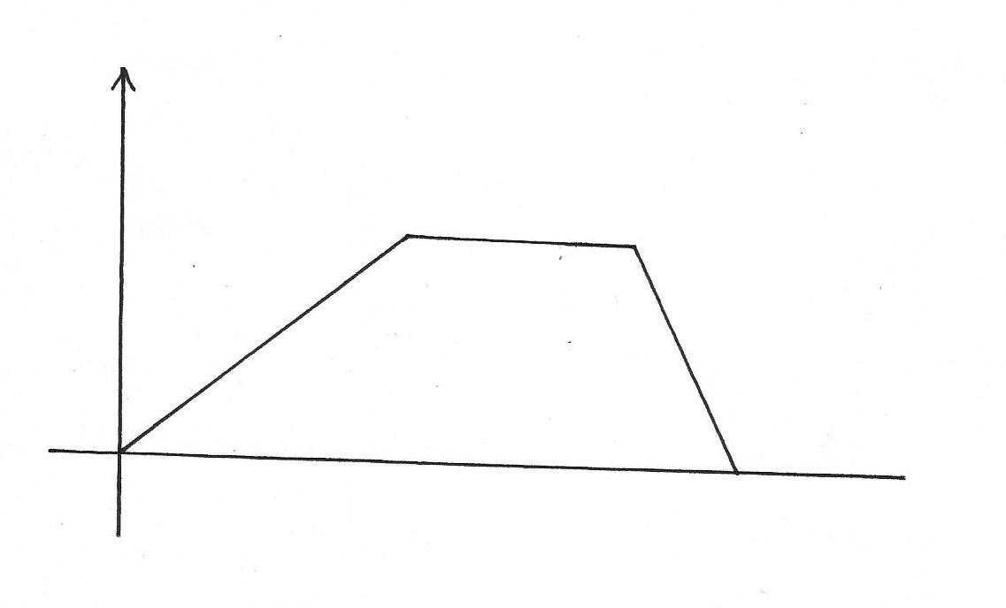
18. A cyclist moves from O to P covering a total distance of 3.75km. The cyclist starts from rest, accelerates uniformly for 240sec before moving at a constant speed for 100 sec and finally decelerates uniformly for 60 sec

Speed m/s

Time (sec)

(a) Determine the maximum speed attained by the cyclist. (3mks)

(b) Calculate the deceleration of the cyclist. (2mks)

(c) Calculate distance in metres, the cyclist travelled over the last 40 seconds (2mks)

(d) Determine the time in seconds, the cyclist took to travel 3/5 of the journey (3mks)

19. Three trees R S and T are the vertices of a triangular field. R is 300m from S on a bearing of 300º and T is 450m directly south of R
(a) Using scale of 1cm rep 60m draw a diagram to show the positions of the trees. (3mks)

(b) Use the scale to determine
(i) the distance between T and S in metres (2mks)
(ii) the bearing of T from S (1mk)
(c) Find the area of the field, in hectares to 1 d.p (4mks)

20. Two alloys A and B are each made up of copper, Zinc and tin. In alloy A, the ratio of copper to zinc is 3:2 and the ration of zinc to tin 3:5
(a) Determine the ratio Copper: Zinc: tin in alloy A (2mks)

(b) The mass of alloy is 250kg. alloy B has the same mass as alloy A but the amount of copper is 30% less than that of alloy A
Calculate
(i) the mass of tin in alloy A (2mks)

(ii) The total mass of zinc and tin in alloy B (3mks)

(c) Given that the ratio of zinc to tin in alloy B is 3:8 determine the amount of tin in alloy B than in alloy A (3mks)

21. The table below shows the height of mango trees

Height | 20-24 | 25-29 | 30-34 | 35-39 | 40-44 | 45-49 | 50-54 | 55-59
Freg. | 2 | 15 | 18 | 25 | 30 | 6 | 3 | 2

(a) State the modal class (1mk)

(b) Calculate to 2 d.p
(i) The mean height (4mks)

(ii) The difference between the median height and the mean height (5mks)

22. The diagram below represents a conical vessel containing water to a depth of 30cm. the radius of the water surface is 21cm (π= ²²/₇)
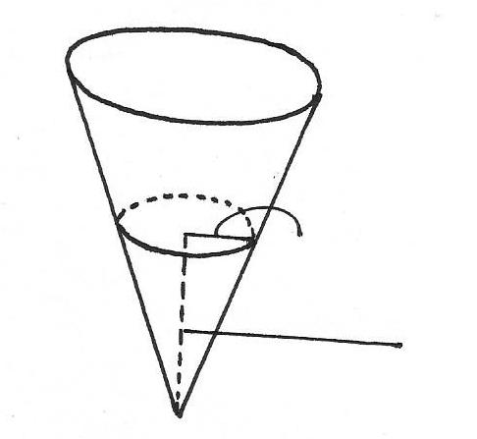

21cm
30cm

(a) Calculate the volume of the water in the vessel in cm3 (2mks)

(b) Metal sphere is completely submerged in the water the level of water rises by 6cm
Calculate
(i) Radius of the new surface in the vessel (2mks)

(ii) The volume of the metal sphere in cm3 (3mks)

(iii) The radius of the sphere (3mks)

23. (a) The ratio of Juma’s and Akinyi’s earnigs was 5:3 Jumas earnings rose to sh.8400 after an increase
of 12%.

(a) Calculate the percentage increase in Akinyi’s earnings given that the sum of their new earnings s
shs. 14,100. (6mks)

(b) Juma and Akinyi contributed all the new earnings to buy maize at 1175 per bag. The maize was
then sold at shs.1762.50. The two shared the money from the sales of the maize in ratio of their
contributions. Calculate the amount that Akinyi got. (4mks)

24. A triangle ABC has vertices A(3,4) B(1,3) and C(2,1)
(a) On the grid given draw triangle ABC (1mk)

(b) Draw triangle A'B'C' the image of Δ ABC under rotation of +90º about (0,0) and give its coordinates (2mks)

(c) Draw triangle A''B''C'' the image of Δ A'B'C' under reflection in the line y=x and give its coordinates (3mks)

(d) By construction, find the triangle A'''B'''C''' the image of Δ A''B''C'' after enlargement scale factor -2 centre (0,-1)
Give coordinates of the image A'''B'''C''' (4mks)

BUTERE EAST DISTRICT JOINT EXAMS
MATHEMATICS 121/1
OCT/NOV 2013
MARKING SCHEME

1 | 6 -6 | M1  M1  A1  03 | Multiply by LCM
2 | grad of = ½  y=mx +c  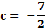  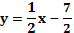 | B1  M1  A1  02 | Accept alteration
3. | 90-A  √13²-5²=12  5  13  =12  Tan (90-A)= | B1  B1  02
4 | 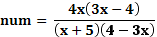  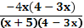  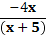 | B1  M1  M1  A1  04 | Numerator  Denominator  Introducing on either num or den
5 | 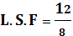 =  A.S.F=  Area of smaller Δ =  = 149.333  Area QRST =  =186.7 | B1  M1  M1  04
6 | ∴8100= (8100x 0.45)  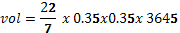 | M1  M1  A1  03
7 | 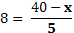  𝑥=0 | M1  A1  02
8 | 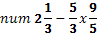  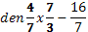 | M1  M1  A1  03
9 | 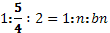  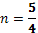  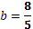 | M1  M1  A1  03
10 | = ÷  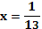 | M1  M1  A1  03 | Solve base
11 |  | M1  A1  B1  A1  04
12 | (a)  (b)  =63172 | M1  A1  M1  A1  04
13 | (a)  (b) | B1  M1  A1  03
14 |  | B1  B1  B1  03
15 | = 17.64 | M1  A1  B1  03
16 | Q  R  S  P | B1  B1  B1  B1 | Construct of 75o  ∠SPQ  PS and PQ  Completion of 11  Height 3.9±1
17. | (a)(i)  (ii) Height =  (b)  Man = | M1M1  A1  B1  M1M1  A1  M1  M1  A1  10 | Accept 441.86 and 414.69 for different .π  Accept 754.29  Or  753.98
18. | Max speed  (b) Decelaration =  (c) Distance in 40 last sec  area =  (d) Time in sec to travel of journey  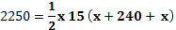 | M1  M1  A1  M1  A1  B1  B1  M1  A1  B1  10
19 | 5cm  7.5cm  T  R  S  (b)(i)  (ii) Bearing of T from S  221º  (c)  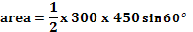  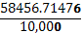 | B1  B1  B1  B1  A1  B1  M1  M1  A1 | Lengths 5cm bearing 300º  Length 7.5cm south R  Completed Δ  Follow  Accept other methods  Accept  5.7ha  5.9 ha
20. | (a) C:Z  (b) (i)  100kg  (ii) Copper in A =  =90kg  Copper in B=  (c)Zinc =  Tin = | M1  A1  M1  A1  M1  M1  A1  M1  M1  A1  10
21 | (a) Modal class 40-44  (b)  class x f c.f fx  20-24 25-29 30-34 35-39 40-44 45-49 50-54 55-59 22 27 32 37 42 47 52 57 2 15 18 25 30 6 3 2 2 17 35 60 90 96 99 101 44 405 576 925 1260 282 156 114 3762  Mean=  ©Median = 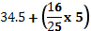  37.7  Dif  =0.45 | B1  B1  M1  B1  M1  A1  M1  M1  A1  B1  10 | X value  Fx  c.f  Lower C.f 34.5 be used  16/25 x 5  Accept use of form  37.6  Or 0.35
22 | (a) 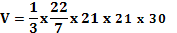  (b) (i)  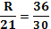  R=25.2  (ii) Vol of metal sphere  (iii) Radius of sphere  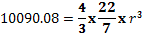 | M1  A1  M1  A1  M1M1  A1  M1  M1  A1  10
23 | (a) Ratio Juma: Akinyi = 5:3  Initial Juma 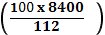  Initial sal Akinyi =  New earning for Akinyi =  % Akinyi = 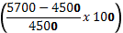  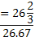  (b) main earnings Juma 8400  Akinyi 5700  Ratio 84:57  Total money  No of sacks =  =12sacks  Sale of maize =  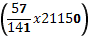 | M1  A1  M1  M1M1  A1  M1  M1  M1  A1  10
24 | (a) ABC plotted = B1  (b) rotating B1  A¹B¹C¹ cordinates B1  A¹(-4,3) D¹(-3,1) C¹(-1,2)  (c) Line y=x B1  A¹¹ B¹¹C¹¹ drawn B1  A¹¹(3,-4) B¹¹(1,-3) C¹¹(2,1) B1  (d) Identification and drawing of lines  Through centre (0,-1) B1  A¹¹¹ B¹¹¹ C¹¹¹ identified B1  Completed Δ A¹¹¹ B¹¹¹C¹¹¹ B1  A¹¹¹(-6,5) B¹¹¹(-2,3) C¹¹¹(-4,-1) B1  10mks

