Name:….….……………………………………………... Adm. No: …………………………………….

School:…….……………………………………………. Candidate’s Sign:……………………..….……

Date: ……………………………………………………...

121/2
PAPER 2
MATHEMATICS
OCT/NOV 2017
TIME: 2 ½ HOURS

Kenya Certificate of Secondary Education (K.C.S.E)
Mathematics
Paper 1
2 ½ hours

INSTRUCTIONS TO THE CANDIDATES:-
- Write your name and index number in the spaces provided above.
- Sign and write the date in the space provided above.
- This paper consists two sections: Section I and Section II.
- Answer all the questions in Section 1 and any five questions from Section II.
- All working and answers must be written on the question paper in the spaces provided below each question.
- Show all the steps in your calculations, giving your answers at each stage in the spaces provided below each question.
- Non-programmable silent electronic calculators and KNEC mathematical tables may be used, except where stated otherwise.
- Marks may be given for correct working even if the answer is wrong.
- Candidates should check the question paper for error and omissions.
For Examiners’ Use Only.
Section I
Questions | 1 | 2 | 3 | 4 | 5 | 6 | 7 | 8 | 9 | 10 | 11 | 12 | 13 | 14 | 15 | 16 | Total
Marks

Section II

GRAND TOTAL
Questions | 17 | 18 | 19 | 20 | 21 | 22 | 23 | 24 | Total
Marks

This paper consists of 15 printed pages. Candidates should check to ascertain that all pages are printed as indicated and that no questions are missing.

1. Use tables of logarithms to evaluate $\left[\frac{6.195 x 11.82}{83.52}\right]$ (3mks)
¼

2. Solve the quadratic equation below $=\frac{4}{25}x^{2}+\frac{4}{ 5}x+1=0$ (3mks)

3. A box measures 6.4cm by 4cm by 5cm. find the limits within which its volume lies (3mks)

4. Ingwe and Okusimba live 8km apart. They left their homes at the same time and cycled at 8km/h and 7km/h respectively towards each other. Calculate the time they took before meeting. (2mks)

5. Given that $\sqrt{2}$ = 1.414 and $\sqrt{3}=1.732$ evaluate $\frac{5}{2\sqrt{2}-\sqrt{3}}$ (3mks)

6. Solve for x the equation log ₂(x+3) = log ₂ (x-2) (2mks)

7. Give the inequalities that define the unshaded area
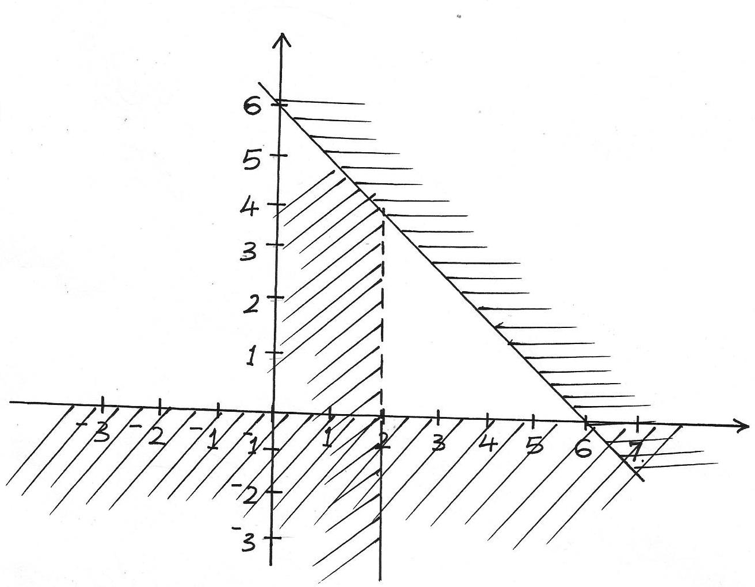
y
L₁
L₃
L₂

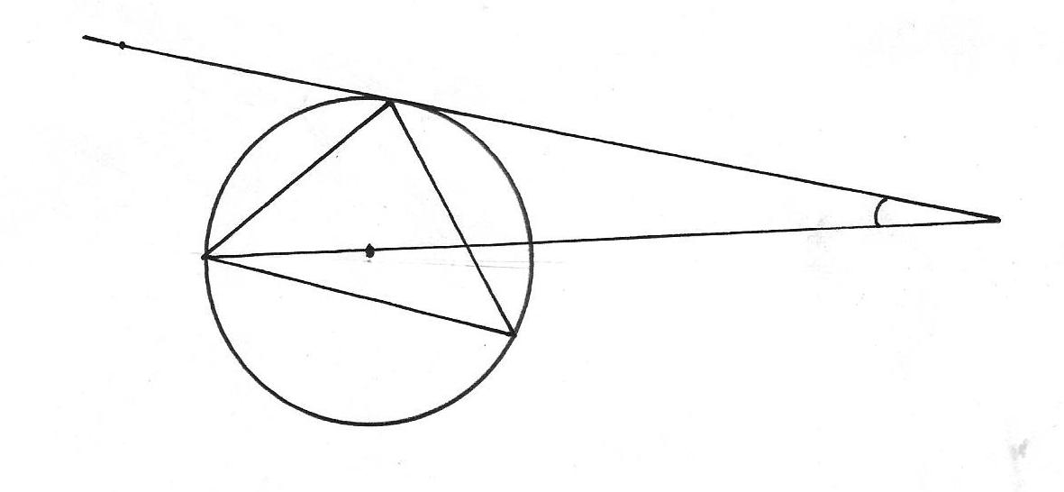
8. In the figure below R, T and S are points on a circle centre O. PQ is a tangent to the circle at T6, POR is a straight line and ∠ QPR =20º. Find the size of ∠ RST (3mks)
Q
T
O
S
P
20º
R

9. The size of interior angle of a regular polygon is 3xº while its exterior angle is (x-20). Find the number of sides of the polygon. (3mks)

10. Make h the subject of the formula (3mks)
$q=\frac{1+rh}{1-ht}$

11. The third and the fifth term of an arithmetic progression are 10 and -10 respectively
(a) Determine the first and the common difference (2mks)

(b) The sum of the first 15 terms (2mks)

12. A watch which loses a half –minute every hour was set to read the correct time at 0545h on Monday. Determine the time in the 12 hour system, the watch will show on the following Friday at 1945h. (3mks)

13. (a) Expand (1+x)⁷ up to the 4th term (2mks)

(b) Use the expression in part (a) above to find the approximate value of (0.94)⁷ (2mks)

14. Given that X varies directly as the square of y and x=2 when y=1, find x when y=4 (2mks)

15. A tea dealer mixes two brands of tea, x and y to obtain 35kg of the mixture worth Ksh.62 per kg. if brand x is valued at Ksh.68 per kg and brand y at Ksh 53 per kg . Calculate the ratio in its simplest form they are mixed. (3mks)

16. Obtain the centre and radius of the circle represented by the equation $x^{2}+y^{2}-10y+16=0$
(3mks)

SECTION II (50 MARKS)
Answer any five questions in this section in the spaces provided
17. In the figure below (not drawn to scale), AB=8cm, AC=6cm, AD=7cm, CD=2.82cm and angle CAB=80ºC
A
7cm
6cm
D
B
8cm
C
2.82cm
50º
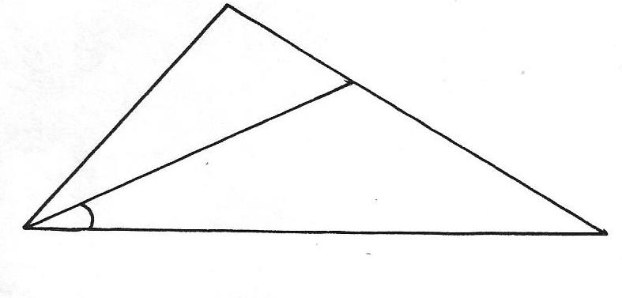

Calculate to 2 decimal places
(a) the length BC (2mks)

(b) the size of angle ABC (3mks)

(c) the size of angle CAD (3mks)

(d) the area of triangle ACD (2mks)

18. At the beginning of the year 1998, Okubasu bought two houses, one in Kakamega and other one in Mumias, each at Ksh.1,240,000 value of the house in Kakamega appreciated the rate of 12%
(a) Calculate the value of the house in Kakamega after 9 years, to the nearest shillings (2mks)

(b) After n years, the value of the house in Kakamega was Ksh. 2741245 while the value of the house in Mumias was Ksh. 2917231
(i) Find n (4mks)

(ii) Find the annual rate of appreciation of the house in Mumias (4mks)

19. (a) Draw the graph for the function $y=-x^{2}+4x-1$ for -2 ≤ x ≤6 (5mks)
(b) On the same axes draw the graph of y= 2x-3 (1mk)
(c) Use your graph to solve the following equation
(i) $x^{2}-4x+1=0$ (2mks)
(ii) $x^{2}-2x-2=0$ (2mks)

20. Using a ruler and pair of compasses only, construct a parallelogram PQRS in which PQ=8cm, PS=5cm and angle SPQ=45º
(a) Measure SQ
(b) (i) Construct a perpendicular bisector of the line S and Q
(ii) Construct a perpendicular bisector of line QR to meet the one constructed in b(i) above at
point O.
(iii) Draw a circle passing through points S, Q and R and measure its radius

Q
P

21. (a) Find A⁻¹, the inverse of matrix A = $\left(\begin{matrix}5 & 6 \\ 7 & 9\end{matrix}\right)$ (2mks)
(b) Asira bought 5 books and 6 sets for a total of Ksh. 2440. Awino bought 7 boooks and 9 sets for a total of Ksh. 3560.
(i) Form a matrix equation to represents the information (1mk)
(ii) Use matix method to find the price of a book and that of a set. (3mks)
(c) A school bought 36 books and 50 sets. A discount of 5% was allowed on each book whereas
8% on each set. Calculate the percentage discount on the cost of all the items bought by the
school (4mks)

22. The figure below shows triangle OAB in which M divides OA in the ratio 2:3 and N divides OB in the ratio 4:1
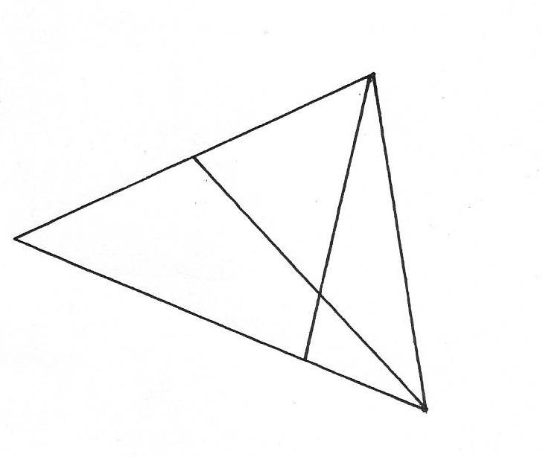
A
B
X
N
O
M
2
3

(a) Given that OA= a and OB =b, express in terms of a and b
˜
˜
˜
˜
˜
˜
(i) AN (1mk)
(ii) BM (1mk)
(b) Express OX in terms of a , b, t and s given that AX=SAN and BX = tBM and t and s are constants (2mks)

(c)Find the value of s and t hence write OX interms of a and b (6mks)

23. The probality that Hillary, Leonard and Charles will be late for breakfast on any one morning are ¼ , ¹/₃ and ¹/₅ respectively on any one morning
(a) Draw a probability tree diagram to represent the information. (2mks)

(b)(i) none of them will be late (2mks)

(ii) Only one of them will be late (2mks)

(c)(i) at least one of them will be late (2mks)

(ii) at most one of them will be late (2mks)

24. A hot water tap can fill a bath in 5 minutes while a cold water tap can fill the same bath in 3 minutes. The drain pipe can empty the full bath in 3 ¾ minutes. The two taps and the drain pipe are fully open for 1 ½ min after which the drain pipe is closed. How much longer will it take to fill the bath? (10mks)

