Name: …………………………………………… Adm. No: ……………………..……………...........
Date: ……………….…………..…...................... Candidate’s Signature:…………………….............

232/1
PHYSICS
Paper 1
(THEORY)
September 2017
Time: 2 Hours

Kenya Certificate of Secondary Education

Physics
Paper 1
INSTRUCTIONS TO CANDIDATES:-
- Write your name, index number, date and sign in the spaces provided.
- Answer ALL the questions in section A and B in the spaces provided.
- ALL working MUST be clearly shown.
- Mathematical tables and electronic calculators may be used
For Examiners’ Use Only:
SECTION | QUESTIONS | MAXIMUM SCORE | CANDIDATE’S SCORE
A | 1 – 12 | 25
B | 12 | 12
 | 13 | 09
 | 14 | 12
 | 15 | 14
 | 16 | 08
TOTAL SCORE |  | 80

This paper consists of 11 Printed pages. Candidates should check to ascertain that all pages are printed as indicated and that no questions are missing.

SECTION A (25MARKS)
Answer all questions in this section.
1. Explain why potatoes cook more faster in a sufuria with a tight lid than in an open one (1mk)
…………………………………………………………………………………………………….
…………………………………………………………………………………………………….
2. A spring is stretched by 1.5cm by a force of 2N. Calculate the amount of elactic potential energy stored by the spring (3mks)
…………………………………………………………………………………………………….
…………………………………………………………………………………………………….
3. State two factors that affect the stability of an object (2mks)
…………………………………………………………………………………………………….
…………………………………………………………………………………………………….
4. When a mercury thermometer is used to measure the temperature of hot water it is observed that the mercury level first drops before beginning to rise. Explain this observation (2mks)
…………………………………………………………………………………………………….
…………………………………………………………………………………………………….
5. A bubble of air has a dimater of 2.0mm. When it is 0.5m. Below the water surface of a boiler. Calculate the diameter of the bubble as it reaches the surface assuming that the temperature remains constant (take g= 10Nkg⁻¹), density of water = 10³ kgm⁻³ and atmospheric pressure= 10 ⁵NM⁻²) (4mks)
…………………………………………………………………………………………………….
…………………………………………………………………………………………………….
…………………………………………………………………………………………………….
…………………………………………………………………………………………………….
6. Explain the effects of increase in fructional force in a machine to its effieciency (1mk)
…………………………………………………………………………………………………….
…………………………………………………………………………………………………….
7. Draw a sketch of a mictometer screw gauge showing a reading of 8.33mm (2mks)

8. A liquid flows a long a horizontal pipe of cross sectional area of 24cm³ with a speed of 3ms⁻¹. The speed increases to 9ms⁻¹. Where there is a constriction calculate the cross sectional are of the constriction (3mks)
…………………………………………………………………………………………………….
…………………………………………………………………………………………………….
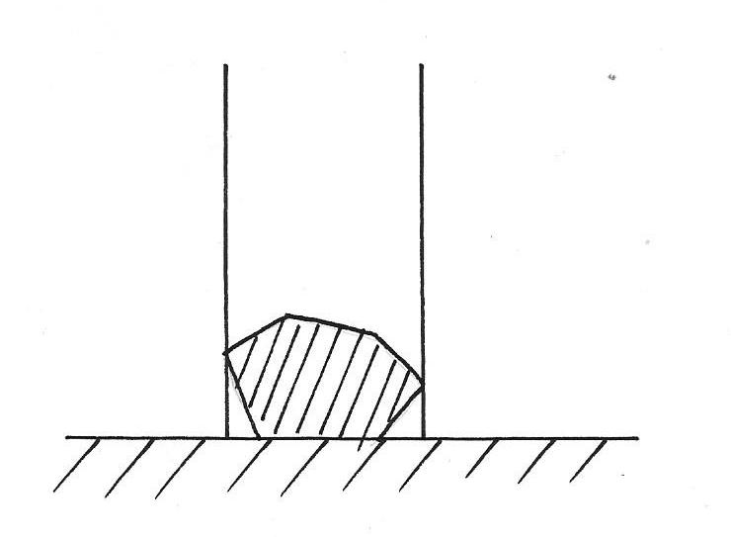
9. The figure below shows a beaker placed on a bench. Ablock of ice is placed in the beaker as shown
Beaker
Ice
Bench

State and explain the change in the stability of the beaker when the ice melts (2mks)
…………………………………………………………………………………………………….
…………………………………………………………………………………………………….
10. On the axes provided below sketch displacement-time graph for a body moving with uniform retardation.
Time
Displacement (m)

(1mk)
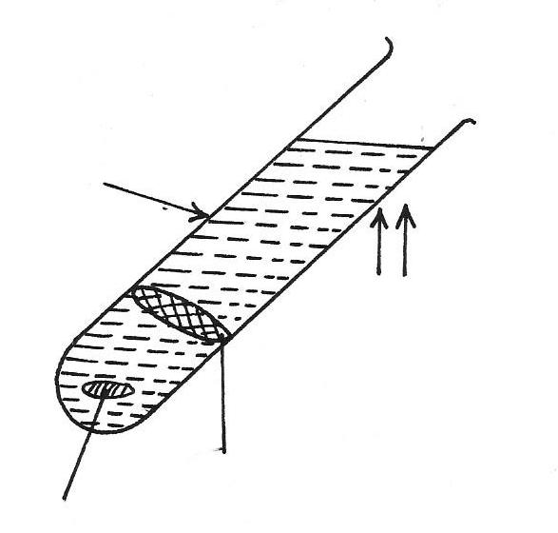
11. The figure below shows water in a test tube heated over a long time

Heat
Wire gauze
Wax
Test tube

(a) State and explain the observation made on the wax (2mks)
……………………………………………………………………………………………………..
……………………………………………………………………………………………………..
(b) State and explain the observation when the position of the wax and the flame are interchanged.
(2mrks)
..........................................................................................................................................................
.........................................................................................................................................................

SECTION B(55MARKS)
12. In an experiment to determine the specific latent heat of vaporization of water, steam at 100ºC
was passed into water contained in a well lagged calorimeter.
The following measurements were taken
Mass of calorimeter=50g
Initial temperature of water=5ºC
Initial mass of water = 70g
Final mass of calorimeter +water +condensed steam=132g
Final temperature of mixture =30oC
Specific heat capacity of water=4200Jkg-1K-1
Specific heat capacity of calorimeter=3900J
(a) Determine the
(i) Mass of condensed steam (3mks)
…………………………………………………………………………………………………….
…………………………………………………………………………………………………….
......................................................................................................................................................
(ii) heat gained by calorimeter and water (3mks)
…………………………………………………………………………………………………….
(b) Given that L_{v} is the specific latent heat of vaporisation of steam
(i) Write an expression for the heat given out by the steam (2mks)
…………………………………………………………………………………………………….
.......................................................................................................................................................
(ii) Determine the value of L_{v} (4mks)
…………………………………………………………………………………………………….
13. (a) A bicycle has wheels 66cm in diameter its crank wheel has 44 teeth and the rear sprocket 16 teeth. The crank radius is 16.5cm
(i) Determine the radious of the rear sprocket (3mks)
…………………………………………………………………………………………………….
…………………………………………………………………………………………………….
(ii) The bicycle moves when the rear sprocket is made to move. Hence determine the velocity ratio. …………………………………………………………………………………………………….
(b) A man uses a block and tackle mehcnaism of velocity ratio 6 to lift a car engine smoothly through a height of 1m in 5 sec. The man applies a force of 300N while the mass of the engine is 120kg. Determine
(i) The mechanical advantage of the pulley system (3mks)
…………………………………………………………………………………………………….
…………………………………………………………………………………………………….
(ii) its effieciency (3mks)
…………………………………………………………………………………………………….
…………………………………………………………………………………………………….
14. (a) State
(i) Boyle’s law (1mk)
…………………………………………………………………………………………………….
(ii) Charles law (1mk)
…………………………………………………………………………………………………….
(b) A form three student carried out an experiment on one of the gas laws she obtained the following result

Temperature (oC) | 10 | 35 | 60 | 80 | 90 | 110
Volume v(cm3) | 5 | 5.8 | 6.4 | 7.0 | 7.2 | 7.8

(i) Plot a graph of V (y-axis) against temperature. (5mks)

(i) Suggest how the temperature of the gas could be kept constant (1mk)
…………………………………………………………………………………………………….
…………………………………………………………………………………………………….
(ii) Given that the relationship between P and V is given by PV=k. where k is a constant use the graph to determine the value of k (4mks)
…………………………………………………………………………………………………….
…………………………………………………………………………………………………….
15. (a) State the three equations of linear motion (3mks)
…………………………………………………………………………………………………….
…………………………………………………………………………………………………….
…………………………………………………………………………………………………….
(b) A car is travelling uniformly at 100km/hr.When the driver observes a road block ahead. He takes 0.5 sec before applying brakes which brings the car to rest with a uniform decelaration of
4MS⁻². Determine the distance travelled by the car from the time the driver observed the road block until the car comes to rest. (4mks)
…………………………………………………………………………………………………….
…………………………………………………………………………………………………….
…………………………………………………………………………………………………….
(c) A car moves at a constant speed of 20MS⁻¹ for 50 sec and then accelerates uniformly to a speed of 25MS⁻¹ over a period of 10sec. This speed is maintained for 50 sec before the car is brought to rest with uniform deceleration in 15 sec
(i) Sketch a graph of velocity (y-axis) against time (on graph paper provided) (3mks)

(a) From the graph determine the everage speed for the whole journey (3mks)
…………………………………………………………………………………………………….
…………………………………………………………………………………………………….
(b) the accelaration when the velocity changes from 20ms⁻¹ to 25ms⁻¹ (2mks)
…………………………………………………………………………………………………….
…………………………………………………………………………………………………….
16. (a) State the law of conservation of linear momentum (1mk)
…………………………………………………………………………………………………….
…………………………………………………………………………………………………….

(b) A lorry has a mass of 10,000kg initially travelling at a velocity of 10MS⁻¹ collides with a car of mass 2000kg travelling in the opposite direction at a velocity 20MS⁻¹. The two vehicles move together after impact through a distance of 20m before coming to rest.
(i) Determine the accelaration of the system after the collision (4mks)
…………………………………………………………………………………………………….
…………………………………………………………………………………………………….
(ii) What is the impulsive force on the car given the collision lasts two seconds (3mks)
…………………………………………………………………………………………………….
…………………………………………………………………………………………………….

