NAME…………………………….……….ADM NUMBER…………........…..CLASS………
232/- Candidate’s Signature…………………………………….
Physics
Paper Date…………………………………………………………
JULY /AUGUST 2018
2 hours

IMMACULATE CONCEPTION BOYS HIGH SCHOOL-MUKUYU
END-TERM TWO EXAM
PHYSICS
Paper
2 hours

INSTRUCTIONS TO CANDIDATES

Write your name, ADM no and class in the spaces provided above.
Sign and write the date of examination in the spaces provided above.
This paper consists of TWO sections: A and B.
Answer ALL the questions in sections A and B in the spaces provided.
ALL working MUST be clearly shown.
Non-programmable silent electronic calculators and KNEC mathematical tables may be used.
Candidates should check the question paper to ascertain that all the pages are printed as indicated and that no questions are missing.
For Examiner’s Use Only
Section | Question | Maximum Score | Candidate’s Score
A | 1 – 12 | 25
B | 13 | 08
 | 14 | 12
 | 15 | 11
 | 16 | 12
 | 17 | 12
 | Total Score | 80

SECTION A
- Give the reading on the micrometer screw gauge if it has a positive zero error of 0.01mm (2 marks)
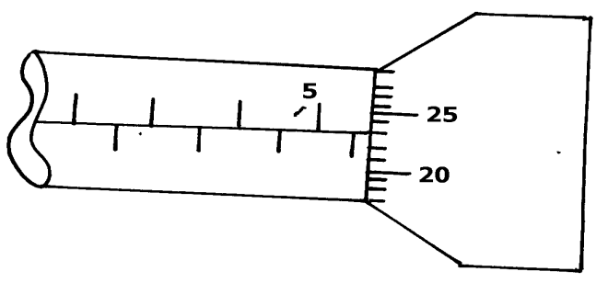

- Figure below shows a uniform metre rule in equilibrium under the forces shown

400g
100cm
40cm
20cm
200g
Frictionless pulley

Determine the weight of the metre rule (3 marks)

- State two factors that may be considered when designing the body of a racing car to enhance stability. (2 marks)

- Sea water of density 1.04g/cm³ is being pumped into a tank through a pipe of uniform
Cross-sectional area of 3.142cm². If the speed of water in the pipe is 5m/s, determine the
Volume flux in S.I units. (2 marks)

- Figure below shows two glass tubes of different size of bore, dipped in a glass beaker half full of water
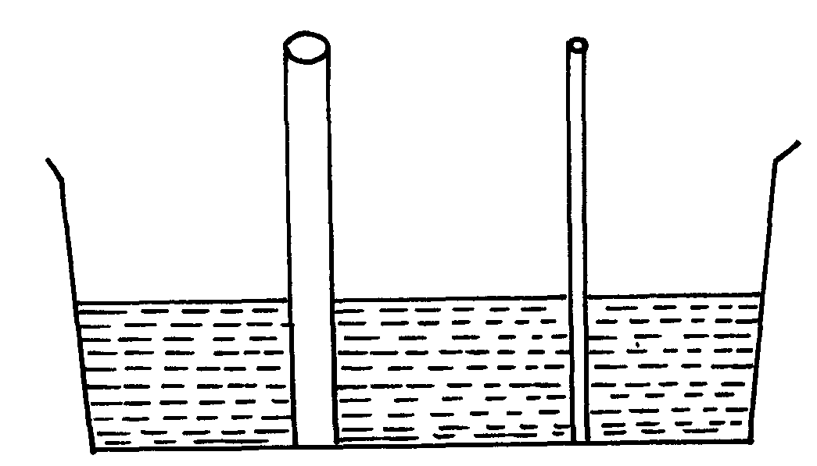

fig. 2

Complete the diagram to show how water will rise up in the two glass tubes. (1 mark)

- A bus of mass 2500kg initially moving at 20m/s is brought to rest over a distance of 20m. Determine the force required to achieve this. (3 marks)

- A ball is kicked vertically upward from the ground with a velocity of 60m/s and reaches a maximum height (h), it then falls freely back to the ground and bounces upwards to a height of 5M
- Sketch a velocity-time graph to represent the motion of the ball from the time it is kicked vertically upwards until it bounces to a height of 5M. (1 mark)

- Determine:
- The time taken by the ball to reach the maximum height(h). (2 marks)

(ii) The maximum height (h) reached by the ball. (2 marks)

- Water flow in a pipe of varying cross-section as shown in figure below
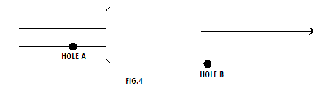
Hole A and B develops with time on the pipe if they holes have the same dimensions suggest with reason which hole leaks (2marks)

- A girl standing 220m from the foot of a high wall claps her hands and the echo reaches her 1.29 seconds later. Calculate the velocity of sound in air using this observation. (2 marks)

- Figure shows the variation force against extension for a spring obeying Hooke’s law

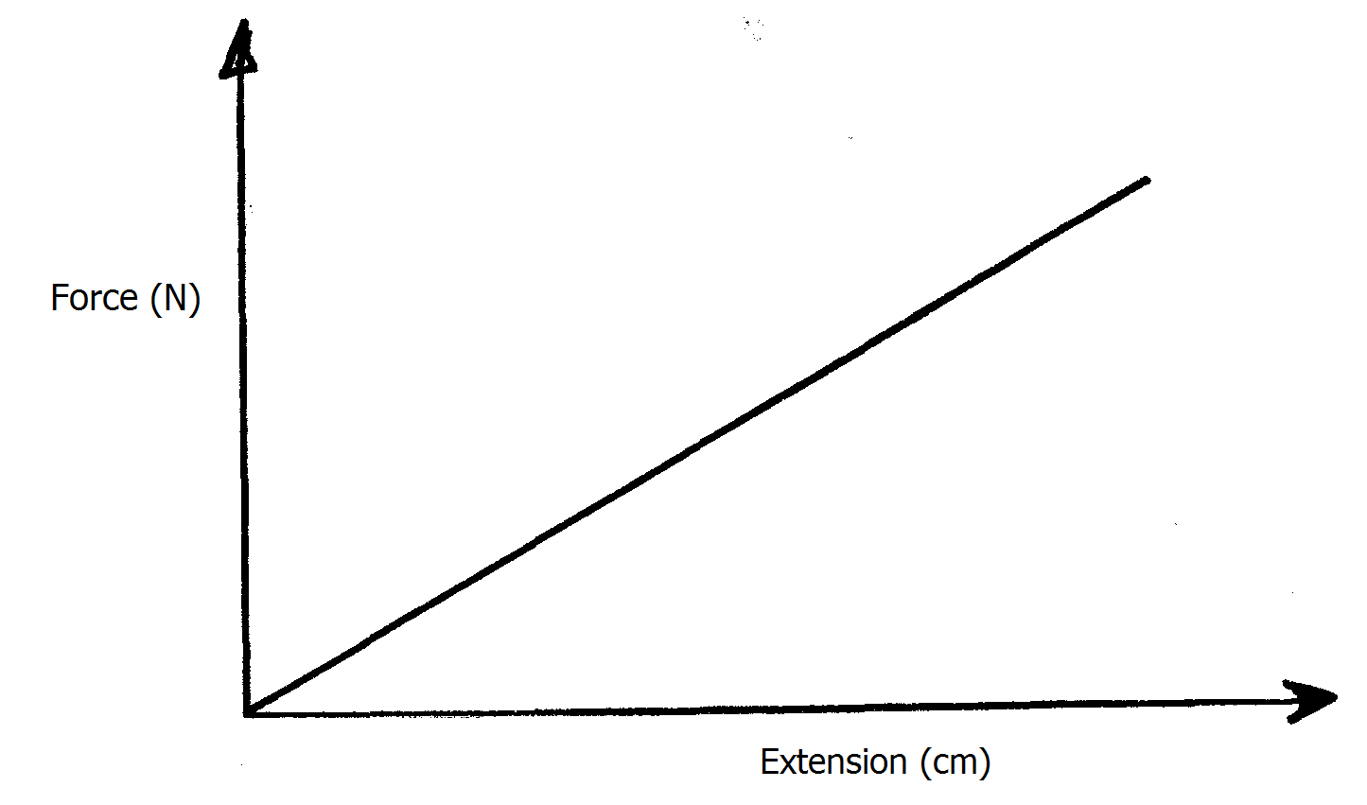
Sketch the same axes the variation of force against extension when two such springs are connected end to end. (1mark)
- State two factors that affects the speed of sound in gases (2marks)

- Figure below shows a magnetic material being magnetized

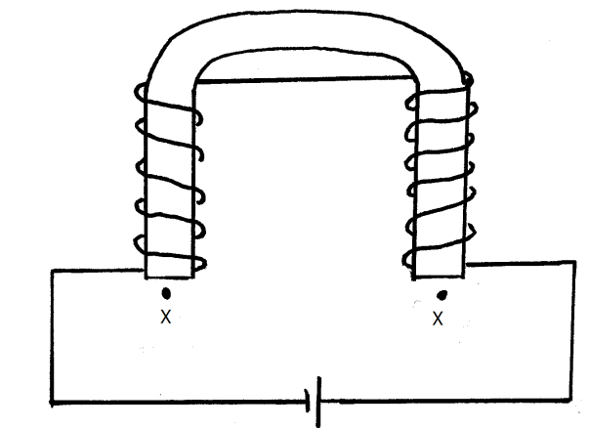
Identify the polarities of X and Y (1 mark)
X: …………………………………………………...................................................
Y: ……………………………………………………………………………………

SECTION B
- a) Define the term magnification as applied to curved mirrors. (1 mark)

b) The table below shows the results obtained in an experiment with a concave mirror.

Image distance V(cm) | 20 | 25 | 30 | 35 | 40 | 45
Magnification M | 1.0 | 1.5 | 2.0 | 2.5 | 3.0 | 3.5
- On the grid below plot the graph of magnification M against the image distance V. (5 marks)

- Use your graph to determine the focal length of the mirror given that the equation relating M and V is such that: $M+1=\frac{V}{f}$ (2 marks)

\

- a) Distinguish between speed and velocity. (1mark)

b) The figure below shows the motion of a ticker tape through a ticker – timer whose frequency is 100Hz.
Determine
I. Velocity at AB and PQ. (2marks)

II Constant acceleration of the tape. (3marks)

c) i) State Newton’s second law of motion. (1mark)

(ii) The diagram below shows a water sprinkler.
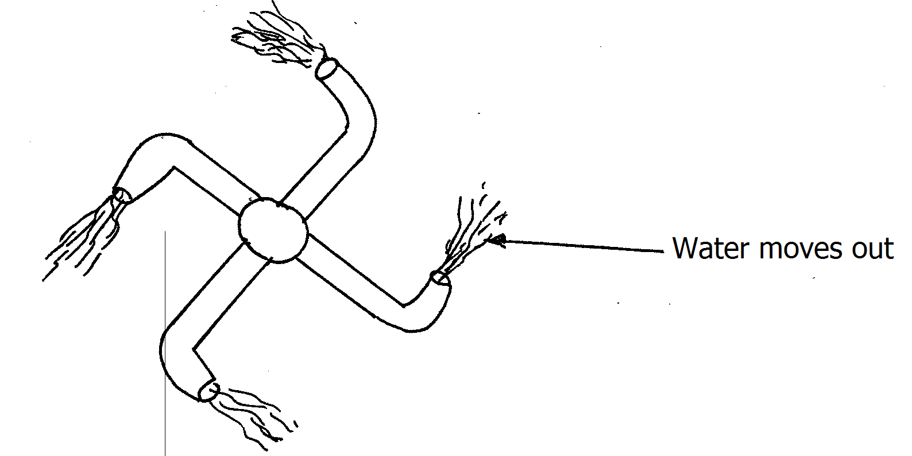
Explain how it is able to spray the garden (continuously) (2 marks)

d) A rugby player of mass 75kg, running east at 8.0 m/s, tackles another player of mass 90kg and who is running directly towards him at 5.0m/s. If the two players cling together, determine their common velocity. (3 marks)

- (a) State the law of conservation of energy. (1 mark)

(b) Draw a block and tackle system with a velocity ratio of 5. (2 marks)

(c ) The block and tackle system in (b) above was used to lift a load of 80kg.
Given that its efficiency is 80%. Calculate the effort applied to lift the load. (3 marks)

(d) Give two reasons why the efficiency of the machine above is less than 80%. (2 marks)

(e) An effort of 60N is applied to the brake of a car jack whose hand moves through a circle of radius 17.5cm. The pitch of the screw is 2.5mm. Determine the velocity ratio of the screw jack. (3 marks)

- The figure below shows path of ray of yellow light through a glass prism. The speed of yellow
light in the prism is 1.88 x 10⁸m/s.

60⁰

Ө
r

- Determine the refractive index of the prism material for the light
( speed of light in vacuum = 3.0 x 10⁸m/s) (3 marks)

(b) (i) Show on the diagram the critical angle . (1 mark)

(ii) Determine the value of the critical angle. (3 marks)

(c ) Given that r = 21.2⁰, determine angle Ө. (3 marks)

(d) On the same figure, sketch the path of the light after striking the prism if the prism was replaced by another of similar shape but lower refractive index
( Use doted line for your answer ) (2 marks)

- a) Define electric resistance. (1mark)

b) Figure below shows three resistors connected as shown.
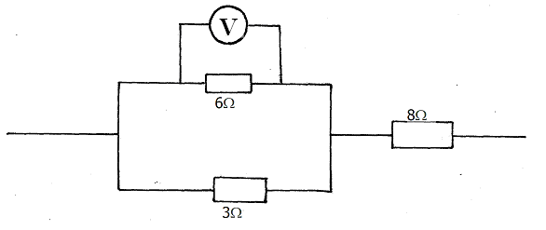
If the voltmeter reads 4v, find the
(i) effective resistance. (2marks)

(ii) Current through the 3Ω resistor. (2marks)

(iii) Potential difference across the 8Ω resistor. (2marks)

c)i) What is meant by the term “lost volts”? (1mark)

ii) A cell supplies a current of 0.5A when connected to a 2Ω resistor and 0.25A
when connected to a 5Ω resistor.
Find the e.m.f and the internal resistance of the cell. (4 marks)

THIS IS THE LAST PRINTED PAGE

