Name: …………………………………………………. Class: ………… Index.No. ……………
School: ………………..………………………………… Date……..………Sign:…………..
233/1
CHEMISTRY
Paper 1
MARCH 2018
Time: 2 hours

CATHOLIC DIOCESE OF KERICHO (CDK) EXAMS – 2018
PRE-MOCK
CHEMISTRY PAPER 1
TIME: 2 HOURS

INSTRUCTIONS TO CANDIDATES
- Write your name, admission number, date and school in the spaces provided.
- Answer all the questions in the spaces provided.
- All working must be clearly shown where necessary.
- Scientific calculators may be used.

FOR EXAMINERS’ USE ONLY

Questions | Maximum Score | Candidate’s Score
1 – 28 | 80

- State three properties common to both ammonia and calcium hydroxide solutions but different from solution of sulphur (IV) oxide in water (3mks)
………………………………………………………………………………………………………………………………………………………………………………………………………………………………………………………………………………………………………………………………………………………………………………………………………………………………
- Describe a simple test that can be carried out in the laboratory to distinguish between manganes (IV) oxide and copper (II) oxide (3mks)

………………………………………………………………………………………………………………………………………………………………………………………………………………………………………………………………………………………………………………………………………………………………………………………………………………………………
- Write any three balanced equations of possible reactions that take place when excess magnesium metal is burnt in air (3mks)
.................................................................................................................................................................................................................................................................................................................................................................................................................................................................................

- In the figure below
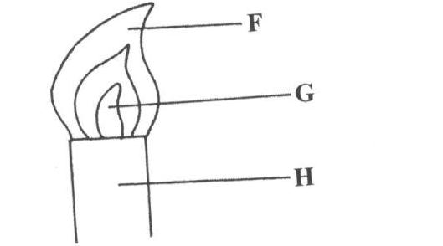

- Name the parts labeled F, G and H (1 ½ mks)
F …………………………………………………………………
G…………………………………………………………………
H…………………………………………………………………

- Describe an experiment that would confirm that region labeled G is unsuitable for heating
(1 ½ mks)
...............................................................................................................................................................................................................................................................................................................................................................................................................................................................................
- Give names of the following processes used to:
- Obtain a solvent from a saturated solution (2mks)
…………………………………………………………………………………………………
- Remove steam from air …………………………………………………………………

- Separate zinc carbonate from water
…………………………………………………………………………………………………
- Separate a mixture of nitrogen and helium
…………………………………………………………………………………………………
- Define the following terms:
- Anion (1mk)
……………………………………………………………………………………………………………………………………………………………………………………………………
- Atomic number (1mk) …………………………………………………………………………………………………………………………………………………………………………………………………..
- Isotopes (1mk)
…………………………………………………………………………………………………………………………………………………………………………………………………

- (a) Explain why the following combination of reagents is unsuitable for the laboratory preparation of hydrogen
- Zinc + dilute nitric acid (1 ½ mks)
………………………………………………………………………………………………

- Lead + dilute hydrochloric acid ( ½ mk)
………………………………………………………………………………………………
- Copper + dilute sulphuric acid ( ½ mk)
………………………………………………………………………………………………

- Potassium + dilute Sulphuric acid. ( ½ mk)
………………………………………………………………………………………………

(b) The diagram below was used to obtain hydrogen in the laboratory

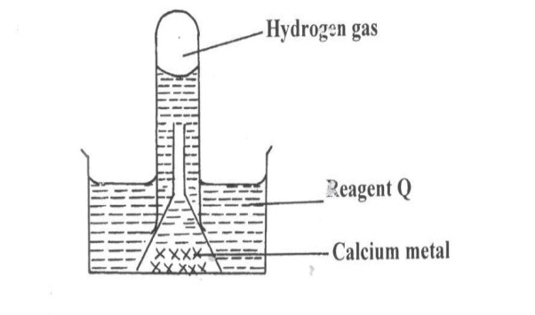

Name reagent Q ……………………………………………… (1mk)
- The diagram below is a set up used to investigate the effect of heat on hydrated copper (II) sulphate. Study the diagram and answer the questions that follow

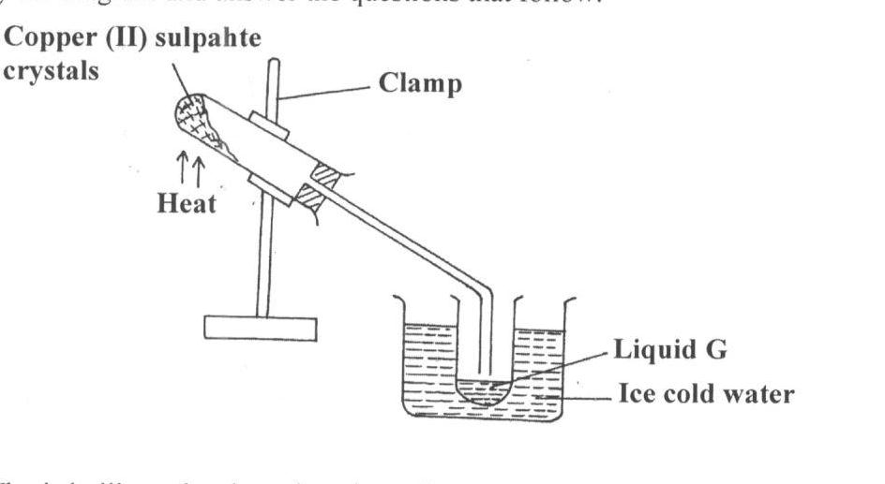

- Why is the boiling tube slanted as shown? (1mk)
…………………………………………………………………………………………………

- What is observed in the boiling tube (1mk)
……………………………………………………………………………………………………………………………………………………………………………………………………

- Identify liquid G ………………………………………………. (1mk

- In the reaction, an alkanol B was converted to pent-2-ene
- Give the structural formula of alkanol B (1mk)

- Name (i) the type of reaction that converts alkanol B to pent-2-ene (1mk)

…………………………………………………………………………………………………
(ii) The reagent used (1mk)
…………………………………………………………………………………………………

- In an experiment to study properties of carbon, a small amount of charcoal is placed in a boiling tube. 5.0cm³ of concentrated nitric acid is added. The mixture is then heated.
- What observations are made (1mk)
………………………………………………………………………………………………………………………………………………………………………………………………………………………………………………………………………………………………
- Write an equation for the reaction that took place in the boiling tube (1mk)
………………………………………………………………………………………………….

- What property of carbon is shown is this reaction? (1mk)
…………………………………………………………………………………………………

- 0.5g of Manganese (IV) oxide were added to 50cm³ of 3.5M hydrogen peroxide. The temperature of the solution rose from 21⁰C to 64⁰C. The information was represented on an energy level diagram as shown.
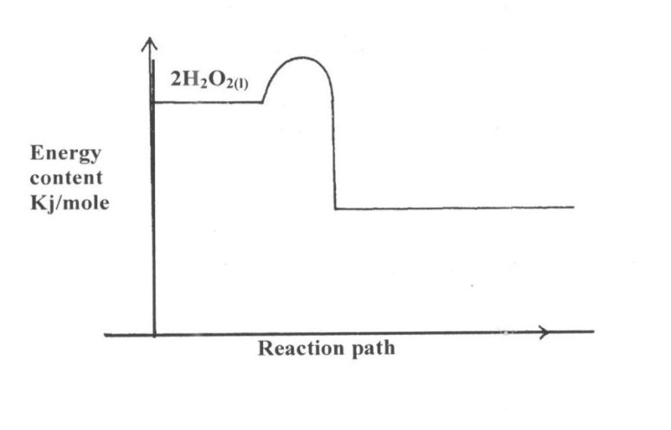

- Determine the number of moles of hydrogen peroxide that decomposed (1mk)

- Calculate the molar enthalpy of decomposition of hydrogen peroxide (1mk)

- On the same set of axes above sketch the curve that would be obtained if manganese (IV) oxide was not used and other conditions remained constant
- The electronic arrangement of two stable ions Q²⁺ and P²⁻ are 2.8.8 and 2.8.8 respectively.
- Write the electron arrangement of neutral atoms Q and P (1mk)
Q………………………………………………………………………………………………

P…………………………………………………………………………………………………

- What is the most likely structure of an oxide element P (1mk)

- The set up below was used by a student. Filter paper soaked in purple litmus solution was placed in the middle of the combustion tube

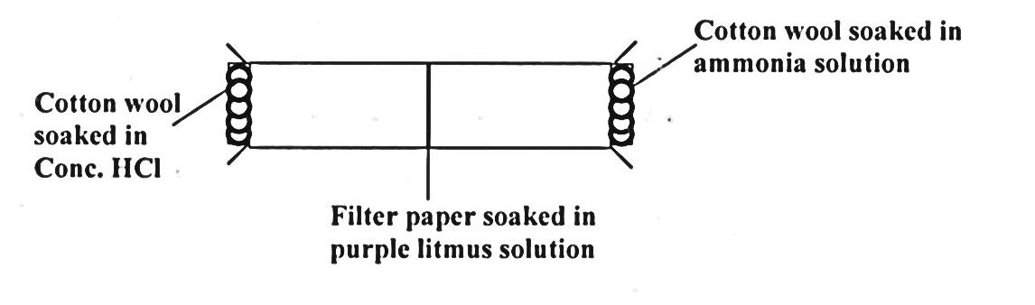
- What is the main aim of the experiment (1mk)
………………………………………………………………………………………………………………………………………………

- State the first observation likely to have been made in the tube. Explain the observation (2mks)
……………………………………………………………………………………………………………………………………………………………………………………………………………………………………………………………………………………………..

- Study the flow chart below and use it to answer the questions that follow

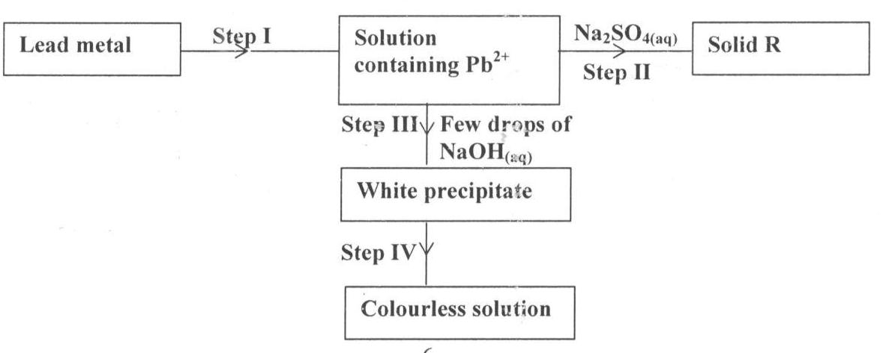
- Identify the reagent use in step I (1mk)
………………………………………………………………………………………………………

- Name solid A …………………………………………………… (1mk)

- Explain the observation in step IV (1mk)

……………………………………………………………………………………………………………………………………………………………………………………………………………….
- a. In which homologous series do the following compounds belong?
- CH3CCH (1mk)
………………………………………………………………………………………………

- CH3CH2COOH (1mk)
………………………………………………………………………………………………
b.Raw rubber is heated with sulphur in the manufacture of natural rubber,
i. What is the name given to the process (1mk)
………………………………………………………………………………………………………
- Why is the process necessary (1mk)
………………………………………………………………………………………………………………………………………………………………………………………………

- The table below gives the solubilities of salt L and K at 10⁰C and 40⁰C

Salt | Solubility in g/100g of water
 | At 10⁰C | At 40⁰C
L | 60 | 75
K | 20 | 32

When the aqueous mixture containing 80g of L and 10g of K in 100g of water at 50C was cooled to 10⁰C
- Identify the salt whose crystals were obtained (1mk)
………………………………………………………………………………………………

- Define solubility (1mk)
………………………………………………………………………………………………………………………………………………………………………………………………

- Suggest one industrial application of the method (1mk)
………………………………………………………………………………………………………………………………………………………………………………………………

- 60cm³ of ozone (O₃) diffused through a semi permeable membrane in 80 seconds. Calculate the time taken for 90cm³ of nitrogen (IV) oxide (NO₂) to diffuse under the same conditions (O=16, N=14) (3mks)

- Some salts may be classified as double salts or basic salts. Trona with the formula Na₂CO₃. NAHCO₃ is an example of double salt. An example of a basic salt is basic magnesium carbonate with formula MgCO₃.Mg(OH)₂
- What is meant by a double salt? (1mk)
…………………………………………………………………………………………………………………………………………………………………………………………………………………………………………………………………………………………………………
- Write equations of reactions that occur when diluted hydrochloric acid is reacted with: (2mks)
- Trona ………………………………………………………………………………………………
- Basic magnesium carbonate ………………………………………………………………………………………………

- Write equation to show the effects of heat on each of the following (3mks)
- Potassium hydrogen carbonate
…………………………………………………………………………………………………
- Silver nitrate
…………………………………………………………………………………………………

- Anhydrous iron (II) sulphate
…………………………………………………………………………………………………

- A hydrated salt has the following compositions by mass. Iron is 20.2%, oxygen is 23.0%, sulphur is 11.5%, water 45.3%. Its relative formula mass is 278. Determine the formula of the hydrated salt. (Fe=56, S=32.0, O=16, H=1) (3mks)

- Chlorine water is a mixture of some elements and compounds
- Write down the formula of two elements found in chlorine water (1mk)
…………………………………………………………………………………………………
- Name any two compounds in chlorine water (1mk)
……………………………………………………………………………………………………………………………………………………………………………………………………
- State any two chemical properties of chlorine water (1mk)
……………………………………………………………………………………………………………………………………………………………………………………………………

- Calculate the mass of zinc carbonate that would remain if 17.0g of zinc carbonate was reacted with 50cm³ of 4M nitric acid. The equation of the reaction is (3mks)
ZnCO_{3 (g)} + 2HNO₃ _{(aq)} Zn(NO₃)₂ + CO_{2(g)} + H₂O_{(l)}
(Zn=65.4, C=12.0, O=16.0)

- A solution of bromine in methyl benzene turns colourless when butane gas is passed through it.
- What type of reaction takes place (1mk)
……………………………………………………………………………………………..

- Write equation of the reaction which takes place. (1mk)
…………………………………………………………………………………………………

- Explain this observation:
When hydrogen chloride gas is dissolved in water, the solution conducts electricity while a solution of hydrogen chloride gas in propane does not conduct electricity (2mks)
………………………………………………………………………………………………………………………………………………………………………………………………………………………………………………………………………………………………………………………
- a. Describe hardness of water (1mk)
……………………………………………………………………………………………………………………………………………………
- Explain how dilute hydrochloric acid can be used to determine the type of hardness in a sample of tap water (1mk)
…………………………………………………………………………………………………………………………………………………………………………………………………….…………

- State two large scale uses of hard water (1mk)
……………………………………………………………………………………………………………………………………………………………………………………………………..

- A sealed glass tube containing 250cm³ of nitrogen gas at r.t.p was immersed in boiling water. Calculate the pressure inside the tube if the volume of the gas does not change due to expansion of glass (room pressure=760mmHg, room temperature=298K) (3mks)

- a. Write down the electron arrangement for an atom of element U which has a mass number 14 and contains 8 neutrons (1mk)

b.Draw the structure of an atom of A given in (a) above (2mks)

- Chlorine and hydrogen sulphide gases were introduced into sealed tube as shown

- State the observation that would be made in the tube. Explain. (1mk) …………………………………………………………………………………………………………………………………………………………………………………………………
- Both chlorine and hydrogen sulphide gases can be prepared using hydrochloric acid as one of the reagents. Write two separate equations showing how each gas can be prepared using HCl_{(aq)} as one of the reagents.
Cl_{2(g)} (1mk)
…………………………………………………………………………………………………
H₂S_{(g}) (1mk)
……………………………………………………………………………………………………………………………………………

