2901/304A
INFORMATION COMMUNICATION
TECHNOLOGY 111 (Theory)
November 2016
Time: 2 hours
THE KENYA NATIONAL EXAMINATIONS COUNCIL
DIPLOMA IN SECRETARIAL STUDIES
MODULE 111
INFORMATION COMMUNICATION TECHNOLOGY 111 (Theory)
2 hours
INSTRUCTIONS TO THE CANDIDATES
Answer FOUR ofthefollowing SIX queStions in the answer booklet provided. Candidates should answer the questions in English.
This paper consists of 4 printed pages.
Candidates should check the question paper to ascertain that all the pages are printed as indicated and that no questions are missing.
Turn over
C) 2016 The Kenva National Examinations Council.

(a) Outline two qualities of a good project schedule. (2 marks)
- Explain two strategies of risk management in project management. (4 marks)
- Distinguish between critical and summarized tasks as applied in project management.
(4 marks)
- Fibre cables are popular in computer networks. Outline five advantages of this medium that could be influencing this trend. (5 marks)
- List two types oftext alignment used in presentation programs. (I mark)
(ii) Outline two advantages of using presentation programs. (2 marks)
- Work breakdown structures (WBS) are used to plan resources in a project. Explain two benefits that could be used when using the tool. (4 marks) (c) Outline two methods of zooming in presentation documents. (2 marks) (d) With the aid of sketches, describe each of the following type of presentation views:
  - slide master; (3 marks)
  - slide sorter. (3 marks)
3. (a) Outline two limitations ofpeer to peer computer network. (2 marks)
- Figure I shows tools used in project management programs. Outline the function of each of the tools labelled (i) and (ii). (2 marks)
(ii)
Figure I
- Explain two circumstances that could necessitate the use of extranets in organizations.
(4 marks)
- (i) Outline three methods of placing a photo in a presentation slide. (3 marks)
(ii) Print preview is a critical feature of a presentation program. Outline four functions of this feature. (4 marks)
2901/304A

4. (a) Explain the term derailment as applied in project management. (2 marks)
- Differentiate between a transceiver and node as applied in data transmission. (4 marks)
- Explain two benefits of the Internet to students. (4 marks)
- Pauline was required to identify characteristics ofintranet during a job interview.
Outline five characteristics that she could have mentioned. (5 marks)
5. (a) Network diagrams are used for planning in project management. Outline three rules of thumb that should be considered when developing them. (3 marks)
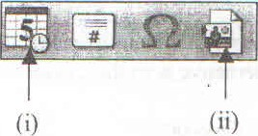
- Figure 2 shows a typical toolbar in a presentation program. Explain the function of each of the tools labelled (i) and (ii). (4 marks)
Figure 2
- Charles intends to email his job application letter to a certain company, Outline four requirements that he should consider to realize his goal. (4 marks)
- Spell checker is a critical feature when preparing presentation documents Outline the procedure that should be used to enable it check spelling automatically. (4 marks)
6. (a) Explain each of the following terms as applied in network diagrams:
  - forward pass; (2 marks)
  - backward pass. (2 marks)
(b) Maureen intends to protect her presentation document with a password. Outline the
procedure that she could use to achieve the goal. (4 marks)

2901/304A
November 2016 3 Turn over

(c) Figure 3 shows a presentation. Use it to answer the questions that follow.
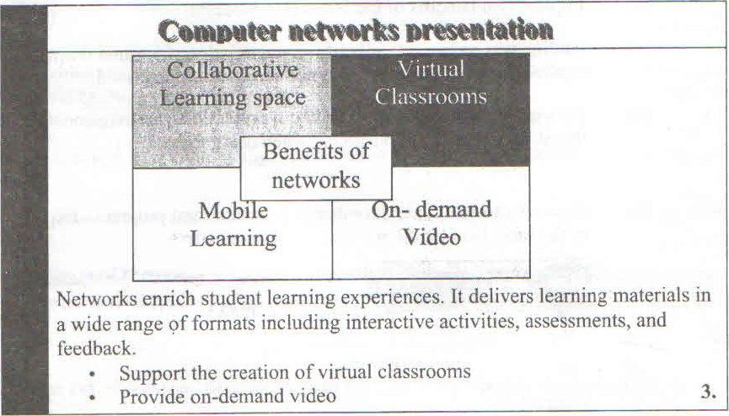
Figure 3
- Identify six formatting features used in the slide. (3 marks)
- Explain the procedure that could be used to customize effects in the slide.
(4 marks)

THIS IS THE LAST PRINTED PAGE.
2901/304A
November 2016 4

