NAME ………………………………………………………INDEX NO……………………………
SCHOOL………………………………………………………SIGNATURE………………………

443/2
AGRICULTURE
PAPER 2
AUGUST/SEPTEMBER
TIME: 2 HOURS

RARIEDA SUB-COUNTY POST MOCK JOINT EXAMS 2016
Kenya Certificate of Secondary Education (K.C.S.E)
443/2
AGRICULTURE
PAPER 2

INSTRUCTIONS TO CANDIDATES
[a] Write your name and index number in the spaces provided above .
[b]Sign and write the date of examination in the spaces provided above .
[c]This paper consists of three sections : A ,B,C .
[d]Answer all the questions in Section A and B and any two questions in Section C
[e]All answers should be written in the spaces provided on the question paper .

FOR EXAMINERS USE ONLY
SECTION | QUESTIONS | MAX.SCORE | CAND. SCORE
A | 1-19 | 30
B | 20-23 | 20
C | 24 ,25 ,26 | 20
 | 24 ,25 ,26 | 20
TOTAL SCORE |  | 90

his paper consists of 10 printed pages students to confirm the same and ensure there are no questions missing.
SECTION A [30 MARKS]
Answer all the questions in this section in the spaces provided.
- Name four dairy breeds of goats. [2marks]
………………………………………………………………………………………………………………………………………………………………………………………………………………………………………………………………………………………………………………………………
- Give four characteristics of clean and high quality milk . [2marks]
…………………………………………………………………………………………………………………………………………………………………………………………………………………………………………………………………………………………………………………………………………………………………………………………………………………………………………
- Name two classes of livestock feedstuff. [1mark]
……………………………………………………………………………………………………………………………………………………………………………………………………………………
- Give three systems of out breeding .[1.5marks]
……………………………………………………………………………………………………………………………………………………………………………………………………………………
- Give the pathogens that cause the following livestock diseases.
[a] Anthrax [0.5marks]
………………………………………………………………………………………………………….
[b] Gumboro [0.5marks
………………………………………………………………………………………………………….
- State two reasons for hoof trimming in livestock .[1mark]
……………………………………………………………………………………………………………………………………………………………………………………………………………………
- Give four symptoms of Newcastle disease .[2marks]
………………………………………………………………………………………………………………………………………………………………………………………………………………………………………………………………………………………………………………………………

- State four management activities done to piglets immediately after parturition [2marks]
………………………………………………………………………………………………………………………………………………………………………………………………………………………………………………………………………………………………………………………………………………………………………………………………………………………………………..
- Give four pre disposing factors of mastitis in dairy cows. [2marks]
…………………………………………………………………………………………………………………………………………………………………………………………………………………………………………………………………………………………………………………………………………………………………………………………………………………………………………
- State four routine management practices carried out on a replacement stock that is a heifer.[2marks]
…………………………………………………………………………………………………………………………………………………………………………………………………………………………………………………………………………………………………………………………………………………………………………………………………………………………………………
11. Outline two control measures of roundworms. [1mark]
……………………………………………………………………………………………………………………………………………………………………………………………………………………
12. Give two maintenance practices carried out on a barbed wire fence . [1mark]
……………………………………………………………………………………………………………………………………………………………………………………………………………………
[a] Name a pig breed that is purely black with a long back and drooping ears . [0.5mark]
…………………………………………………………………………………………………………
[b] Name four materials collected by bees. [2marks]
……………………………………………………………………………………………………………………………………………………………………………………………………………………
14. State four mechanical methods of controlling ticks . [2marks]
…………………………………………………………………………………………………………………………………………………………………………………………………………………………………………………………………………………………………………………………………………………………………………………………………………………………………………

15. Give two roles of ovaries in a cows reproductive system . [1mark]
……………………………………………………………………………………………………………………………………………………………………………………………………………………
16. State four reasons that make keeping of rabbits popular. [2marks]
…………………………………………………………………………………………………………………………………………………………………………………………………………………………………………………………………………………………………………………………………………………………………………………………………………………………………………
17. Give two roles of a bee drone. [1 mark ]
……………………………………………………………………………………………………………………………………………………………………………………………………………………
18. State four management practices carried out in a deep litter system of poultry keeping . [2marks]
…………………………………………………………………………………………………………………………………………………………………………………………………………………………………………………………………………………………………………………………………………………………………………………………………………………………………………
19. Name two functions of a clutch in the tractors transmission system .[1mark]
……………………………………………………………………………………………………………………………………………………………………………………………………………………
SECTION B [20MARKS]
Answer all the questions in this section in the spaces provided .
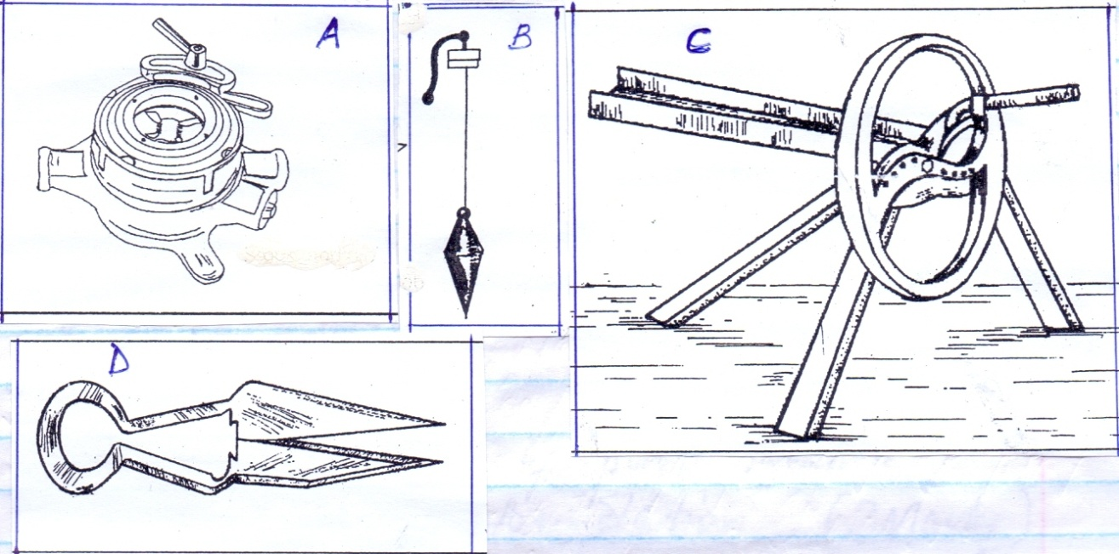
20.The diagrams below represent some farm tools and equipment .Study them and answer the questions that follow .

[a]Identify the tools labeled A and B
A……………………………………………………………………………… [1mark]
B………………………………………………………………………………. [1mark]
[b]State one use of each of the tools labeled C and D
C……………………………………………………………………………. [1mk.]
D……………………………………………………………………………… . [1mk.]
[c] Explain one maintenance practice carried out on tool D . [1mk.]
…………………………………………………………………………………………………………....................................................................................................................................................................

21.The diagram below represents a foundation of a farm structure .Study it and answer questions that follow .
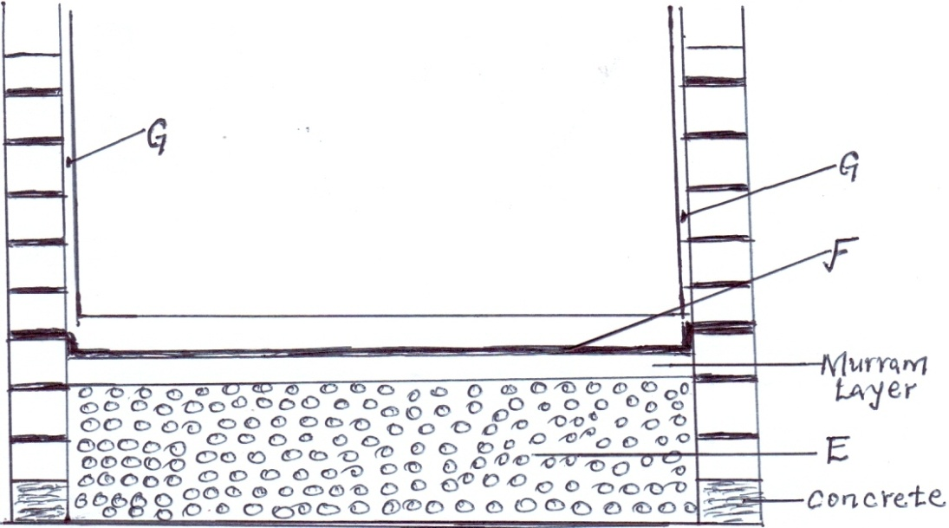
[a] Identify the parts labeled E and F .
E……………………………………………………………………………………. [1mk.]
F………………………………………………………………………………… [1mk.]
[b]State two uses of part labeled F in a foundation structure . [2mks.]
………………………………………………………………………………………………………………………………………………………………………………………………………………………………………………………………………………………………………………………………

[c]What ingredients are used to complete part G . [1mk.]
…………………………………………………………………………………………………………………………………………………………………………………………………………………..
22.The diagram below illustrates an internal parasite of livestock .

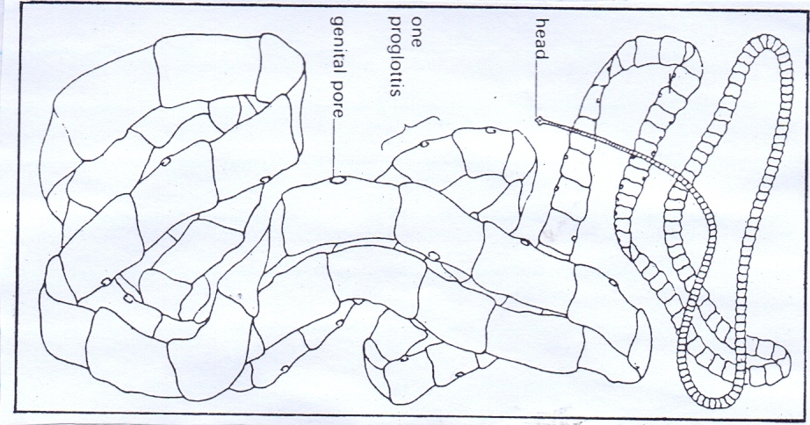

[a] Identify the parasite above . [1mk.]
…………………………………………………………………………………………………………………………………………………………………………………………………………………..
[b]Name two common species of the parasite illustrated a bove . [2mks.]
…………………………………………………………………………………………………………
…………………………………………………………………………………………………………
[c] Give two control measures of the above parasite . [2mks.]
………………………………………………………………………………………………………………………………………………………………………………………………………………………………………………………………………………………………………………………………
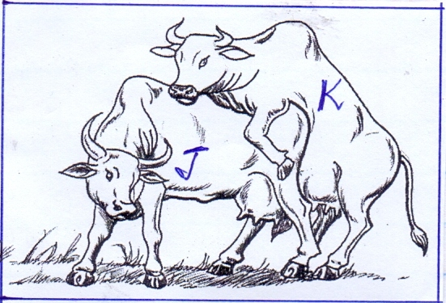
23. Study the diagram below and answer questions that follow.

[a] Which of the above cows shows the signs of heat ? [1mk.]
…………………………………………………………………………………………………………………………………………………………………………………………………………………….
[b]Give one reason to confirm your answer in [a] above.
…………………………………………………………………………………………………………………………………………………………………………………………………………………….
[c] State two benefits of natural mating system . [2mks.]
………………………………………………………………………………………………………………………………………………………………………………………………………………………………………………………………………………………………………………………………
[d] Name a disease that is easily spread by this method of mating . [1mk.]
…………………………………………………………………………………………………………………………………………………………………………………………………………………….
SECTION C [40MARKS]
Answer any two questions from this section in the spaces provided .
24. [a] Describe six signs of furrowing in a sow . [6mks.]
……………………………………………………………………………………………………………………………………………………………………………………………………………………………………………………………………………………………………………………………………………………………………………………………………………………………………………………………………………………………………………………………………………………………………………………………………………………………………………………………………………………………………………… ………………………………………………………..
[b]Explain six benefits of the Kenya top bar hive . [6mks.]
…………………………………………………………………………………………………………………………………………………………………………………………………………………………………………………………………………………………………………………………………………………………………………………………………………………………………………………………………………………………………………………………………………………………………………………………………………………………………………………………………………………………………………………………………………………………………………

[c]Explain eight factors considered when siting farm structures . [8mks.]
…………………………………………………………………………………………………………………………………………………………………………………………………………………………………………………………………………………………………………………………………………………………………………………………………………………………………………………………………………………………………………………………………………………………………………………………………………………………………………………………………………………………………………………………………………………………………………………………………………………………………………………………………………………………………………………………………………………………………………………………………………………………………………………………………………………………………………………………………………………………………………………………………………………………………………………………………………………………………………………………………………………………………………………………………………………………………………
25. [a] Describe rinderpest disease under the following sub headings .
Animals affected . [2marks]
……………………………………………………………………………………………………………………………………………………………………………………………………………………………………………………………………………………………………………………………….
Causal organism . [1 mark ]
……………………………………………………………………………………………………………………………………………………………………………………………………………………
Symptoms of attack . [ 5 marks]
……………………………………………………………………………………………………………………………………………………………………………………………………………………………………………………………………………………………………………………………………………………………………………………………………………………………………………………………………………………………………………………………………………………………………………………………………………………………………………………………………………………………………………………………………………………………………………………………………………………………………………………………………………………………………………………………………………………………………………………………….
Control measures . [2 marks ]
………………………………………………………………………………………………………………………………………………………………………………………………………………………………………………………………………………………………………………………………

[b] Describe the digestion of food in poultry from the beak to the duodenum . [5marks]
………………………………………………………………………………………………………………………………………………………………………………………………………………………………………………………………………………………………………………………………………………………………………………………………………………………………………………………………………………………………………………………………………………………………………………………………………………………………………………………………………………………………………………………………………………………………………………………………………………………………………………………………………………………………………………………………………………………………………………………………………………………………………………………………………………………………………………………………………………………………………………………………………………………………………………………………………………………………………………………………………………………………………………………………………………………………………………………………………………………………………………………………………………………………………………………………………………………………………………………………

[c] Explain five uses of solar energy in a farm . [5marks]
……………………………………………………………………………………………………………………………………………………………………………………………………………………………………………………………………………………………………………………………………………………………………………………………………………………………………………………………………………………………………………………………………………………………………………………………………………………………………………………………………………………………………………………………………………………………………………………………………………………………………………………………………………………………………………………………………………………………………………………………………………………………………………………………………………………………………………………………………………………………………………………………………………………………………………………………………………………………………………………………………………………………………………………………………………………………………………………………………………………………………………………………………………………

26. [a]Describe the working of a two stroke cycle engine . [10mks.]
………………………………………………………………………………………………………………………………………………………………………………………………………………………………………………………………………………………………………………………………………………………………………………………………………………………………………………………………………………………………………………………………………………………………………………………………………………………………………………………………………………………………………………………………………………………………………………………………………………………………………………………………………………………………………………………………………………………………………………………………………………………………………………………………………………………………………………………………………………………………………………………………………………………………………………………………………………………………………………………………………………………………………………………………………………………………………………………………………………………………………………………………………………………………………………………………………………………………………………………………………………………………………………………………………………………………………………………………………………………………………………………………………………………………………………………………………………………………………………………………………………………………………………………………………………………………………………………………………………………………………………………………………………………………………………………………………………………………………………………………

[b]Explain five factors considered when siting a fish pond. [5mks.]
………………………………………………………………………………………………………………………………………………………………………………………………………………………………………………………………………………………………………………………………………………………………………………………………………………………………………………………………………………………………………………………………………………………………………………………………………………………………………………………………………………………………………………………………………………………………………………………………………………………………………………………………………………………………………………………………………………………………………………………………
[c]Explain five reasons for swarming of bees. [5mks.]
……………………………………………………………………………………………………………………………………………………………………………………………………………………………………………………………………………………………………………………………………………………………………………………………………………………………………………………………………………………………………………………………………………………………………………………………………………………………………………………………………………………………………………………………………………………………………………………………………………………………………………………………………………………………………………………………………………………………………………………………………………………………………………………………………………………………………………………………………………………………………………………………………………………………………………………………………………………………………………………………

