NAME ………………………………………………………INDEX NO……………………………
SCHOOL………………………………………………………SIGNATURE………………………

233/2
CHEMISTRY
PAPER 2
AUGUST/SEPTEMBER
(THEORY)
TIME: 2 HOURS
RARIEDA SUB-COUNTY POST MOCK JOINT EXAMS 2016
Kenya Certificate of Secondary Education (K.C.S.E)
233/2
Chemistry
Paper 2

INSTRUCTIONS TO CANDIDATES

- Write your name and Index number in spaces provided above.
- Sign and write the date of examination in the spaces provided above
- Answer all the questions in the spaces provided above.
- KNEC Mathematical tables and silent electronic calculators may be used.
- All working must be clearly shown where necessary.
- Candidates should answer the questions in English.

FOR EXAMINERS USE ONLY
Question | Maximum score | Candidate’s score
1 | 12
2 | 11
3 | 09
4 | 12
5 | 11
6 | 12
7 | 13
Total score | 80

This paper consists of 11 printed pages. Candidates should check to ascertain that all pages are printed as indicated and that no questions are missing.

1. The table below shows elements with their atomic numbers, mass numbers and their melting points. Study it and answer the questions that follow. Letters do not represent the actual symbols of the elements
Element | B | C | D | E | F | G | H | I | J | K
Atomic number | 7 | 8 | 19 | 15 | 2 | 9 | 6 | 16 | 12 | 11
Atomic mass | 14 | 16 | 39 | 31 | 4 | 19 | 12 | 32 | 24 | 23
Melting point | - | - | 637 | 44 | -272 | -223 | vary | 113 | 669 | 980
(a) Select two elements with oxidation state -2 (1mk)
……………………………………………………………………………………………………
……………………………………………………………………………………………………
(b) Which element represents
(i) the most powerful oxidizing agent? (1mk)
……………………………………………………………………………………………………
(ii) the most powerful reducing agent? (1mk)
……………………………………………………………………………………………………
(c) Which element has the highest ionization energy? Explain (1mk)
……………………………………………………………………………………………………
……………………………………………………………………………………………………
(d) Select two elements, when reacted form a compound that conducts electricity in molten
and acqueous state (1mk)
……………………………………………………………………………………………………
……………………………………………………………………………………………………
(e) Select two elements when reacted form a compound that dissolves in water to form acidic solution (1mk)
……………………………………………………………………………………………………
……………………………………………………………………………………………………
(f) Using dot (•) and cross (x), draw the diagram that shows the bond between B and J (2mks)

(g) Explain why the melting point of K is higher than that of D (2mks)
……………………………………………………………………………………………………
……………………………………………………………………………………………………
2. Pure Calcium Carbonate weighing 7.50g was placed in a flask with 50cm³ of dilute hydrochloric acid. The flask was kept at constant temperature and the carbon (IV) oxide evolved was collected in a graduated vessel. The volume of carbon (IV) Oxide was recorded every 20 minutes intervals (some of calcium carbonate remained undissolved at the end of the experiment. The results of the experiment are given in the table; study it and answer the questions that follows

Time form at the start of reaction/min | Volume of Carbon (IV) Oxide formed at stp /cm³
20 | 655
40 | 910
60 | 1065
80 | 1100
100 | 1120
120 | 1120

(i) On the grid provided, plot the graph of the volume of Carbon (IV) Oxide against time (4mks)

(ii) From the graph determine the volume of the gas collected after 43 seconds (1mk)
……………………………………………………………………………………………………
(iii) Determine the rate of reaction at the 25th minute (2mks)
……………………………………………………………………………………………………
……………………………………………………………………………………………………
(iv) What mass of calcium carbonate will react with the acid after 100 seconds (3mks)
……………………………………………………………………………………………………
……………………………………………………………………………………………………
(II) When dilute hydrochloric acid is added to a yellow solution of Pottassium Chromate (VI)
an orange solution of Pottassium dichromate (VI) is produced as in the equation below
2K₂CrO_{4(aq)} + 2HCl_{(aq)} K₂Cr₂O_{7(aq)}+ H₂O_{(l)}
Yellow Orange
(i) What would you observe, if dilute Sodium hydroxide solution was added to the
Orange solution? Explain (2mks)
……………………………………………………………………………………………………
……………………………………………………………………………………………………
3. (a)(i) An evacuated flask has a mass of 90.050g. When filled with gas X at s.t.p the flask weighs 90.121g. If the volume of the flasks was 22.2cm³. Calculate the relative molecular mass of X. (Molar gas volume at s.t.p=22.4dm³) (2mks)

(ii) Write the equation of the reaction taking place when propane is burnt in excess Oxygen(1mk)
……………………………………………………………………………………………………
……………………………………………………………………………………………………
(b)(i) A fixed mass of a gas occupies 4dm3 at 227ºC and 152mmHg pressure. At what pressure
will the volume of the same mass of gas be 2dm³ if the temperature is lowered to -23ºC(3mks)

(c) (i) Study the scheme diagram below and answer the questions that follow
Solid R
Solid S
No precipitate
Colourless solution Q
White precipitate soluble in excess
White precipitate insoluble in excess
Acidified Ba(NO3)2(aq)
Water
Dil. HCl
Excess NaOH (aq)
Excess NH _{3(aq)}

Identify
Solution Q…………………………………….
Solid R………………………………………… (2mks)
(d) The following is a nuclear equation (X and Y are not actual symbols)
0
4
90
230
m
a
X Y + 2 He + 2 e
-1
2
(a) Determine the value of a and m
…………………………………………………………………………………………….……..
(b) Compare the atomic size of R and L 2mks)
……………………………………………………………………………………………………
……………………………………………………………………………………………………
4. (I) When hydrogen gas was passed over heated Iron (III) oxide was heated. However, when Iron (III) oxide was heated with carbon, a reaction occurred resulting in the formation of solid product Z. When solid Z was dissolved in dilute Sulpuric (VI) acid, gas Y was evolved.
(a) Explain why carbon reacted with Iron (III) Oxide while hydrogen did not? (1mk)
……………………………………………………………………………………………………
……………………………………………………………………………………………………
(b) Identify gas Y (1mk)
……………………………………………………………………………………………………
……………………………………………………………………………………………………

(c) (i) Write an equation for the reaction between Iron (III) Oxide and Carbon (1mk)
……………………………………………………………………………………………………
……………………………………………………………………………………………………
(ii) Calculate amount of solid Z formed in grams, if 1.5g of Iron (III) oxide was used (Fe=55.8,O=16) (3mks)
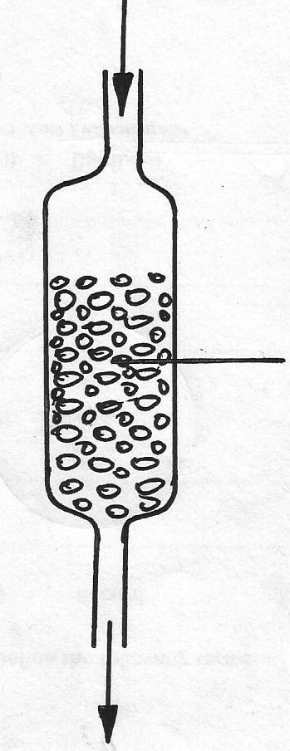
(II) The calcium below was used to soften hard water
Hard water

Permutit ( contains Na⁺)

Soft water

(i) Explain how the hard water was softened as it passed through the column (2mks)
……………………………………………………………………………………………………
……………………………………………………………………………………………………
(ii) After some time the material in the column is not able to soften hard water. How can the
material be activated (2mks)
……………………………………………………………………………………………………
……………………………………………………………………………………………………
(iii) Give one advantage of using hard water for domestic purposes (1mk)
……………………………………………………………………………………………………
……………………………………………………………………………………………………
(iv) Some Copper turnings were added to dilute Nitric (V) acid at 40ºC
(a) State one observation made (1mk)
………………………………………………………………………………………………………………………………………………………………………………………………………………....
(b) State and explanation observation you will make if the reaction temperature is increased to 55ºC (2mks)
……………………………………………………………………………………………………
……………………………………………………………………………………………………
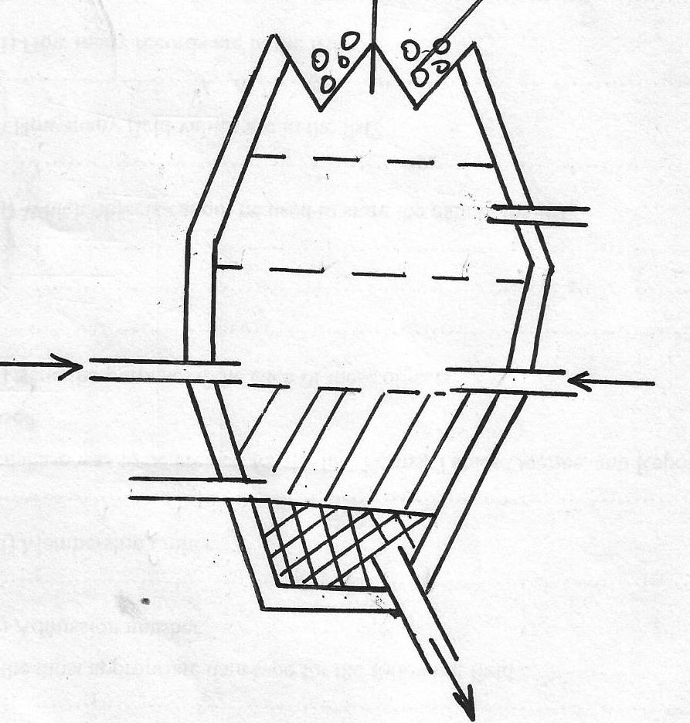
5. The diagram below shows the blast furnace for the extraction of iron. Study it and answer the questions that follow
Hot air blast
Iron
Hot air blast
Iron ore
P
Q
R

(i) Identify the ore from which Iron is extracted from (1mk)
……………………………………………………………………………………………………
(ii) Which roles does the following material perform in extraction of iron
(a) Coke (1mk)
……………………………………………………………………………………………………
(b) Carbon (II) Oxide (1mk)
……………………………………………………………………………………………………
(iii) Write down the equation for the two chemical changes that takes place in zone P (2mks)
……………………………………………………………………………………………………

……………………………………………………………………………………………………
……………………………………………………………………………………………………
(iv) What is the temperature range in zone R? and what the importance of the temperature for extraction of Iron metal (1mk)
……………………………………………………………………………………………………
……………………………………………………………………………………………………
(v) What is the composition of slag? (2mks)
……………………………………………………………………………………………………
………………………………………………………………………………………………………………………………………………………………………………………………………………….
(vi) List any two physical properties of iron metal (2mks)
……………………………………………………………………………………………………
……………………………………………………………………………………………………

(II) A student was provided with 50cm³ of HCl in a 250cm³ volumetric flask (acid in excess). When the reaction stopped he filled the volumetric flask to the 250cm³ mark up with distilled water.
25cm³ of this solution requires 2cm³ of 0.1M NaOH for complete neutralization
(a) Write the equation for the reaction taking place between XCO3 and HCl (1mk)
……………………………………………………………………………………………………
(b)(i) Calculate the number of moles of the acid in 250cm³ of solution (2mks)
…………………………………………………………………………………………………………………………………………………………………………………………………………………………………………………………………………………………………………………………………………………………………………………………………………
(ii) How many moles of the acid reacted with XCO₃? (2mks)
…………………………………………………………………………………………………………………………………………………………………………………………………………………………………………………………………………………………………………………………………………………………………………………………………………
(iii) Calculate the molecular mass of the XCO₃ (3mks)
…………………………………………………………………………………………………………………………………………………………………………………………………………………………………………………………………………………………………………………………………………………………………………………………………………
(d) What is the percentage of X by mass is XCO₃? (1mk)
………………………………………………………………………………………………………………………………………………………………………………………………………………………………………………………………………………………………………………………
6. The set-up below was used to study some properties of air
Moist iron wool
Moist iron wool
Water
Test tube
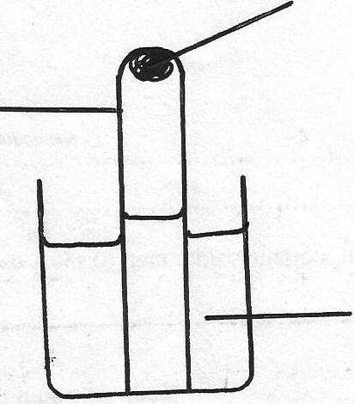

(i) State and explain two observation that would be made at the end of the experiment (3mks)
…………………………………………………………………………………………………………………………………………………………………………………………………………………………………………………………………………………………………………………………………………………………………………………………………………
(ii) Write the chemical equation for the chemical change that will take place (1mk)
…………………………………………………………………………………………………………………………………………………………………………………………………
(II) The diagram below represents a paper chromatogram from three brands of juices suspected to contain burned food colour
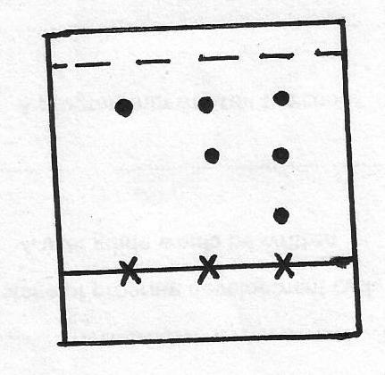

M
K
L

The results showed the presence of burned formed colorings’ in L and M only. On the same diagram
(a) Circle the spots which show the burned food colorings’ (1mk)
(b) Show solvent front (1mk)
(III) (i) Name another gas which is used together with Oxygen in welding (1mk)
……………………………………………………………………………………………………
……………………………………………………………………………………………………
(ii) Oxygen and Sulphur belong to group (VI) of the periodic table. Explain why there is big difference in their melting point (melting points of Oxygen is -216ºC while that of sulphur is 44ºC
(2mks)
……………………………………………………………………………………………………
……………………………………………………………………………………………………

(iv) Explain how a solid mixture of sodium sulphate can be separated from lead (I) sulphate if the two are mixed together (3mks)
…………………………………………………………………………………………………………………………………………………………………………………………………………………………………………………………………………………………………………………………………………………………………………………………………………,……………………………...
7. The table below shows some properties of some organic compounds. Use it to answer the questions that follows;
Compound | Molecular | Mptºc | BptºC
P  Q  R  S  T | C₂H₄O₂  C₃H₆  C₃H₈O  C₅H₁₂  C₅H₈ | 16.6  185  -127  -130  -90 | 118  -47.7  97.2  36  39.3

(i)

Which of the compounds above is a gas at 25ºC? Explain (2mks)
……………………………………………………………………………………………………
……………………………………………………………………………………………………
(ii) Describe chemical test that would distinguish between T and S (2mks)
……………………………………………………………………………………………………
……………………………………………………………………………………………………
(iii) Compounds R and P reacted to form compound K. Give the name of K and state the group of compounds to which it belongs (2mks)
……………………………………………………………………………………………………
……………………………………………………………………………………………………
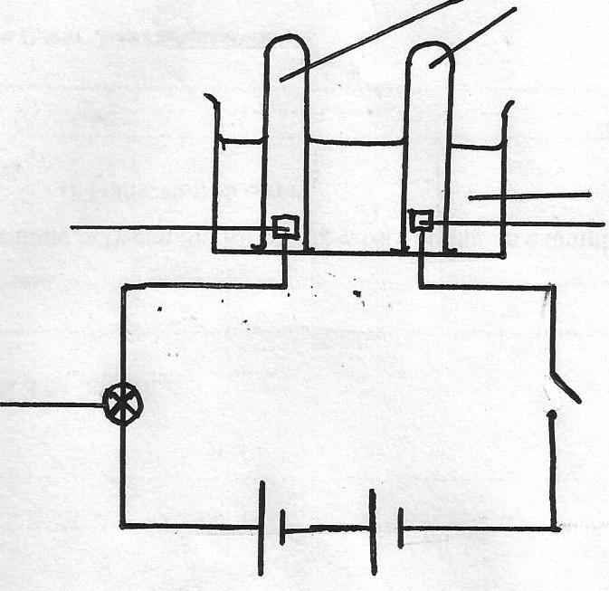
(II) Study the diagram below and answer the questions that follow;
B
Distilled water
Switch
Bulb
A
Test tube

(a) State, which electrode is the cathode and which one is anode (1mk)
……………………………………………………………………………………………………
…………………………………………………………………………………………………….
…………………………………………………………………………………………………….
(b) Explain why no observation was made when the switch was closed (1mk)
……………………………………………………………………………………………………
……………………………………………………………………………………………………
……………………………………………………………………………………………………
(c) Small amount of concentrated sulphuric (VI) acid was added to the distilled water and the
Switch closed.
(i) State and explain observation made (2mks)
……………………………………………………………………………………………………
……………………………………………………………………………………………………
(ii) Using equations show the reactions that took place at each electrode given that A and B are inert electrodes (2mks)
……………………………………………………………………………………………………
……………………………………………………………………………………………………
(iii) Write down overall cell equation for the reaction (2mks)
……………………………………………………………………………………………………
……………………………………………………………………………………………………

