NAME ………………………………………… INDEX NO …….…………………..
SCHOOL ………………………………………… SIGNATURE …………..……....…….
DATE ……………….………..
231/2
BIOLOGY
PAPER 2
(THEORY)
MARCH/APRIL, 2018
2 HOURS

MOKASA JOINT EVALUATION TEST, 2018

Kenya Certificate of Secondary Education (K.C.S.E)

INSTRUCTIONS TO CANDIDATES
- Write your name and Index Number in the spaces provided above.
- This paper consists of two sections. Section A and section B.
- Answer ALL questions in section A in the spaces provided. In section B answer question 6 (compulsory) and either question 7 or 8 in the spaces provided after question 8.
- This paper consists of 10 Printed pages. Candidates should check the question paper to ensure that all the papers are printed as indicated and no questions are missing
For Examiners use only.
Section | Question | Maximum score | Candidates score
A | 1 | 8
 | 2 | 8
 | 3 | 8
 | 4 | 8
 | 5 | 8
B | 6 | 20
 | 7 | 20
 | 8 | 20
 | Total score | 80

- In an ecological study, form three students obtained the following data
organism | Population | Biomass in kg
A | 10000 | 10
B | 1000 | 0.1
C | 100 | 0.01
D | 10000 | 1000
E | 10 | 0.01

a)Work out a possible food chain from the above ecosystem (1mark) ………………………………………………………………………………………………………………………………………………………………………………………………
b) i. Construct a pyramid of biomass using the above data (2marks)
……………………………………………………………………………………………………………………………………………………………………………………………………………………………………………………………………………………………………………………………………………………………………………………………………………………………………………………………………………………………………………
ii. Which two organisms are most likely to occupy the same trophic level in the ecosystem? Give reasons for your answer. (3marks)
……………………………………………………………………………………………………………………………………………………………………………………………………………………………………………………………………………………………………… iii. State one disadvantage of representing ecological data in a pyramid of numbers (1mark)
……………………………………………………………………………………………………………………………………………………………………………………………………………………………………………………………………………………………………….
iv. State the type of competition exhibited by the organisms you have named in b (ii) above.(1mark)
………………………………………………………………………………………………….

- The micrographs below is of a tissue showing mitosis. Examine it and answer the questions.
R T
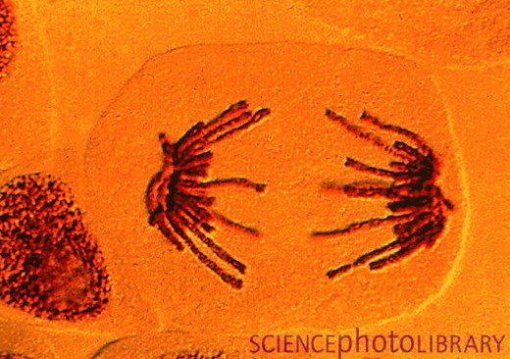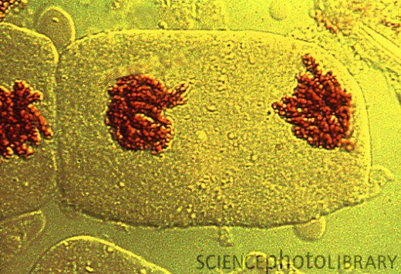

a.) i. Identify the tissue from which the micrographs were obtained (1mark)
………………………………………………………………………………………………………
ii.Give a reason for your answer in a) i above (1mark)
………………………………………………………………………………………………………………………………………………………………………………………………………………
Name the stages represented by R and T. (2marks)
R……………………………………………………………………………………………………T……………………………………………………………………………………………………
b.) State two significance of mitosis to an organism (2 marks)
………………………………………………………………………………………………………………………………………………………………………………………………………………………………………………………………………………………………………………………
c.) Name two regions in higher plants where cells actively undergo mitosis (2marks)
………………………………………………………………………………………………………………………………………………………………………………………………………………

3 The diagram below represents epidermis of a leaf.

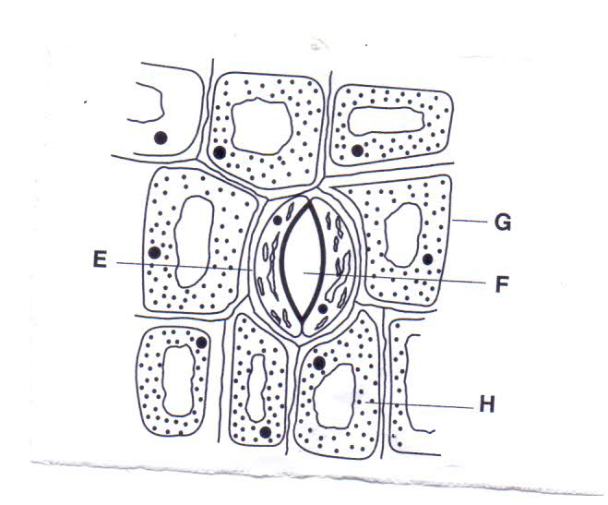
a.) Name the parts labeled E, F and G (3marks)
……………………………………………………………………………………………………………………………………………………………………………………………………………………………………………………………………………………………………………………...b.) State two adaptations of E two its functions (2marks)
…………………………………………………………………………………………………………………………………………………………………………………………………………………………………………………………………………………………………………………….. c.) Briefly explain what happens to the part labeled F when the level of Carbon (IV) oxide drops in the cytoplasm.(3marks)
……………………………………………………………………………………………………………………………………………………………………………………………………………………………………………………………………………………………………………………………………………………………………………………………………………………………………………………………………………………………………………………………………..
4 a.) Describe an experiment to demonstrate osmosis in red blood cells in hypertonic solution
(6 marks)
………………………………………………………………………………………………………………………………………………………………………………………………………………………………………………………………………………………………………………………………………………………………………………………………………………………………………………………………………………………………………………………………………………………………………………………………………………………………………………………………………………………………………………………………………………………………………………………………………………………………………………………………………………………………………………………………………………………………………………………………………………………………………………………………………………………………………………………………………………………………………………………………………………………………………………………………………………………………………………………………………………………………………………………………………………………………………………………………………………………………………………………………………………………………………………………………………………………………………………………………………………………………………………………………………………………………………………………………………………………………………………………………………………………………………………………………………………………………………………………………………………………………………………………………………………………………………………………………………………………………
b.)Sstate the significance of the process in (a) above in animal. (2marks)
……………………………………………………………………………………………………………………………………………………………………………………………………………………………………………………………………………………………………………………..

5. In a fruit fly the gene for wing size is sex linked and located on X- chromosome. Vestigial wing gene is recessive. A cross was made between a heterozygous long winged female and a vestigial winged Male. Using letter N for dominant gene and letter n for recessive gene, work out the genotypic and phenotypic ratio for their F1 generation.(5marks)
………………………………………………………………………………………………………………………………………………………………………………………………………………………………………………………………………………………………………………………………………………………………………………………………………………………………………………………………………………………………………………………………………………………………………………………………………………………………………………………………………………………………………………… b.)Explain any three disorders arising from chromosomal mutations (3marks)
…………………………………………………………………………………………………………………………………………………………………………………………………………………………………………………………………………………………………………………………………………………………………………………………………………………………………………………………………………………………………………………………………………………………………………………………………………………………………………………………………………………………………………………...................................................................................................................................................................................................................................................................................................................................................................................................................................................................

6. During germination and growth of wheat, the dry weight of endosperm, embryo and total dry weight were determined at two-day intervals. The results are shown in the table below.

Time after planting days | Dry weight of endosperm  (mg) | Dry weight of embryo  (mg) | Total dry weight  (mg)
0 | 43 | 2 | 45
2 | 40 | 2 | 42
4 | 33 | 7 | 40
6 | 20 | 17 | 37
8 | 10 | 25 | 35
10 | 6 | 33 | 39

- Using same axes draw graphs of dry weight of endosperm, embryo and the total dry weight against time.(8marks)

- What was the total dry weight on day 5?(1mark)
…………………………………………………………………………………………………
- (i) Account for the dry weight of endosperm from day 0 to day 10 (3marks)
………………………………………………………………………………………………………………………………………………………………………………………………………………………………………………………………………………………………………
(ii) Increase in dry weight of embryo from day 0 to day 10 (2marks)
……………………………………………………………………………………………………………………………………………………………………………………………………
(iii) Decrease in total dry weight from day 0 to day 10 (2marks)
……………………………………………………………………………………………………………………………………………………………………………………………………
(iv) Increase in total dry weight after day 8 (2marks)
……………………………………………………………………………………………………………………………………………………………………………………………………
(v)State one factors within the seed and one outside the seed that cause dormancy
Within the seed
……………………………………………………………………………………………………… Outside the seed
………………………………………………………………………………………………………7 (a) Describe the process of absorption and movement of water from the soil to the xylem of the root. (8marks)
(b) Explain the structure and functions of the blood. (12marks)
8 Describe the evidences of organic evolution. (20marks)

………………………………………………………………………………………………………………………………………………………………………………………………………………………………………………………………………………………………………………………………………………………………………………………………………………………………………………………………………………………………………………………………………………………………………………………………………………………………………………………………………………………………………………………………………………………………………………………………………………………………………………………………………………………………………………………………………………………………………………………………………………………………………………………………………………………………………………………………………………………………………………………………………………………………………………………………………………………………………………………………………………………………………………………………………………………………………………………………………………………………………………………………………………………………………………………………………………………………………………………………………………………………………………………………………………………………………………………………………………………………………………………………………………………………………………………………………………………………………………………………………………………………………………………………………………………………………………………………………………………………………………………………………………………………………………………………………………………………………………………………………………………………………………………………………………………………………………………………………………………………………………………………………………………………………………………………………………………………………………………………………………………………………………………………………………………………………………………………………………………………………………………………………………………………………………………………………………………………………………………………………………………………………………………………………………………………………………………………………………………………………………………………………………………………………………………………………………………………………………………………………………………………………………………………………………………………………………………………………………………………………………………………………………………………………………………………………………………………………………………………………………………………………………………………………………………………………………………………………………………………………………………………………………………………………………………………………………………………………………………………………………………………………………………………………………………………………………………………………………………………………………………………………………………………………………………………………………………………………………………………………………………………………………………………………………………………………………………………………………………………………………………………………………………………………………………………………………………………………………………………………………………………………………………………………………………………………………………………………………………………………………………………………………………………………………………………………………………………………………………………………………………………………………………………………………………………………………………………………………………………………………………………………………………………………………………………………………………………………………………………………………………………………………………………………………………………………………………………………………………………………………………………………………………………………………………………………………………………………………………………………………………………………………………………………………………………………………………………………………………………………………………………………………………………………………………………………………………………………………………………………………………………………………………………………………………………………………………………………………………………………………………………………………………………………………………………………………………………………………………………………………………………………………………………………………………………………………………………………………………………………………………………………………………………………………………………………………………………………………………………………………………………………………………………………………………………………………………………………………………………………………………………………………………………………………………………………………………………………………………………………………………………………………………………………………………………………………………………………………………………

