1. Given that , and , evaluate  (3 mks)







1. Two boys and a girl shared some money .The elder boy got of it, the younger boy got of the reminder and the girl got the rest. Find the percentage share of the younger boy to the girl’s share. (3 marks)

Let the amount of money shared be 

Elder boy 

Younger boy 

Girl 



1. Annette has some money in two denominations only. Fifty shilling notes and twenty shilling coins. She has three times as many fifty shilling notes as twenty shilling coins. If altogether she has sh. 3400, find the number of fifty shilling notes and 20 shilling coins. (3 marks)

Let Shs. 20 coins be 

Then Shs. 50 notes will be 







Shs. 50 notes = 

Shs. 20 coins = 20

1. Kamau withdrew some money from the bank. He spent 3/8 of the money to pay Korir’s school fees and 2/5 to pay Omollo’s school fees. If he remained with ksh 12,330, calculate the amount of money he paid for Omollo’s fees. (4mks)

|  |
| --- |
| 3/8x – Korir  2/5x – Omollo  Total – 3/8x + 2/5x = 15x + 16x = 31x   1. 40   Remaining x – 31x = 9 x   1. 40   9x = 12330  40  x = ?  12330 x 40  9x  = sh. 54800  Paid = 2/5 x 54800  = sh. 21,920 |

1. Evaluate without using mathematical table or calculator. (3mks)

0.0625 x 2.56

0.25 x 0.08 x 0.5

|  |
| --- |
| 0.0625 x 2.56  0.25 x 0.08 x 0.5  = 625 x 256  25 x 8 x 5 x 10  √16 = 4 |

1. In the figure below PQ is parallel to RS. Calculate the value of **x** and **y**  (4mks)

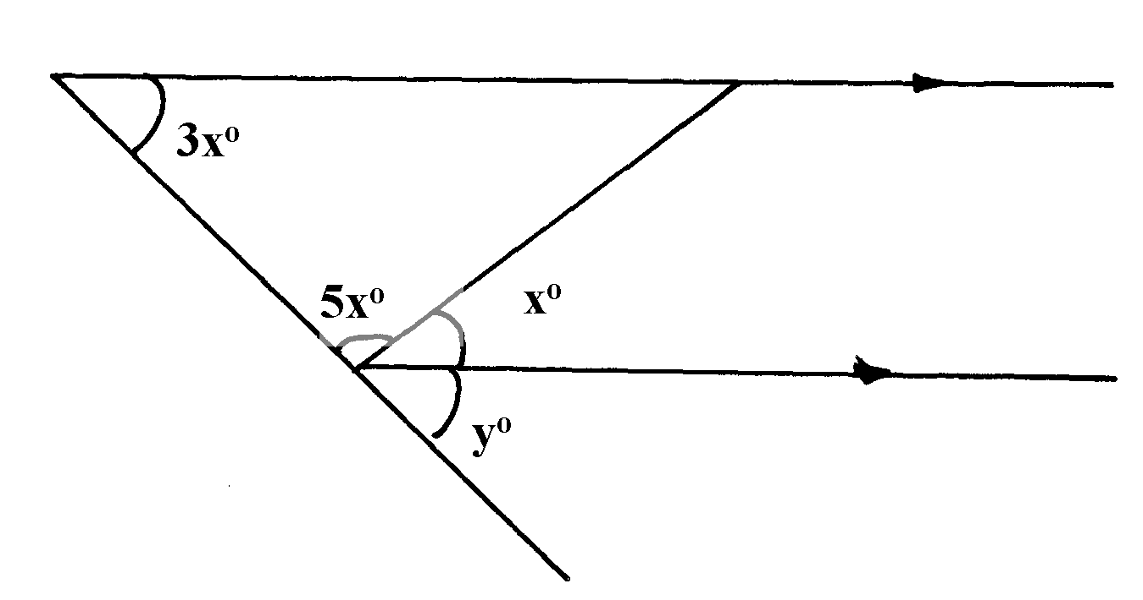

Q

S

T

Q

P

1. Thirty men working at the rate of 10 hours a day can complete a job in 14 days. Find how long it would take 40 men working at the rate of 7 hours a day to complete the same job. (3mks)

|  |
| --- |
| 14 x 30 days  40  No. of days increase in ratio 10:7 days  14 x 30 x 10  40 7  = 15days |

1. The length of a rectangle is increased by 25% while its width is decreased by 5%. Determine the percentage increase in the area of the rectangle. (3mks)

|  |
| --- |
| Old length and width = l & w  New length = L = 1.25I  New width = W= 0.95w  Old area = l x w = 11w  New area A1 = 1.25l x 0.95w  = 1.1851w  ∴ % increase = 1.185 – 1 x 100  1  = 0.1875 x 100  = 18.75% |

1. Ruhu, Toru, and Lwamawa contributed a total of Kshs. 8041950.00 for their joint

campaigns ahead of 2012 general elections. The ratios of their contributions were Ruhu

to Toru 5:4 and Lwamawa to Toru 2:3.

a) How much did each contribute? (4 Marks)

Ruhu to Toru = (5: 4) 3 = 15: 12

Lwamawa to Toru = ( 2:3) 4 8: 12🗸

Ruhu: Toru : Lwamawa = 15:12:8

Ruhu = 🗸

Toru = 

Lwamawa = 

b) Ruhu further contributed Kshs. 875,000.00 towards the campaigns kitty. in response, Toru and Lwamawa increased their contributions in the ratios 10:9 and 11:6

respectively. How much did Toru and Lwamawa further contribute (3 marks)

Toru = 🗸

= Shs. 306,360🗸

Lwamawa = (11 – 1) = Shs. 1838160

6

= Kshs. 1,531, 800.00🗸

c) The three agreed that if they win elections they would share the 15 cabinet positions amongst them in the ratio of their contributions. How many cabinets positions did Lwamawa get? (3 Marks)

Total Contributions.

= 8,041,950 + 875000 +306360+

531800 = Kshs.10,755,110.00



1. Solve the following simultaneous equations using substitution Method. (3 marks)

4a+3b=120

2a+5b=130

A= -15/5/7

B= -20/5/7

1. A self help group of 10 young men invested Shs 72,000 in two companies A and B. A pays a dividend of 22.5% while B pays a dividend of 21%. If from their total investment they obtained a return of 21.5%, how much monet did they invest in each company?(4 marks)

Total amount invested=

=87,480



8,748,000-8,712,000=1.5A

36,000=1.5A

A=Shs. 24,000✓

B=72,000-24,000=Shs. 48,000✓

1. The angles of a quadrilateral are 3x, 2x, x +14 and 2( x – 7) degrees. Find the smallest angle.

(3mks)



1. Without using a calculator, evaluate, , leaving your answer as a fraction in its simplest form. ( 3mks)



= 

= 

= 1 ½

1. Given that  = 1 a/b, Find the values of a and b. (3mks)



Let x = 1.05050505





=1

a= 5, b= 99

1. Evaluate;

$\frac{4+\frac{1}{3} of 27 ÷9 (-6 × -2)}{2x-\left(-50\right)- 54 ÷9 ×12}$ (3 marks)

4 + 9 9 -12



4 + 1 – 12 = -7

2 x 50 – 6 x 12

100 – 72 = 28

$\frac{-7}{28}= -\frac{1}{4}$

1. Three businessmen Mutuku, Mutiso and Kitili decided to buy a bus. The market price of the bus was sh2,800,000. The men could pay a deposit of 60% of the money and the rest to be paid within one year. Mutuku, Mutiso and Kitili raised the deposit in the ratio 3:2:5 respectively. The balance was to be paid to the dealer from the proceeds of the bus in the same deposits. During the year the bus realized sh.2,080,000
2. How much deposit did each contribute? (4 marks)

Deposit = $\frac{60}{100}$ x 2,800,000

= 1,680,000

Ratio 3:2:5

Mutuku’s contribution = $\frac{3}{10}$ x 1,680,000

= 504,000

Mutiso’s contribution = $\frac{2}{10}$ x 1,680,000

= 336,000

Kitili’s contribution = $\frac{5}{10}$ x 1,680,000

= 840,000

1. How much of the remaining amount did Kitili pay at the end of the year? (2 marks)

balance of payment

sh(2,800,000 – 1,680,000)

= 1,120,000

Kitili’s payment = $\frac{5}{10}$ x 1,120,000

= 560,000

1. After paying the remaining amount at the end of the year, how much money was Mutuku left with? (4 marks)

Mutuku’s share of proceeds

$\frac{3}{10}$ x 2,080,000

$=624,000$

Mutuku’s contribution on balance

$\frac{3}{10}$ x 1,120,000

$=336,000$

Amount left

Sh(624,000 – 336,000)

= 288,000

1. In Ngamongo village, a piece of work can be completed by 45 workers in 10 days .They worked for 4 days after which 15 workers were laid off. How many days would it take the remaining workers to complete the work? (3mks)

45×10=450

45×4=180

Remaining day =270

No. of days ==9 days

1. In the Kapsabet station church choir, the ratio of male to female is 2:3. On one Sunday service, 10 male members were absent and six new female members joined the choir as guests for that day. If on this day the ratio of males to females was 1:3, how many regular members does the choir have? (3 marks)

Normal ratio:  B1

Sunday service ratio:  B1

∴ 3M = F + 36

3 × F = F + 36

F = 36, M = 24

Members = 60

1. Okisai is three times as old as his son now. If ten years ago the sun of their ages was 44. How

Old was Okisai when his son was born ? (3mks)

Let the son’s now age be x

(3x – 10) + (x – 10) = 44

3x + 4 – 10 – 10 = 44

4x = 64

X = 16 years

16 x 3 – 16

=> 48 – 16 =32 years

Okisai age was 32 years

1. The G.C.D of two numbers is 36 and their L.C.M. is 1260. If one of the numbers is 252,

find the other number. (2mks)

L.C.M = 



= 180

the other number is 180

1. A poultry farmer has twenty times as many hens as turkeys and three quarters as many ducks as turkeys.
2. If there are t, turkeys, write down a simplified expression in terms of t for the total number of birds on the farm. (1mk)

b)Given that he has 72 ducks, calculate as a percentage the sum of turkeys and ducks to the number of hens on the farm. (3mks)

|  |
| --- |
| No of hens =20t, No of ducks=  a) Total No.    b)  t=96. Hens=1920 |

1. Given the ratio x : y = 2:3, find the ratio (7x – 3y) : (2x + 3y). (2mks)
2. Given that x = 2, y = 3 and p = -4 simplify (4mks)

6x2y2 + 13py – 5p

3x2p– 13xy + 6

1. A trader bought 5 exercise books and 6 pens at a total cost of sh.180 from a shop. At the same day, he later decided to buy 12 exercise books and 3 pens at a total cost of sh. 300.

a) Taking the cost of one exercise book as sh. x and that of a pen as sh. Y, form two equations in x and y (1mk)

b) Determine the cost of one exercise book and the cost of one pen (3mks)

c) The trader sold all the pens at sh. 165 to a shopkeeper. Calculate the percentage profit that the trader made. (3mks)

d) if the trader sold all the exercise books to the shopkeeper generating a loss of 20%, determine the amount the trader got after selling all the exercise books. (3mks)

1. Simplify;

(a) 2*x* – 2 3*x* + 2 (2mk)

**-**

2*x* 4*x*

(b) Hence solve the equation

2*x* – 2 3*x* + 2 = 1 (2mk)

2*x* 4*x* 3