DOCTOR AGGREY HIGH SCHOOL
FORM THREE TRIAL EXAM 2018
INSTRUCTIONS:Answer all the questions.
- In which homologous series do the following compounds belong?
(i) CH₃CCH (1 mk)
(ii) CH₃CH₂COOH (1 mk)
(b) Raw rubber is heated with sulphur in manufacture of natural rubber.
(i) What name is given to the process? (1 mk)
(ii) Why is the process necessary? (1 mk
(c) Study the scheme given and answer the questions that follow
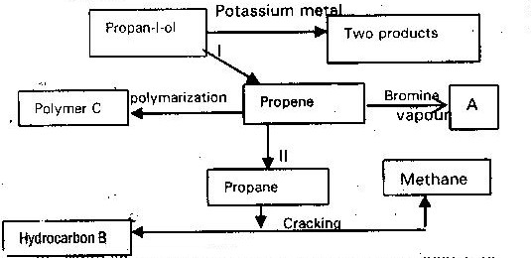

  - Write an equation for the reaction between propan-1-ol and potassium metal ( 1mk)
  - Name process I and II ( 2 mks)
  - Identify the products “A” and “B” ( 2 mks)
  - Name ONE catalyst used in process II (1 mk)
  - Draw the structural formula of the repeating unit in the polymer “C”
(d) State two uses industrial uses of methane (2 mks)
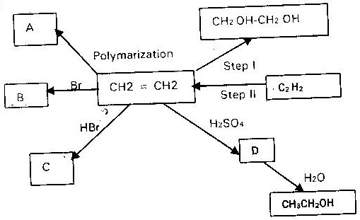
- Below is a scheme of some reaction of ethyne

(i) State the condition and reagents required to effect steps I and II (2mks)
(ii) Give the formula of products A, B, C and D (4mks)
- Below is a scheme of some reactions of ethanol. Study it and answer the questions that follow
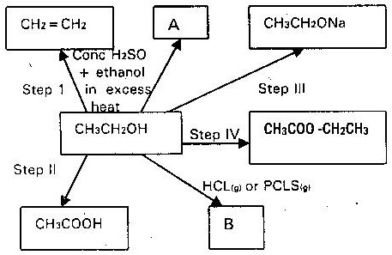

(i) State the conditions and the reagents required in steps I, II, III and IV (4mks)
(ii) Name the major products “A” and “B” (2mks)
- Consider the following compounds
(a) CH₃ CH₂ CH₂COOH
(b) CH₃ CH₂ COOCH₂ CH₂
(c) HOOCCH₂ CH₂ COOH
(d)CH₃ CH(OH) CH₃
Which of these compounds is
(i) Diabasic acid
(ii) An Ester
- The flow chart below shows a series of reactions starting with ethanol. Study it and answer the questions that follows.
Ethanoic acid
Ethanol
Gas B
Polymer
C
Methane
Process A
NaOH _{(aq)}
High Pressure
Conc H₂SO₄
Heat

(i) Name I. Process A (1 mk)
II. Substance “B” and “C” (1 mk)
(ii) Write the equation for the combustion of ethanol (1 mk)
(iii) Explain why it is necessary to use high pressure to change B into polymer
(1 mk)
- Study the below chart and answer the questions that follows
N
NaCO₃
P
CCL₄
Soda lime
Step 1
U.V
Step 2
Excess

- An organic compound with the formula C₄H₁₀O react with potassium metal to give hydrogen gas and a white solid.
(a) Write the structure formula of the compound (1 mk)
(b) To which homologous series does the compound belong (1 mk)
(c) Write the equation for the reaction between the compound and potassium metal (1 mk)
- Complete the table below by inserting the missing information in the spaces provided (4mks)

Name of polymer | Name of monomer | Use of polymer
Polystyrene
 | Vinyl chloride
- (a) Draw the structure of ethanol and propanoic acid (2mks)
(b) Give the name of the organic compound formed when ethanol and
propanoic acid react in presence of concentrated sulphuric acid (1 mk)

