NAME: ……………………………………………………. INDEX NUMBER: …………………………
SCHOOL: ……………………….. CANDIDATES SIGNATURE: ………………..
DATE: ……………………………………………..
231/2
BIOLOGY
THEORY
PAPER 2
JULY/ AUGUST 2018
2 Hours

FORM FOUR MALLIET EXAM TERM TWO 2018
Kenya Certificate of Secondary Education (K.C.S.E)

INSTRUCTIONS TO CANDIDATES
- Write your name and Index Number in the spaces provided above.
- Answer ALL the questions in the spaces provided
- In section B Answer question 6 (Compulsory) and either question 7 or 8 in the spaces provided after question.
For Examiners use only.
SECTION | QUESTION | MAX. SCORE | CAND. SCORE
A | 1 | 8
 | 2 | 8
 | 3 | 8
 | 4 | 8
 | 5 | 8
B | 6 | 20
 | 7 | 20
 | 8 | 20
Total score |  | 80

This paper consists of 8 Printed pages .Candidates should check the question paper to ensure that all the Papers are printed as indicated and no questions are missing

SECTION A (40 MARKS)
Answer all the questions
- Study the diagram below represents a plant in the division Bryophyta
- 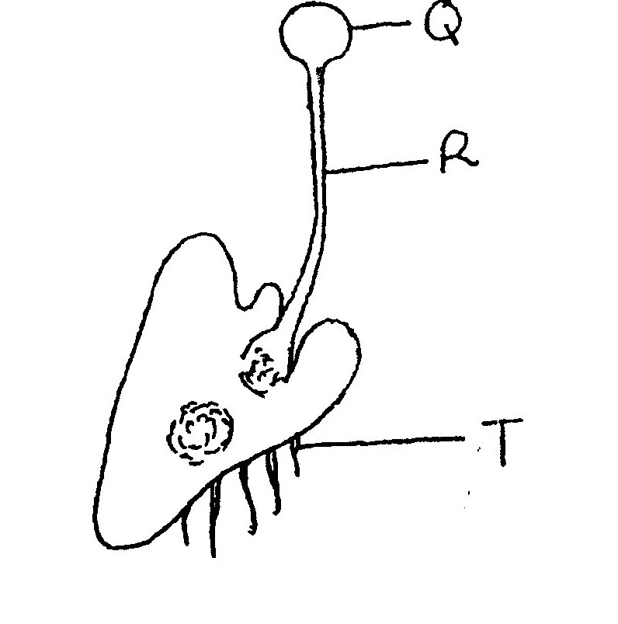
- Name the parts labelled Q and R 2mks
Q…………………………………………..
R…………………………………………..

- State two functions of part T 2mks

- During a practical activity, Form three students of Butere Boys collected a specimen whose drawing is shown below during class activity. State the phylum and class that the organism belong giving a reason for each case based on observable features only. 4mks
Phylum……………………………………………………………………..
Reason…………………………………………………………………………………
Class………………………………………………………………………………….
Reason ………………………………………………………………………………

- The diagram below shows a structure found in insects. Study it carefully answer the questions
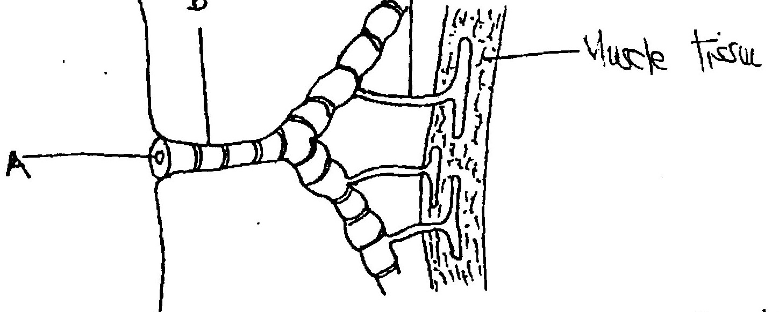
- Name the parts A and B 2mks
A

B

- State two ways in which part C is adapted to its function. 2mks

- Give brief explanation to the following observations
- Fish dies when taken out of water after some time 2mks

- The danger associated with sleeping in a poorly ventilated room with a charcoal jiko on. 2mks

- a. What is meant by the sex-linked genes 1mk

b. In Drosophila the eye colour is sex-linked; the red eye colour is dominant over white eye colour. A cross was made between a red eyed male and a red eyed female. The offspring`s were as follows:- Two red eyed females, one white eyed male and one red eyed male. 1 mk

iii. Carry out possible cross to confirm the above results 4mks

c. i. Define the term mutation 1 mk

ii. Name the gene mutation that causes albinism 1mk

- The following set up was used to investigate a physiological process in life
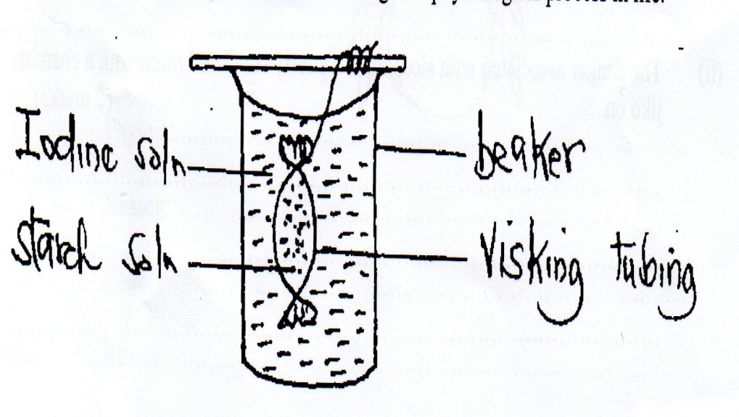

- i. Name the physiological process that was being investigated 1mk

ii. What is the representative the visking tubing in life? 1mk

- i. State the observation that would be made in the visking tube after 2mks

ii. Explain why similar results were not obtained inside the beaker 2mks

- The diagram below illustrate blood circulation in a certain organs in human.
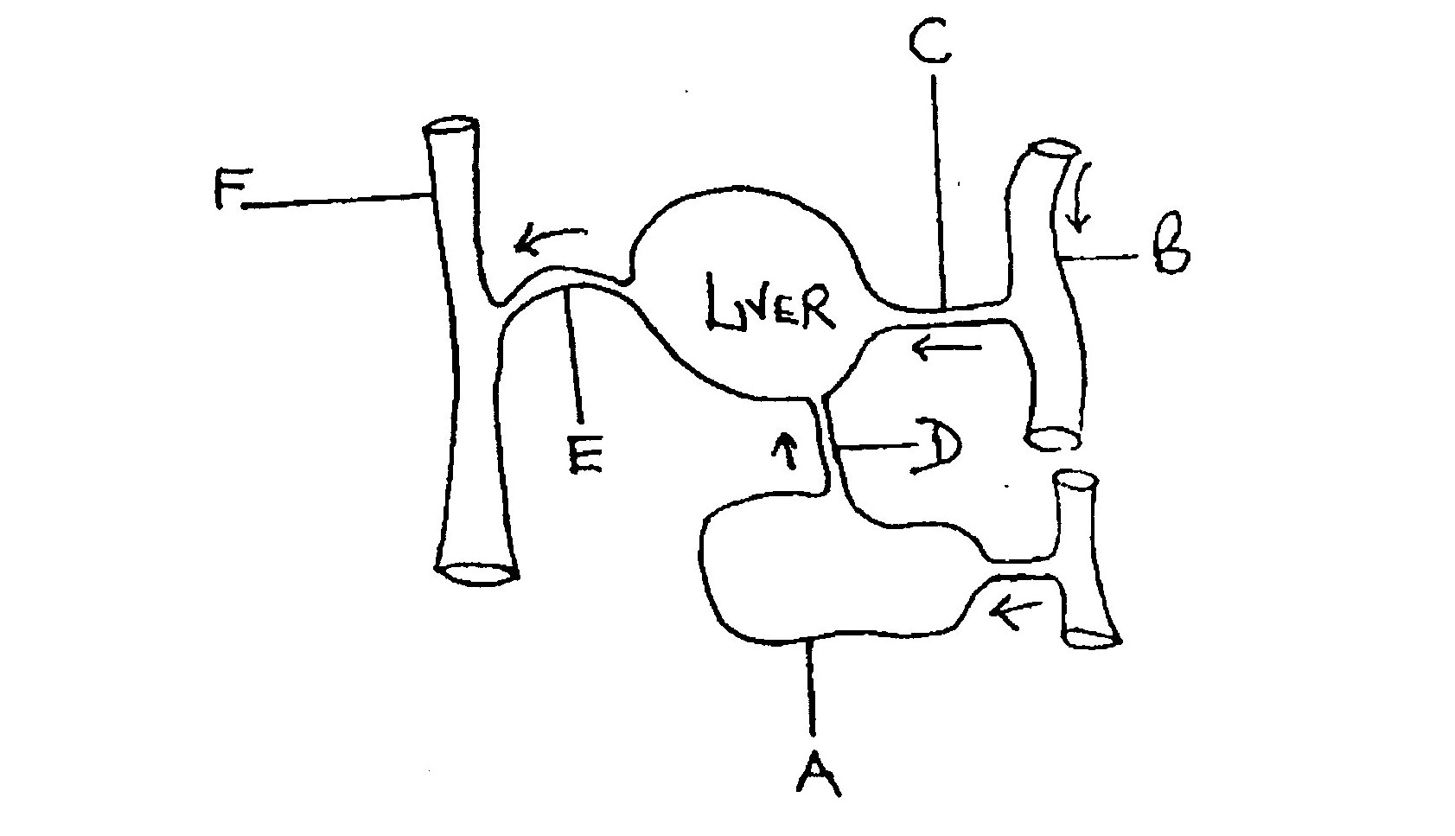
- Identify the part labelled A 1mk
A…………………………………..
- Name the blood vessels B and F 2mks
B……………………………………..
F………………………………………

- State how the composition of blood in vessel E differ from that in vessel D 3mks

- State two nutrients that are stored in the liver 2mks

SECTION B 40 MARKS
Answer question 6 (Compulsory) and either question 7 or 8 in the spaces provided after question.
- An experiment was carried out to investigate the effect of the temperature on the rate of a reaction catalysed by an enzyme. The results are shown in the table below.
Temperature (⁰C) | Rate of reaction in mg of products per unit time
5 | 0.2
10 | 0.5
15 | 0.8
20 | 1.1
25 | 1.5
30 | 2.1
35 | 3.0
40 | 3.7
45 | 3.4
50 | 2.8
55 | 2.1
60 | 1.1

- On the grid draw a graph of reaction against temperature 6mks
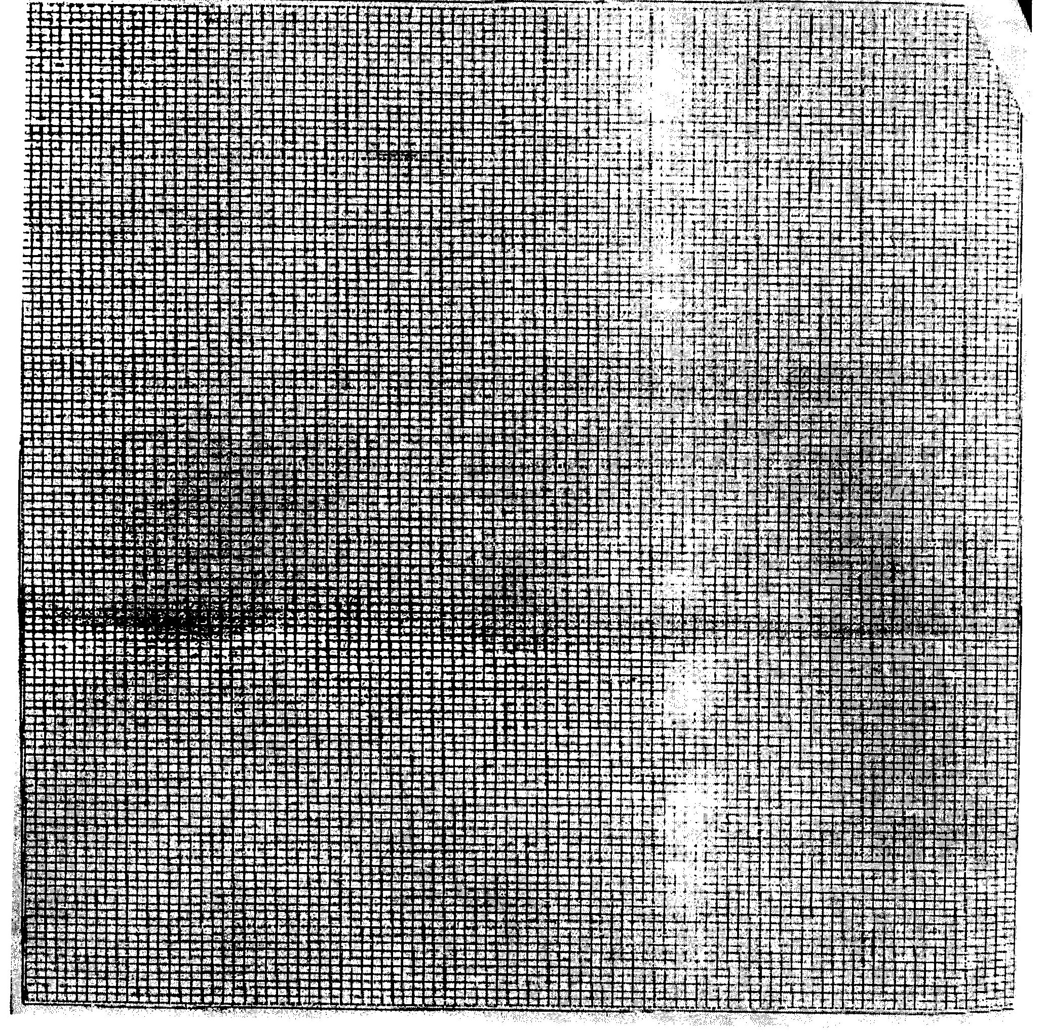
- When the rate of reaction is 2.6mg of product per unit time? 2mks

- Account for the shape of the graph between:
- 5⁰C and 40⁰C 1mk

- 45⁰C and 60⁰C 1mk

- Other than temperature name two ways in which the rate of reaction between 5⁰C and 40⁰C could be increased. 2mks

- i) Name one digestive enzyme in the human body which works best in acidic condition 1mk

ii) How is the acidic condition for the enzyme name in (e) (i) above attained? 2mks

- The acidic condition in (e) (ii) above is later neutralized
- Where does the neutralization take place? 1mk

- Name the substance responsible for neutralization 1mk

- How are flowers adapted to wind and insect pollination 20mks
- a. What is meant by natural selection 2mks
b. Describe how natural selection brings about the adaptation to its environment 18mks

