Name: …………………………………………………………… Index No: …………….……………………
School: ………………………………………….………………. Candidate’s Sign.:………………...............
Date: ………………………………............................................

443/1
AGRICULTURE
PAPER 1
NOV/DEC - 2017
TIME: 2 HOURS

Kenya Certificate of Secondary education (K.C.S.E)

Agriculture
Paper 1

INSTRUCTION TO CANDIDATES
- Write your name and Index number in the spaces provided above.
- Sign and write the date of examination in the spaces provided above.
- This paper consists of Three section;A,B and C
- Answer ALL the question in Section A and B
- Answer only Two Question from C in the answer sheet provided

FOR EXAMINERS USE ONLY

SECTION | QUESTION | MAXIMUM SCORE | CANDIDATE’S SCORE
A | 1-20 | 30
B | 21-26 | 20
C | 27 | 20
C | 28 | 20
C | 29 | 20
 |  | 90

This paper consists of 12 printed pages.
Candidate should check to ascertain that all pages are printed as indicated and that no questions are missing.
SECTION A (30 MARKS)
Answer ALL the questions in this section in the spaces provided
1. Give four conditions of the land which may make it necessary to carry out reclamation practices. (2mks)
………………………………………………………………………………………………………………………
………………………………………………………………………………………………………………………
………………………………………………………………………………………………………………………
………………………………………………………………………………………………………………………
2. State four factors that should be considered when classifying crop pests. (2mks)
………………………………………………………………………………………………………………………
………………………………………………………………………………………………………………………
………………………………………………………………………………………………………………………
………………………………………………………………………………………………………………………
3. Give two factors that may determine the size of a pit for silage making. (1mk)
………………………………………………………………………………………………………………………
………………………………………………………………………………………………………………………
4. Give three reasons for controlling weeds in pastures. (1 ½ mks)
………………………………………………………………………………………………………………………
………………………………………………………………………………………………………………………
………………………………………………………………………………………………………………………
………………………………………………………………………………………………………………………
5. Define the following terms
(a) Apiculture. ( ½ mk)
………………………………………………………………………………………………………………………
………………………………………………………………………………………………………………………
(b) Floriculture ( ½ mk)
………………………………………………………………………………………………………………………
………………………………………………………………………………………………………………………
6. Name four types of record a maize farmer would keep. (2mks)
………………………………………………………………………………………………………………………
………………………………………………………………………………………………………………………
………………………………………………………………………………………………………………………
7. How does the germination percentage affect the seed rate? (1mk)
………………………………………………………………………………………………………………………
………………………………………………………………………………………………………………………
8. Give four distinguishing features of large scale faming. (2mks)
………………………………………………………………………………………………………………………
………………………………………………………………………………………………………………………
………………………………………………………………………………………………………………………
………………………………………………………………………………………………………………………
9. State four factors that determine the depth of primary cultivation. (2mks)
………………………………………………………………………………………………………………………
………………………………………………………………………………………………………………………
………………………………………………………………………………………………………………………
………………………………………………………………………………………………………………………
10. Why is it not advisable to plant eucalyptus trees.
(a) Along the river bank ( ½ mk)
………………………………………………………………………………………………………………………
………………………………………………………………………………………………………………………
(b) On arable land. ( ½ mk)
………………………………………………………………………………………………………………………
………………………………………………………………………………………………………………………
12. Outline three advantages of land fragmentation. (1 ½ mks)
………………………………………………………………………………………………………………………
………………………………………………………………………………………………………………………
………………………………………………………………………………………………………………………
………………………………………………………………………………………………………………………
13. (a) Give two advantages of over sowing in pasture establishment. (1mk)
………………………………………………………………………………………………………………………
………………………………………………………………………………………………………………………
(b) List two methods of conserving excess forage. (1mk)
………………………………………………………………………………………………………………………
………………………………………………………………………………………………………………………

14. Highlight four factors outside the animal that determine the quality of farm yard manure. (2mks)
………………………………………………………………………………………………………………………
………………………………………………………………………………………………………………………
………………………………………………………………………………………………………………………
………………………………………………………………………………………………………………………
15. State two human factors that may lower crop production. (1mk)
………………………………………………………………………………………………………………………
………………………………………………………………………………………………………………………
16. Give two properties of soil that are influenced by its texture. (1mk)
………………………………………………………………………………………………………………………
………………………………………………………………………………………………………………………
17. Outline three pieces of information contained in a land tittle deed. (1 ½ mks)
………………………………………………………………………………………………………………………
………………………………………………………………………………………………………………………
………………………………………………………………………………………………………………………
………………………………………………………………………………………………………………………
18. State four factors that determine the method of weed control a farmer will choose to use. (2mks)
………………………………………………………………………………………………………………………
………………………………………………………………………………………………………………………
………………………………………………………………………………………………………………………
………………………………………………………………………………………………………………………
19. Give a reason why each of the following are discouraged in nursery management.
(i) Heavy shading (1 ½ mks)
………………………………………………………………………………………………………………………
………………………………………………………………………………………………………………………
………………………………………………………………………………………………………………………
(ii) Intensive watering ( ½ mk)
………………………………………………………………………………………………………………………
………………………………………………………………………………………………………………………
20. What is herbicide selectivity? ( ½ mk)
………………………………………………………………………………………………………………………
………………………………………………………………………………………………………………………
SECTION B (20 MARKS)
Answer ALL Questions in this section in the spaces provided.
21. The diagrams labeled A₁, A₂, A₃ and B below illustrate materials and methods of vegetative propagation. Study them and answer the questions that follow.
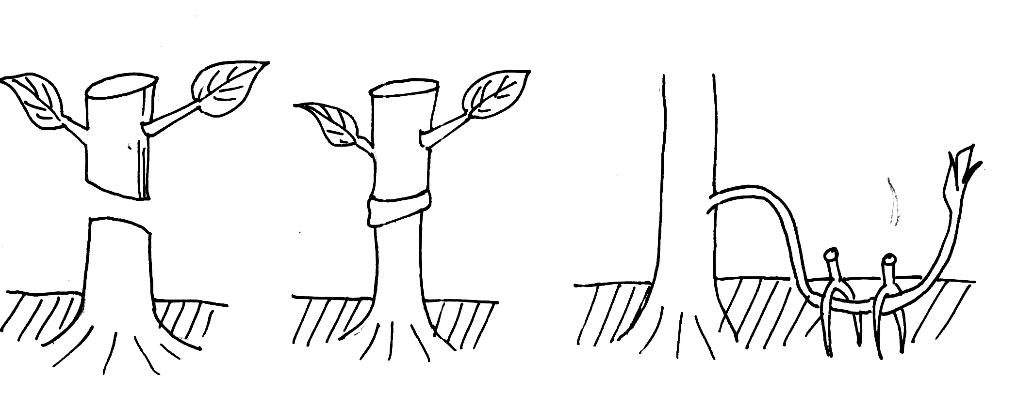

A₂
A₁
A₃

B
(a) Name the parts labeled A₁ and A₂
A₁ (1mk)
………………………………………………………………………………………………………………………
………………………………………………………………………………………………………………………
A₂ (1mk)
………………………………………………………………………………………………………………………
………………………………………………………………………………………………………………………
(b) Name the methods of propagation illustrated in diagrams A₃ and B.
A₃ (1mk)
………………………………………………………………………………………………………………………
………………………………………………………………………………………………………………………
B (1mk)
………………………………………………………………………………………………………………………
………………………………………………………………………………………………………………………
22. A member of young farmers club was advised to apply a complete fertilizer 30:20:10 in a tomato plot measurig 10m long by 5m wide at the rate of 300kg per hectare.
(a) State the percentage of P₂O₅ in the complete fertilizer. (1mk)
………………………………………………………………………………………………………………………
………………………………………………………………………………………………………………………

(b) Calculate the amount of fertilizer the member would require for the plot.(show your workings)
(2mks)

23. The diagrams labeled D and E below are illustrations of coffee established using two different formative pruning systems. Study them and answer the questions that follow.

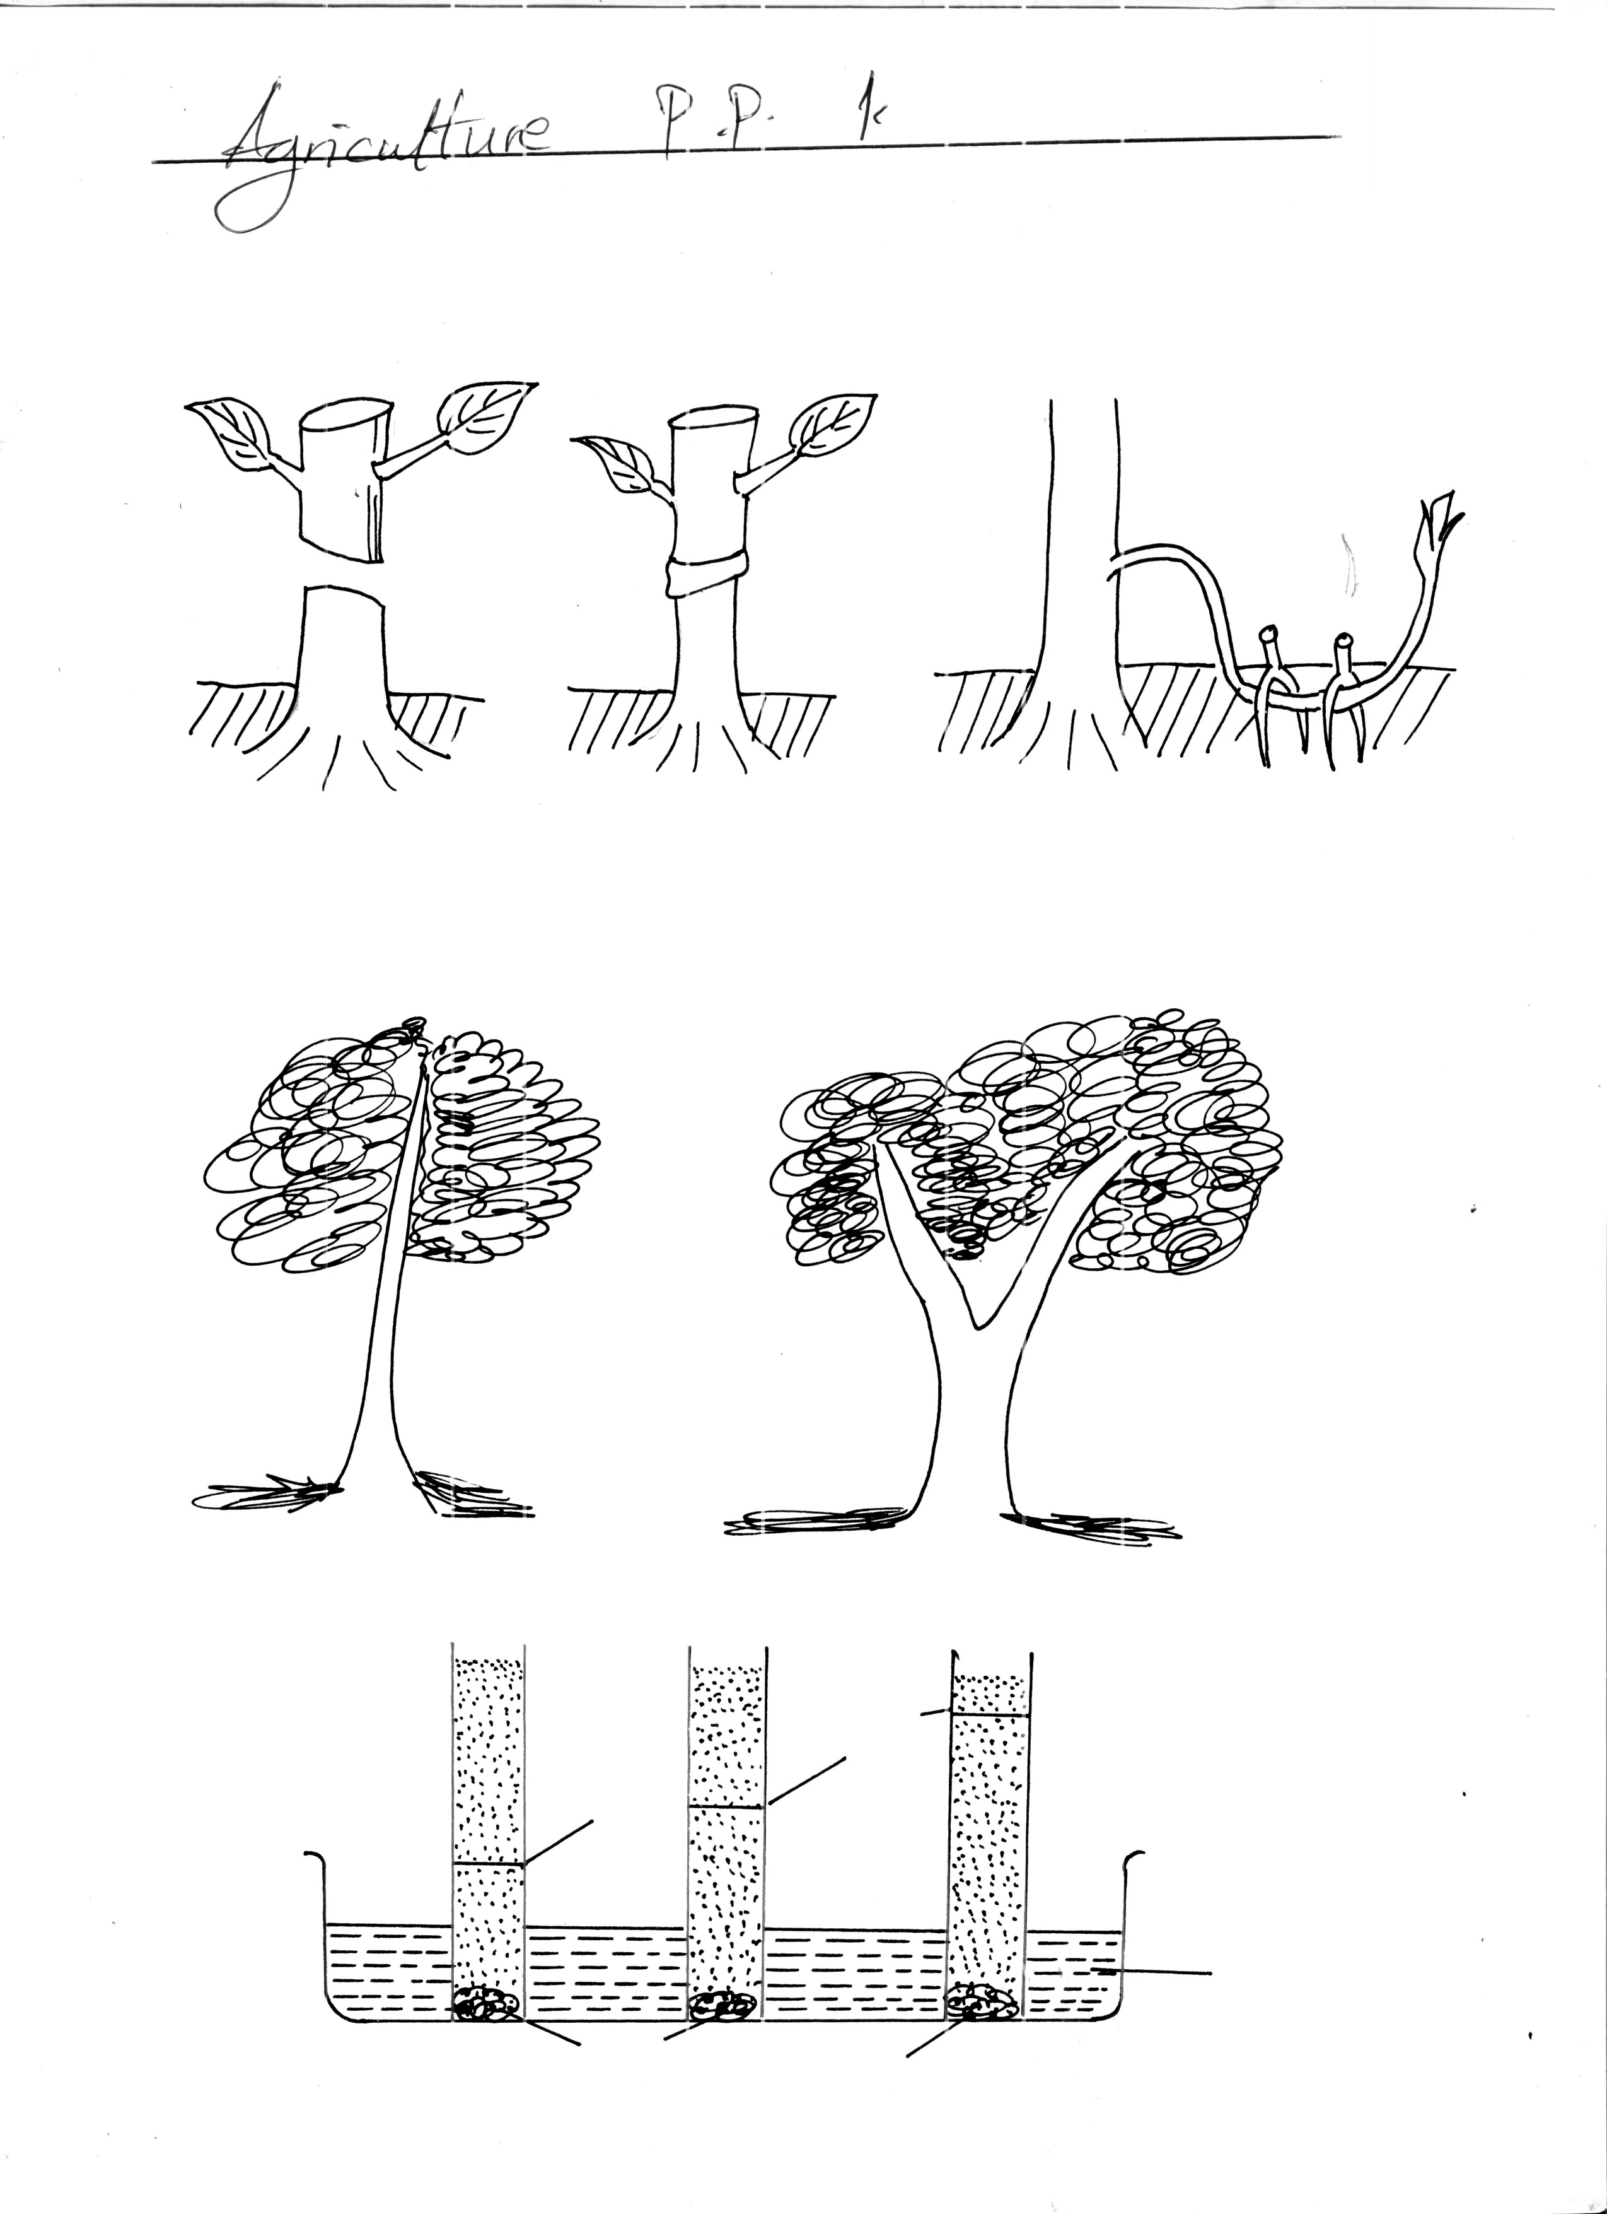
D
E

(a) Name the system of pruning illustrated in diagram D above. (1mk)
………………………………………………………………………………………………………………………
………………………………………………………………………………………………………………………
(b) Outline how the pruning system illustrated in diagram E is carried out. (2mks)
………………………………………………………………………………………………………………………
………………………………………………………………………………………………………………………
………………………………………………………………………………………………………………………
………………………………………………………………………………………………………………………
24. The diagram below is an illustration of an experiment set up by some students to investigate A, B and C, and observations made after about six hours. Study it to answer the questions that follow.
Soil type A
Soil type B
Soil type C
Water
level
Water
level
Water
Cotton
Cotton

(a) State the aspect of soil they were investigating. (1mk)
………………………………………………………………………………………………………………………
………………………………………………………………………………………………………………………
(b) Suggest the identity of the soil types A, B and C. (3mks)
………………………………………………………………………………………………………………………
………………………………………………………………………………………………………………………
………………………………………………………………………………………………………………………
………………………………………………………………………………………………………………………
………………………………………………………………………………………………………………………
………………………………………………………………………………………………………………………
25. The diagram below is an illustration of a structure used to raise tea seedlings. Use it to answer the questions below it.
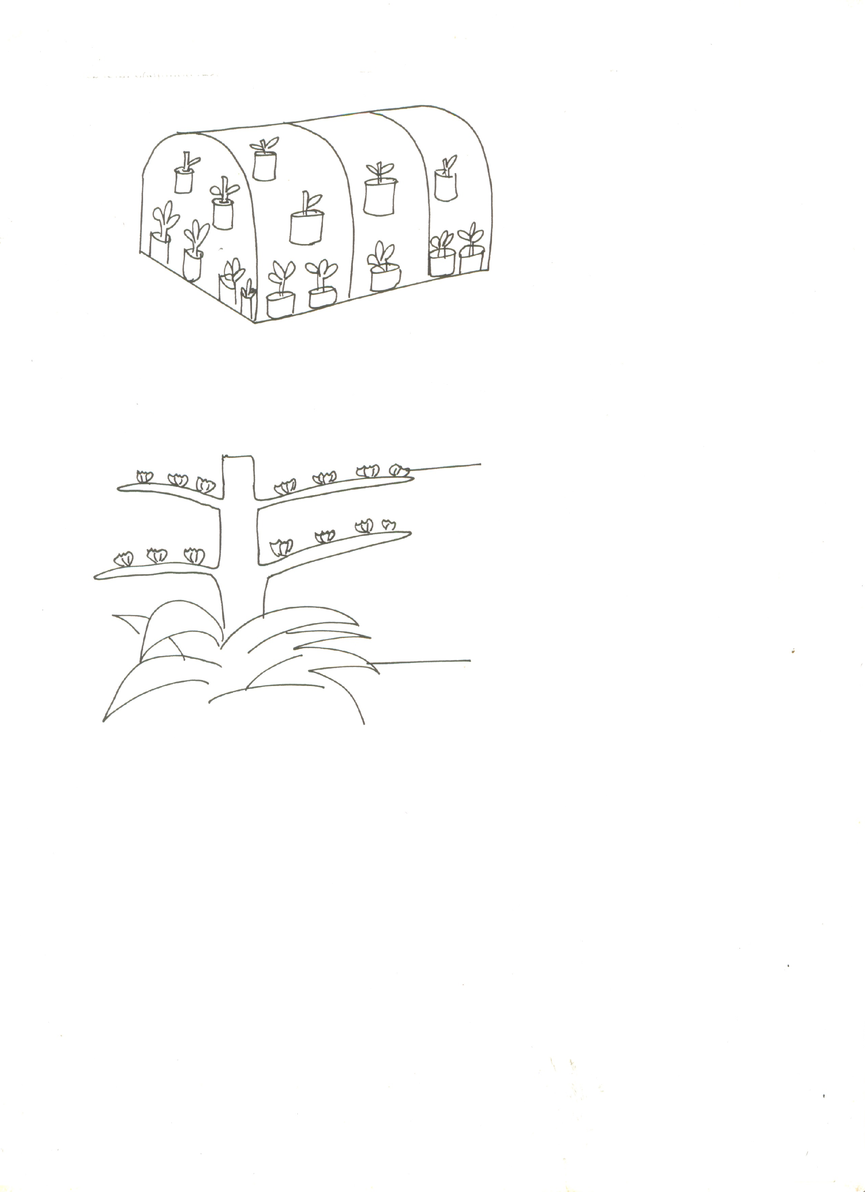

(a) Name the structure ( ½ mk)
………………………………………………………………………………………………………………………
………………………………………………………………………………………………………………………
(b) Describe the procedure of establishing the structure and the seedlings in it. (3 ½ mks)
………………………………………………………………………………………………………………………
………………………………………………………………………………………………………………………
………………………………………………………………………………………………………………………
………………………………………………………………………………………………………………………
………………………………………………………………………………………………………………………
………………………………………………………………………………………………………………………
………………………………………………………………………………………………………………………
………………………………………………………………………………………………………………………
………………………………………………………………………………………………………………………
………………………………………………………………………………………………………………………
………………………………………………………………………………………………………………………
………………………………………………………………………………………………………………………
………………………………………………………………………………………………………………………
………………………………………………………………………………………………………………………
………………………………………………………………………………………………………………………
………………………………………………………………………………………………………………………
26. The diagram below illustrates a sisal plant. Use it to answer the questions that follow.

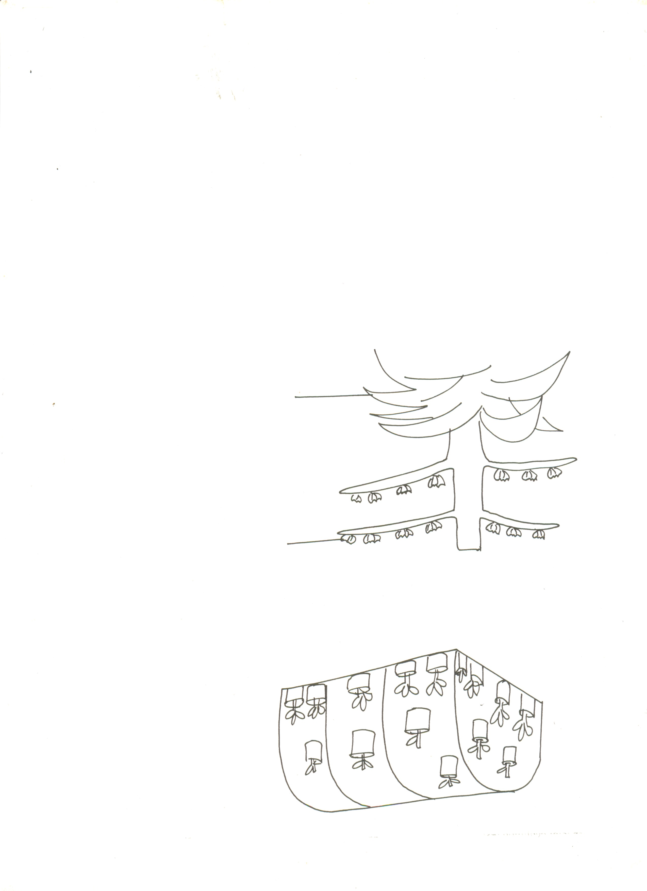
G
H

(i) Identify the planting materials labeled G and H.
G……………………………………………………………………………..
H……………………………………………………………………………..

(ii) Give one advantage of each of the materials G and H. (1mk)
………………………………………………………………………………………………………………………
………………………………………………………………………………………………………………………
SECTION C (40 MARKS)
Answer any two questions in this section
27. (a) Discuss he importance of irrigation in farming. (12 mks)
(b) Explain the factors that influence he type of irrigation to be used in a farm. (8 mks)
28. (a) Describe the harvesting of coffee under the following sub-headings.
(i) Method and procedure. (5 mks)
(ii) Precautions (2mks)
(b) Explain the factors considered in designing a crop rotation program. (6mks)
(c) Describe seed preparation and planting directly planted onions. (7 mks)
29. (a) Describe the various types of erosion caused by water on the farm. (8mks)
(b) Describe how various methods help to remove excess water from the soil. (4mks) (c) Explain how various climatic factors can be controlled in a green house to favour crop
production. (4mks)
(d) Describe various methods used to break seed dormancy. (4mks)
………………………………………………………………………………………………………………………
………………………………………………………………………………………………………………………
………………………………………………………………………………………………………………………
………………………………………………………………………………………………………………………
………………………………………………………………………………………………………………………
………………………………………………………………………………………………………………………
………………………………………………………………………………………………………………………
………………………………………………………………………………………………………………………
………………………………………………………………………………………………………………………
………………………………………………………………………………………………………………………
………………………………………………………………………………………………………………………
………………………………………………………………………………………………………………………
………………………………………………………………………………………………………………………
………………………………………………………………………………………………………………………
………………………………………………………………………………………………………………………
………………………………………………………………………………………………………………………
………………………………………………………………………………………………………………………
………………………………………………………………………………………………………………………
………………………………………………………………………………………………………………………
………………………………………………………………………………………………………………………
………………………………………………………………………………………………………………………
………………………………………………………………………………………………………………………
………………………………………………………………………………………………………………………
………………………………………………………………………………………………………………………
………………………………………………………………………………………………………………………
………………………………………………………………………………………………………………………
………………………………………………………………………………………………………………………
………………………………………………………………………………………………………………………
………………………………………………………………………………………………………………………
………………………………………………………………………………………………………………………
………………………………………………………………………………………………………………………
………………………………………………………………………………………………………………………
………………………………………………………………………………………………………………………
………………………………………………………………………………………………………………………
………………………………………………………………………………………………………………………
………………………………………………………………………………………………………………………
………………………………………………………………………………………………………………………
………………………………………………………………………………………………………………………
………………………………………………………………………………………………………………………
………………………………………………………………………………………………………………………
………………………………………………………………………………………………………………………
………………………………………………………………………………………………………………………
………………………………………………………………………………………………………………………
………………………………………………………………………………………………………………………
………………………………………………………………………………………………………………………
………………………………………………………………………………………………………………………
………………………………………………………………………………………………………………………
………………………………………………………………………………………………………………………
………………………………………………………………………………………………………………………
………………………………………………………………………………………………………………………
………………………………………………………………………………………………………………………
………………………………………………………………………………………………………………………
………………………………………………………………………………………………………………………
………………………………………………………………………………………………………………………
………………………………………………………………………………………………………………………
………………………………………………………………………………………………………………………
………………………………………………………………………………………………………………………
………………………………………………………………………………………………………………………
………………………………………………………………………………………………………………………
………………………………………………………………………………………………………………………
………………………………………………………………………………………………………………………
………………………………………………………………………………………………………………………
………………………………………………………………………………………………………………………
………………………………………………………………………………………………………………………
………………………………………………………………………………………………………………………
………………………………………………………………………………………………………………………
………………………………………………………………………………………………………………………
………………………………………………………………………………………………………………………
………………………………………………………………………………………………………………………
………………………………………………………………………………………………………………………
………………………………………………………………………………………………………………………
………………………………………………………………………………………………………………………
………………………………………………………………………………………………………………………
………………………………………………………………………………………………………………………
………………………………………………………………………………………………………………………
………………………………………………………………………………………………………………………
………………………………………………………………………………………………………………………
………………………………………………………………………………………………………………………
………………………………………………………………………………………………………………………
………………………………………………………………………………………………………………………
………………………………………………………………………………………………………………………
………………………………………………………………………………………………………………………
………………………………………………………………………………………………………………………
………………………………………………………………………………………………………………………
………………………………………………………………………………………………………………………
………………………………………………………………………………………………………………………
………………………………………………………………………………………………………………………
………………………………………………………………………………………………………………………
………………………………………………………………………………………………………………………
………………………………………………………………………………………………………………………
………………………………………………………………………………………………………………………
………………………………………………………………………………………………………………………
………………………………………………………………………………………………………………………
………………………………………………………………………………………………………………………
………………………………………………………………………………………………………………………
………………………………………………………………………………………………………………………
………………………………………………………………………………………………………………………
………………………………………………………………………………………………………………………
………………………………………………………………………………………………………………………
………………………………………………………………………………………………………………………
………………………………………………………………………………………………………………………
………………………………………………………………………………………………………………………
………………………………………………………………………………………………………………………
………………………………………………………………………………………………………………………
………………………………………………………………………………………………………………………
………………………………………………………………………………………………………………………
………………………………………………………………………………………………………………………
………………………………………………………………………………………………………………………
………………………………………………………………………………………………………………………
………………………………………………………………………………………………………………………
End

