Name: …………………………………………………………… Index no ……..…...................................

School: ……………………………………………………....…. Candidate’s sign ……………………....

Date: ……………………………………………………………

443/2
AGRICULTURE
PAPER 2
NOV/DEC - 2017
TIME: 2 HOURS

Kenya Certificate of Secondary education (K.C.S.E)

Agriculture
Paper 2

INSTRUCTIONS TO CANDIDATES:
- Write your name and index number in the spaces provided.
- Sign and write date of examination in the spaces provided above
- This paper consists of three sections A, B, and C
- Answer all the questions in section A and B and any two questions in section C
- Write your answers in the spaces provided.

For Examiner’s Use Only:

SECTION | QUESTIONS | MAXIMUM SCORE | CANDIDATES SCORE
A | 1-20 | 30
B | 21-24 | 20
C | 25 | 20
C | 26 | 20
C | 27 | 20
 | TOTAL SCORE | 90

This paper consists of 12 printed pages.
Candidates should check to ascertain that all papers are printed as indicated and that no questions are missing.
SECTION A (30 MARKS)
1. State four signs of infection by external parasites in livestock. (2mks)
……………………………………………………………………………………………………………
……………………………………………………………………………………………………………
……………………………………………………………………………………………………………
……………………………………………………………………………………………………………
2. Giving example, explain the following terms as used in livestock health. (2mks)
(a) Notifiable disease.
……………………………………………………………………………………………………………
……………………………………………………………………………………………………………
(b) Zoonotic disease
…………………………………………………………………………………………………………………………………………………………………………………………………………………………
3. Distinguish between out crossing and cross breeding. (1mk)
…………………………………………………………………………………………………………………………………………………………………………………………………………………………
4. Give three reasons for treating timber to be used in construction of a farm building. (1 ½ mks) ……………………………………………………………………………………………………………
……………………………………………………………………………………………………………
5. Other than chicken, name two other birds considered as poultry. (1mk)
……………………………………………………………………………………………………………
……………………………………………………………………………………………………………
6. What are two proper ways of disposing of infected carcass? (1mk)
……………………………………………………………………………………………………………
……………………………………………………………………………………………………………
7. Give three functions of lipids in livestock diet. (1 ½ mks)
…………………………………………………………………………………………………………………………………………………………………………………………………………………………
…………………………………………………………………………………………………………………………………………………………………………………………………………………………
8. Name the part of poultry digestive system where
(a) Food is stored temporarily as it is moistened and softened. ( ½ mk)
…………………………………………………………………………………………………………………………………………………………………………………………………………………………

(b) Insoluble grit helps to grind food into paste. ( ½ mk)
…………………………………………………………………………………………………………………………………………………………………………………………………………………………
9. (a) What is creep feeding? ( ½ mk)
…………………………………………………………………………………………………………………………………………………………………………………………………………………………
(b) Highlight three qualities of a good creep feed. (1 ½ mks)
…………………………………………………………………………………………………………………………………………………………………………………………………………………………
…………………………………………………………………………………………………………………………………………………………………………………………………………………………
10. Give four reasons for proper feeding of livestock. (2mks)
…………………………………………………………………………………………………………………………………………………………………………………………………………………………
…………………………………………………………………………………………………………………………………………………………………………………………………………………………
11. Give two functions of testes in cattle production. (1mk)
…………………………………………………………………………………………………………………………………………………………………………………………………………………………
…………………………………………………………………………………………………………………………………………………………………………………………………………………………
12. Outline three methods of preserving fish. (1 ½ mks)
…………………………………………………………………………………………………………………………………………………………………………………………………………………………
…………………………………………………………………………………………………………………………………………………………………………………………………………………………
13. Give three non-chemical ways of controlling ticks in cattle. (1 ½ mks)
…………………………………………………………………………………………………………………………………………………………………………………………………………………………
…………………………………………………………………………………………………………………………………………………………………………………………………………………………
14. Outline two roles of roughages in livestock diet. (1mk)
…………………………………………………………………………………………………………………………………………………………………………………………………………………………
…………………………………………………………………………………………………………………………………………………………………………………………………………………………
15. Highlight any four factors that would influence the siting of a calf pen. (2mks)
…………………………………………………………………………………………………………………………………………………………………………………………………………………………
…………………………………………………………………………………………………………………………………………………………………………………………………………………………
…………………………………………………………………………………………………………………………………………………………………………………………………………………………
16. Name the mineral whose deficiency may lead to milk fever. ( ½ mk)
…………………………………………………………………………………………………………………………………………………………………………………………………………………………
…………………………………………………………………………………………………………………………………………………………………………………………………………………………
17. State two factors that could lead to failure to conceive in sows after service (1mk)
…………………………………………………………………………………………………………………………………………………………………………………………………………………………
18. State two reasons for dehorning cattle. (1mk)
…………………………………………………………………………………………………………………………………………………………………………………………………………………………
19. (a) Name four breeds of dairy goats. (2mks)
…………………………………………………………………………………………………………………………………………………………………………………………………………………………
…………………………………………………………………………………………………………………………………………………………………………………………………………………………
(b) Mention two distinguishing characteristics of the Bactarian Camel breed. (1mk)
…………………………………………………………………………………………………………………………………………………………………………………………………………………………
20. State three maintenance practices that should be carried out on a feed trought. ( 1 ½ mks)
…………………………………………………………………………………………………………………………………………………………………………………………………………………………
…………………………………………………………………………………………………………………………………………………………………………………………………………………………

SECTION B (20 MARKS)
Answer ALL questions in this section in the spaces provided.
21. Below are diagrams of common farm tools and equipment. Use them to answer the questions below.
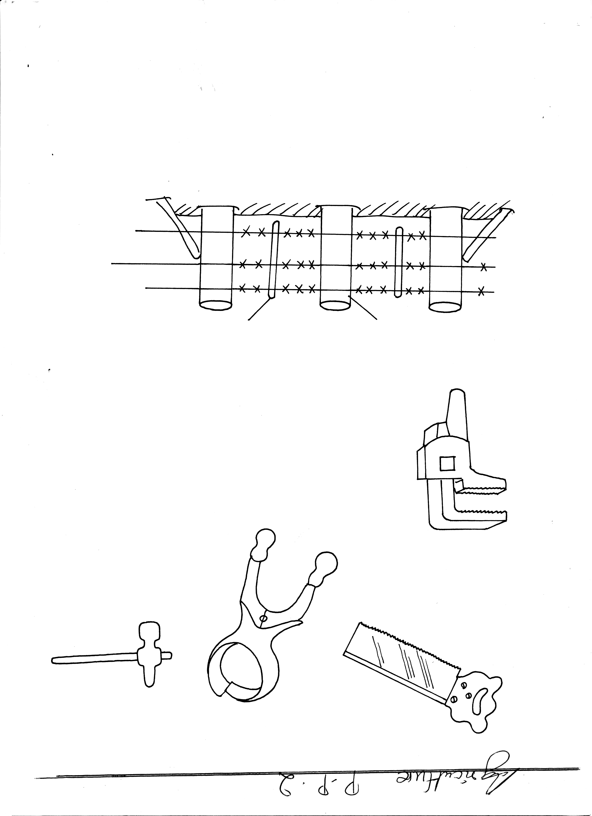
A
B
C
D

(a) Identify the tools labeled A,B, C and D. (2mks)
A…………………………………………………………
B…………………………………………………………
C…………………………………………………………
D…………………………………………………………
(b) State one use of tools B and D. (2 mks)
B……………………………………………………………………………………………………D……………………………………………………………………………………………………
(c) Name one alternative tool that would be used instead of tool B. (1mk)
…………………………………………………………………………………………………………………………………………………………………………………………………………………………
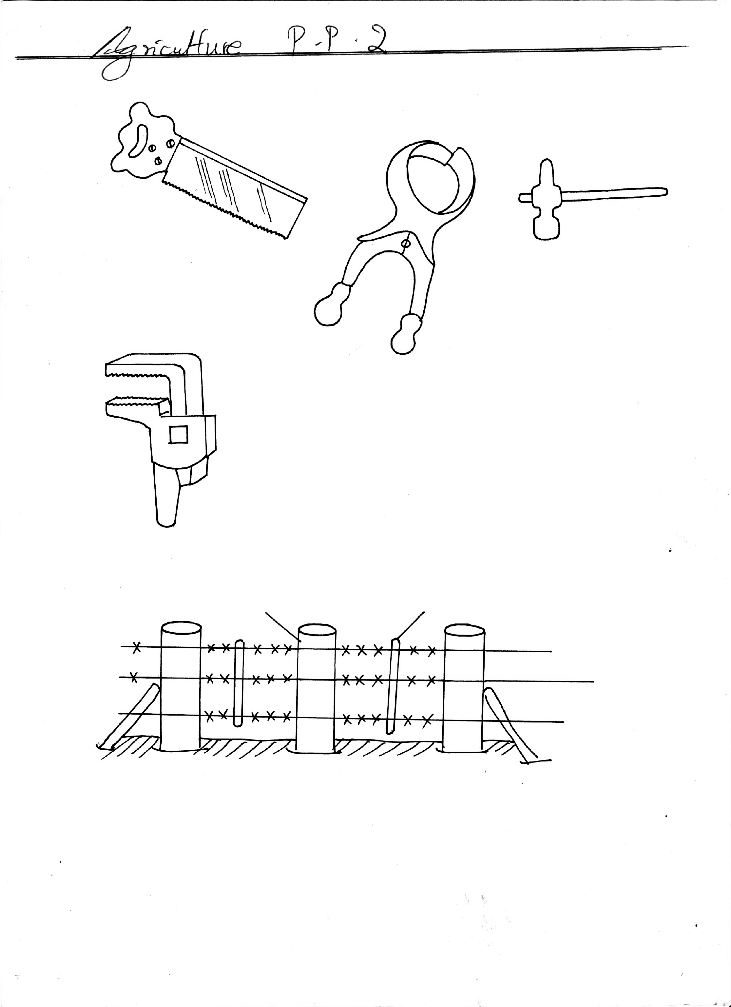
22. The diagram below shows a farm fence. Study it to answer the questions that follow
B
A

(a) Identify the type of fence shown above. ( ½ mk)
…………………………………………………………………………………………………………………………………………………………………………………………………………………………
(b) Describe the procedure of erecting the fencing posts. (3mks)
…………………………………………………………………………………………………………………………………………………………………………………………………………………………
…………………………………………………………………………………………………………………………………………………………………………………………………………………………
…………………………………………………………………………………………………………………………………………………………………………………………………………………………
…………………………………………………………………………………………………………………………………………………………………………………………………………………………
(c) Name the parts labeled A and B (1mk)
A……………………………………………………………………………………………………………B……………………………………………………………………………………………………………
23. Below is a diagram of a bee hive. Use it to answer the questions that follow.
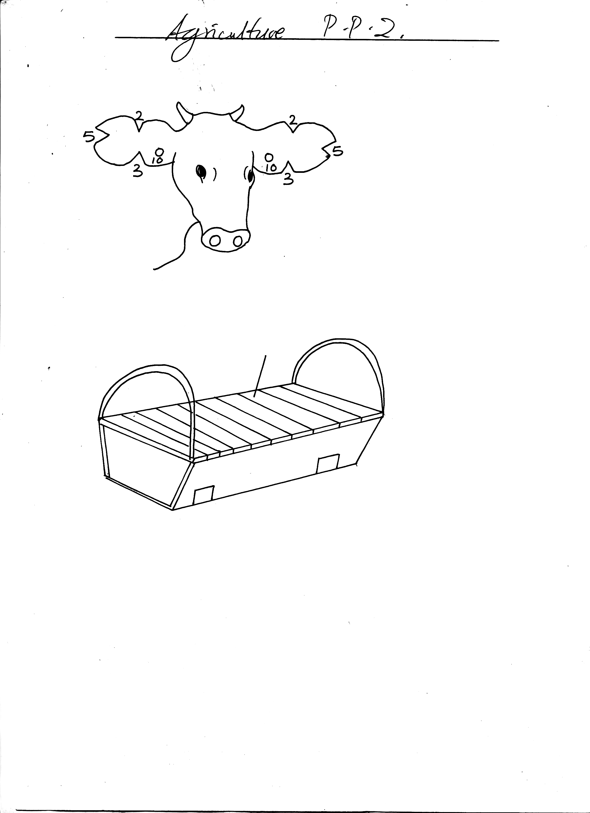
H

(a) Give the name of this hive type. (1mk)
…………………………………………………………………………………………………………………………………………………………………………………………………………………………
(b) Outline three methods of stocking the hive. (3mks)
…………………………………………………………………………………………………………………………………………………………………………………………………………………………
…………………………………………………………………………………………………………………………………………………………………………………………………………………………
…………………………………………………………………………………………………………………………………………………………………………………………………………………………
(c) Name the part labeled H (1mk)
…………………………………………………………………………………………………………………………………………………………………………………………………………………………
24. The diagram below illustrates a method of identification in livestock production. Study the diagram and answer the questions that follow.

(i) Name the type of identification illustrated above. (1mk)
…………………………………………………………………………………………………………………………………………………………………………………………………………………………
(ii) Give the identification number of the animal illustrated in the diagram above. (1mk)
…………………………………………………………………………………………………………………………………………………………………………………………………………………………
(iii) Using diagrams illustrate how you can identify animals Nos. 24 and 36 using the above method. (2mks)
Animal No. 24.

Animal No. 36.

(b) If a sow was successfully served on 27th September, 2006, state the date she is likely to have
farrowed. (1mk)
…………………………………………………………………………………………………………………………………………………………………………………………………………………………
…………………………………………………………………………………………………………………………………………………………………………………………………………………………

SECTION C (40 MARKS)
Answer any two questions in this section
25. (a) Name and describe the features of an ideal calf pen. (9mks)
(b) Discuss pneumonia in calves under the following sub-headings.
(i) Pre disposing factors (3mks)
(ii) Symptoms (5 mks)
(iii) Control measures. (3 mks)
26. (a) Describe pig rearing under the following sub – headings
(i) Management during parturition. (5mks)
(ii) Signs of heat (5 mks)
(b) Outline the factors to consider when selecting livestock for breeding. (10mks)
27. (a) Describe bee keeping under the following sub-headings
(i) Methods of processing honey (3 mks)
(ii) Process of honey harvesting. (7mks)
(b) Describe measures taken to control livestock diseases. (10mks)
…………………………………………………………………………………………………………………………………………………………………………………………………………………………
…………………………………………………………………………………………………………………………………………………………………………………………………………………………
…………………………………………………………………………………………………………………………………………………………………………………………………………………………
…………………………………………………………………………………………………………………………………………………………………………………………………………………………
…………………………………………………………………………………………………………………………………………………………………………………………………………………………
…………………………………………………………………………………………………………………………………………………………………………………………………………………………
…………………………………………………………………………………………………………………………………………………………………………………………………………………………
…………………………………………………………………………………………………………………………………………………………………………………………………………………………
…………………………………………………………………………………………………………………………………………………………………………………………………………………………
…………………………………………………………………………………………………………………………………………………………………………………………………………………………
…………………………………………………………………………………………………………………………………………………………………………………………………………………………
…………………………………………………………………………………………………………………………………………………………………………………………………………………………
…………………………………………………………………………………………………………………………………………………………………………………………………………………………
…………………………………………………………………………………………………………………………………………………………………………………………………………………………
…………………………………………………………………………………………………………………………………………………………………………………………………………………………
…………………………………………………………………………………………………………………………………………………………………………………………………………………………
…………………………………………………………………………………………………………………………………………………………………………………………………………………………
…………………………………………………………………………………………………………………………………………………………………………………………………………………………
…………………………………………………………………………………………………………………………………………………………………………………………………………………………
…………………………………………………………………………………………………………………………………………………………………………………………………………………………
…………………………………………………………………………………………………………………………………………………………………………………………………………………………
…………………………………………………………………………………………………………………………………………………………………………………………………………………………
…………………………………………………………………………………………………………………………………………………………………………………………………………………………
…………………………………………………………………………………………………………………………………………………………………………………………………………………………
…………………………………………………………………………………………………………………………………………………………………………………………………………………………
…………………………………………………………………………………………………………………………………………………………………………………………………………………………
…………………………………………………………………………………………………………………………………………………………………………………………………………………………
…………………………………………………………………………………………………………………………………………………………………………………………………………………………
…………………………………………………………………………………………………………………………………………………………………………………………………………………………
…………………………………………………………………………………………………………………………………………………………………………………………………………………………
…………………………………………………………………………………………………………………………………………………………………………………………………………………………
…………………………………………………………………………………………………………………………………………………………………………………………………………………………
…………………………………………………………………………………………………………………………………………………………………………………………………………………………
…………………………………………………………………………………………………………………………………………………………………………………………………………………………
…………………………………………………………………………………………………………………………………………………………………………………………………………………………
…………………………………………………………………………………………………………………………………………………………………………………………………………………………
…………………………………………………………………………………………………………………………………………………………………………………………………………………………
…………………………………………………………………………………………………………………………………………………………………………………………………………………………
…………………………………………………………………………………………………………………………………………………………………………………………………………………………
…………………………………………………………………………………………………………………………………………………………………………………………………………………………
…………………………………………………………………………………………………………………………………………………………………………………………………………………………
…………………………………………………………………………………………………………………………………………………………………………………………………………………………
…………………………………………………………………………………………………………………………………………………………………………………………………………………………
…………………………………………………………………………………………………………………………………………………………………………………………………………………………
…………………………………………………………………………………………………………………………………………………………………………………………………………………………
…………………………………………………………………………………………………………………………………………………………………………………………………………………………
…………………………………………………………………………………………………………………………………………………………………………………………………………………………
…………………………………………………………………………………………………………………………………………………………………………………………………………………………
…………………………………………………………………………………………………………………………………………………………………………………………………………………………
…………………………………………………………………………………………………………………………………………………………………………………………………………………………
…………………………………………………………………………………………………………………………………………………………………………………………………………………………
…………………………………………………………………………………………………………………………………………………………………………………………………………………………
…………………………………………………………………………………………………………………………………………………………………………………………………………………………
…………………………………………………………………………………………………………………………………………………………………………………………………………………………
…………………………………………………………………………………………………………………………………………………………………………………………………………………………
…………………………………………………………………………………………………………………………………………………………………………………………………………………………
…………………………………………………………………………………………………………………………………………………………………………………………………………………………
…………………………………………………………………………………………………………………………………………………………………………………………………………………………
…………………………………………………………………………………………………………………………………………………………………………………………………………………………
…………………………………………………………………………………………………………………………………………………………………………………………………………………………
…………………………………………………………………………………………………………………………………………………………………………………………………………………………
…………………………………………………………………………………………………………………………………………………………………………………………………………………………
…………………………………………………………………………………………………………………………………………………………………………………………………………………………
…………………………………………………………………………………………………………………………………………………………………………………………………………………………
…………………………………………………………………………………………………………………………………………………………………………………………………………………………
…………………………………………………………………………………………………………………………………………………………………………………………………………………………
…………………………………………………………………………………………………………………………………………………………………………………………………………………………
…………………………………………………………………………………………………………………………………………………………………………………………………………………………
…………………………………………………………………………………………………………………………………………………………………………………………………………………………
…………………………………………………………………………………………………………………………………………………………………………………………………………………………
…………………………………………………………………………………………………………………………………………………………………………………………………………………………
…………………………………………………………………………………………………………………………………………………………………………………………………………………………
…………………………………………………………………………………………………………………………………………………………………………………………………………………………
…………………………………………………………………………………………………………………………………………………………………………………………………………………………
End

