Name: …………………………………………………………… Index No. …………………………...
School: …………………………………………………………. Candidate’s Sign. …………..............
Date: ………………………………...............

233/2
CHEMISTRY
PAPER 2
THEORY
NOV/DEC 2017
TIME: 2 HOURS

Kenya Certificate of Secondary Education

FORM 3
Chemistry
Paper 2

INSTRUCTIONS TO CANDIDATES:
- Write your name and index on the spaces provided above
- Answer all the questions in the spaces provided.
- All working must be clearly shown where necessary.
- Mathematical tables, Electronic calculators may be used.

For Examiners Use Only

Question | Maximum score | Candidate’s score
1 | 11
2 | 13
3 | 12
4 | 13
5 | 11
6 | 13
7 | 07
Total | 80

This paper consists of 12 printed pages. Candidates should check to ascertain that all pages are printed as indicated and that
no questions are missing.
- The table below gives elements represented by letters A, B, C, D, E and F. Use the information in the table to answer the questions that follow
Element | A | B | C | D | E | F
Atomic number | 12 | 13 | 14 | 15 |  | 17
Electronic configuration | 2:8:2 |  | 2:8:4 |  | 2:8:6

(a) Complete the table above by giving the atomic number and electronic configuration of the elements.
[2mks]
(b) In which period of the periodic table do these elements belong? Give a reason. [1mk]

………………………………………………………………………………………………………………………………………………………………………………………………………………………………
(c) Compare the atomic radii of A and E. Explain [2mks]
………………………………………………………………………………………………………………………………………………………………………………………………………………………………
………………………………………………………………………………………………………………
(d) State the kind of oxides formed when the following elements are heated in oxygen, B and E. [1mk]
B…………………………………………………………………………………………………… C.……………………………………………………………………………………………………
(e) (i) Using dots(.) and crosses (×) to represent elements show bonding in the compound formed
between elements C and F. [1mk]

(ii) Name the structure exhibited by the compound formed between C and F. [1mk]
………………………………………………………………………………………………………………………………………………………………………………………………………………………………
(f) When the chloride of B is reacted with water, the resultant solution is strongly acidic. Name the process. [1mk]
………………………………………………………………………………………………………………………………………………………………………………………………………………………………
(g) Compare the electrical conductivity of elements A and B. Explain [2mks]
………………………………………………………………………………………………………………………………………………………………………………………………………………………………
………………………………………………………………………………………………………………
2. (a) The set up below represents the apparatus that would be used in the preparation of hydrogen sulphide gas.
Dilute HCl_{(aq)}

Solid D

(i) Name solid D. [1mk]
………………………………………………………………………………………………………………
(ii) Complete the diagram to show how hydrogen sulphide is collected (not dry). [2mks]
(iii) Write the equation for the reaction that occurs in the flask. [1mk]
………………………………………………………………………………………………………………………………………………………………………………………………………………………………
(iv) Explain with the help of an equation why concentrated sulphuric (VI) acid is not suitable for drying hydrogen sulphide gas. [1mk]
………………………………………………………………………………………………………………………………………………………………………………………………………………………………
………………………………………………………………………………………………………………
(b) The diagram below represents a set-up that can be used to prepare sulphuric (VI) oxide. Study it and answer the questions that follow.
Solid X
O_{2(g)}

9g
0
SO_{2(g)}

9g
0
Freezing mixture
To fume cupboard
Liquid Y
Heat

(i) Name liquid Y and solid X and state their functions in this set-up. [2mks]
Name of X………………………………………………………………………………………….
Function…………………………………………………………………………………………….
Name of Y………………………………………………………………………………………….
Function…………………………………………………………………………………………….
(ii) Given the equation for the reaction in the combustion tube is
2SO₂₍g) + O₂(g) 2SO₃(g)
- Name the three conditions for optimum yield of sulphur (VI) oxide. [3mks]
……………………………………………………………………………………………………………………………………………………………………………………………………………………
……………………………………………………………………………………………………………………………………………………………………………………………………………………
(b) Explain why sulphur (VI) oxide is dissolved in concentrated Sulphur (VI) acid and not directly in water during the manufacture of Sulphuric (VI) acid. [2mks]
………………………………………………………………………………………………………………………………………………………………………………………………………………………………
………………………………………………………………………………………………………………………………………………………………………………………………………………………………
- Given that a concentrated H2SO4 is 18.2M, determine the volume of conc. H2SO4 that can be mixed with distilled water to make one litre of 1M Sulphuric (VI) acid. [1mk]
……………………………………………………………………………………………………………………………………………………………………………………………………………
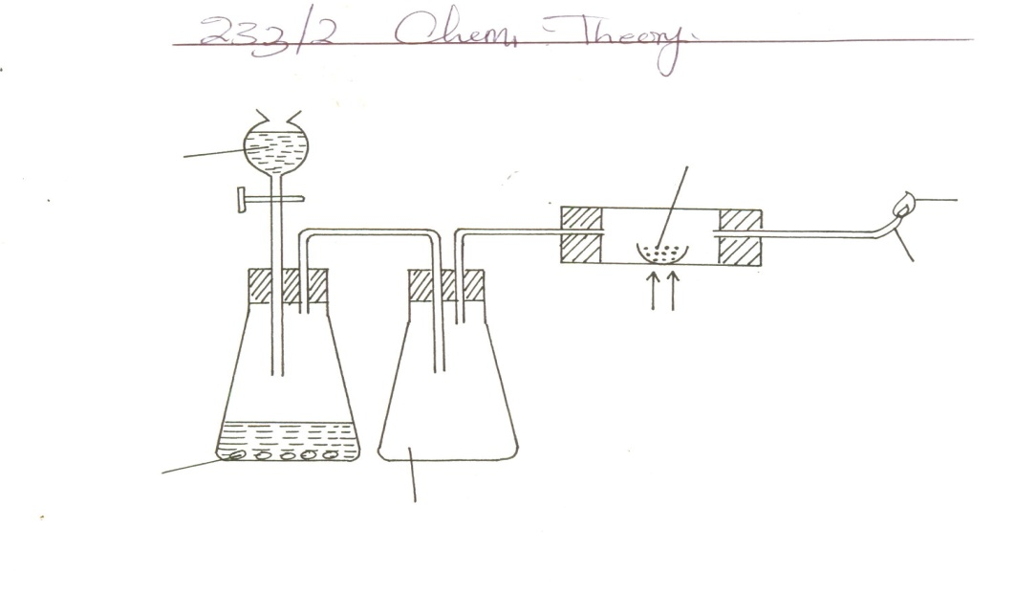3. Study the diagram below and use it to answer the questions that follow.
Zinc granules
Dilute H₂SO₄
Copper (II) oxide
Excess gas X
Jet
Heat

Concentrated sulphuric (VI) acid
Liquid Y

- Name gas X………………………………………………………….. [1mk]
- Write an equation for the formation of gas X [1mk]
………………………………………………………………………………………………………
- Name the catalyst that can be used in the above experiment. [1mk]
………………………………………………………………………………………………………
- State and explain the observation that will be made in the combustion tube at the end of the experiment. [2mks]
………………………………………………………………………………………………………………………………………………………………………………………………………………
- Explain why it is advisable to let gas X flow out for some time before burning it at the jet.
[1mk]
………………………………………………………………………………………………………………………………………………………………………………………………………………………………
- Write an equation for the reaction in the combustion tube. [1mk]
………………………………………………………………………………………………………
- Name TWO uses of gas X [12mks]
………………………………………………………………………………………………………………………………………………………………………………………………………………
- Name TWO other substances that can be used in place of concentrated sulphuric (VI) acid and (Liquid Y) [2mks]
………………………………………………………………………………………………………………………………………………………………………………………………………………
4. (a) State Boyle’s law [1mk]
………………………………………………………………………………………………………………………………………………………………………………………………………………………………
- The table below shows the variation of volumes at different amounts of pressure.

Pressure in atmospheres | 10 | 8 | 5 | 2 | 1
Volume (cm³) | 16 | 20 | 32 | 80 | 160
Reciprocal of pressure (¹/_{p})

(i) Complete the table by determining the reciprocal of pressure. [2 ½ mks]
(ii) Plot a graph of volume against reciprocal of pressure.
(USE GRAPH ON THE NEXT PAGE) [3mks]
(iii) Use the graph to determine the volume of the gas at a pressure of 3.2 atmosphers [1 ½ mks]
(c) Calculate the pressure at which the gas has a volume of 0.15litres. [2mks]
………………………………………………………………………………………………………………………………………………………………………………………………………………………………
(d) It takes 30seconds for 100cm³ of nitrogen gas to diffuse through a membrane. How long will it take
150cm³ of carbon (IV) oxide gas to diffuse through the same membrane. (N = 14, O =16, C =12)
[3mks]
………………………………………………………………………………………………………………………………………………………………………………………………………………………………
………………………………………………………………………………………………………………………………………………………………………………………………………………………………
………………………………………………………………………………………………………………
5. Use the scheme below to answer the questions that follow.
Ca(OH)₂
Step 2
Heat
Step (I)
White precipitate
Carbon (IV) oxide
Black solid
J
Solid H
Heat/H₂(g)
Step III
Barium solid + water
Add
H₂SO₄
Step (V)
Step (IV)
Blue solution
Add Na₂CO_{3 (aq)}
Filter
Solid X

(a) Identify solids [3mks]
H…………………………………………………………………………………………………………… J………………………………………………………………………………………………………………
X……………………………………………………………………………………………………………
(b) Write an ionic equation for the formation of solid X [1mk]
………………………………………………………………………………………………………………
(c) What property of hydrogen gas is shown in the step III [1mk]
………………………………………………………………………………………………………………
(d) Name the process in step V that is used to prepare solid X. [1mk]
………………………………………………………………………………………………………………
(e) Starting with lead (II) oxide describe how a solid sample of Lead (II) carbonate can be prepared in the
laboratory. [3mks]

………………………………………………………………………………………………………………………………………………………………………………………………………………………………
………………………………………………………………………………………………………………………………………………………………………………………………………………………………
(f) Write a balanced chemical equation for the thermal decomposition of anhydrous iron (II) Sulphate
(FeS0₄) [1mk]
………………………………………………………………………………………………………………
(g) Name one nitrate salt that does not produce oxygen when it undergoes thermal decomposition.
[1mk]
………………………………………………………………………………………………………………
6. Corrosion of iron was investigated by heating six identical nails. The seventh nail was left untreated. The seven nails were left for several weeks exposed to the atmosphere. The results of the experiment are given below and one has an error.
Nails | Treated | Cost of treatment | Mass of nails + coating before exposure to the atmosphere | Mass of nails + coating after exposure to the atmosphere.
P | Waxed | Low | 5.0 | 5.3
Q | Oiled | Low | 5.0 | 4.1
R | Chromium plated | High | 5.0 | 5.0
S | Painted | Low | 5.0 | 5.4
T | Untreated | - | 4.9 | 6.1
U | Galvanized | Fairly high | 5.0 | 5.1
V | Put in salt solution | Low | 5.0 | 6.7

(a) Name the best treatment which can be used to prevent corrosion of items made of iron. [1mk]
………………………………………………………………………………………………………………………………………………………………………………………………………………………………
(b) Which treatment made the nail corrosion worse? Explain [2mks]
………………………………………………………………………………………………………………………………………………………………………………………………………………………………
(c) Explain why bodies of motor vehicles wear out more quickly in Mombasa than in Kisumu [2mks]
………………………………………………………………………………………………………………………………………………………………………………………………………………………………
………………………………………………………………………………………………………………
(d) Give one advantage of rusting [1mk]
………………………………………………………………………………………………………………………………………………………………………………………………………………………………
(e) Write a chemical equation for the formation of rust. [1mk]
………………………………………………………………………………………………………………………………………………………………………………………………………………………………
(f) Name TWO conditions that accelerate rusting. [2mks]
………………………………………………………………………………………………………………………………………………………………………………………………………………………………
(g) Study the diagram below and answer the questions that follow
water

Water
Oxygen gas

Pale yellow solid
(i) Name the pale yellow solid [1mk]
………………………………………………………………………………………………………………
(ii) Write a balanced equation for the reaction between yellow solid and water to produce oxygen.
[1mk]
………………………………………………………………………………………………………………………………………………………………………………………………………………………………
(iii) Name TWO gases that can be used together with oxygen separately in welding and cutting of metals.
[2mks]
………………………………………………………………………………………………………………………………………………………………………………………………………………………………
7. Study the flow chart below and use it to answer questions.
Z

HCl
polymerisation
Step 1
Gas K
Nickle
catalyst
T
CH₃CH₂ CH₃
CH₃CH = CH₂
Process
A
Conc.H₂SO₄
Liquid X and carbon (IV) oxide
Combustion
Na
P
Solution B + H_{2(g)}

(a) Name substances. [3mks]
K…………………………………………………………………………………………………………. T……………………………………………………………………………………………………………
P……………………………………………………………………………………………………………
B…………………………………………………………………………………………………………..
X……………………………………………………………………………………………………………
Z……………………………………………………………………………………………………………
(b) Write an equation for the reaction between P and Sodium (Na) [1mk]
………………………………………………………………………………………………………………
(c) Name the process A. [1mk]
………………………………………………………………………………………………………………
(d) Apart from Nickle catalyst, name another condition required in step 1 [1mk]
………………………………………………………………………………………………………………
(e) Write an equation for the combustion of P in excess air. [1mk]
………………………………………………………………………………………………………………

