NAME:….….……………………………..…………….. INDEX NO: ……………..………………..….
SCHOOL:…….………………………………………… CANDIDATE’S SIGN:………………………
DATE: ………………………………………………….

312/1
GEOGRAPHY
PAPER 1
Nov. 2017
TIME: 2 ¾ HOURS

Kenya Certificate of Secondary education (K.C.S.E)

Form Three (3)
Geography
Paper 1

INSTRUCTIONS
- This paper consist of Section A and B
- Answer ALL questions in Section A and from Section B, answer question 6 and any other two questions
- Questions in section B carry equal marks.
- Answers to the questions must be written on the answer booklet provided.

This paper consists of 4 printed pages.
Candidate should check to ascertain that all pages are printed as indicated and that no questions are missing.
SECTION A
Answer all questions in this section in the answer booklet provided
1. (a) Give the term ‘Great circle’
[b] Give the name of the following imaginary lines;
[i] Longitude 0º [1mk]
[ii] Latitude 0º [1mk]
[iii] Longitude 180ºC

2. (a) Differentiate between a mineral and a rock [2mks]
[b] (i) State the reason why coal is classified as a mineral. [1mk]
[ii] Give two changes that occur in sedimentary rocks when subjected to intense pressure. [2mks]

3. The diagram below shows a glaciated highland. Use it to answer the questions below;-
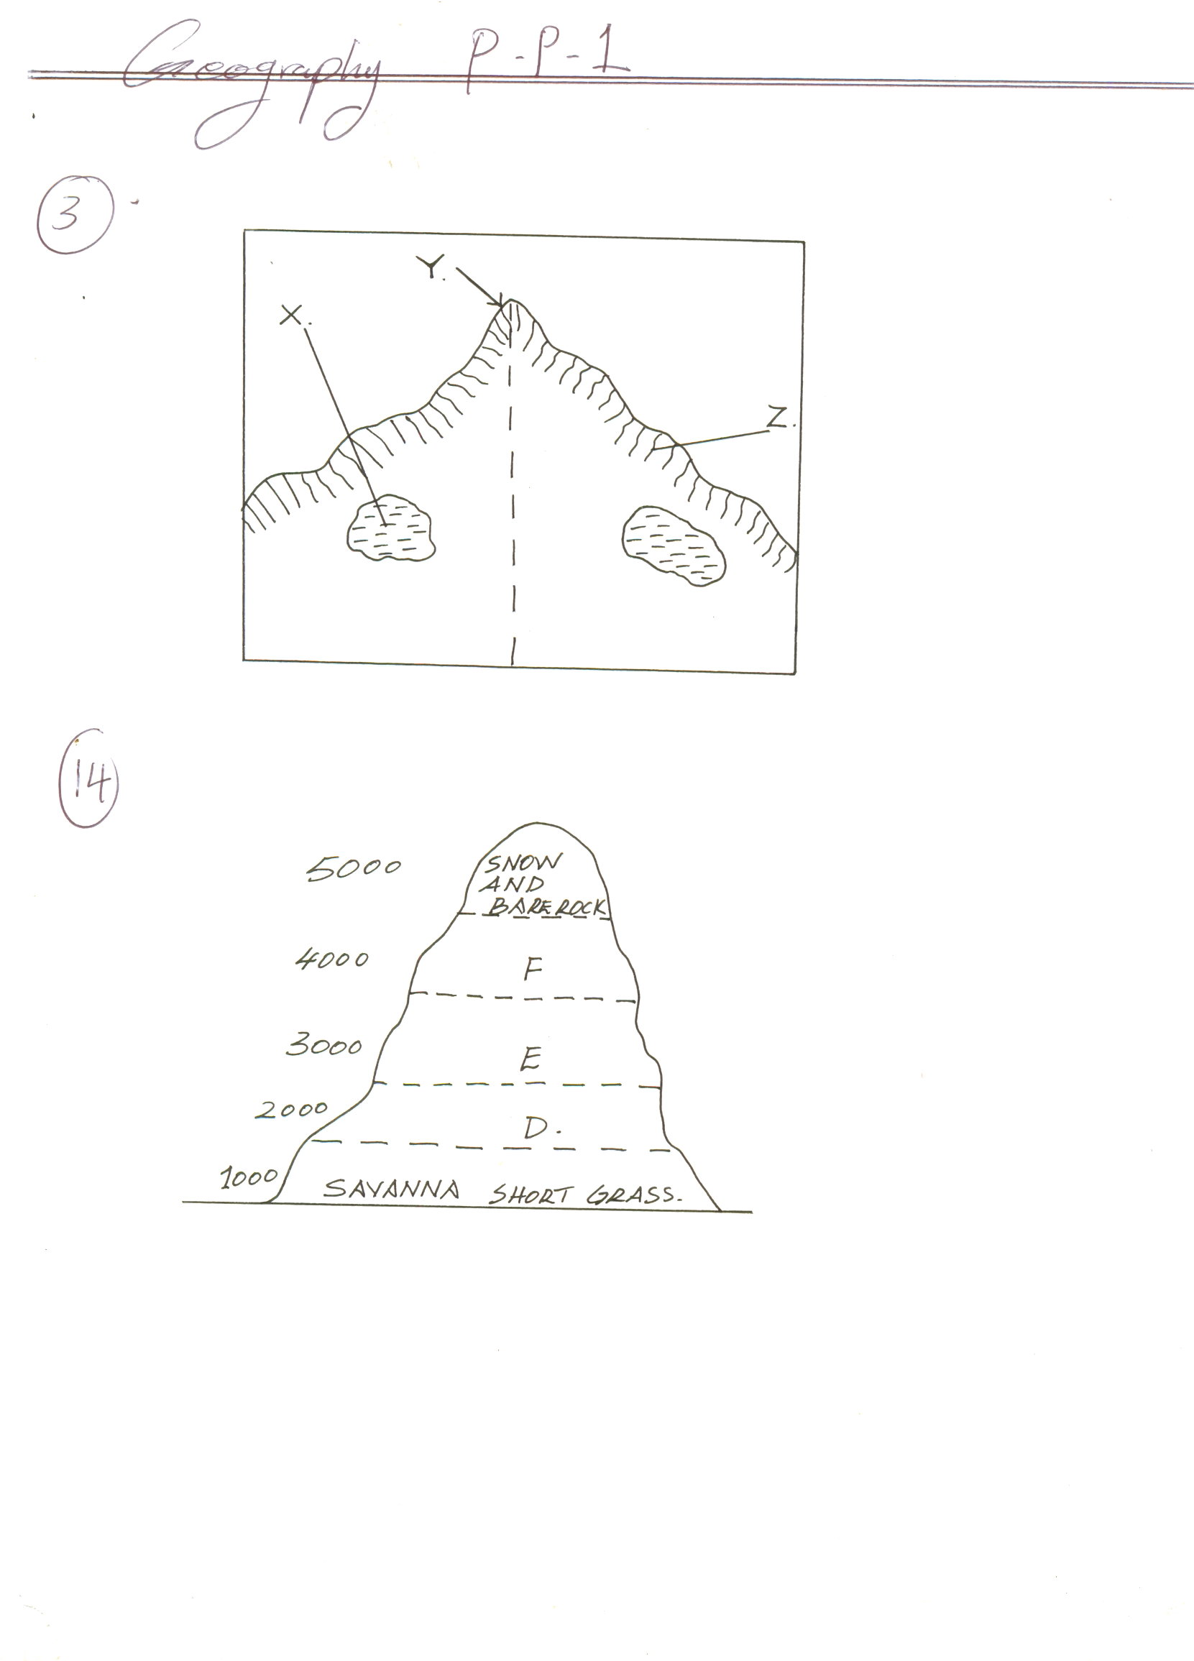

[a] Identify the features marked X, Y and Z [3mks]
[b] Name two mountains in Kenya that have such features [2mks]
4. The diagram below represents zones of natural vegetation mountain within the tropical region

[a] Name the vegetation zones marked D, E and F [3mks]
[b] Give two reasons why the mountain top has no vegetation [2mks]
5. a] Name the instruments used to measure the intensity and magnitude of earthquake
in a place [2mks]
[b] State three negative effects of earthquakes in built up areas [3mks]

SECTION B
6. Answer question six and any other two questions in this section
Study the map of HOMAY [1:50,000] sheet 129/2 and answer the questions that follow;
[a] (i) State the height of the Nyagidha flour mill at grid square 5840 [1mk]
[ii] What man-made feature is found at grid square 534 [1mk]
[iii] State the bearing and direction of Godjope school from Urianda school at Grid
square 4941 [2mks]

[b] (i) Calculate the gradient of the line X-Y [2mks]
[ii] What is the length of the dry weather road from Ogeg Calvert to Ikamungu junction
[Grid ref. 547342] [2mks]
[iii] Name two types of natural vegetation shown on the map [2mks]
[c] (i) Citing evidence form the map, give four economic activities carried out in the area
covered by the map [4mks]
[ii] Draw a section of the map easting 60 to 65 and Northing 40 to 44. And on it indicate
the following: [5mks]
- Municipal boundary
- Dry weather road
- Lake
[d] (i) Identify four drainage patterns in the area covered by the map [4mks]
[ii] Find the magnetic variation of the area covered by the map [1mk]
7. The graph below represents the climate of a station in Africa. Use it to answer the questions
that follow;-

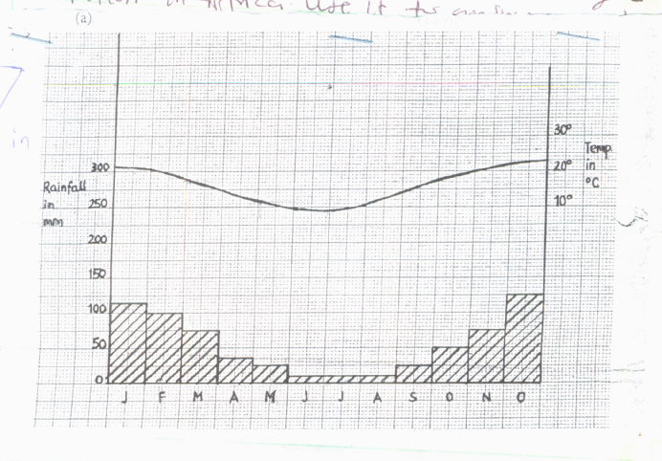

[a] (i) Describe the characteristics of the climate represented by the graph [4mks]
[ii] Describe the types of natural vegetation likely to be found in an area with the type
of climate represented by the graph [3mks]
[b] Explain four factors that influence climate [8mks]
[c] You intend to carry out a field study on the weather experienced in the locality of your school.
[i] State three ways in which you would prepare for the study [3mks]
[ii] Describe how you would use the following instruments during the study
- A rain gauge [2mks]
- Maximum and minimum thermometer [2mks]
[iii] State three advantages of studying the weather through field work [3mks]
8. [a] Explain how the following cause earth movements;
[i] Movement of magma within the earth’s crust [4mks]
[ii] Isostatic adjustment [4mks]
[b] (i) Name two types of boundaries associated with tectonic plates [2mks]
[ii] Describe two effects of the movement of tectonic plates on the boundaries [2mks]
[c] Using diagrams, describe the following types of faults;
[i] Normal fault [3mks]
ii] Shear/tear fault [3mks]
d] With the aid of well labeled diagrams, explain how Ruwenzori mountains formed
in East Africa [7mks]
9. a] i] Differentiate between mass wasting and soil erosion [2mks]
[ii] Name two types of rapid mass wasting [2mks]
[iii] Using a relevant diagram, describe how rock debris fall takes place [6mks]
[b] Describe how crystal growth leads to physical weathering of rocks [5mks]
[c] Explain two effects of landslides on drainage [4mks]
[d] Explain the economic importance of weathering to the economy [6mks]

10. a] What is a Karst scenery? [2mks]
b] State four sources of underground water [4mks]
[c] Outline four factors which influence the development of a karst scenery [4mks]
[d] nderground karst features [5mks]
[e] ExplaOutline five uin how the following factors affect the occurrence of underground water: [10mks]
[i] Precipitation and evaporation

[ii] Porosity of rocks
[iii] Permeability of the rocks
[iv] Slope
[v] vegetation cover
End

