Name:_____________________________________________ Class:______Adm:_________
312/1 Index:_________________________
GEOGRAPHY Sign:___________________________
Paper 1
June 2018
Time: 2 ³/₄ Hours

KASSU-JET JOINT EXAMINATION
Kenya Certificate of Secondary Education
312/1
Paper 1
GEOGRAPHY

Instructions to Candidates
- This paper has two sections A and B
- Answer ALL the questions in section A. In section B, answer question 6 and any other two questions.

FOR EXAMINER’S USE

SECTION A
QUESTION 6
QUESTION 7
QUESTION 8
QUESTION 9
QUESTION 10

7.a(i) Identifying two features formed by vertical earth movements. (2mks)

(ii) Explain how the following factors cause Earth movements
- Gravitative pressure (2mks)
- Isotactic adjustment (4mks)

b. Describe the plate tectonics (5mks)

c.(i) Define faulting (2mks)

(ii) Study the diagram below and answer the questions that follow
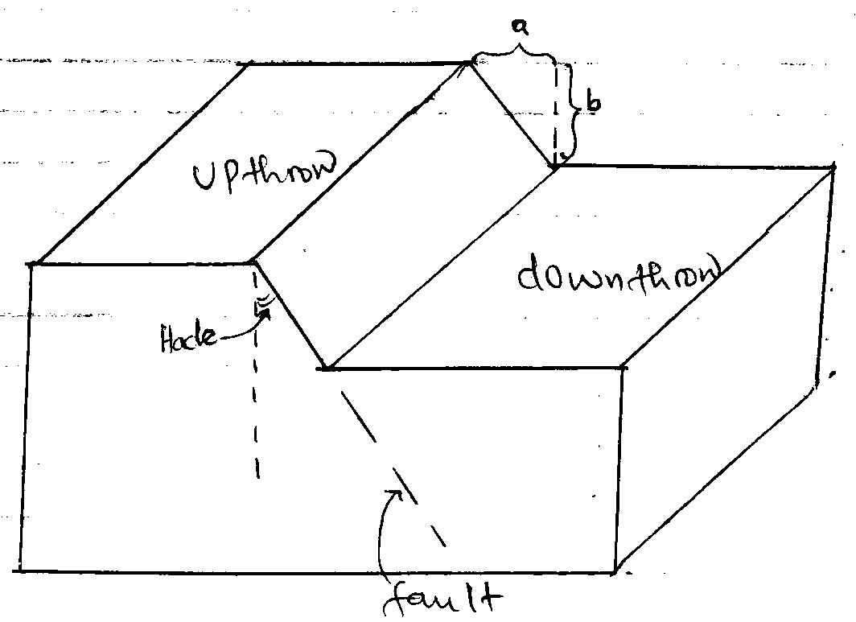

Name the parts marked;- (2mks)
A
B
(iii) Apart from the above type of fault, name two other types of faults. (2mks)

d. Explain three ways in which faulting influences drainage. (6mks)
10 (a) What is glaciation? (2mks)

(b) Describe the following process of glacial erosion
Plucking (4mks)
Abrasion (3mks)
(c) The diagram below shows features in glaciated lowland
Use it to answer question (i)
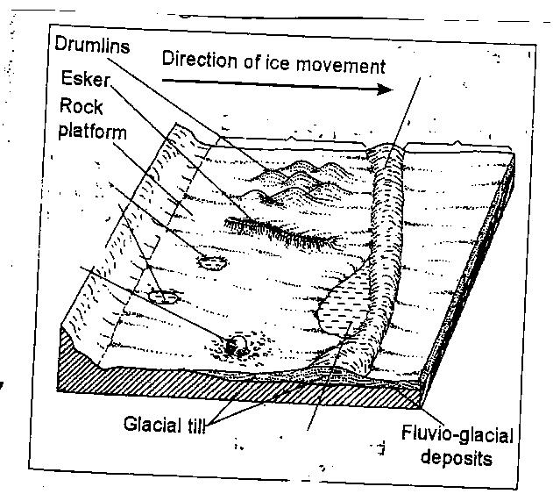

- Identify the features marked L, M, N (3mks)
L
M
N
- State three characteristics of drumlins (3mks)
- Describe how eskers are formed. (4mks)
- Explain three significance of erosional features found in glaciated upland. (6mks)

KASSU P1 M.S
7a(i) Identify two features formed by vertical earth movements (2mks)
- Basins
- Plateaus
- Fault scarps/escarpments
- Tilt blocks
- Rift valleys.
- Submerged coasts
- Emerged coasts.

(ii) Explain how the following factors cause earth movements
- Gravitative pressure
- When large amounts of magma escape to the surface large cavities or voids are left behind.
- The force of gravity exerts pressure on the crustal rocks from the voids causing them to move inwards hence vertical earth movements.

- Isotatic adjustment (4mks)
- If ice sheets melt over the highland or soil erosion occurs deposition of water or soil occurs in the sea or depression.
- A vertical isotactic uplift occurs on the highland because it is high while Isostatic sinking occurs on the depression because it is heavier.
- The adjustment which is meant to maintain isostacy is called isotactic adjustment.

b) Describe the plate tectonics (5mks)
- Is the study of movement of plates and the result land forms
- This theory suggest that the earths lithosphere IS made up of semi-rigid block called tectonic plates.
- The have distinct boundaries which separates them.
- The plates are in constant motion relative to each other.
- This is caused by convectional currents within the mantle.

c.(i) Define faulting (2mks)

- Is a process through which are brittle crustal rocks fracture or break due to tectonic forces.

(ii) Study the diagram below and answer the questions that follow

Name the parts marked : (2mks)
A – Heave
B - Throw

(iii) Apart from the above type of fault, name two other types of faults. (2mks)
- Reverse fault
- Shear/tear fault
- Thrust fault
- Anticlinal fault.

d) Explain three ways in which faulting influences drainage. (6mks)
- Faulting across a river causes it to change its course or even disappear along a fault line/fault guided.
- Subsidence of the land caused by faulting may result n the formation of depressions which may fill with water to form lakes.
- Faulting created weaklines in the crusty which may become passage of hot water t the surface forming hot springs and geysers.
- Fault scarp slopes may expose underground water resulting in the formation of scarp springs which could be sources of clean water.
- Faulting leads to formation of block mountains which receive a lot of rain forming sources of rivers.\faulting across a river or formation of escarpment forms waterfalls.

10(a) What is glaciation? (2mks)
- Is the process by which moving ice erodes transports and deposits materials on the earth’s surface.
b) Describe the following process of glacial erosion
- Plucking
- Pressure from the overlying mass of ice cause freeze ad thaw action.
- melting water fills the cracks or joints in the bed rock.
- When temperature falls, the water in the cracks freeze.
- This freeze and thaw process is repeated several times resulting in an increase in the volume of ice within the crack.
- The part of the rock embedded in the ice is under stress as the glacier is snowing forward causing part of it to break off.
- The weathered rock particles are then carried along by the moving ice.

- Abrasion
-Caused by rock debris embedded in the glacier
-The debris at the base on the sides of the ice acts as a tool for scratching and polishing the rock surface over which the glacier moves.
-This takes place over the underlying rocks during ice movement.

c)i) Identify the features marked L,M,N (3mks)
L – Terminal moraine
M – Rock basin lakes, kettle lake
N – Erratic
ii) State three characteristics of drumlins (3mks)
- Made up of unstratified materials
- Low rounded hills/ egg shaped / elongated / oval shaped
- Occur in groups
- Steep on the upstream and the downstream is long and gentle sloping
- Upstream is smoothened by abrasion
- Vary in size between 50 m – 1km long.
iii) Describe how eskers are formed. (4mks)
- A mass of ice stops moving in a lowland area.
- The ice starts melting at the base
- Streams are formed beneath the ice and form permanent sub-glacial tunnels.
- Water flows through the tunnels under hydrostatic pressure
- The water thus flows rapidly hence the amount of load carried is quite large.
- When the ice melts, the tunnels collapse and materials are deposited there
- This results in formation of along winding steep-sided ridge of deposits called an esker.
d) Explain three significance of erosional features in glaciated upland. (6mks)
- hanging valleys from waterfalls which are ideal sites for generation of HEP
- Glacial lakes provide natural route ways and they can also be need for fishing.
- The glacial features like pyramidal peaks aretes and cirques farm beautiful sceneries which act as tourist attractions, earn the country foreign exchange.
- Fiords formed in a glaciated upland coast from suitable sites for harbor and fish breeding grounds.
- Glaciated highlands are sources of rivers that provide water for irrigation, domestic industrial use.
- Glaciated highlands covered by snow are good sites for winter sports.
- Glacial roughs provide good sites for grazing of animals.

