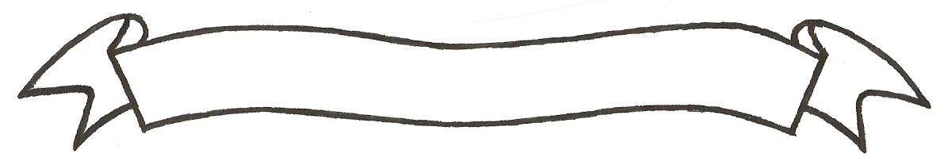

MERU UNIVERSITY OF SCIENCE AND TECHNOLOGY
P.O. Box 972-60200 – Meru-Kenya.
Tel: 020-2069349, 061-2309217. 064-30320 Cell phone: +254 712524293, +254 789151411
Fax: 064-30321
Website: www.must.ac.ke Email: info@must.ac.ke

University Examinations 2015/2016

SECOND YEAR, SECOND SEMESTER EXAMINATION FOR THE DIPLOMA IN INFORMATION TECHNOLOGY

CIT 2283: NETWORK DESIGN AND SETUP

DATE: NOVEMBER 2015 TIME: 1^{1/}₂ HOURS

INSTRUCTIONS: Answer question one and any other two questions

QUESTION ONE (30 MARKS)
- List four steps of designing a good network (4 Marks)
- Draw a network diagram that shows the Access layer, Distribution layer and the Core layer are connected. Briefly explain the application area of each layer. (5 Marks)
- John Okello Mwangi has been contracted as the new network administrator of a newly established organization, list and briefly explain any two design goals that he should consider while designing a new network for the organization. (4 Marks)
- State the three basic layers that are found in the hierarchical network design model. (3 Marks)
- What are the three steps that are used when designing a large network? (3 Marks)
- List any three types of common security risks that occur on networks. (3 Marks)
- What do you understand by the term “server farm’? (2 Marks)
- Define the following terms as used in computer networks
- Security (2 Marks)
ii) Firewall (2 Marks)
iii) Demilitarized zone (DMZ) (2 Marks)
QUESTION TWO (20 MARKS)
- List any four best practices that can be employed while using the WLAN (4 Marks)
- As a network designer, while you are identifying the user requirements, which are the two categories in which you can classify the customer needs? Briefly explain (4 Marks)
- What do you understand by the term DNS? (2 Marks)
- List any three network topologies that can be implemented in a network. (3 Marks)
- List any two LAN standards that are used in networking. (2 Marks)
QUESTION THREE (20 MARKS)
- As a network administrator, you have been contracted to advise Mr. Samuel Matiang’i on why he should not use a mesh topology in his small cyber cafe. What are the two disadvantages that are associated with this topology that you will discourage. (3 Marks)
- With the help of a well labelled diagram, design a small network for the IT & CS department. Include devices such as router, switch, printers in your network. (6 Marks)
- List any five OSl model layers (5 Marks)
- What do you understand by the term Ethernet token ring? (2 Marks)
QUESTION FOUR (20 MARKS)
- Briefly explain the uses of the following networking devices
i)Bridge (2 Marks)
ii) Repeater (2 Marks)
iii)Router (2 Marks)
iv) Switch (2 Marks)
- List three layers that are found on the TCP/IP Model (3 Marks)
- List any four requirements that are needed while designing a computer network (4 Marks)

QUESTION FIVE (20 MARKS)
- As a network consultant to the Meru county government, what three measures will you put in place to ensure that the network performance in optimal (4 Marks)
- List any four network operating systems you know. (4 Marks)
- What is the difference between UDP and TCP and describe where each is applicable (4 Marks)
- Name three protocols in the application layer of the OSl model. (3 Marks)

