**Name………………………………….……...………. Adm ……………………………..**

**PHYSICS Candidate’s Signature…..……….**

**(Theory) Date……………………………….**

**June 2018**

**2 hours**

**DAKU SECONDARY SCHOOL**

**Kenya Certificate of Secondary Education (KCSE)**

FORM TWO PHYSICS

**(Theory)**

**2 hours**

**Instructions to candidates**

* *Write your* ***name*** *and* ***Admn number*** *in the spaces provided above.*
* *Sign and write the date of examination in the spaces provided above.*
* *This paper consists of* ***one*** *sections* ***A***
* *Answer* ***ALL*** *the questions in sections* ***A*** *in the spaces provided.*
* ***ALL*** *working* ***MUST*** *be clearly shown.*
* *KNEC mathematical tables may be used.*
* ***This paper consists of 7 printed pages.***
* ***Candidates should check the question paper to ascertain that all the pages are printed as indicated and that no questions are missing****.*

**For Examiner’s Use Only**

|  |  |  |  |
| --- | --- | --- | --- |
| **Section** | **Question** | **Maximum Score** | **Candidate’s Score** |
| A | 1 - 18 | 50 |  |

**SECTION A**

1. A drop of blue ink is introduced at the bottom of a beaker containing water. It is observed that after sometime, all the water in the beaker turns blue. Name the process that takes place. (2 Marks)

…………………………………………………………………………………………………………………………………………………………………………………………………………………………………………………………………………………………………………………………………………………………………………………………………………

1. State two factors that determine the pressure at a point in a liquid. (2 Marks)

…………………………………………………………………………………………………………………………………………………………………………………………………………………………………………………………………………………………………………………………………………………………………………………………………………

1. A student wearing sharp pointed heeled shoes is likely to damage a soft wooden floor. Explain.. (2 Marks)

…………………………………………………………………………………………………………………………………………………………………………………………………………………………………………………………………………………………………………………………………………………………………………………………………………

1. In the set up shown in figure 3, water near the top of the boiling tube boils while at the bottom it remains cold.

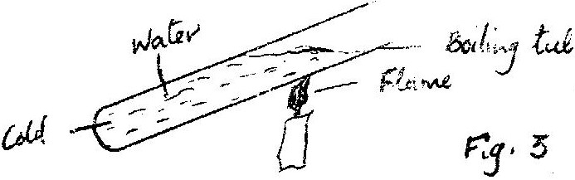

Water

Boiling tube

Flame

Cold

Give and explain the reason for the observation above (2mks)

……………………………………………………………………………………………………………………………………………………………………………………………………………………………………………………………………………………………………………………………………………...............................................................................................................................................................................

1. Give a reason why the weight of the body varies from place to place (1mk)

....................................................................................................................................................................................................................................................................................................................................

1. Figure 5 shows a bimetallic strip at room temperature. Brass expands more than invar when heated equally.

**Brass**

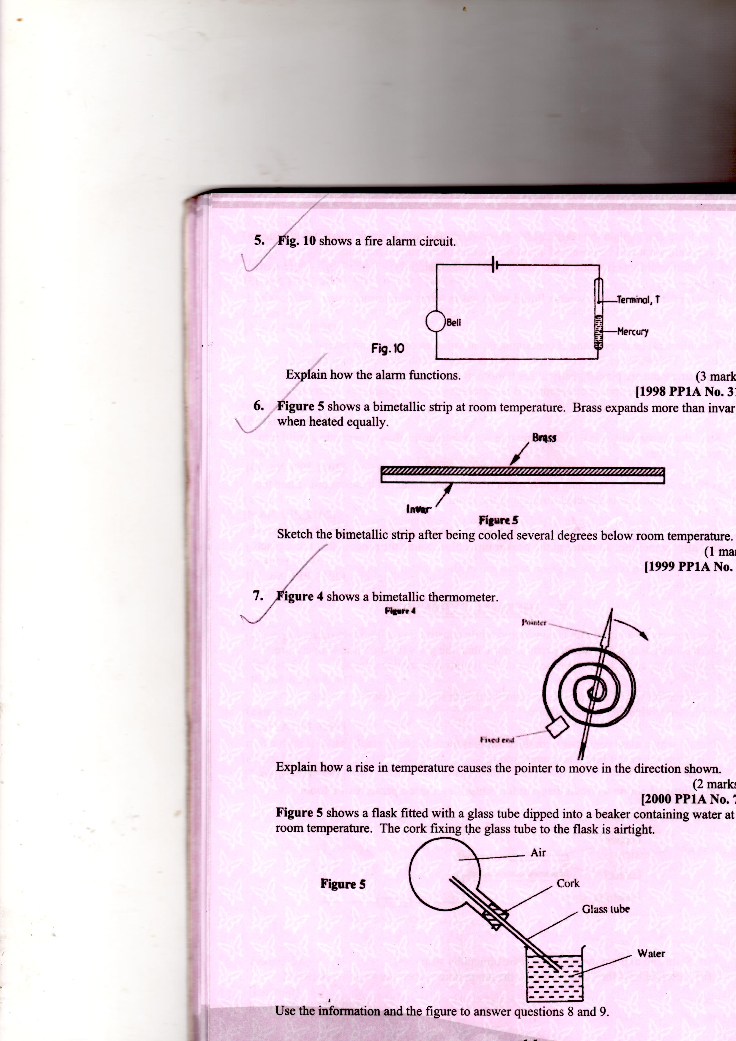

**Invar**

**Figure 5**

Sketch the bimetallic strip after being cooled several degrees below room temperature. (2mks)

………………………………………………………………………………………………………………………………………………………………………………………………………………………………………………………………………………………………………………………………………………………………………………………………………………………………………………………………………………………………………………………….

1. Figure 6 shows a ray of light incident on plane mirror at point O.

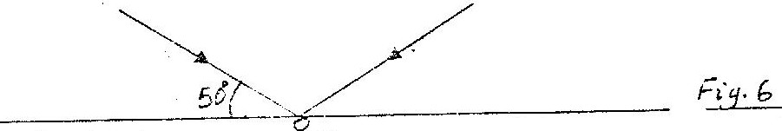

500

The mirror is rotated clockwise through an angle 300 about an axis perpendicular to the paper. Determine the angle through which the reflected ray rotated. (2 Marks)

………………………………………………………………………………………………………………………………………………………………………………………………………………………………………………………………………………………………………………………………………………………………………………………………………………………………………………………………………………………………………………………………………………………………………………………………

1. a) State hook’s principle. ( 1 Mark)

…………………………………………………………………………………………………………………………………………………………………………………………………………………………………………………………………………………………………………………………………………………………………………………………………………

b). the following table shows the extension produced on the string when a different weights were hang.

|  |  |  |  |  |  |  |  |  |
| --- | --- | --- | --- | --- | --- | --- | --- | --- |
| Weight (N) | 0 | 20 | 40 | 60 | 80 | 100 | 120 | 140 |
| Extension (m) | 0 | 0.02 | 0.04 | 0.06 | 0.08 | 0.10 | 0.12 | 0.14 |

Use the table above to draw the graph of weight against extension (5 Marks)

Use your graph to calculate spring constant. (2 Marks)

……………………………………………………………………………………………………………………………………………………………………………………………………………………………………………………………………………………………………………………………………………………………………………………………………………………………………………………………………………………………………………

1. A current of 0.5A flows in a circuit. Determine the quantity of charge that crosses a point in 4 minutes. (2 marks)

…………………………………………………………………………………………………………………………………………………………………………………………………………………………………………………………………………………………………………………………………………………………………………………………………………

1. Explain why a Matatu is more likely to topple over when the roof- rack is heavily loaded than when the roof- rack is empty. (2marks)

…………………………………………………………………………………………………………………………………………………………………………………………………………………………………………………………………………………………………………………………………………………………………………………………………………

1. A building 40m high is located 10m from the opening of a pinhole camera it the image distance is 10cm, calculate the size of image formed (3 Marks)

……………………………………………………………………………………………………………………………………………………………………………………………………………………………………………………………………………………………………………………………………………………………………………………………………………………………………………………………………………………………………………………………………………………………………………………………………………………………………………………………………………………………………………………………………………………………………………………………………………………

1. State the property of light associated with formation of shadows (1 Mark)

……………………………………………………………………………………………………………………………………………………………………………………………………..

1. In terms of intermolecular forces, explain the difference between liquid and gaseous state.

(2 Marks)

……………………………………………………………………………………………………………………………………………………………………………………………………………………………………………………………………………………………………………………………………………………………………………………………………………………………....

1. a). What is meant by the centre of gravity of an object? (1mark)

……………………………………………………………………………………………………………………………………………………………………………………………….......

1. A uniform metre rule is in equilibrium on a knife-edge placed at 40cm mark as shown on figure 2 when a weight of 60N and 40N is placed at 10cm and 60cm mark respectively. Determine the weight of the metre rule. (3 Marks)

10cm 40cm 60cm

60N 40N

………………………………………………………………………………………………………………………………………………………………………………………………………………………………………………………………………………………………………………………………………………………………………………………………………………………………………………………………………………………………………………………………………………………………………………………………………………………………………………………………………………………………………………………………………………………………………………………………………………………………………………………………………………………………

1. The figure 3 below shows two capillary tubes of different sizes dipped in water.

Figure 3

A



Water

(a) Mark on the diagram the level of water in the capillary tubes. (1 Mark)

(b) Explain the difference in the level of water in the two tubes. (2 Marks)

………………………………………………………………………………………………………………………………………………………………………………………………………………………………………………………………………………………………………………………………………………………………………………………………………...

1. The figure1 below shows a wire wound on a test tube. The windings just touch each other. If the total number of complete loops was found to be 15, and the distance covered by the windings on the test tube is 20cm; find the radius of the wire. (2marks)

**Figure 1**

20cm

……………………………………………………………………………………………………………………………………………………………………………………………………………………………………………………………………………………………………………………………………………………………………………………………………………………………………………………………………………………………………………..

1. Explain why steel is selected as a better material for reinforcement for a concrete beam. (1 Mark)

………………………………………………………………………………………………………

………………………………………………………………………………………………………………………………………………………………………………………………………………

1. Define the following terms as used in waves; (4 Marks)

a). Frequency

………………………………………………………………………………………………………………………………………………………………………………………………………………………………………………………………………………………………………

b). Wavelength

………………………………………………………………………………………………………………………………………………………………………………………………………………………………………………………………………………………………………

c). Period

…………………………………………………………………………………………………………………………………………………………………………………............................

d). Velocity

……………………………………………………………………………………………………………………………………………………………………………………………………

1. The following shows the displacement time graph for a wave. Study it and answer the following questions.

Displacement (m)

0.02 0.04 0.06

Time (s)

a). calculate the frequency of the wave above. (2 Marks)

………………………………………………………………………………………………………………………………………………………………………………………………………………………………………………………………………………………………………………………………………………………………………………………………………………………………

b). given that the wavelength of the wave above is 20m, calculate the velocity of the wave. (3 Marks)

…………………………………………………………………………………………………………………………………………………………………………………………………………………………………………………………………………………………………................................