NAME……………………………………………………………….. INDEX. NO …………………………...
SCHOOL: …………………………………………………………… DATE: ………………….………………
CANDIDATE’S SIGN…………………….………………………..

121/1
MATHEMATICS
PAPER 1
June 2018
TIME: 2¹/₂ HOURS

DAKU SECONDARY SCHOOL
Kenya Certificate of Secondary Education (K.C.S.E)
MATHEMATICS
PAPER 1
2 ½ hours

INSTRUCTIONS TO THE CANDIDATES
- Write your name and school and index number in the spaces provided above
- This paper contains two sections; Section 1 and Section 11.
- Answer all the questions in section 1 and any five questions from Section 11
- All necessary workings and answers must be written on the question paper in the spaces provided below each question.
- Marks may be given for correct working even if the answer is wrong.
- Non-calculators and KNEC Mathematical tables may be used EXCEPT where stated otherwise.
- Show all the steps in your calculations, giving your answers at each stage in the spaces below each question.

FOR EXAMINERS’S USE ONLY
Section 1
Question | 1 | 2 | 3 | 4 | 5 | 6 | 7 | 8 | 9 | 10 | 11 | 12 | 13 | 14 | 15 | 16 | Total
Marks
Section 1I GRAND TOTAL
Question | 17 | 18 | 19 | 20 | 21 | 22 | 13 | 24 | Total
Marks

This paper consists of 14 printed pages. Candidates should check carefully to ascertain that all the pages are printed as indicated and no questions are missing.

SECTION A (50 MARKS)
Answer all questions in this section
- Evaluate without using a calculator
¼ + ¹/₅ ÷ ½ of ¹/₃ (3mks)
½ of (⁴/₅ – ¾ + ½)

- Simplify completely.
3a² + 5ab – 2b² (3 Marks)
b² – 9a²

- An artisan has 63kg of metal of density 7000kg/m³. He intends to use it to make a rectangular pipe with external dimensions 12cm by 15cm and internal dimensions 10cm by 12 cm. Calculate the length of the pipe in metres. (3 Marks)

- Given that Sin θ = 2/3 and θ is an acute angle, find without using tables or calculators
(a) tan θ, giving your answer in surd form. (2 Marks)

- Cos (90 - θ) (1 Mark)

- Four machines give out signals at intervals of 24, 27, 30 and 50 seconds respectively. At 5.00pm all the four machines give out a signal simultaneously. Find the time this will happen again. (3 Marks)

- Two pipes A and B can fill an empty tank in 3hrs and 5hrs respectively. Pipe C can empty the full tank in 4 hours. If the three pipes A, B, and C are opened at the same time, find how long it will take for the tank to be full. (3 Marks)

- A tourist arrived in Kenya with sterling pound (£) 4680 all of which he exchanged into Kenyan money. He spent Ksh. 51,790 while in Kenya and converted the rest of the money into U.S dollars. Calculate the amount he received in U.S dollars. The exchange rates were as follows.

Buying Selling.
US $ 65.20 69.10
Sterling Pound (£) 123.40 131.80 (4 Marks)

- The gradient of a straight line L₁ passing through the points P (3, 4) and Q (a, b) is ⁻³/₂. A line L₂ is perpendicular to line L₁ and passes through the points Q and R (2, -1). Determine the values of a and b. (4 Marks)

- The distance from a fixed point of a particle in motion at any time t seconds is given by
S = t³ – $\frac{5}{2}$ t²+ 2t + 5 metres
Find it’s;
- Acceleration after t seconds (1mk)

- Velocity when acceleration is zero. (2 Marks)

- Find the number of sides of a regular polygon whose interior angle is five times the exterior angle. (3 Marks)

- Solve for x in the equation given by cos 2x = sin 36 $O≤x≤360$ (3 Marks)

- Find the possible values of X in the equation $9^{X^{2}}$ = 27^{(2X + 12)} (3 Marks)

- Two similar solids have surface areas of 48cm² and 108cm² respectively. Find the volume of the smaller solid if the bigger one has a volume of 162cm3. (3 Marks)

- Use the inequality below to find the integral values of x that satisfy the inequality and show the solution on the number line. (4 Marks)
3x + 1 ≤ 4x + 5 ≤x + 13

- Simplify without using tables (2 marks)
$\frac{Log 125 – log 25}{Log 25+log5}$

- Express the 512 and 10752 as a product of their prime numbers and hence evaluate $\frac{10 752}{512}$
( 4 Marks)

SECTION II (50 MARKS)
Answer any five questions in this section.
- (a) Complete the table below for the equation y = x² + 3x – 6 given -6 ≤ x ≤ 4 (2mks)
x | -6 | -5 | -4 | -3 | -2 | -1 | 0 | 1 | 2 | 3 | 4
y

(b) Using a scale of 1cm to represent 2 units in both axes; draw the graph of y = x² + 3x – 6 (3 Marks)

(c) Use your graph to solve the quadratic equations.
- x² + 3x – 6 = 0 (2mks)
- x² + 3x – 2 = 0 (3mks)
- (a) Plot a triangle ABC with coordinates A(-2,6) B(2,3) and C(-2, 3) (1mk)
(b) Reflect ΔABC in the line x = -3. Plot Δ A^{I}B^{I}C¹ the image of ΔABC under this transformation.
(2mks)

- Translate A_{I}, B_{I}, C_{I} through 10 Label the image A₂B₂C₂ and write down the
2
coordinates of the points A₂, B₂, C₂ (3 Marks)

(d) A₃ (6, -6), B₃ (2, -3) and C₃ (6, -3) is the image of A₂ B₂ C₂ after a transformation P plot A₃B₃C₃ and describe the transformation. (2 Marks)

(e) Describe fully a single transformation that would have mapped ABC to A₃B₃C₃. (2Marks)

- In the figure below OB = b , OC = 3OB and OA = a
∼
∼

- Given that OD = 1/3 OA and AN = ½ AC, CD and AB meet at M. Determine in terms of a and b
N
C
∼
∼
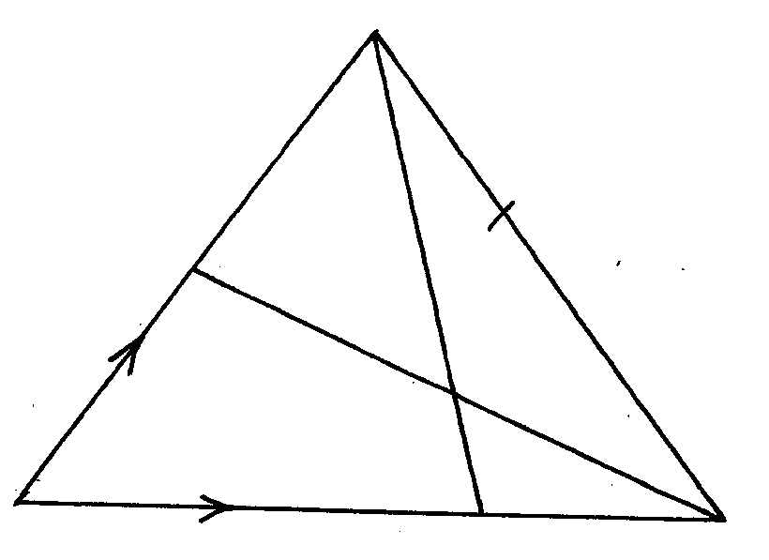

B

O
M
D
A

- AB (1mk)

- CD (1mk)

- Given that CM = k CD and AM = h AB determine the values of the scalars k and h (5mks)

- Show that O, M and N are collinear. (3mks)

- a) Complete the table below for the function $y=2x^{3}+5x^{2}-x-6$ (2 Marks)
x | -4 | -3 | -2 | -1 | 0 | 1 | 2
2x³ | -128 | -54 |  |  | 0 | 2 | 16
5x² | 80 | 45 | 20 | 5 | 0 | 5 | 20
-x | 4 | 3 |  |  | 0 | -1
-6 | -6 | -6 | -6 | -6 | -6 | -6 | -6
y | -50 |  |  |  | -6 | 0

(b) On the grid provided draw the graph $y=2x^{3}+5x^{2}-x-6$ for.
Use 2cm to represent 1 unit on the x-axis and 1 cm to represent 5 units on the y – axis (4 Marks)

(c) By drawing a suitable line, use the graph in (b) to solve the equations:
- (2 Marks)

- (2 Marks)

- A parent has two children whose age difference is 5 years. Twice the sum of the ages of two children is equal to the age of the parent.
- Taking x to be age of the elder child, write an expression for
- The age of the younger child. (1 Mark)

- The age of the parent. (1 Mark)

- In twenty years time, the product of the children’s age will be 15 times the age of their parent.
- Form an equation in x and hence determine the present ages of the elder child. (4 Marks)

- Find the present possible ages of the parent. (2 Marks)

- Determine the possible ages of the younger child in 20 years time (2 Marks)

