SUNSHINE SECONDARY SCHOOL

KASSU JET EXAMINATION - 2018
Kenya Certificate of Secondary Education

232/2
PHYSICS
PAPER ONE
June 2018
2 hours

Name...................................................................................Index Number......................../............
Admission Number………….Class: ……....Candidate’s Signature....................Date...............
INSTRUCTIONS TO CANDIDATES
- Write your name, admission number and index number in the spaces provided above.
- Sign and write the date of examination in the spaces provided above
- This paper consists of TWO sections A and B.
- Answer ALL the questions in section A and B in the spaces provided.
- All working MUST be clearly shown.
- Electronic calculators and mathematical tables may be used.
- ALL numerical answers must be expressed in decimal notation.
- This paper has 13pages. It is the responsibility of the candidate to ascertain that all the pages are printed as indicated and that no questions are missing.
- Candidates should answer the questions in English.
For Examiners Use Only

Section | Question | Maximum Score | Candidate’s Score
A | 1 – 13 | 25
B | 14 | 10
 | 15 | 13
 | 16 | 10
 | 17 | 12
 | 18 | 10
TOTAL |  | 80

SECTION A (25 marks)
Answer ALL the questions in this section in the spaces provided.

1. A micrometer screw gauge has a zero error of 0.12mm.Sketch the reading of the micrometer screw gauge when used to measure the size of a ball of diameter 3.44mm. (1 mark)

.……………………………………………………………………………………………………………………………………………………………………………………………………………………………………………………………………………………………………………………………………………………………………………………………………………………… …………………….……
2. Figure 1 (a) and 1(b) shows capillary tubes inserted in water and mercury respectively.

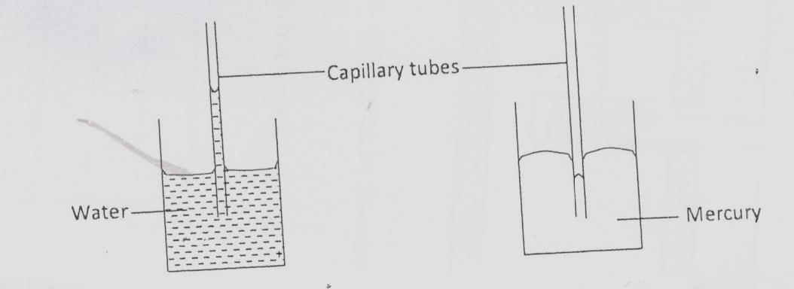

Figure 1(a) Figure 1(b)

It is observed that in water the meniscus in the capillary tube is higher than the meniscus in the beaker, while in mercury the meniscus in the capillary tube is lower than the meniscus in the beaker. Explain these observations. (2 marks)

.……………………………………………………………………………………………………………………………………………………………………………………………………………………………………………………………………………………………………………………………………………………………………………………………………………………… …………………….……
3. A block of mass 500g and measuring 30cm by 25cm by 15cm rests on a flat floor. Determine maximum pressure exerted on the floor. (3 marks)
.……………………………………………………………………………………………………………………………………………………………………………………………………………………………………………………………………………………………………………………………………………………………………………………………………………………… …………………….……
4. In figure 2 ammonia gas and an acid gas diffuse and react to form a white deposit on the walls of the glass tube. Explain why the white deposit forms nearer end B than A. ( 1mark)

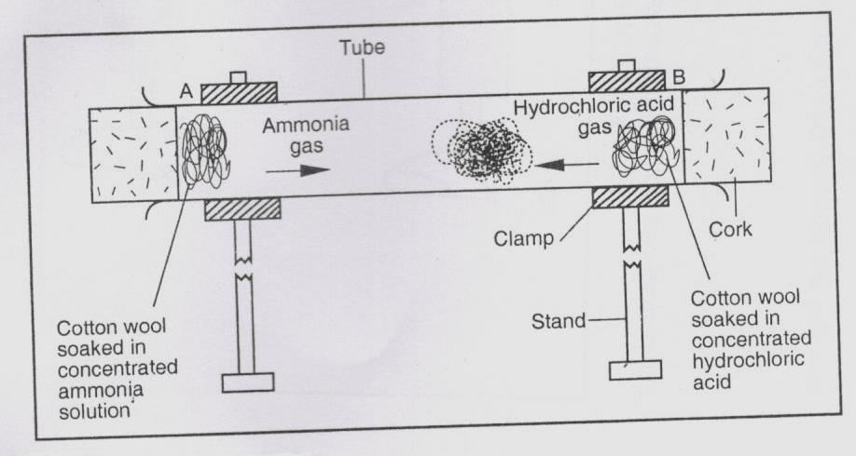

Figure 2
.………………………………………………………………………………………………………………………………………………………………………………………………………………………………………………………………………………………………………………………………………

5. A man wants to fit a brass ring tightly onto a steel rod of equal diameter to the inner diameter of the ring. Explain how this can be achieved. (2 marks)
.……………………………………………………………………………………………………………………………………………………………………………………………………………………………………………………………………………………………………………………………………………………………………………………………………………………… …………………….……

6. State how conduction and radiation is minimized in a thermos flask. (2 marks)
.……………………………………………………………………………………………………………………………………………………………………………………………………………………………………………………………………………………………………………………………………………………………………………………………………………………… …………………….……
7. A body moving around a circle is accelerating and yet the speed is constant. Explain. (1 mark)
.…………………………………………………………………………………………………………………………………………………………………………………………………………………………
8. Figure 3 shows a uniform bar of mass 0.8kg supported by a spring balance at its centre and the bar is at equilibrium.
////////////////////// support

Spring balance

0.8m 0.6m

XN 24N

Figure 3
Determine the:
(a) value of X (3 marks)

.……………………………………………………………………………………………………………………………………………………………………………………………………………………………………………………………………………………………………………………………………………………………………………………………………………………… …………………….……
(b) reading of the spring balance (1mark)
.………………………………………………………………………………………………………………………………………………………………………………………………………………………………………………………………………………………………………………………………………

9. Figure 4 shows a load-extension graph for various loads hung from a single spring.
Extension (m)
Load (N)

Figure 4

On the same axes, sketch a graph for a spring double the diameter of the first one.
(1mark)
10. An aeroplane is moving horizontally through still air at uniform speed. State with reason what is observed when the speed of the plane is increased. (2marks)
.……………………………………………………………………………………………………………………………………………………………………………………………………………………………………………………………………………………………………………………………………………………………………………………………………………………… …………………….……
11. A crane lifts a load of 2000kg through a vertical distance of 4.0 m in 5 seconds. Determine the power developed by the crane. ( ɳ = 80% ) (3 marks)
.……………………………………………………………………………………………………………………………………………………………………………………………………………………………………………………………………………………………………………………………………………………………………………………………………………………… …………………….……
12. Sketch a displacement time graph for a freely falling body and describe the motion. (2marks)

.……………………………………………………………………………………………………………………………………………………………………………………………………………………………………………………………………………………………………………………………………………………………………………………………………………………… …………………….……

13. State Newton’s first law of motion. (1mark)
.……………………………………………………………………………………………………………………………………………………………………………………………………………………………………………………………………………………………………………………………………………………………………………………………………………………… …………………….……
SECTION B (55 marks)
Answer ALL the questions in this section in the spaces provided.

14. Figure 5 shows a crate of mass 70kg being pushed by a man with a force of 150 N along the plane AB.
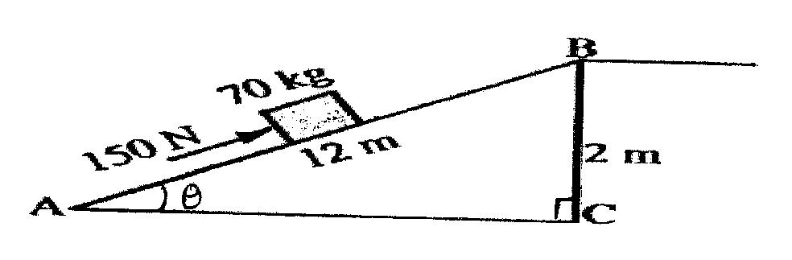
Figure 5
(a) Show that V.R of the inclined plane is given by $\frac{1}{Sinϴ}$ (2 marks)
.………………………………………………………………………………………………………………………………………………………………………………………………………………………………………………………………………………………………………………………………………
(b) Determine the work done:
(i) by the force of the man. (2marks)
.……………………………………………………………………………………………………………………………………………………………………………………………………………………………………………………………………………………………………………………………………………………………………………………………………………………… …………………….……
(ii) on the mass. (2marks)
.……………………………………………………………………………………………………………………………………………………………………………………………………………………………………………………………………………………………………………………………………………………………………………………………………………………… …………………….……
(iii) to overcome friction. (1mark)
.…………………………………………………………………………………………………………………………………………………………………………………………………………………………
(c) Determine the efficiency of the inclined plane. (2marks)
.………………………………………………………………………………………………………………………………………………………………………………………………………………………………………………………………………………………………………………………………………
(d) Suggest one method of improving the efficiency of an inclined plane. (1mark)

.……………………………………………………………………………………………………………
15.(a)Figure 6 shows incomplete set up that can be used in an experiment to determine the specific heat capacity of a solid of mass m by electrical method.
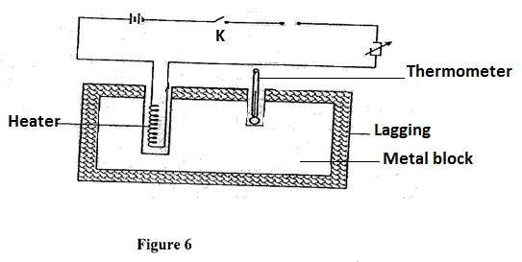

(i) Complete the diagram by inserting the missing components for the experiment to work.( 2 marks)
(ii) State four measurements that should be taken. (2 marks)
.……………………………………………………………………………………………………………………………………………………………………………………………………………………………………………………………………………………………………………………………………………………………………………………………………………………… …………………….……
(iii) The final temperature was recorded as ϴ. Write an expression that can be used to determine the specific heat capacity of the solid. ( 2 marks)
.………………………………………………………………………………………………………………………………………………………………………………………………………………………………………………………………………………………………………………………………………
(b) Figure 7 shows a graph of temperature against time for a 200g mass of ice at -14⁰C slowly heated by an electric heater of power 30W.

Figure 7

I) Determine the:-
(i) the time corresponding to the line AB (2marks)

.……………………………………………………………………………………………………………………………………………………………………………………………………………………………………………………………………………………………………………………………………………………………………………………………………………………… …………………….……
(ii) The time corresponding to the line BC (2marks)

.……………………………………………………………………………………………………………………………………………………………………………………………………………………………………………………………………………………………………………………………………………………………………………………………………………………… …………………….……
II) Determine the specific heat capacity of ice (3marks)

.…………………………………………………………………………………………………………………………………………………………………………………………………………………………………………………………………………………………………………………………………………………………………………………………………………………………………….……
( Specific heat capacity of water = 4200J/kgK and specific latent heat of fusion of ice = 336000J/kg)

16. ( a) When the temperature of a gas in a closed container is raised, the pressure of the gas increases. Explain how the molecules of the gas cause the increase in pressure. (2 marks)
.……………………………………………………………………………………………………………………………………………………………………………………………………………………………………………………………………………………………………………………………………………………………………………………………………………………… …………………….……

(b) Figure 8 shows a set up that may be used to verify Boyle’s law.
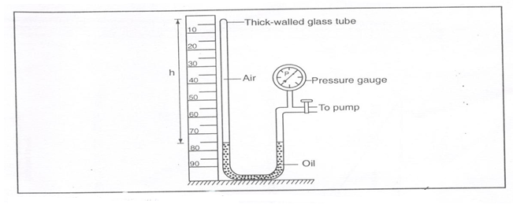
Figure 8
(i)State the measurements that should be taken in the experiment. (2 marks)
.……………………………………………………………………………………………………………………………………………………………………………………………………………………………………………………………………………………………………………………………………………………………………………………………………………………… …………………….……
(ii) Explain how the measurements taken in (i) above may be used to verify Boyle’s law. ( 3 marks)
.……………………………………………………………………………………………………………………………………………………………………………………………………………………………………………………………………………………………………………………………………………………………………………………………………………………… …………………….……
.……………………………………………………………………………………………………………………………………………………………………………………………………………………………………………………………………………………………………………………………………………………………………………………………………………………… …………………….……
(c) A certain mass of hydrogen gas occupies a volume of 1.5m³ at a pressure of 1.6x10⁵Pa and temperature 14⁰C.Determine its volume when the temperature is 0ºC at a pressure of 1.0x10⁵ Pa.
(3 marks)
.……………………………………………………………………………………………………………………………………………………………………………………………………………………………………………………………………………………………………………………………………… ……………………………………………………………………………… …………………….…… 17. (a) State the principle of conservation of linear momentum. (1 mark)
.……………………………………………………………………………………………………………………………………………………………………………………………………………………………………………………………………………………………………………………………………… ……………………………………………………………………………… …………………….……

(b) Distinguish between elastic and inelastic collision. (1 mark)
.……………………………………………………………………………………………………………………………………………………………………………………………………………………………………………………………………………………………………………………………………………………………………………………………………………………… …………………….……
(c) A striker kicks a ball of mass 200g initially at rest with a force of 78N.Given that the foot was in contact with the ball for 0.30s; determine the take off velocity of the ball. (3 marks)
.……………………………………………………………………………………………………………………………………………………………………………………………………………………………………………………………………………………………………………………………………………………………………………………………………………………… …………………….……

(d)A high jumper usually lands on thick soft mattress. Explain how the mattress helps in reducing the force of impact. (2 marks)
.……………………………………………………………………………………………………………………………………………………………………………………………………………………………………………………………………………………………………………………………………………………………………………………………………………………… …………………….……
(e)A ball is thrown horizontally from the top of a vertical tower of height 75m and strikes the ground at a point 80m from the bottom of the tower. Determine the:
(i) time taken by the ball to hit the ground. (Acceleration due to gravity=10m/s²) (3 marks)
.……………………………………………………………………………………………………………………………………………………………………………………………………………………………………………………………………………………………………………………………………………………………………………………………………………………… …………………….……
(ii) initial horizontal velocity of the ball. (2 marks)
.……………………………………………………………………………………………………………………………………………………………………………………………………………………………………………………………………………………………………………………………………………………………………………………………………………………… …………………….……
18 (a) State the Archimedes’ principle. (1 mark)
.……………………………………………………………………………………………………………………………………………………………………………………………………………………………………………………………………………………………………………………………………………………………………………………………………………………… …………………….……

(b) A block of wood of mass 300g is held under water by a string attached to the bottom of the container. The tension in the string is 0.6N.Determine the density of the wood.(Gravitational field strength =10N/kg and Density of water=1000kg/m³) (4marks)
.……………………………………………………………………………………………………………………………………………………………………………………………………………………………………………………………………………………………………………………………………………………………………………………………………………………… …………………….……
(c) Define angular velocity. (1mark)
.……………………………………………………………………………………………………………………………………………………………………………………………………………………………………………………………………………………………………………………………………………………………………………………………………………………… …………………….……
(d) State one way in which the centripetal force on a body of mass m can be reduced. (1 mark)
.……………………………………………………………………………………………………………………………………………………………………………………………………………………………………………………………………………………………………………………………………………………………………………………………………………………… …………………….……
(e) A turntable of radius 5cm is rotating at 40 revolutions per second. Determine the linear speed of a point on the circumference of the turn table. (3 marks)
.……………………………………………………………………………………………………………………………………………………………………………………………………………………………………………………………………………………………………………………………………………………………………………………………………………………… …………………….……

THIS IS THE LAST PRINTED PAGE

