NAME……………………………………………………….INDEX NO:………………

SCHOOL: ………………………………………………………………………………

451/1
COMPUTER STUDIES
PAPER 1
THEORY
TIME 2 ½ HOURS

BUNYORE/MARANDA
Kenya Certificate of Secondary Education 2014

COMPUTER STUDIES
PAPER 1
THEORY

INSTRUCTION TO CANDIDATES

- Write your name and index number in the spaces provided above
- This paper consists of two sections A and B
- Answer ALL questions in section A
- Answers question 16 and any other THREE questions from section B
- All answers should be written in the spaces provided on the question paper

For Examiners Use Only

Section | Questions | Candidates  Score
A | 1-15
B | 16
 | 17
 | 18
 | 19
 | 20
 | TOTAL SCORE

SECTION A (40 MARKS)

1. Kaperi Secondary School upgraded their computer lab by installing modern computers.
Outline three ways of controlling theft of hardware and software from the lab (3 marks)
……………………………………………………………………………………………… ………………………………………………………………………………………………
………………………………………………………………………………………………
……………………………………………………………………………………………..
2. Give three reasons why smaller computers like Laptops tend to be more expensive than Desktop computers. (3 marks)
……………………………………………………………………………………………… ………………………………………………………………………………………………
………………………………………………………………………………………………
……………………………………………………………………………………………..
3. Describe any three parts of a query grid (3 marks)
……………………………………………………………………………………………… ………………………………………………………………………………………………
………………………………………………………………………………………………
………………………………………………………………………………………………
4. Paul purchased a computer with RAM capacity of 128MB. After sometime he wanted to upgrade his memory to 1024MB. How many 128MB modules required by Paul to upgrade his computer (3 marks)
……………………………………………………………………………………………… ………………………………………………………………………………………………
………………………………………………………………………………………………
……………………………………………………………………………………………..
5. Give four ICT related courses offered at Post Graduate level in Kenyan Universities (2 marks)
……………………………………………………………………………………………… ………………………………………………………………………………………………
………………………………………………………………………………………………
……………………………………………………………………………………………..
6. Use the diagram below to answer the questions that follows
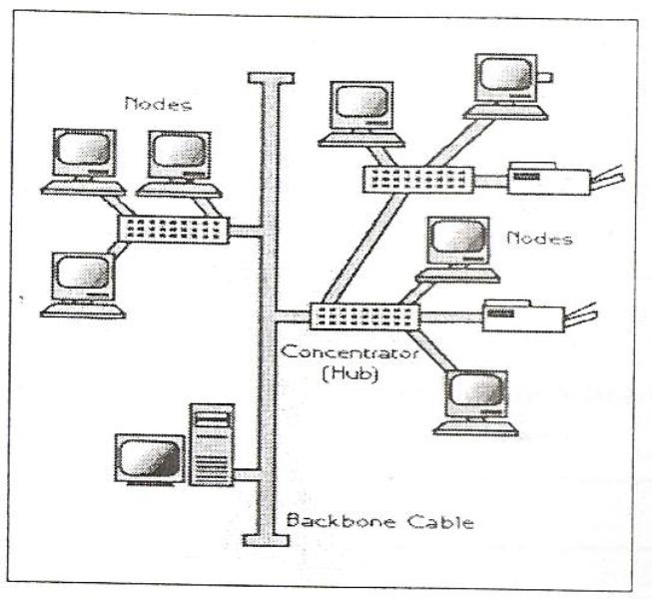

- Identify the network topology represented in the above diagram (1 marks)

………………………………………………………………………………………………………………………………………………………………………………………………
(ii) Outline three disadvantages of this topology (3 marks)

……………………………………………………………………………………………… ………………………………………………………………………………………………
……………………………………………………………………………………………… ………………………………………………………………………………………………
7. Majority of people withdraw cash by using A.T.M. List down two input and output devices of an A.T.M. machines at pesa-point in our country.
(i) Input devices (1 mark)
……………………………………………………………………………………………… ………………………………………………………………………………………………
……………………………………………………………………………………………… ………………………………………………………………………………………………

8. State two application areas of Batch processing (2 marks)
……………………………………………………………………………………………… ………………………………………………………………………………………………
……………………………………………………………………………………………… ………………………………………………………………………………………………
9. Find the value of X in base 8 and 16 in this equation 011₂ +x₂ = 12₈. (3 marks)

……………………………………………………………………………………………… ………………………………………………………………………………………………
……………………………………………………………………………………………… ………………………………………………………………………………………………
10. State three factors that are likely to cause system entropy (3 marks)

……………………………………………………………………………………………… ………………………………………………………………………………………………
……………………………………………………………………………………………… ………………………………………………………………………………………………
11. Name three types of tool bars available in Microsoft Word (3 marks)

……………………………………………………………………………………………… ………………………………………………………………………………………………
……………………………………………………………………………………………… ………………………………………………………………………………………………
12. List any four non-electronic computing tools (2 marks)

……………………………………………………………………………………………… ………………………………………………………………………………………………
……………………………………………………………………………………………… ………………………………………………………………………………………………
13. Peter wanted to access the internet when he launched the web browser an error message appeared on the screen “Server not found. State three causes of this problem. (3 marks)
……………………………………………………………………………………………… ………………………………………………………………………………………………
……………………………………………………………………………………………… ………………………………………………………………………………………………
14. Principal of Tecta Secondary school purchased an application package from a software vendor in Kisumu. Name two items that the principal would use to measure authenticity of this application package. (2 marks)
……………………………………………………………………………………………… ………………………………………………………………………………………………
……………………………………………………………………………………………… ………………………………………………………………………………………………
15. Identify the tools shown below and state their functions as used in DPT (2 marks)

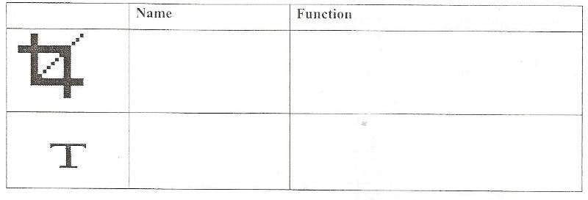

SECTION B (60 MARKS)
Answer question 16 and ANY other THREE Questions from the section

16. a) Study the flow chart below and use it answer the questions that follows.
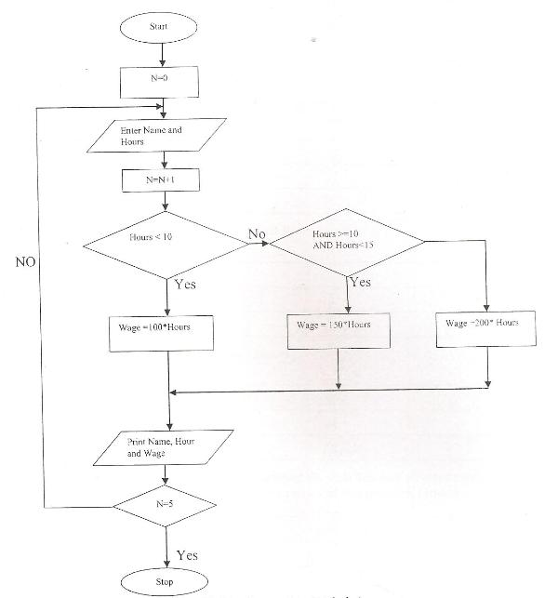

- What will happen if the decision N = 5 is changed to (2 marks)
N> 0
……………………………………………………………………………………………… ………………………………………………………………………………………………
………………………………………………………………………………………………
(b) N < 0
……………………………………………………………………………………………… ………………………………………………………………………………………………
(ii) Generate a pseudo code from the flowchart given (8 marks)

(b) Use a flowchart extracts to describe the difference between REPEAT UNTIL and WHILE Loop
……………………………………………………………………………………………… ………………………………………………………………………………………………
……………………………………………………………………………………………… ………………………………………………………………………………………………
……………………………………………………………………………………………… ………………………………………………………………………………………………

c) Name Four examples of 5th Generation programming languages (2 marks)

……………………………………………………………………………………………… ………………………………………………………………………………………………
……………………………………………………………………………………………… ………………………………………………………………………………………………

17. (a) Distinguish between analog and digital signals (13 marks)
……………………………………………………………………………………………… ………………………………………………………………………………………………
……………………………………………………………………………………………… ………………………………………………………………………………………………
(b) Arrange the following numbers from the smallest to the biggest (2 marks)
FFH,330₁₀,514₈,1011001₂
……………………………………………………………………………………………… ………………………………………………………………………………………………
……………………………………………………………………………………………… ………………………………………………………………………………………………

(c) Using twos compliment, perform the following binary arithmetic leaving the answer in binary notation. (3 marks)
……………………………………………………………………………………………… ………………………………………………………………………………………………
……………………………………………………………………………………………… ………………………………………………………………………………………………
(d) A 7-bit coding scheme represent letter C as 1000011, how will letter I be represented (2 marks)
……………………………………………………………………………………………… ………………………………………………………………………………………………
………………………………………………………………………………………………
(e) Convert 3BD₁₆ to Octal (2 marks)
……………………………………………………………………………………………… ………………………………………………………………………………………………
………………………………………………………………………………………………
(f) Convert 4598 to Binary (1 mark)
……………………………………………………………………………………………… ………………………………………………………………………………………………
………………………………………………………………………………………………
(g) Calculate the word length in the word COMPUTER (2 marks)
……………………………………………………………………………………………… ………………………………………………………………………………………………
18a) State the function of the following
- Startup disk (1 mark)
………………………………………………………………………………………………………………………………………………………………………………………………
………………………………………………………………………………………………
(ii) Disk portioning (1 mark)
……………………………………………………………………………………………… ………………………………………………………………………………………………
………………………………………………………………………………………………
(b) Describe two main parts of the operating system (2 marks)
……………………………………………………………………………………………… ………………………………………………………………………………………………
………………………………………………………………………………………………
(c) Identify how the operating system will label the following drives in case a computer have one floppy drive, one hard disk partitioned into two, one DVD drive, one USB and a memory card. (2 marks)
……………………………………………………………………………………………… ………………………………………………………………………………………………
………………………………………………………………………………………………
(d) State three ways of resolving windows related problem like missing operating system. (3 marks)
……………………………………………………………………………………………… ………………………………………………………………………………………………
………………………………………………………………………………………………
(e) Outline three functions of the recycle bin (3 marks)
………………………………………………………………………………………………
……………………………………………………………………………………………… ………………………………………………………………………………………………
(f) Name any three items that can be used to sort Folders and Files (3 marks)
……………………………………………………………………………………………… ………………………………………………………………………………………………
………………………………………………………………………………………………
19. (a) Define the following terms
(i) Ergonomics (1 mark)
……………………………………………………………………………………………… ………………………………………………………………………………………………
(ii) Job Displacement (1 mark)
……………………………………………………………………………………………… ………………………………………………………………………………………………
(iii) Job Replacement (1 mark)
……………………………………………………………………………………………… ………………………………………………………………………………………………

(b) Mention four ways of controlling Repetitive Strain Injury (2 marks)
……………………………………………………………………………………………… ………………………………………………………………………………………………
………………………………………………………………………………………………
(c) (i) What is expert system (1 mark)
……………………………………………………………………………………………… ………………………………………………………………………………………………
(ii) State three application areas of Expert Systems (3 marks)
……………………………………………………………………………………………… ………………………………………………………………………………………………
(iii) Highlight four advantages of Robots (2 marks)
……………………………………………………………………………………………… ………………………………………………………………………………………………
……………………………………………………………………………………………… ………………………………………………………………………………………………

(d) Mention four negative impacts of ICT on our cultural effects (4 marks)
……………………………………………………………………………………………… ………………………………………………………………………………………………
……………………………………………………………………………………………… ………………………………………………………………………………………………

20. The following spreadsheet shows the profit or loss at an ice-cream stall during a four week period.
 | A | B | C | D | E | E
1 | ICE-CREAM STALL
2 |  | Cost price |  |  |  | 7 – 6 – 2014
3 | Ice Cream | 3
4 | Orange Juice | 2
5
6 |  | Ice cream sales | Orange juice sales | Income | Expenses | Profit/Loss
7 | WEEK 1 | 300 | 40 | 980 | 900 | PROFIT
8 | WEEK 2 | 250 | 10 | 770 | 900 | LOSS
9 | WEEK 3 | 450 | 10 | 1370 | 900 | PROFIT
10 | WEEK 4 | 300 | 20 | 940 | 900 | PROFIT
11

- Mention data type in cell (2 marks)
- E10
………………………………………………………………………………………………………
- A7
………………………………………………………………………………………………………
- D8
………………………………………………………………………………………………………

- F2
………………………………………………………………………………………………………
(ii) Write down a formula that if entered in cell D7 and copied down upto D10 will calculate the income as shown in the table (2 marks)
……………………………………………………………………………………………… ………………………………………………………………………………………………
(iii) State how the formula will appear in cell D10 (1 mark)
……………………………………………………………………………………………… ………………………………………………………………………………………………
(iv) Use R₁c₁ style to represent cell D6 (1 mark)
………………………………………………………………………………………………………
(v) State two formatting styles applied in cell C6 and D6 (2 marks)
……………………………………………………………………………………………… ………………………………………………………………………………………………

- Write functiosn that will display text in cell F7 to F10 (3 marks)
……………………………………………………………………………………………… ………………………………………………………………………………………………

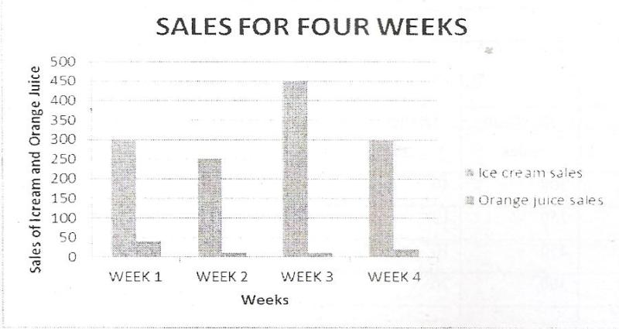

- State the cells that are needed to create the above column chart (2 marks)

………………………………………………………………………………………………………………………………………………………………………………………………
……………………………………………………………………………………………… ………………………………………………………………………………………………

- Apart from Ms-Excel state four examples of spreadsheets (2 marks)

………………………………………………………………………………………………………………………………………………………………………………………………
……………………………………………………………………………………………… ………………………………………………………………………………………………

