CHEMISTRY HOLIDAY ASSIGNMENT
FORM 1, TERM 2 2018
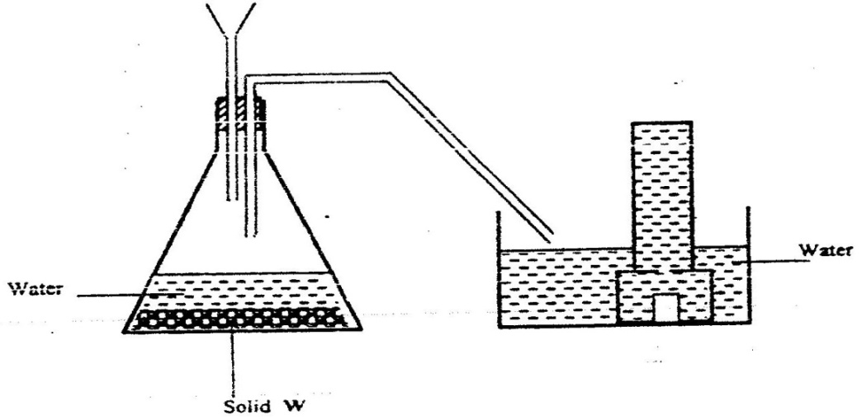
- The diagram below shows a set up used by a student in an attempt to prepare collect oxygen gas

a) i) Complete the diagram by collecting the mistakes in it. (2mks)
ii) Identify solid w. (1mk)
b) A piece of phosphorous was burnt in excess air. The amount of hot water to make a solution.
i) Write an equation for the burning of phosphorous in excess air. (1mk)
ii) The solution obtained in (b) above was found to have a PH of 2.0. Give reasons for this observation. (2mks)
- Why is iron not used to make steam boilers? (1mk)
- Study the arrangement below and answer the questions that follows.
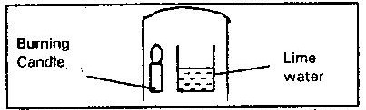

Explain what happens to the lime water after some time. (1mk)
4. When air is bubble through pure water (Ph 7.0). The PH drops to 6.0. Explain why. (1mk)
5. Magnesium ribbon was burned in a gas jar of Nitrogen. A few drops of water were then added to the jar. Write equation for the reactions in the jar. (2mks)
6. The diagram below represents two iron nails with some parts wrapped tightly with zinc and copper strips respectively.
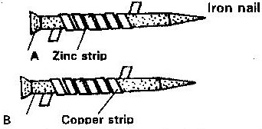

What observations would be made at the exposed points A and B if the wrapped nails are left in the open for several months? Explain. (3mks)
7. State and explain the change in mass that occurs when the following substances are separately heated in open crucibles.
i) Copper metal
ii) Copper (II) Nitrate
8. The diagram below shows an iron bar, which supports a bridge. The iron is connected to a piece of magnesium metal.
Iron bar
Soil
Connecting wire
Magnesium metal

Explain why it is necessary to connect the piece of magnesium metal to the iron bar.
9. Nitrogen (II) Oxide and nitrogen (IV) Oxide are some of the gases released from car exhaust pipes. State these gases affect the environment. (2mks)
10. When a student was stung by a nettle plant, a teacher applied an aqueous solution of ammonia to the affected area of the skin and the student was relieved of pain. Explain.
11. Explain 4 methods of preventing rusting.
12. State 2 factors that accelerates rusting.

