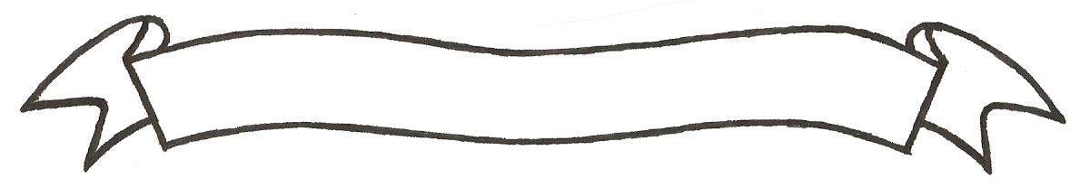

MERU UNIVERSITY OF SCIENCE AND TECHNOLOGY
P.O. Box 972-60200 – Meru-Kenya.
Tel: 020-2069349, 061-2309217. 064-30320 Cell phone: +254 712524293, +254 789151411
Fax: 064-30321
Website: www.must.ac.ke Email: info@mucst.ac.ke

University Examinations 2015/2016
FOURTH YEAR SECOND SEMESTER EXAMINATION FOR THE DEGREE OF BACHELOR OF SCIENCE IN FOOD SCIENCE AND TECHNOLOGY
AFT 3478: POST-HARVEST TECHNOLOGY OF NON-PERISHABLES
DATE: NOVEMBER 2015 TIME: 2 HOURS
INSTRUCTIONS: Answer question one and any other two questions

QUESTION ONE (30 MARKS)
- Outline any five preventive measures for control of grain insects from invading grains in storage. (5 Marks)
- Explain the main objectives of seed ratification. (1 Mark)
- Discuss briefly factors to consider when selecting a site to locate an on-farm grain drying, handling and storage facility. (4 Marks)
- Why is it important to cool grains immediately after drying? (4 Marks)
- Elucidate effect of ambient and grain temperature on safe storage of grains. (3 Marks)
- Monitoring of carbon dioxide levels in stored grains is an effective method for early detection of grain spoilage. Explain. (4 Marks)
- Diatomaceous earth is a cheap and effective grain protectant ag ainst pest. Elaborate. (5 Marks)
- Outline any four ways in which rodents damage stored grains. (4 Marks)

QUESTION TWO (20 MARKS)
- Discuss measures to be undertaken in preparation for reception of grains in an off-farm silo storage facility. (7 Marks)
- Grain insects can be classified in three groups based on the mode of accessing the part of grain that they feed on. Discuss. (8 Marks)
- Dehusking and drying of raw macadamia nuts is a critical step in its processing. Discuss. (5 Marks)
QUESTION THREE (20 MARKS)
- Explain use of “salt-jar” method to determine moisture content of grains in the field. (5 Marks)
- Distinguish between:
- Natural and artificial drying of grains. (2 Marks)
- Shallow-bed (or thin layer) drying and deep –bed drying of grains. (3 Marks)
- Discuss factors that determine the choice of drying system to be used in drying of grains. (10 Marks)
QUESTION FOUR (20 MARKS)
- Discuss main measures of preventing contamination of grains with aflatoxins. (8 Marks)
- Distinguish between endospermic seed and non-endospermic seed. (7 Marks)
- A seed coat is a vital part of a seed. Explain. (5 Marks)

