NAME: …………………………………………………… INDEX: ……………………………

SCHOOL.……………………………………………………………….………………………

233/1
CHEMISTRY
JULY 2018

233 / 1
CHEMISTRY
PAPER 1

EXCEL JOINT EVALUATION TEST
END OF TERM TWO 2018

INSTRUCTIONS TO CANDIDATES
- Answer all the questions in the spaces provided
- Mathematical tables and electronic calculators may be used
- All workings must be clearly shown where necessary
- Answer all questions in English

For Examiner’s Use Only

Questions | Maximum Score | Candidates Score
1-29 | 80

1.An element M has atomic number 5
(a) Write the electronic configuration of M (1mk)
………………………………………………………………………………………………………………………………………………………………………………………………(b) State the group and period to which element M belongs in the periodic table.
(2mks)
Group:………………………………………………

Period:………………………………………………

2. Consider the following equilibrium reaction:
2SO_{2(g)} + O_{2(g)} 2SO_{3(g)} ΔH = -196KJ
What will be the effect of increasing the temperature on the yield of Sulphur (VI) Oxide? Explain. (2mks)
……………………………………………………………………………………………………………………………………………………………………………………………………………………………………………………………………………………................
3.Use the following standard electrode potentials to answer the questions that follow.
Zn²⁺_{(aq)} + 2e⁻ Zn_{(s)} Eθ volts - 0.76
Cl_{2(g)} + 2e⁻ 2Cl⁻_{(aq)} + 1.36
Calculate the e.m.f of the following cell:
Zn_{(s)} / Zn^{2t}_{(aq)} // 2Cl⁻_{(aq)}, Cl_{2(g)} /Pt (2mk)
……………………………………………………………………………………………………………………………………………………………………………………………………………………………………………………………………………………................………………………………………………………………………………………………………………………………………………………………………………………………

(b) Write down the equation for the overall cell reaction (1mk)
………………………………………………………………………………………………

4 .Below is a table of the first five alkanes and their boiling points.
Name | Boiling Point (⁰C)
Methane | -161.5
Ethane | -88.6
Propane | -42.1
Butane | -0.5
Pentane | 36.1

(a) What is the state of pentane at room temperature (25⁰C)? (1mk)
…………………………………………………………………………………………………………………………………………………………………………………………………………
(b) Why do the boiling increase from Methane to Pentane? (2mks)
………………………………………………………………………………………………………………………………………………………………………………………………………………………………………………………………………………………………
5.In 30 seconds 180cm³ of oxygen diffused through a porous plate. How long will it take 400cm³ of carbon (IV) oxide to diffuse through the same plate? ( C= 12, 0= 16) (3 mks) ………………………………………………………………………………………………………………………………………………………………………………………………………………………………………………………………………………………………

6. A student collected the samples of water from two different sources. She measured equal volume of water in two different test-tubes. She added soap solution from a burette until permanent lather was formed. She then boiled another two samples of the same waters and repeated the experiment. She recorded the results in the table below.

Sample of Water | Volume of soap used before boiling (cm³) | Volume of soap used after boiling (cm³)
A | 30 | 10
B | 30 | 30

(a) Name the type of water hardness in sample A. Explain (2mks)
…………………………………………………………………………………………………………………………………………
(b) Name the cations that causes water hardness (2mk)
....................................................................................................................................................................................................................................................................................................................
- Give the systematic names of the following compounds: (2mks)
(a) CH₃ CH (CH₃) CH₂ CH₃
…………………………………………………………………………………………………
(b) CH₃ CH₂ CH₂ CH BrCH₂ OH
…………………………………………………………………………………………………
8. The diagram below show a set-up for the laboratory preparation of dry chlorine gas.

(a) Complete the diagram to show how dry chlorine gas is collected (1mk)
(b) Name:
(i) Substance G (1mk)
………………………………………………………………………………………………………………
(ii) A suitable drying agent (1mk)
………………………………………………………………………………………………………………
(iii) One industrial use of chlorine gas (1mk)
………………………………………………………………………………………………………………

9. An atom P contains 90% of isotope and 10% of isotope Calculate the relative atomic mass of P (3mks)
…………………………………………………………………………………………………………………………………………………………………………………………………………………………………………………………………………………………………………………………………………………………………………………………………………………………………………....................................................................................................
10. Explain why the enthalpy of neutralization of ethanoic acid with sodium hydroxide is different from that of hydrochloric acid with sodium hydroxide. (2mks) ……………………………………………………………………………………………………………………………………………………………………………………………………………………………………………………………………………………………………………………………………………………………………………………………………………………………….................................
11. The following results were obtained in an experiment
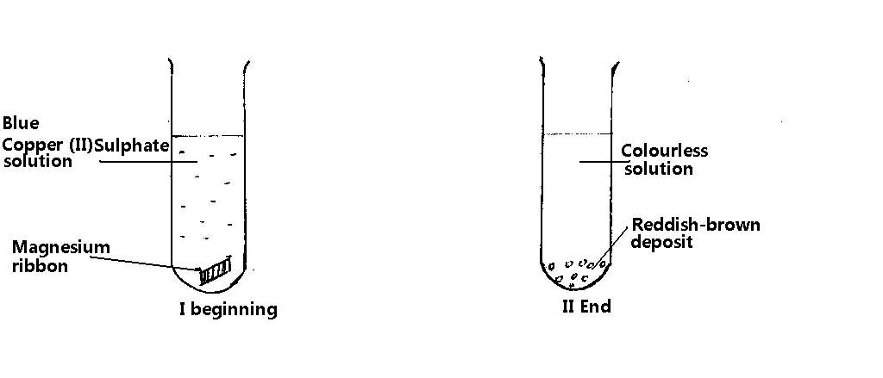
(a) Identify
- the reddish brown deposit (1mk)
…………………………………………………………………………………………………
- the colourless solution (1mk)
…………………………………………………………………………………………………

(b) Write an equation for the reaction taking place (1mk)
……………………………………………………………………………………………………

12 When 2.23g of Lead (II) Oxide were heated in a stream of dry hydrogen gas; 2.07g of Lead were formed and 0.18g of water was collected. Calculate the mass of hydrogen which combines with one mole of Oxygen atoms ( Pb = 27, O =16, H =1) (3mks)
………………………………………………………………………………………………………………………………………………………………………………………………………………………………………………………………………………………………………………………………………………………………………………………………
13 (a) Write an ionic equation for the reaction between copper (II) Sulphate and sodium (1mk) hydroxide solution.
……………………………………………………………………………………………………………………………………………………………………………………………………………………………………………………………………………………................

(b) Name the type of reaction in (a) above (1mk)
…………………………………………………………………………………………………………………………………………......................................................................................

14 How would you distinguish the following compounds; (CH₃COOH and CH₃CH₂OH?
(2mks)
………………………………………………………………………………………………………………………………………………………………………………………………………………………………………………………………………………………………………………………………………………………………………………………………
15 At room temperature Silicon (IV) Oxide is a solid where as Carbon(IV) Oxide is a gas although Silicon is next to carbon in group (IV) of the periodic table. Explain. (2mks)
………………………………………………………………………………………………………………………………………………………………………………………………………………………………………………………………………………………………
16 .Below are the bond dissociation energies of some elements
Bond | Bond dissociation energy (KJmol⁻¹)
C – C | 343
C – H | 414
H – H | 435
C_{(s)} C_{(g)} | 711
Use this information to calculate the heat of reaction for:
2C_{(s)} + 3H_{2(g)} C₂H₆ (g) (3mks)
……………………………………………………………………………………………………………………………………………………………………………………………………………………………………………………………………………………
17 25.0cm³ of a solution of hydrochloric acid dissolved 3g of magnesium ribbon. Calculate the concentration of hydrochloric acid in moldm⁻³ (Mg=24) (3mks)

18 Study the arrangement below and answer the question that follows
Explain what will be observed after sometime. (3mks)
………………………………………………………………………………………………………………………………………………………………………………………………………………………………………………………………………………………………………………………
19. Study the table below showing the solubility of a salt at various temperatures
Temperature (⁰C) | Solubility (g/100g water)
0  30  70  100 | 30  24  19  14
What would happen if a sample of a saturated solution of the salt at 30⁰C is heated to 70⁰C? Explain. (2mks)
……………………………………………………………………………………………………………………………………………………………………………………………………………………………………………………………………………………………………………………………………………………………………………………………………………………................
20. Both diamond and graphite have giant atomic structures. Explain why graphite is soft while diamond is hard. (3mks)
………………………………………………………………………………………………………………………………………………………………………………………………………………………………………………………………………………………………………………………
21. Excess chlorine was bubbled through a solution of potassium bromide. State and explain the observation made. (2mks)
.................................................................................................................................................................................................................................................................................................................................................................................................................................................................................
22. (a) What property of concentrated Sulphuric (VI) acid is illustrated by its action on:
(i) Sugar……………………………………………………………………………….. (1mk)
(ii) Copper metal ……………………………………………………………………. (1mk)
(b) Write the equation for the reaction of concentrated sulphuric acid with copper metal. (1mk)
………………………………………………………………………………………………………
23. A current was passed through molten aluminium oxide for 10minutes. The volume of oxygen collected at the anode was 112cm³ at s.t.p .Calculate the mass of aluminium obtained at the cathode.
(O = 16, Al = 27, molar gas volume at s.t.p = 22.4dm³, F = 96500C) (3mks)
...............................................................................................................................................................................................................................................................................................................................................................................................................................................................................................................................................................................................................................................
24. The formulae below represent the active ingredients in a soap and in a detergent respectively.
    - CH₃ (CH)₁₆ COO⁻ Na⁺
    - CH₃ (CH₂)₆ CH(CH₃)CH₂SO₃⁻Na⁺
(a)Explain why I is not suitable for washing using water from a river (1mk)
……………………………………………………………………………………………………………………………………………………………………………………………………………………………………………………………………………………................
(b)Give one advantage and one disadvantage of II (2mks)
……………………………………………………………………………………………………………………………………………………………………………………………………………………………………………………………………………………................
25.Two experiments were carried out as follows and the volume of hydrogen gas evolved measured at intervals of 10 seconds for 100 seconds
      - 8cm of magnesium ribbon was added to 1M hydrochloric acid.
      - 8cm of magnesium ribbon was added to 0.5M hydrochloric acid
Graphs of volume of hydrogen evolved against time were plotted thus
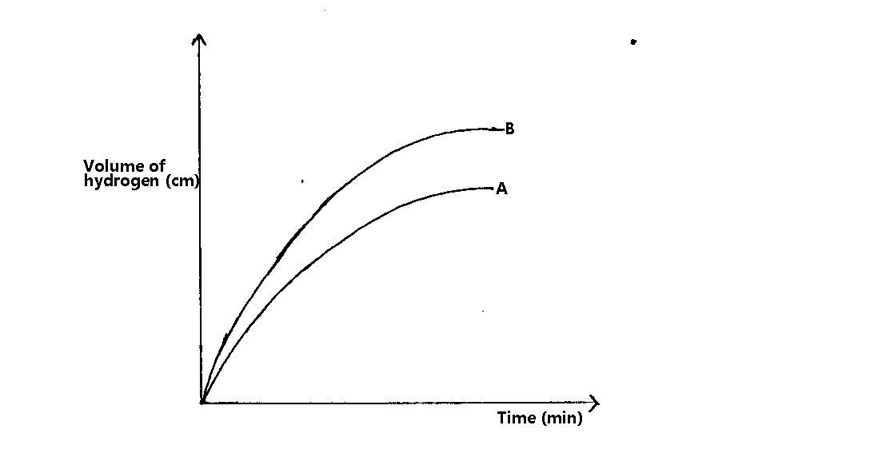
(a) Which of the graphs was obtained for reaction (i) Explain (2mks)
…………………………………………………………………………………………………
(b) Explain the general shape of graphs (1mk)
……………………………………………………………………………………………………………………………………………………………………………………………………………………………………………………………………………………………………… 26. One stage in the manufacture of nitric acid involves the catalytic oxidation of ammonia by the reaction.
4NH_{3 (g)} + 5O_{2 (g)} 4NO _{(g)} + 6H₂O _{(l)}
a) State two conditions under which this reaction is carried out (2mks) ...........................................................................................................................................................................................................................................................................................................................................
b) State two conditions under which nitric acid would react with magnesium metal to produce hydrogen gas. (1 mk)
........................................................................................................................................................................................................................................................................................................................27 .In an experiment, the heat generated from burning 0.7g of ethanol raised the temperature of 250⁰cm³ of water from 15⁰C to 35⁰C. Calculate.
(a) the quantity of heat produced during the experiment (1mk)
( density of water = 1gcm⁻³, sp.ht, cap of water = 4.2Jg⁻¹K⁻¹, O =16, C =12, H =1)
……………………………………………………………………………………………………………………………………………………………………………………………………………………………………………………………………………………................
(b) the molar enthalpy of combustion of ethanol (2mks)
……………………………………………………………………………………………………………………………………………………………………………………………………………………………………………………………………………………..............
28. Draw a dot-cross diagram to show bonding in Cl₂O ( Cl= 17, O = 8) (2mks)
................................................................................................................................................................................................................................................................................................................................................................................................................................................................................................................................................................................................................................................
29.Complete the diagram below to show how particles from a radioactive source can
be distinguished from each other. Label your diagram clearly. (3mks)
