NAME INDEX NUMBER
SCHOOL DATE

RADIOACTIVITY
            - 1989 Q 16
Complete the diagram below to show how the particles and rays are reflected and at
which material each of them is stopped. (2 marks)

Source of
α,βand Electrically charged Thin Sheet Thick lead
γRays plates paper Aluminium

1990 P1A Q 2
What are the values of m and a in the nuclear equation given below? (2 Marks)
a 230
X Y + 2α+2β
m 90

.............................................................................................................................................................................................................................................................................................................................................................................................................................................................................................................................................................................................

3. 1991 P1A Q13
Write mass number and atomic number of the isotope formed when it undergoes
radioactive decay by emitting a particle.
Mass number: (1 mark)

................................................................................................................................................................................................................................................................................................
Atomic number (1 mark)

................................................................................................................................................................................................................................................................................................

4. 1992 P1A Q17
Radioactive, polonium, 216, decays as shown below:-
216 208
PO Pb + Mα + nβ (2 marks)
84 82
Determine the values of M and N.
............................................................................................................................................................................................................................................................................................................................................................................................................................................................................................................................................................................................. ................................................................................................................................................................................................................................................................................................

5. 1993 P1A Q 14
(a) Complete the following equation 14 + 14
N⁺ C⁺ (2 marks)
7 6

.............................................................................................................................................................................................................................................................................................................................................................................................................................................................................................................................................................................................
(b) Give one use of radioactive elements (1 mark)

................................................................................................................................................

6. 1993 Q P1A 7
The Table below gives the rate of decay for radioactive element Y.

Number of days | Mass (g)
0 | 384
270 | 48

Calculate the half-life of the radioactive element Y.

................................................................................................................................................................................................................................................................................................................................................................................................................................................................................................................................................

7. 1995 P1A Q30
(a) 100g of radioactive 233 was reduced to 12.5g after 81 days.
Pa
91
Determine the half-life of Pa. (2 marks).

................................................................................................................................................................................................................................................................................................................................................................................................................................................................................................................................................
b) 233 decays by Beta emission. What is the mass number and the atomic
Pa
91 number of the element formed? (1 mark)

................................................................................................................................................................................................................................................................................................................................................................................................................................................................................................................................................

8. 1996 P1A Q 20
Complete the diagram below to show how α and β particles from radioactive can be
distinguished from each other. Label your diagram clearly. (3 marks)

Source of radiation Paper Metal foil

9. 1997 P1A Q 7
M grammes of a radioactive isotope decayed to 5 grammes in 100 days.
The half –life of the isotope is 25 days.
(a) What is meant by half-life? (1 mark)

........................................................................................................................................................................................................................................................................
(b) Calculate the initial mass M of the radioactive isotope. (2 marks)

............................................................................................................................................................................................................................................................................................................................................................................................................

10. 1998 P1A Q1
An isotope of Uranium 234 , decays by emission of an alpha particle to thorium. Th.
U
94
(a). Write the equation for the nuclear reaction undergone by the isotope. (1 mark)

....................................................................................................................................
(b). Explain why it is not safe to store radioactive substances in containers made from
Aluminum sheets. (1 mark)
............................................................................................................................................................................................................................................................................................................................................................................................................

11 1999 Q 26
The graph below shows the mass of a radioactive isotope plotted against time

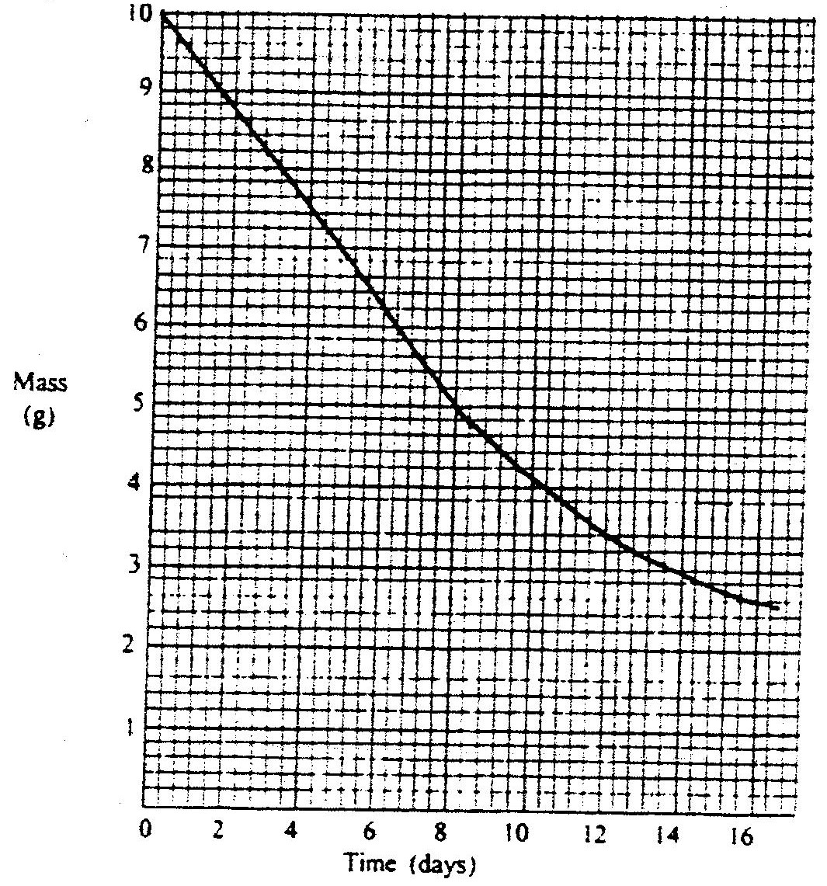

    - Using the graph, determine the half – life of the isotope

............................................................................................................................................................................................................................................................................................................................................................................................................

    - Calculate the mass of the isotope present after 32 days
..............................................................................................................................................................................................................................................................................................................................................................................................................................
12. 2000 Q 13
A radioactive isotope X₂ decays by emitting two alpha (a) particles and one
beta (β) to from 214
Bi
83
(a) What is the atomic number of X₂?
.............................................................................................................................................................................................................................................................................................................................................................................................

(b) After 112 days, ¹/₁₆ of the mass of X₂ remained. Determine the half life of X₂

.............................................................................................................................................................................................................................................................................................................................................................................................
13. 2001 Q 1
Study the nuclear reaction given below and answer the questions that follow.
14
C
6
14
C
6
12
C
6

- 12 and 14 are isotopes. What does the term isotopes. What does the term isotope mean?
C C
6 6

........................................................................................................................................................................................................................................................................
(b) Write an equation for the nuclear reaction in step II
14 14 0 or 14 14 0
C N e C N e
6 7 I 6 7 i

....................................................................................................................................

(c) Give one use of 14
C

6

....................................................................................................................................
- 2002 Q 10
The graph below represents a radioactive decay series for isotope H.
Study it and answer the questions that follow

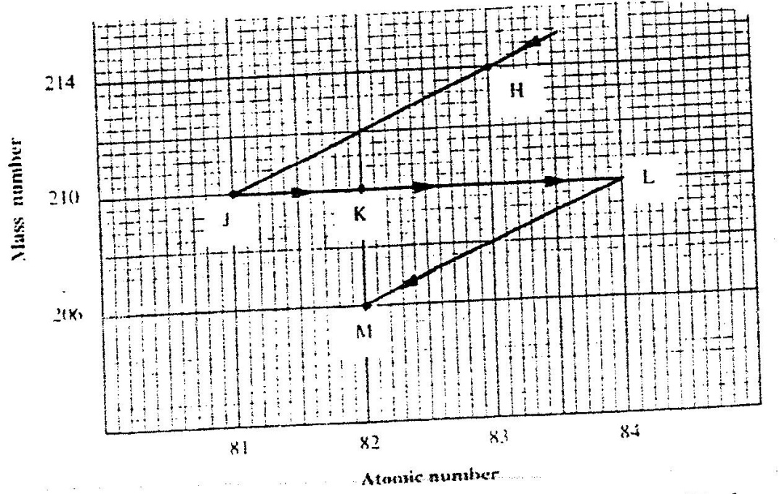

(a) Name the type of radiation emitted when isotope H changes to isotope J.

...............................................................................................................................
(b) Write an equation for the nuclear reaction that occur when isotope J changes to isotope K
210 210
j k e
81 82 + -1

....................................................................................................................................
c) Identify a pair of isotope of an element in the decay series

........................................................................................................................................................................................................................................................................

- 2005 Q 14
100 g of a radioactive substance was reduced to 12.5 g in 15.6 years.
Calculate the half – life of the substance. (2 marks)

............................................................................................................................................................................................................................................................................................................................................................................................................
- 2006 Q 4
(a) Complete the nuclear equation below. (1 mark)
37 37
A….. B
18 17

........................................................................................................................................................................................................................................................................
(b) State one:
(i) Use of radioisotopes in agriculture (1mark)

...............................................................................................................................
(ii) Danger associated with exposure of human beings to radioisotopes (1 mark)

...............................................................................................................................
17. 2007 Q 14
a) Distinguish between nuclear fission and nuclear fusion. (2 marks)

................................................................................................................................................................................................................................................................................................................................................................................................................................................................................................................................................
  - Describe how solid wastes containing radioactive substances should be disposed of. (1 mark)

................................................................................................................................................................................................................................................................................................................................................................................................................................................................................................................................................

18. 2008 Q 24
a) A radioactive substance emits three different particles. Give the symbol of the particle
with the highest mass. (1 mark)

....................................................................................................................................
b) (i) Find the values of Z₁ and Z₂ in the nuclear equation below
_{Z1} ₁ ₉₄ ₁₄₀ ₁
U + n Sr + X_{e} +2 n
⁹² ⁰ ³⁸ ^{Z0} ⁰
ii) What type of nuclear reaction is represented in represented in b (i) above?
(1mark)
Temperature (⁰C)
t₀
t₁
t₂
t₃
t₄

Time (minutes)
Give the name of the:
a) Process taking place between t₀ and t_{1.} (1mark)

....................................................................................................................................
b) Energy change that occurs between t₃ and t₄

...............................................................................................................................
19. 2009 Q 6d P2
(d) Naturally occurring uranium consist of three isotopes which are radioactive.
Isotopes 234 u 235u 238u
Abundance 0.01% 0.72% 99.27%
(i) Which of these isotopes has the longest half-life? Give reasons. (1 mark)

........................................................................................................................................................................................................................................................................
(ii) Calculate the relative atomic mass of uranium. (2 marks)

................................................................................................................................................................................................................................................................................................................................................................................................................................................................................................................................................
(iii) 235 is an alpha emitter .If the product of the decay of this nuclide
U
92 is thorium (Th) .Write a nuclear equation for the process. (1 mark)

...............................................................................................................................
iv) State one use of radioactive isotopes in the paper industry (2 marks)

..............................................................................................................................................................................................................................................................
20. 2010 Q 9
Carbon -14,¹⁴₆C, is used in carbon dating. It decays to form nitrogen, ¹⁴₇N. The graph
below shows the amount of carbon -14 left in a sample against its age in years.

- Write a nuclear equation for the decay process of carbon -14. (1 mark)
...............................................................................................................................
- From the graph, determine the;
- Half-life of carbon -14; (1 mark)
................................................................................................................................................................................................................................................

- Percentage of carbon -14 in a sample whose age is 1950 years. (1 mark)
................................................................................................................................................................................................................................................
21. 2011 Q 2
Complete the nuclear equation below:
- 131 131
I Xe +
53 54
- The half life of 131
I is 8 days.
53

131
Determine the mass of I remaining if 50 grammes decayed for 40 days.
53 ..............................................................................................................................................................................................................................................................................................................................................................................................................................
- Give one harmful effect of radioisotopes. (1 mark)
...............................................................................................................................

22. 2012 Q9 P1
120g of iodine – 131 has a half life of 8 days decays for 32 days. On the grid provided,
plot a graph of the mass of iodine – 131 against time. (3 marks)

