NAME……………………………………………………………
ADM. NO . …………………… date ……………………………
CLASS…………………………………………………………….
P/ score …………………………T/score………………………….
232
PHYSICS
FORM TWO
2 HOURS
SERIES THREE TERM T

THE CENTRAL PUBLISHERS
FORM TWO
Instructions to Candidates
- Write your name and class register number in the spaces provided above.
- Sign and write the date of examination in the spaces provided above.
- Answer ALL the questions in the spaces provided.
- ALL working MUST be clearly shown.
- Mathematical tables and non programmable silent electronic calculators may be used

This paper consists of 8 printed pages.

For Examiner’s Use Only
Section | Question | Maximum  Score | Candidate’s  Score
 | 1-17 | 55

- A butcher has a beam balance and masses 0.5 kg and 2kg. How would he measure 1.5 kg of meat on the balance at once? (2 marks)
………………………………………………………………………………………………………………………………………………………………………………………………………………………………………………………………………………………………………………………………………………………………………
- In an experiment to determine the density of sand using a density bottle, the following measurements were recorded:
Mass of empty density bottle - 43.2g
Mass of density bottle full of water = 66.4g
Mass of density bottle with some sand = 67.5g
Filled up with water = 82.3g

Use the above data to determine the:
    - Mass of the water that completely filled the bottle: (2 marks)
………………………………………………………………………………………………………………………………………………………………………………………………………………………………………………………………………………………………………………………………………………………………………………………………

    - Volume of water that completely filled the bottle: (1 mark)
………………………………………………………………………………………………………………………………………………………………………………………………………………………………………………………………………………………………………………………………………………………………………………………………

    - Volume of the density bottle: (1 marks)
………………………………………………………………………………………………………………………………………………………………………………………………………………………………………………………………………………………………………………………………………………………………………………………………

    - Mass of sand (2marks)
………………………………………………………………………………………………………………………………………………………………………………………………………………………………………………………………………………………………………………………………………………………………………………………………

v). Mass of water that filled the space above the sand. (1marks)
………………………………………………………………………………………………………………………………………………………………………………………………………………………………………………………………………………………………………………………………………………………………………………………………

vi).Volume of the sand: (2marks)
………………………………………………………………………………………………………………………………………………………………………………………………………………………………………………………………………………………………………………………………………………………………………………………………
vi).Density of the sand (2 marks)
……………………………………………………………………………………………………………………………………………………………………………………………………………………………………………………………………………………………………………………………………………………………………………………………………………………………………………………

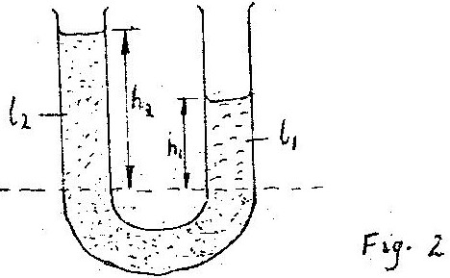

- Figure 2 shows a U tube containing two liquids L₁ and L₂ of densities 0.8 g cm⁻³
and 1.8 cm⁻³ respectively in equilibrium. Given that h₂ = 8 cm determine the value
of h₁ (3 marks)
……………………………………………………………………………………………………………………………………………………………………………………………………………………………………………………………………………………………………………………………………………………………………………………………………………………………………………………………………………………………………………………………………………………………

- State the reason why it may not be possible to suck liquid into your mouth using drinking straw on the surface of the moon. ( 2marks)
………………………………………………………………………………………………………………………………………………………………………………………………………………………………………………………………………………………………

- The total weight of a car with passengers is 25,000N. The area of contact of each of the four tyres with the ground is 0.025m². Determine the minimum car tyre pressure
(3marks) .
……………………………………………………………………………………………………………………………………………………………………………………………………………………………………………………………………………………………………………………………………………………………………………………………………..

- What is meant by virtual image? (1 mark)
………………………………………………………………………………………………………………………………………………………………………………………………………………………………………………………………………………

- Figure 6 shows a ray of light being reflected from a mirror.

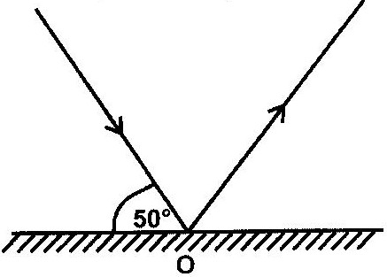

      - Figure 6

    - What is the angle of reflection? (1mark)
………………………………………………………………………………………………………………………………………………………………………………………………

- One property of a liquid that is considered while construction a liquid – in – glass thermometer is that the liquid expands more than the glass for the same temperature change. State any other two properties of the liquids that are considered ( 2marks)
………………………………………………………………………………………………………………………………………………………………………………………………………………………………………………………………………………

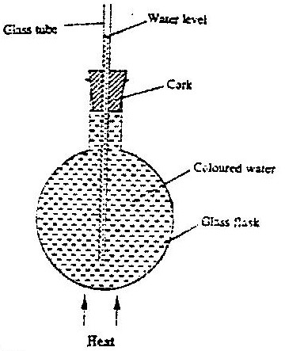
- a)In the set up shown in Figure 4, it is observed that the level of the water initially drops before starting to rise. Explain this observation (2marks)

        - Figure 4
…………………………………………………………………………………………………………………………………………………………………………………………………………………………………………………………………………………………………………………………………………………………………………

  - The temperature of water in a measuring cylinder is lowered from about 20⁰ c to 0⁰. On the axes provided, sketch the graph of the Volume against temperature assuming the water does not freeze. (2marks)

Volume

Temperature

- In the Brownian motion experiment, smoke particles are observed to move randomly. Explain how this motion is caused (2 marks)
……………………………………………………………………………………………………………………………………………………………………………………………………………………………………………………………………………………………………………………………………………………………………….

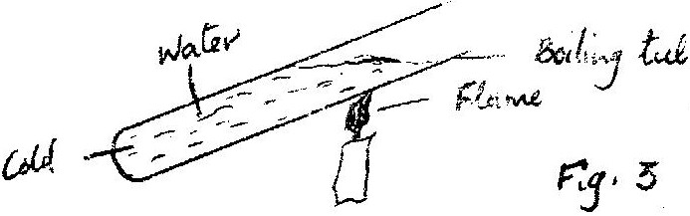
- In the set up shown in figure 3, water near the top of the boiling tube boils while at the bottom it remains cold.

Give a reason for the observation (1mark)
……………………………………………………………………………………………………………………………………………………………………………………………………………………………………………………………………………………………
- A wooden bench and a metal bench are both left in the sun for along time. Explain why the metal bench feels hotter to touch. (1mark)
………………………………………………………………………………………………………………………………………………………………………………………………………………………………………………………………………………

State Hooke's law (2marks)
………………………………………………………………………………………………………………………………………………………………………………

- The three springs shown in the figure are identical and have negligible weight. The extension produced on the system of springs is 20cm.

      - 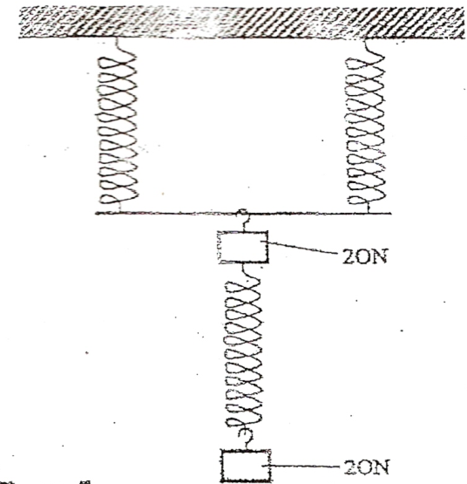

Determine the constant of each spring. (3 marks)
………………………………………………………………………………………………………………………………………………………………………………………………………………………………………………………………………………………………………………………………………………………………………………………………
What is meant by the centre of gravity of a body? (1mark)
……………………………………………………………………………………………………………………………………………………………………………………………………………………………………………………………………………………………

- State one advantage of fitting wide tyres on a vehicle that moves on earth roads. (1mark)
………………………………………………………………………………………………………………………………………………………………………………………………………….

- Fig. 7 shows how magnets are stored in pairs with keepers at the ends
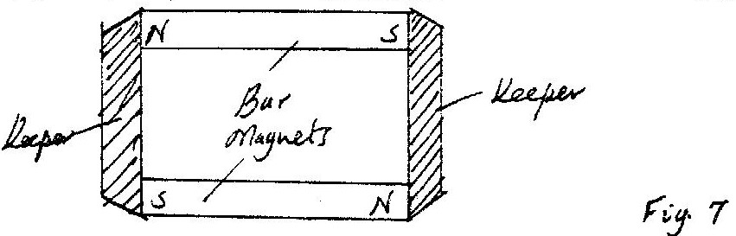

Explain how this method of storing helps in retaining magnetism longer. ( 2marks)
………………………………………………………………………………………………………………………………………………………………………………………………………………………………………………………………………………………………………………………..……………………………

- Give one advantage of using a convex mirror as a driving mirror (1mark)
………………………………………………………………………………………………………………………………………………………………

17. The magnetic field between the poles of two permanent bar magnets is shown below. The neutral point is marked X
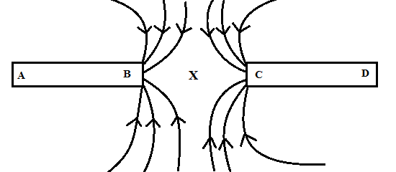
- Explain what is meant by a neutral point? (1 mark)
………………………………………………………………………………………………………………………………………………………………………………………………………………………………………………………………………………………………………
- Identify the poles marked A, B, C and D. (2 marks)

…………………………………………………………………………………………………………………………………………………………………………………………………………………………………………………………………………………………………………………………………………………………………………………………………………
- Which is the stronger pole? B or C. (1 mark)
……………………………………………………………………………………………………………………………………………………………………………………………………
- Give a reason to your answer in (c) above. (1 mark)

………………………………………………………………………………………………………………………………………………………………………………………………………………………………………………………………………………………………………
- The two magnets were prepared by a student in a college. Suggest two different methods by which she could have prepared the two magnets. (2 marks)
………………………………………………………………………………………………………………………………………………………………………………………………………………………………………………………………………………………………………

- Draw the magnetic domains in magnet AB showing clearly the north and south poles.
(2 marks)
A B

- (i) State one difference between the magnetic properties of steel and iron. (2 marks)
…………………………………………………………………………………………………………………………………………………………………………………………
- Given the two materials state which you would use to make: (2 marks)
- An electromagnet
…………………………………………………………………………………………

- A compass needle.
…………………………………………………………………………………………

THIS IS THE LAST PRINTED PAGE
BEST WISHES

