Name: ………………………………………………………….. Index No. ……………………………………

Date: …………………………………………………………. Candidate’s Sign. …………................................

443/1
AGRICULTURE
Paper 1
OCT/NOV 2017
Time: 2 Hours

Kenya Certificate of Secondary Education (K.C.S.E.)
FORM THREE

INSTRUCTIONS TO THE CANDIDATES:
- Write your name, index number and school in the spaces provided above.
- Sign and write the date of examination in the spaces provided.
- This paper consists of Three Sections: A, B and C.
- Answer ALL the questions in section A and B and any TWO questions from section C.
- Answers should be written in the spaces provided.
- This paper consists of 11printed pages.
- Candidates should check the questions paper to ascertain that all the pages are printed as indicated and that no questions are missing.

For Examiners’ Use Only
SECTION | QUESTIONS | MAXIMUM SCORE | CANDIDATE’S SCORE
A | 1-18 | 30
B | 19-24 | 20
C 25-27 |  | 20
 |  | 20
 |  | 90
This paper consists of 11 printed pages. Candidates should check to ascertain that all pages are printed as indicated and that no questions are missing.
SECTION B (30MARKS)
Answer all the questions in the spaces provided
1. List four methods of draining a waterlogged land. (2 mks)
………………………………………………………………………………………………………..
………………………………………………………………………………………………………..
………………………………………………………………………………………………………..
………………………………………………………………………………………………………..
2. State four factors that determine the scale of production in agriculture. (2 mks)
………………………………………………………………………………………………………..
………………………………………………………………………………………………………..
………………………………………………………………………………………………………..
………………………………………………………………………………………………………..
3. Define the following terms:
(a) Pastoralism (1 mk)
………………………………………………………………………………………………………..
(b) Apiculture (1 mk)
………………………………………………………………………………………………………..
4. State three reasons for carrying out tertiary tillage practices in crop production. (1 ½ mks)
………………………………………………………………………………………………………..
………………………………………………………………………………………………………..
………………………………………………………………………………………………………..
………………………………………………………………………………………………………..
5. State four advantages of extensive farming. (2 mks)
………………………………………………………………………………………………………..
………………………………………………………………………………………………………..
………………………………………………………………………………………………………..
………………………………………………………………………………………………………..
6. Distinguish between oversowing and undersowing in crop production. (2 mks)
………………………………………………………………………………………………………..
………………………………………………………………………………………………………..
7. State four factors that a farmer should consider when selecting materials for vegetative
propagation. (2 mks)
………………………………………………………………………………………………………..
………………………………………………………………………………………………………..
………………………………………………………………………………………………………..
………………………………………………………………………………………………………..
8. State two conditions that lead to salinisation. (1 mk)
………………………………………………………………………………………………………..
………………………………………………………………………………………………………..
9. Name the type of farm record; (2 mks)
(a) that show the total yield and yield per enterprise. …………………………………………………
(b) that show all the farm assets. …………………………………………………………….…………
(c) that show field activities. ……………………………………………………………..……………
(d) that show date of employment of workers. …………………………………………………………
10. State three reasons for earthing up in crop production. (1 ½ mks)
………………………………………………………………………………………………………..
………………………………………………………………………………………………………..
………………………………………………………………………………………………………..
………………………………………………………………………………………………………..
11. State three methods that facilitate rotational grazing. (1 ½ mks)
………………………………………………………………………………………………………..
………………………………………………………………………………………………………..
………………………………………………………………………………………………………..
………………………………………………………………………………………………………..
12. State two ways of classifying pastures. (1 mk)
………………………………………………………………………………………………………..
………………………………………………………………………………………………………..
13. Give one reason for forking in carrot production. ( ½ mk)
………………………………………………………………………………………………………..
14. Give four pieces of information contained in a land title deed. (2 mks)
………………………………………………………………………………………………………..
………………………………………………………………………………………………………..
………………………………………………………………………………………………………..
………………………………………………………………………………………………………..
15. State four management practices carried out on young trees immediately after transplanting. (2 mks)
………………………………………………………………………………………………………..
………………………………………………………………………………………………………..
………………………………………………………………………………………………………..
………………………………………………………………………………………………………..
16. State two ways in which transport and communication influence agricultural production. (2 mks)
………………………………………………………………………………………………………..
………………………………………………………………………………………………………..

17. State four characteristics of materials used in preparation of compost manure. (2 mks)
………………………………………………………………………………………………………..
………………………………………………………………………………………………………..
………………………………………………………………………………………………………..
………………………………………………………………………………………………………..
18. Give two deficiency symptoms of phosphorus. (1 mk)
………………………………………………………………………………………………………..
………………………………………………………………………………………………………..
SECTION B (20 MARKS)
Answer ALL the questions in this section in the spaces provided.
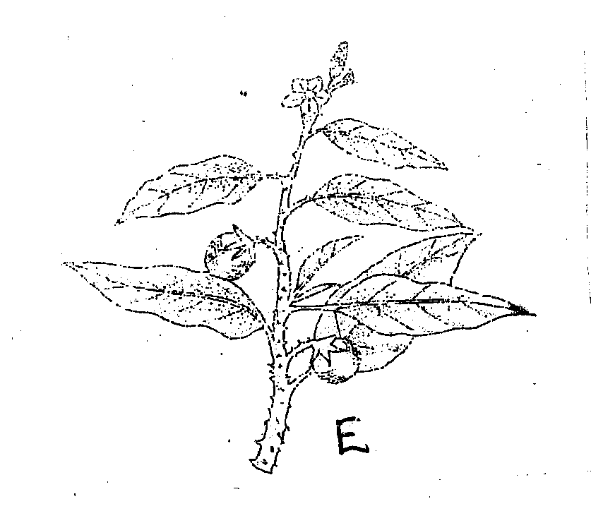
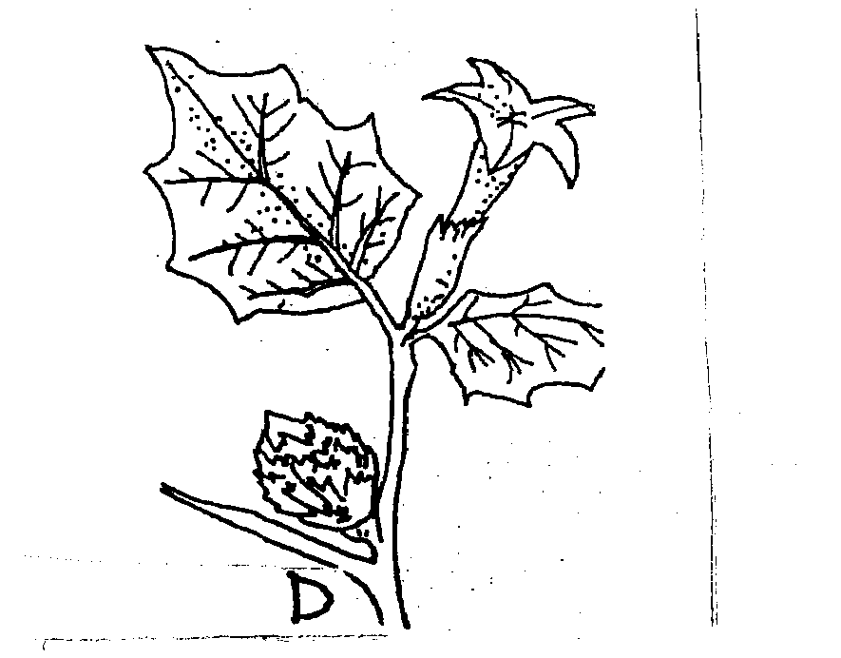
19. The diagrams below show some common arable weeds. Study them and answer the questions that follow.

(a) Identify the weeds: (1 mk)
D………………………………………………………
E………………………………………………………
(b) Give one reason why it is difficult to control weed E. (1 mk)
…………………………………………………………………………………………………
(c) State one major harmful effect of weed D. (1 mk)
…………………………………………………………………………………………………
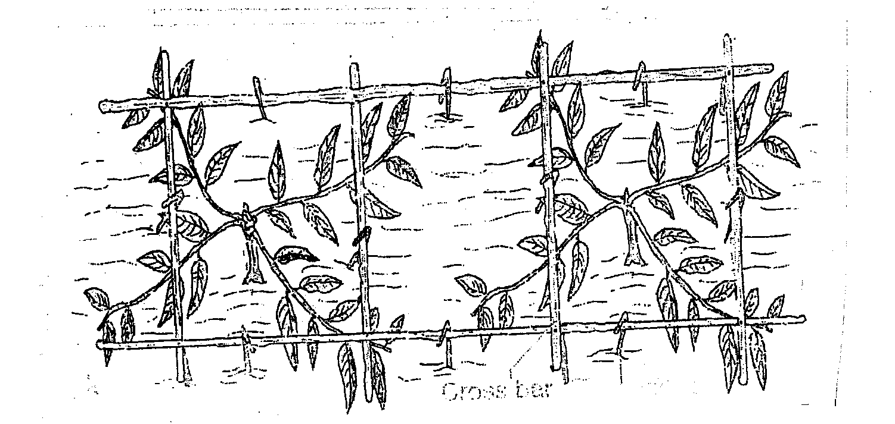
20. The diagram below shows one of the methods of bringing young tea into bearing. Study it and answer the questions below.

Cross bar

(a) Identify the method. (1 mk)
………………………………………………………………………………………………
(b) State two advantages of using the method identified above. (2 mks)
……………………………………………………………………………………………………..
……………………………………………………………………………………………………..
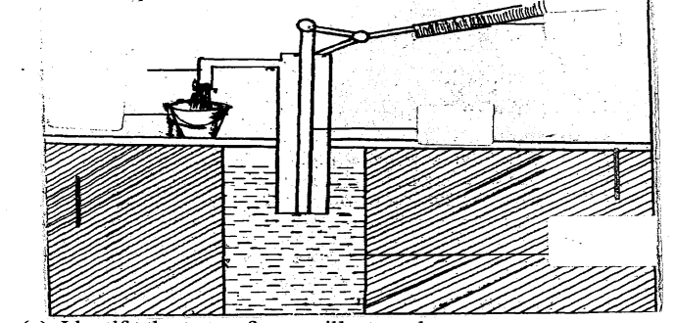
21. The diagram below is an illustration of a way of pumping water in a farm. Study it and answer the questions that follow.

(a) Identify the type of pump illustrated. (1 mk)
………………………………………………………………………………………………….
(b) Apart from the one named in 2 1(a) above, give two other pumps used in a farm. (2 mks)
…………………………………………………………………………………………………
…………………………………………………………………………………………………
22. Study the diagrams below and answer the questions that follow.
The diagrams represent different types of a soil property.
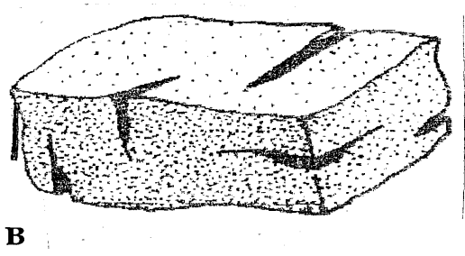
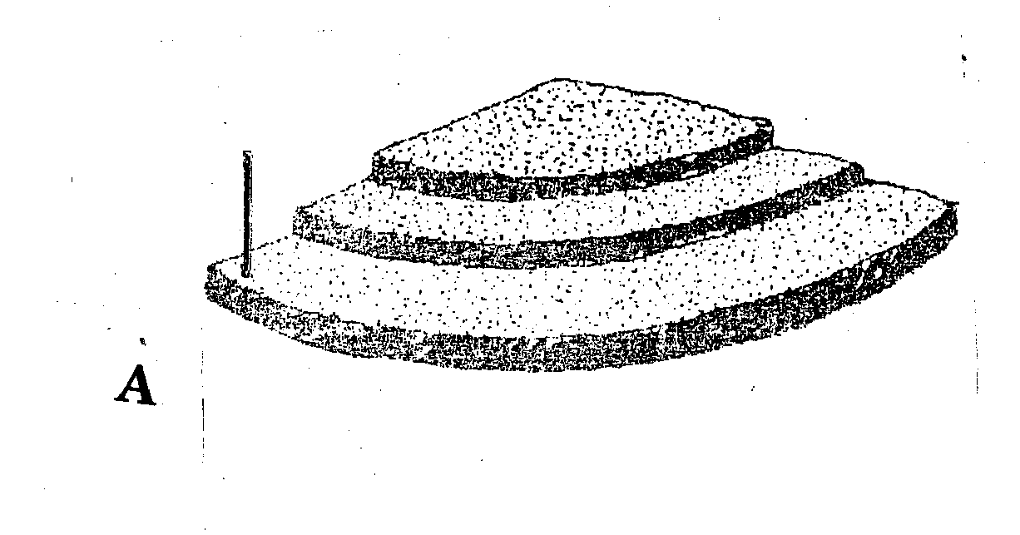

(a) Identify the property of soil illustrated above in A and B. (2 mks)
A……………………………………………………..
B……………………………………………………
(b) State two ways by which the property influences crop production. (2 mks)
………………………………………………………………………………………………………..
………………………………………………………………………………………………………..
………………………………………………………………………………………………………..
23. Study the diagram shown below and use it to answer the questions that follow.

(a) Identify the fungal disease indicated above. (1 mk)
………………………………………………………………………………………………
(b) State the causal organism of the disease identified above. (1 mk)
………………………………………………………………………………………………..
(c) State one symptom of the disease above. (1 mk)
…………………………………………………………………………………………………
24. Study the diagram below and answer the questions that follow.
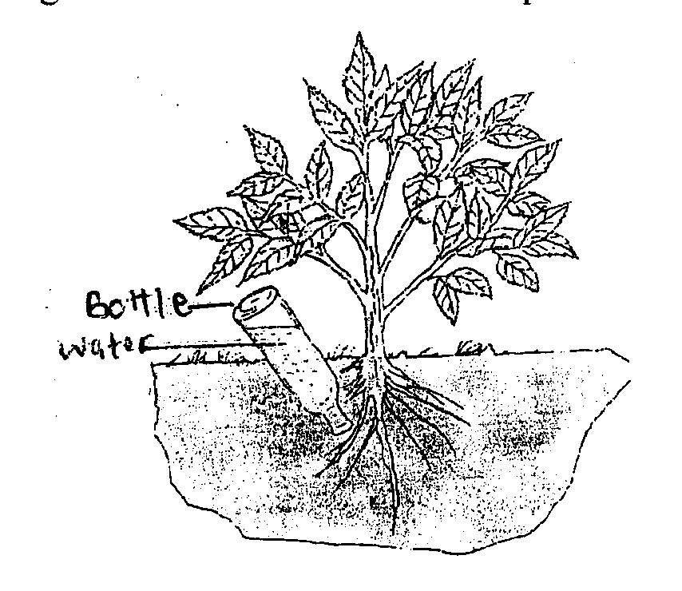

(a) Identify the irrigation system shown in the diagram. (1 mk)
…………………………………………………………………………………………………..
(b) State three advantages of using the above irrigation system. (3 mks)
…………………………………………………………………………………………………..
…………………………………………………………………………………………………..
…………………………………………………………………………………………………..

SECTION C (40 MARKS)
Answer any TWO questions from this section in the answer sheet provided.
25. (a) Explain why it is necessary to carryout drainage in a waterlogged soil before
growing a crop. (4 mks)
(b) Explain five important qualities of a fertile soil. (10 mks)
(c) Explain six reasons for timely planting in crop production. (6 mks)
26. (a) Describe the production of bulb onions under the following sub-headings:
(i) Ecological requirements (4 mks)
(ii) Nursery establishment (4 mks)
(iii) Weed control (3 mks)
(iv) Harvesting (3 mks)
(b) Describe the procedure of harvesting cotton. (6 mks)
27. (a) Explain six cultural methods of controlling pests in a crop field. (12 mks)
(b) Describe the process of Gully Erosion. (4 mks)
(c) Describe four structural methods used in controlling soil erosion. (4 mks)
………………………………………………………………………………………………………..
………………………………………………………………………………………………………..
………………………………………………………………………………………………………..
………………………………………………………………………………………………………..
………………………………………………………………………………………………………..
………………………………………………………………………………………………………..
………………………………………………………………………………………………………..
………………………………………………………………………………………………………..
………………………………………………………………………………………………………..
………………………………………………………………………………………………………..
………………………………………………………………………………………………………..
………………………………………………………………………………………………………..
………………………………………………………………………………………………………..
………………………………………………………………………………………………………..
………………………………………………………………………………………………………..
………………………………………………………………………………………………………..
………………………………………………………………………………………………………..
………………………………………………………………………………………………………..
………………………………………………………………………………………………………..
………………………………………………………………………………………………………..
………………………………………………………………………………………………………..
………………………………………………………………………………………………………..
………………………………………………………………………………………………………..
………………………………………………………………………………………………………..
………………………………………………………………………………………………………..
………………………………………………………………………………………………………..
………………………………………………………………………………………………………..
………………………………………………………………………………………………………..
………………………………………………………………………………………………………..
………………………………………………………………………………………………………..
………………………………………………………………………………………………………..
………………………………………………………………………………………………………..
………………………………………………………………………………………………………..
………………………………………………………………………………………………………..
………………………………………………………………………………………………………..
………………………………………………………………………………………………………..
………………………………………………………………………………………………………..
………………………………………………………………………………………………………..
………………………………………………………………………………………………………..
………………………………………………………………………………………………………..
………………………………………………………………………………………………………..
………………………………………………………………………………………………………..
………………………………………………………………………………………………………..
………………………………………………………………………………………………………..
………………………………………………………………………………………………………..
………………………………………………………………………………………………………..
………………………………………………………………………………………………………..
………………………………………………………………………………………………………..
………………………………………………………………………………………………………..
………………………………………………………………………………………………………..
………………………………………………………………………………………………………..
………………………………………………………………………………………………………..
………………………………………………………………………………………………………..
………………………………………………………………………………………………………..
………………………………………………………………………………………………………..
………………………………………………………………………………………………………..
………………………………………………………………………………………………………..
………………………………………………………………………………………………………..
………………………………………………………………………………………………………..
………………………………………………………………………………………………………..
………………………………………………………………………………………………………..
………………………………………………………………………………………………………..
………………………………………………………………………………………………………..
………………………………………………………………………………………………………..
………………………………………………………………………………………………………..
………………………………………………………………………………………………………..
………………………………………………………………………………………………………..
………………………………………………………………………………………………………..
………………………………………………………………………………………………………..
………………………………………………………………………………………………………..
………………………………………………………………………………………………………..

