Name :…………………………………………………….…… Adm.no ………..........................................

School :…………………………………………………..……… .. Class…………………………….………..

Candidate’s sign……………………………..… Date :…………………………………

443/2
AGRICULTURE
Paper 2
OCT/NOV 2017
Time: 2 Hours

Kenya Certificate of Secondary Education (K.C.S.E.)
FORM THREE

INSTRUCTIONS TO THE CANDIDATES:
- Write your name, index number and school in the spaces provided above.
- Sign and write the date of examination in the spaces provided.
- This paper consists of Three Sections: A, B and C.
- Answer ALL the questions in section A and B and any TWO questions from section C.
- Answers should be written in the spaces provided.
- This paper consists of 11printed pages.
- Candidates should check the questions paper to ascertain that all the pages are printed as indicated and that no questions are missing.

For Examiners’ Use Only
SECTION | QUESTIONS | MAXIMUM SCORE | CANDIDATE’S SCORE
A | 1-19 | 30
B | 20-23 | 20
C 24 -26 |  | 20
 |  | 20
 |  | 90
This paper consists of 8 printed pages. Candidates should check to ascertain that all pages are printed as indicated and that no questions are missing.
SECTION A (30 MARKS)
Answer ALL the questions in this section in the spaces provided
1. State four importance of keeping livestock healthy. (2 mks)
………………………………………………………………………………………………………………..
………………………………………………………………………………………………………………..
………………………………………………………………………………………………………………..
………………………………………………………………………………………………………………..
2. Give one use of each of the following hammers: (1 mk)
(a) Ball-pein Hammer
………………………………………………………………………………………………………………..
(b) Sledge Hammer
………………………………………………………………………………………………………………..
3. State two pre-disposing factors of foot rot. (1 mk)
………………………………………………………………………………………………………………..
………………………………………………………………………………………………………………..
4. State four functions of water in the body of animals. (2 mks)
………………………………………………………………………………………………………………..
………………………………………………………………………………………………………………..
………………………………………………………………………………………………………………..
………………………………………………………………………………………………………………..
5. State three various methods used in selection of livestock. ( ½ mks)
………………………………………………………………………………………………………………..
………………………………………………………………………………………………………………..
………………………………………………………………………………………………………………..
6. Outline three disadvantages of artificial insemination in cattle management (1 ½ mks)
………………………………………………………………………………………………………………..
………………………………………………………………………………………………………………..
………………………………………………………………………………………………………………..
7. Name four breeds of dairy goats. (2 mks)
………………………………………………………………………………………………………………..
………………………………………………………………………………………………………………..
………………………………………………………………………………………………………………..
………………………………………………………………………………………………………………..
8. Give four advantages of using spray race in controlling ticks from livestock. (2 mks)
………………………………………………………………………………………………………………..
………………………………………………………………………………………………………………..
………………………………………………………………………………………………………………..
………………………………………………………………………………………………………………..

9. State four reasons for proper maintenance of farm tools and equipment. (2 mks)
………………………………………………………………………………………………………………..
………………………………………………………………………………………………………………..
………………………………………………………………………………………………………………..
………………………………………………………………………………………………………………..
10 Give four reasons why farmers handle livestock . (2mks)
………………………………………………………………………………………………………………..
………………………………………………………………………………………………………………..
………………………………………………………………………………………………………………..
………………………………………………………………………………………………………………..
11. State three importance of flushing in sheep. ( ½ mks)
………………………………………………………………………………………………………………..
………………………………………………………………………………………………………………..
………………………………………………………………………………………………………………..
12. Name three common pests that attack bees in a hive. ( 1½ mks)
………………………………………………………………………………………………………………..
………………………………………………………………………………………………………………..
………………………………………………………………………………………………………………..
13. Give three methods of applying a caricides. ( 1 ½ mks)
………………………………………………………………………………………………………………..
………………………………………………………………………………………………………………..
………………………………………………………………………………………………………………..
14. Name two species of camels that can be kept. (1 mk)
………………………………………………………………………………………………………………..
………………………………………………………………………………………………………………..
15. Give four maintenance practices of a fish pond. (2 mks)
………………………………………………………………………………………………………………..
………………………………………………………………………………………………………………..
………………………………………………………………………………………………………………..
………………………………………………………………………………………………………………..
16. Give two main functions of crop in the digestive systems of poultry. (1 mk)
………………………………………………………………………………………………………………..
………………………………………………………………………………………………………………..
17. Give one reason why a dropper is used in fencing ( ½ mk)
………………………………………………………………………………………………………………..

18. State five ideal features of a rabbit hutch. (2 ½ mks)
………………………………………………………………………………………………………………..
………………………………………………………………………………………………………………..
………………………………………………………………………………………………………………..
………………………………………………………………………………………………………………..
………………………………………………………………………………………………………………..
19. State five advantages of Kenya Top Bar hive over log hive. (2 ½ mks)
………………………………………………………………………………………………………………..
………………………………………………………………………………………………………………..
………………………………………………………………………………………………………………..
………………………………………………………………………………………………………………..
SECTION B (20MARKS)
Answer all the questions in the spaces provided
20. Observe the tools X and Y illustrated below and answer the questions that follow

Y
X

(a) Identify the tools. (2 mks)
X…………………………………………
Y…………………………………………
(b) State ONE use of each of the following tools. (2 mks)
X…………………………………………………………………………………………………………….
Y……………………………………………………………………………………………………………..
(c) State one maintenance practice carried out on X. (1 mk)
…………………………………………………………………………………………………………
21. The diagram below represents the reproductive system of a cow.
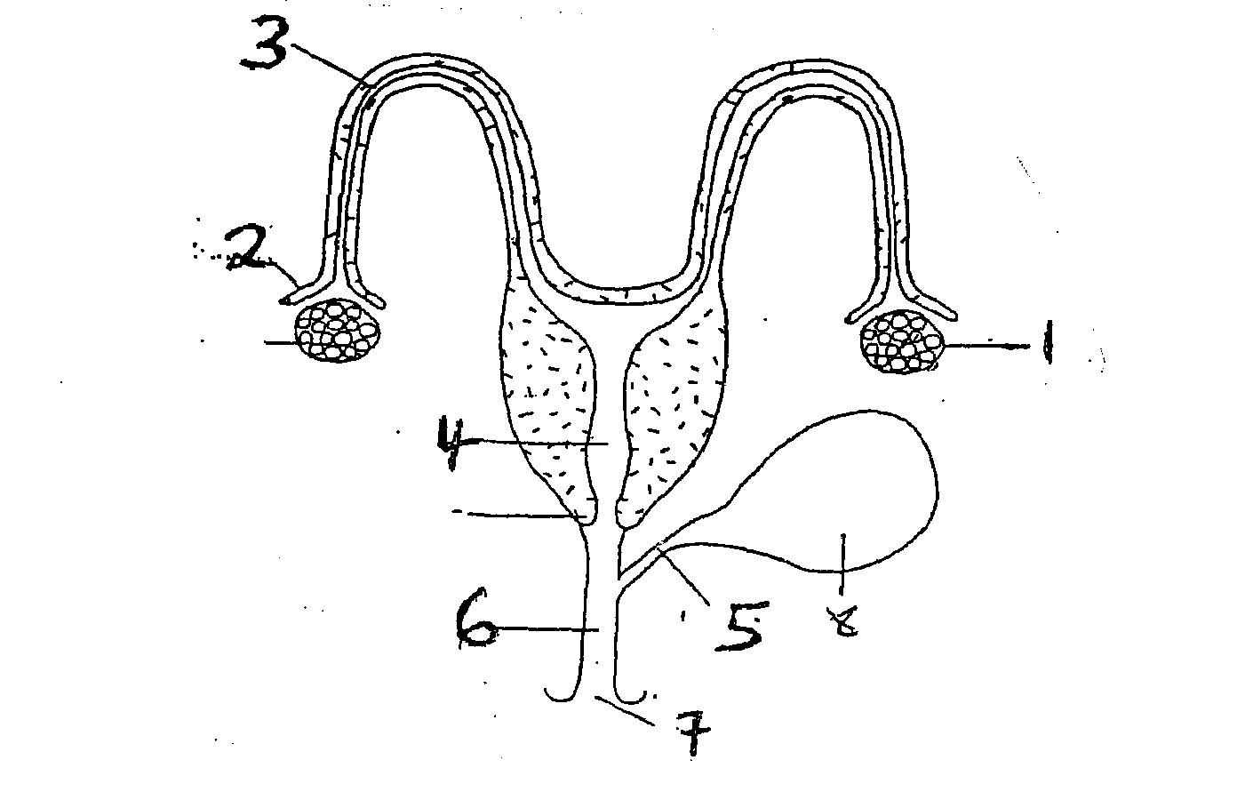
1
8
5
7
6
4
2
3

(a) Identify the parts labeled 1-4 (2mks)
1……………………………………. 2:……………………………………….
3……………………………………. 4:………………………………………..
(b) Name two hormones produced by the part labelled (1). (2 mks)
…………………………………………………………………………………………………………
…………………………………………………………………………………………………………
(c) Give function of the part labelled (7). (1 mk)
…………………………………………………………………………………………………………
22. The diagram below illustrates a livestock parasite.

(a) Identify the parasite illustrated above. (1 mk)
…………………………………………………………………………………………………………
(b) Name one animal commonly attacked by the parasite. (1 mk)
…………………………………………………………………………………………………………
(c) Give one major sign that shows the animal is attacked by the above parasite. (1 mk)
…………………………………………………………………………………………………………
(d) Give two control measures of the parasite. (2 mks)
…………………………………………………………………………………………………………
…………………………………………………………………………………………………………
23. The illustration below shows a certain livestock management practice. Study it and answer the questions below.
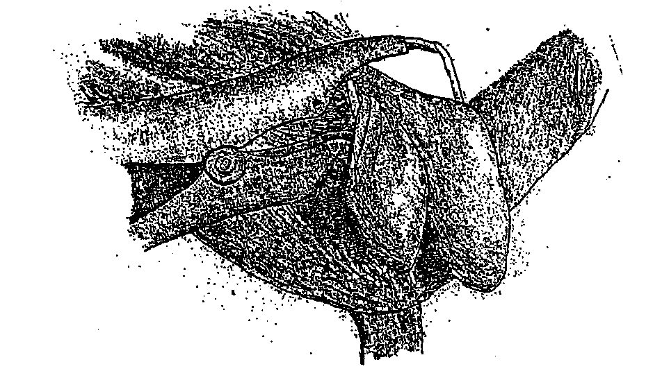

(a) Identify the practice. (1 mk)
………………………………………………………………………………………………………………..
(b) Give three reasons for the above livestock management practice. (3 mks)
………………………………………………………………………………………………………………..
………………………………………………………………………………………………………………..
………………………………………………………………………………………………………………..
(c) State one advantage of this type of practice as compared to other methods. (1 mk)
………………………………………………………………………………………………………………..

SECTION C (30 MARKS)
Answer any TWO Questions from this section in the answer sheet provided.
24. (a) State the factors a farmer should consider when selecting materials for constructing
farm structures. (5 mks)
(b) Describe the use of various hand tools required for the construction of a permanent dairy shed. (10 mks)
(c) Describe the preparation that should be carried out for a sow one week before farrowing. (5 mks)

25. (a) Describe Rinderpest disease under the following sub-headings:
(i) Signs of infection. (6 mks)
(ii) Control measures. (4 mks)
(b) Explain six ways in which ticks can be controlled in livestock farming. (6 mks)
(c) State four signs of heat in a sow (4 mks)

26. (a) Explain five factors determine the amount of water required by an animal. (10 mks)
(b) Describe the procedure of harvesting honey. (6 mks)
(c) State any four functions of worker bees. (4 mks)
………………………………………………………………………………………………………………..
………………………………………………………………………………………………………………..
………………………………………………………………………………………………………………..
………………………………………………………………………………………………………………..
………………………………………………………………………………………………………………..
………………………………………………………………………………………………………………..
………………………………………………………………………………………………………………..
………………………………………………………………………………………………………………..
………………………………………………………………………………………………………………..
………………………………………………………………………………………………………………..
………………………………………………………………………………………………………………..
………………………………………………………………………………………………………………..
………………………………………………………………………………………………………………..
………………………………………………………………………………………………………………..
………………………………………………………………………………………………………………..
………………………………………………………………………………………………………………..
………………………………………………………………………………………………………………..
………………………………………………………………………………………………………………..
………………………………………………………………………………………………………………..
………………………………………………………………………………………………………………..
………………………………………………………………………………………………………………..
………………………………………………………………………………………………………………..
………………………………………………………………………………………………………………..
………………………………………………………………………………………………………………..
………………………………………………………………………………………………………………..
………………………………………………………………………………………………………………..
………………………………………………………………………………………………………………..
………………………………………………………………………………………………………………..
………………………………………………………………………………………………………………..
………………………………………………………………………………………………………………..
………………………………………………………………………………………………………………..
………………………………………………………………………………………………………………..
………………………………………………………………………………………………………………..
………………………………………………………………………………………………………………..
………………………………………………………………………………………………………………..
………………………………………………………………………………………………………………..
………………………………………………………………………………………………………………..
………………………………………………………………………………………………………………..
………………………………………………………………………………………………………………..
………………………………………………………………………………………………………………..
………………………………………………………………………………………………………………..
………………………………………………………………………………………………………………..
………………………………………………………………………………………………………………..
………………………………………………………………………………………………………………..
………………………………………………………………………………………………………………..
………………………………………………………………………………………………………………..
………………………………………………………………………………………………………………..
………………………………………………………………………………………………………………..
………………………………………………………………………………………………………………..
………………………………………………………………………………………………………………..
………………………………………………………………………………………………………………..
………………………………………………………………………………………………………………..
………………………………………………………………………………………………………………..
………………………………………………………………………………………………………………..
………………………………………………………………………………………………………………..
………………………………………………………………………………………………………………..
………………………………………………………………………………………………………………..
………………………………………………………………………………………………………………..
………………………………………………………………………………………………………………..
………………………………………………………………………………………………………………..
………………………………………………………………………………………………………………..
………………………………………………………………………………………………………………..
………………………………………………………………………………………………………………..
………………………………………………………………………………………………………………..
………………………………………………………………………………………………………………..
………………………………………………………………………………………………………………..
………………………………………………………………………………………………………………..
………………………………………………………………………………………………………………..
………………………………………………………………………………………………………………..
………………………………………………………………………………………………………………..
………………………………………………………………………………………………………………..
………………………………………………………………………………………………………………..
………………………………………………………………………………………………………………..
………………………………………………………………………………………………………………..
………………………………………………………………………………………………………………..
………………………………………………………………………………………………………………..
………………………………………………………………………………………………………………..
………………………………………………………………………………………………………………..
………………………………………………………………………………………………………………..
………………………………………………………………………………………………………………..
………………………………………………………………………………………………………………..
………………………………………………………………………………………………………………..
………………………………………………………………………………………………………………..
………………………………………………………………………………………………………………..
………………………………………………………………………………………………………………..
………………………………………………………………………………………………………………..
………………………………………………………………………………………………………………..
………………………………………………………………………………………………………………..
………………………………………………………………………………………………………………..
………………………………………………………………………………………………………………..
………………………………………………………………………………………………………………..
………………………………………………………………………………………………………………..
………………………………………………………………………………………………………………..
………………………………………………………………………………………………………………..
………………………………………………………………………………………………………………..
………………………………………………………………………………………………………………..
………………………………………………………………………………………………………………..
………………………………………………………………………………………………………………..
………………………………………………………………………………………………………………..
………………………………………………………………………………………………………………..
………………………………………………………………………………………………………………..

