312/2
GEOGRAPHY
Paper 2
JULY/AUGUST, 2018

MOKASA- II JOINT EXAMINATION
Kenya Certificate of Secondary Education
312/2
Paper 2
GEOGRAPHY
SECTION A
Answer all the questions in this section.

1. (a) What is dependency ratio (2marks)
(b) The table below shows population of four counties in Rift Valley Kenya in 2009

County | Total population | Total land area (km² )
Bomet | 693,558 | 3337.10
Nakuru | 528,054 | 1479.10
Kericho | 1,623,282 | 2543.40

Calculate the population density of Nakuru (3marks)
2. The sketch map below shows the Great Lakes and St. Lawrence Seaway. Use it to
answer question (a)

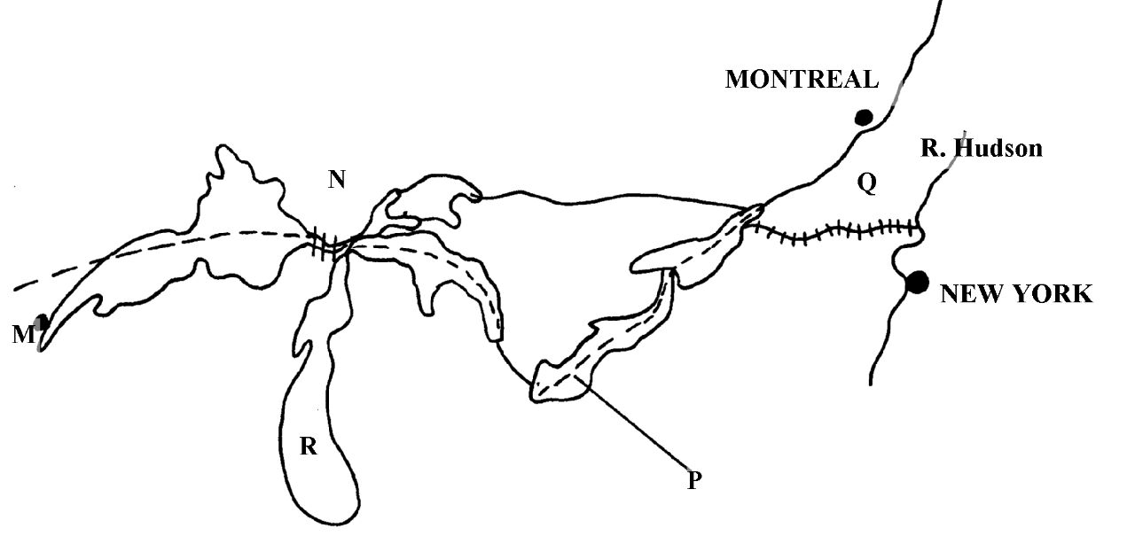
(a) Name:
(i) The lake marked R. (1 mark)

(ii) The canal marked N. (1 mark)

(iii) The port marked M. (1 mark)

(b) Give two reasons for the tremendous increase in the use of motor cycle in Kenya (2marks)

3. (a) State two challenges that face geothermal power generation in Kenya (2marks)

(b) Give three causes of energy crisis in the world. (3marks)
4. (a) Identify three features of horticultural farming in the Netherlands (3marks)

(b) State two climatic conditions that favours dairy farming in Denmark (3marks)

5. (a) Differentiate between heavy manufacturing industries and light manufacturing industries (2marks)

(b) Give three similarities of tourism between Kenya and Switzerland. (3marks)
SECTION B
Answer question 6 and any other two questions from this section.
6. Table below shows the value of the leading import crops by value (Kshs million) from Kenya between 2011 and 2015

CROP/YEAR | Unmilled wheat | Maize | Rice | Wheat flour
2011 | 6989 | 4664 | 1968 | 180
2012 | 7515 | 3342 | 2619 | 636
2013 | 5577 | 229 | 2104 | 237
2014 | 6099 | 1417 | 2181 | 168
2015 | 6754 | 4647 | 3659 | 200
Source: Kenya Economic Survey, 2016
(a) (i) Using a scale of 1cm to represent 1 million Kenya Shillings, draw a comparative bar graph to represent the data shown. (8marks) (ii) Give two disadvantages of using a comparative bar graph in representing information (2marks)

(b) State three physical conditions that favour coffee growing in Kenya. (3marks)

(c) Explain four problems facing coffee farming in Kenya. (8marks)

(d) Compare coffee farming in Kenya and Brazil under the following sub – headings;

- Labour (2marks)
- Soils (2marks)

7. (a) (i) What is mining (2marks)
(ii) State three ways in which minerals may occur (3marks)
(b) (i) Apart from solution method ,give two other underground mining methods (2marks)

(ii) Describe solution method of mining (4marks)

(c) Study the map of East Africa below showing the distribution of minerals.

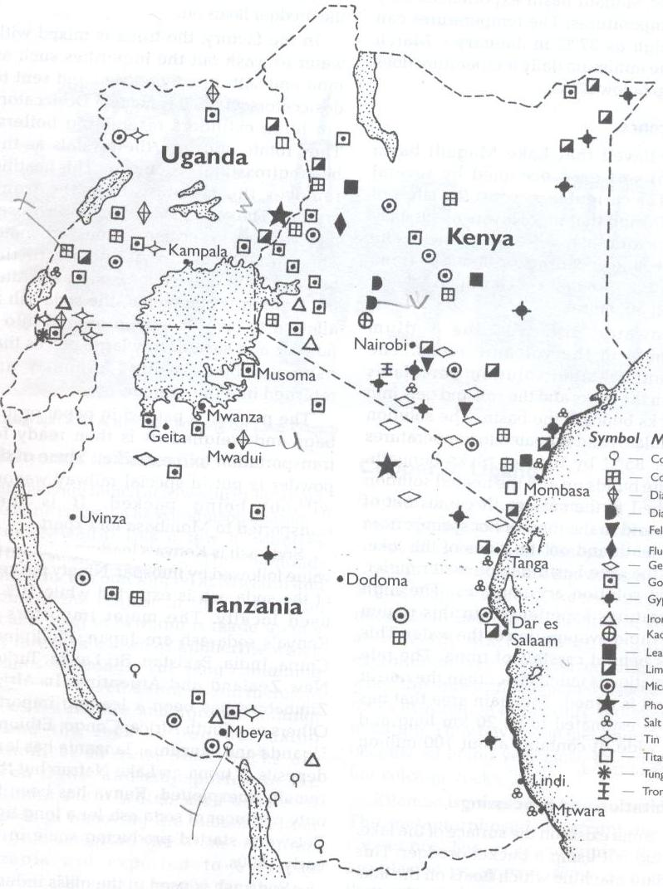
X
W
Y
U
V

(i) Name the mineral mined in the areas marked X, Y and Z. (3marks)
(ii) State three problems facing soda ash mining at Lake Magadi in Kenya (3marks)

(iii) Form four students in your school carried out a field study on a derelict land. State two observations they are likely to make (2marks)

(d) Describe the stages of processing diamond in South Africa (6marks)

8. (a) State four problems experienced by fishermen while fishing in lake Victoria. (4marks)

(b) The map below shows one of the fishing grounds in the world. Use it to answer the questions that follow.
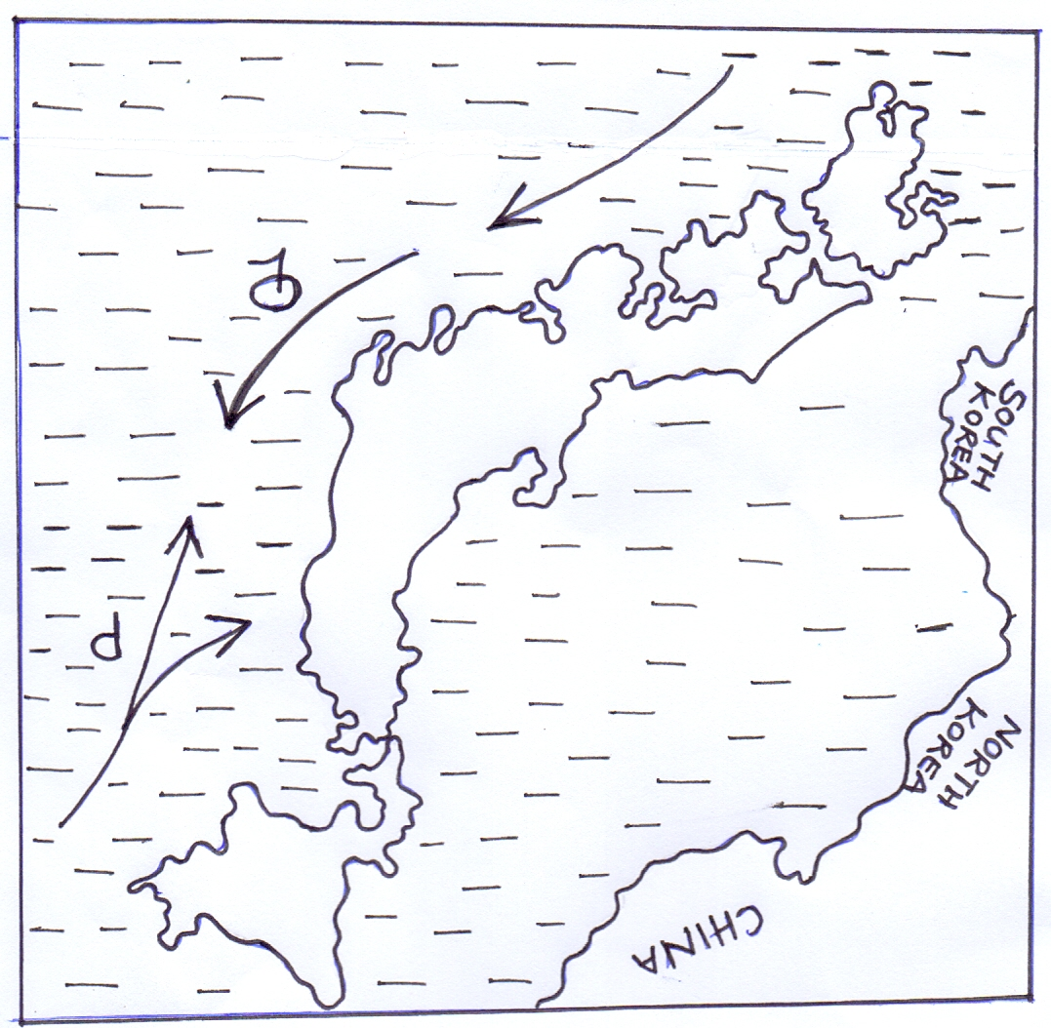

(i) Identify the fishing ground. (1mark)

(ii) Identify the ocean currents marked P and Q. (2marks)

(c) Apart from ocean currents explain four physical factors favoring fishing in the above named fishing ground. (8marks)

(d) (i) State four ways in which the government should conserve fisheries. (4marks)

(ii) Give two traditional methods of fish preservation in Kenya. (2marks)

9 (a) Differentiate between visible and invisible trade. (2marks)

(b) (i) Identify two types of internal trade. (2marks)

(ii) Give four factors promoting international trade in Kenya (4marks)

(iii) Identify four ways through which Kenya Government promotes internal trade (4marks)

(c) (i) State four objectives of COMESA. (4marks)

(ii) Identify three problems facing ECOWAS. (3marks)

(d) Explain how the future of international trade in Kenya can be improved (6marks)

10 (a) Name two non governmental organizations that deals with environmental management and conservation in Kenya. (2marks)

(b) State four causes of land pollution in Kenya. (4marks)

(c) Give reasons why water resources should be managed and conserved. (6marks)

(d) Your class intends to carry out a field study on water pollution in the nearby river.

(i) Give two methods of data collection they are likely to use during the study. (2marks)

(ii) State three follow up activities they may undertake after the field study. (3marks)

(iii) Give three recommendations the students can make to be put in place to control pollution of rivers. (3marks)

(e) Identify ways in which floods can be managed in Kenya. (5marks)

