NAME: …………………………………………..… Class …………
232/1
July/August 2018
PHYSICS
PAPER 1
Time: 2 Hours
MOKASA II EXAMINATION
PHYSICS PAPER 1
Instructions to the candidate:
- Write your name, stream and admission number in the spaces provided above.
- Sign in the space provided above.
- This paper consists of two sections; A and B.
- Answer all the questions both in section A and B in the spaces provided.
- All workings must be clearly shown.
- Mathematical tables and/or silent electronic calculators may be used.
- Take acceleration due to gravity g=10NKg⁻¹
For examiners’ use only
SECTION | QUESTION | MAXIMUM SCORE | STUDENT’S SCORE
Section A | 1-9 | 25
Section B | 10 | 11
 | 12 | 10
 | 13 | 11
 | 14 | 09
 | 15 | 14
Total |  | 80

This paper consists of 16 printed pages. The learner should check to ascertain that all pages are printed as indicated and that no question(s) is/are missing.

- The following diagram shows a micrometer screw gauge used to measure the diameter of a marble whose actual diameter is 6.60 mm.
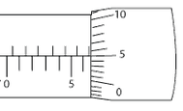
(i) What is the reading on the micrometer screw gauge (1 mark)
……………………………………………………………………………………………………
…………………..……………………………………………………………………………….
(ii) Determine the zero error in the instrument (1mk)
………………………………………………………………………………………………………………………………………………………………………………………………………………
- The figure below is a cylinder of uniform cross section area A containing a liquid of density ρ at a height h . Use the figure to show that the fluid pressure at the bottom is given by p= hρg.
A (3 marks )

Liquid h

…………………………………………………………………………………………………………………………………………………………………………………………………………………………………………………………………………………………………………………………………………………………………………………………………………

3. The two graphs of temperature against time were recorded and plotted by two thermometers placed in contact with surfaces X and Y.
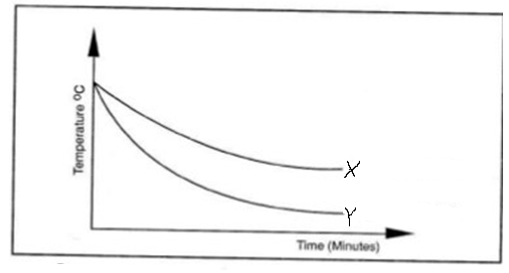
Use the graphs to determine:
(i) Which of the surfaces is a poor emitter? (1mark)
……………..……………………………………………………………………………………………
(ii) Which of the surfaces would be a good absorber of heat? (1mark)
…………………………………………………………………………………………
4. Bronze is an alloy made by mixing molten copper and tin. If the alloy contains 80% by mass of copper and 20 % by mass of tin .Calculate the density of bronze (density of copper is 8900 kg /m³ and density of tin is 7000kg/m³ (3 marks)
………………………………………………………………………………………………………………………………………………………………………………………………………………………………………………………………………………………………………………………………………………

5. The figure below shows a wire loop with a string that has been dipped into soap solution.
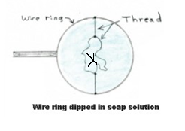
(i) Complete the sketch below to show the observed effect if the soap film is punctured at X
(1 mark)

ii) Explain the observations made in (i) above ( 1 mark)
………………………………………………………………………………………………………………………………………………………………………………………………………………………………………………………………………………………………………………………………………………
6. The horizontal pipe shown in the diagram has a cross section area of 40.0 cm² at the wider section and 10 cm² at the constriction. Water flows in the pipe and the rate from the pipe is 6.00 × 10⁻³ m ³/s.
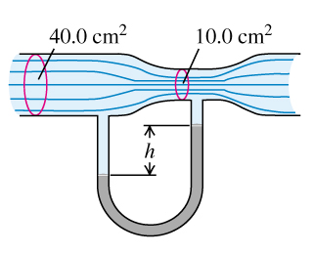
(a) Account for the difference in the height (h) between the mercury column in the U-shaped manometer (1 mark)
………………………………………………………………………………………………………………………………………………………………………………………………………………………………(b) Find the velocity of water at the constriction (2marks)
………………………………………………………………………………………………………………………………………………………………………………………………………………………………………………………………………………………………………………………………………………7. (a). State Hooke’s law (1 mark)
………………………………………………………………………………………………………………………………………………………………………..……………………………………........................
b). A light helical spring will extend by 20cm when a load of 60N is applied to its lower end .Three such springs X , Y and Z are arranged as shown in the diagram.
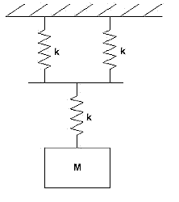
p
W
y
z
x
Determine the value of the load W which will cause the point P to move downwards through a distance of 21 cm. (3 marks )
………………………………………………………………………………………………………………………………………………………………………………………………………………………………………………………………………………………………………………………………………………8. A uniform wooden plank of mass 5kg and length 6m is supported by two strings P and Q at the 2.4m-mark and the 5.6m-mark respectively as shown below.
P
Q
0 2.4m 5.6m 6.0m

Calculate the tension T on string Q (3marks)
………………………………………………………………………………………………………………………………………………………………………………………………………………………………………………………………………………………............................................................................................................................................................................................................................................................9. When marking the lower and upper fixed points on a thermometer, it is observed that at 0 ºC the mercury thread is 2cm and 8cm at 100 ºC. What temperature would correspond to a length of 4.5 cm?
(2 marks)
………………………………………………………………………………………………………………………………………………………………………………………………………………………………………………………………………………………………………………………………………………………………………………………………………………………………………………………………………………………………………………………………………………………………………………

SECTION B (55 MARKS)
10. a). Define power of a machine (1mark)
………………………………………………………………………………………………………………………………………………………………………………….………………………………………..…
b) The radius of the effort piston of a hydraulic lift is 2.8 cm while that of the load piston is 8.4 cm. This machine is used to raise a load of 120kg at a constant velocity through a height of 3m. Given that the machine is 75 % efficient. Calculate:

(i.) The velocity ratio of the lift (2marks )
………………………………………………………………………………………………………………………………………………………………………………………………………………………………
(ii) The effort needed (2 marks)
………………………………………………………………………………………………………………………………………………………………………………………………………………………………………………………………………………………………………………………………………………
(iii) The energy wasted in using the machine (3 marks)
………………………………………………………………………………………………………………………………………………………………………………………………………………………………………………………………………………………………………………………………………………
(iv) State one cause of energy wastage? (1 mark)
………………………………………………………………………………………………………………11. Define;
(i) Heat capacity, C (1 mark)
………………………………………………………………………………………………………………………………………………………………………………………………………………………………………………………………………………………………………………………………………………

(ii) Latent heat of fusion, L_{f} (1mark)
………………………………………………………………………………………………………………………………………………………………………………………………………………………………………………………………………………………………………………………………………………
b) In an experiment to determine the specific latent heat of vaporization of steam l_{v}, the following results were obtained
- mass of calorimeter, m_{c} = 250 g

- mass of calorimeter +water = 750 g

- mass of ice at 0ºC in the calorimeter m_{i=} 20g

- Final temperature when dry steam at 100⁰c is passed over the calorimeter =25ºC

- mass of condensed steam m_{s} =25 g

(Given that the specific latent heat of fusion of ice is 3.36 ×10⁵ Jkg⁻¹, the specific heat capacity of copper is 400 Jkg⁻¹ k⁻¹ and specific heat capacity of water is 4200JKg⁻¹k⁻¹.)
Determine the :
- heat gained by the Ice (2 marks )
………………………………………………………………………………………………
ii. heat gained by the Water ( 1marks)
………………………………………………………………………………………………………………………………………………………………………………………………
iii. heat gained by the Calorimeter (2 marks)
………………………………………………………………………………………………………………………………………………………………………………………………
iv. specific latent heat of vaporization of steam , l_{v}. ( 3 marks )
………………………………………………………………………………………………………………………………………………………………………………………………………………………………………………………………………………………………………………………
c) Explain why a drop of methylated spirit placed at the back of hand feels colder than a drop of distilled water at the same temperature (2 marks)
…………………………………………………………………………………………………………………………………………………………………………………………………………........
12 a). A car moves from rest at a uniform acceleration of 1.0 m/s² for the 20 s. It continues at the constant velocity for the next 30s and finally takes another 10 s to decelerate uniformly to rest .
- Find the final velocity of the car after the first 20 seconds. ( 1 mark) ……………………………………………………………………………………………………………………………………………………………………...………………….
- Sketch a velocity- time graph for the whole journey ( 3 marks)

- From the graph, determine the total distance covered (3 marks)
………………………………………………………………………………………………………………………………………………………………………………………………………………………………………………………………………………………………
b) The figure below shows dots which were made by a ticker timer and tape attached to a trolley. The trolley was moving in the direction shown.
4cm 1cm
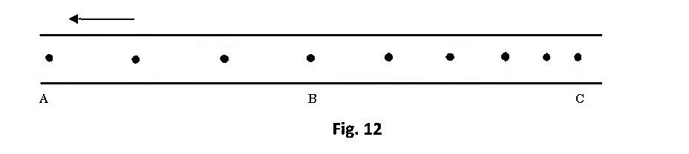
Direction Of motion

A B C D
If the frequency of the ticker timer used was 50 Hz,
i) determine the average velocities of:
( I) AB (1mk)
……………………………………………………………………………………………………………………………………………………………………………………………………………………………..

(II) CD (1 mark)
……………………………………………………………………………………………………………………………………………………………………………………………………………………………………………………………………………………………………………………
ii) The acceleration of the trolley ( 2 marks)
………………………………………………………………………………………………………………………………………………………………………………………………
c) A body of mass 0.6kg falls from a building 80m high. Determine the velocity at which it strikes the ground (2 marks)
…………………………………………………………………………………………………………………………………………………………………………………………………………………………………….................................................................................................................
13 a).State Boyle’s law ( 1 mark)
………………………………………………………………………………………………………………………………………………………………………………………………………………………………………………………………………………………………………………………
b.) Sketch a graph of pressure ( P) against (PV) in the axes provided below for a gas which obeys Hookes law (1mk)

c) A column of air 30cm long is trapped by a mercury thread 6 cm as shown below. When the tube is inverted, the air column is 40cm.
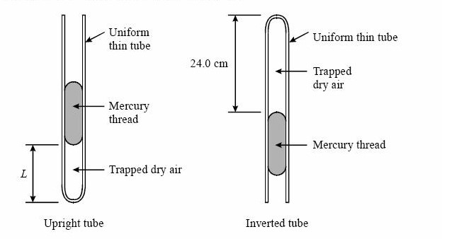
Determine the value of the atmospheric pressure, P_{a} (3 marks)
………………………………………………………………………………………………………………………………………………………………………………………………………………………………………………………………………………………………………………………
d) The volume of a mass of a gas at 27ºC and 75cmHg pressure is 200cm³. Find the volume of the gas at -50ºC and 80cmHg pressure. (3 marks)
………………………………………………………………………………………………………………………………………………………………………………………………………………………………………………………………………………………………………………………………………………………………………………………………………………………………
14 a). A wooden block M of volume 500cm² and density 800kgm⁻³ is suspended inside a liquid of density p by a string as shown below.
If the tension T on the string is 2N, determine the:
- Upthrust, U. (2 marks)
……………………………………………………………………………………………………………………………………………………………………………………………………………
ii. Density of the liquid , p (2mks)
……………………………………………………………………………………………………………………………………………………………………………………………………………………………………………………………………………………………………...
b) i. Define centripetal force ( 1 mark ) ……………………………………………………………………………………………………………………………………………………………………………………………………………
ii. Explain why no work is done by a centripetal force acting on a body moving in a circular horizontal plane (1 mark)
………………………………………………………………………………………………………………………………………………………………………………………………………………iii. A body of mass m is tied to a string and whirled in a vertical plane with a constant speed v. The tensions in the strings at positions A, B and C are marked T_{A,} T_{B} and T_{c} respectively.
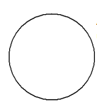

Arrange the tensions T_{A}, T_{B} and T_{C} respectively in ascending order (1 mark)
…………………………………………………………………………………………………………………………………………………………………………………………………………......
- Explain why wet clothes in a spin dryer, dry faster when the spin drum is rotated at a higher speed (2 marks)
………………………………………………………………………………………………………………………………………………………………………………………………………………

