**NAME…………………………………………INDEX NO……………ADM NO………….**

**CANDIDATE’S SIGN………………………DATE………………………………………...**

**SCHOOL……………………………………………………………………………………….**

**MOKASA 2 JOINT EXAMINATIONS**

**Kenya Certificate of Secondary Education (K.C.S.E)**

**121/2**

**MATHEMATICS**

**PAPER 1**

**JULY 2018**

**TIME: 2 ½ HOURS**

**INSTRUCTIONS TO CANDIDATES.**

* Write **your name** and **index number** in the spaces provided above.
* Sign and write the date of examination in the spaces provided above.
* This paper consists of two section **I** and **II**.
* Answer **ALL** questions in section **I** and only **five** questions from section **II**
* Answers and working must be written on the question paper in the spaces provided below each question.
* Marks may be given for correct working even if the answer is wrong.
* Non-programmable electronic calculators may be used.

***FOR EXAMINERS’ USE ONLY.***

**SECTION I**

|  |  |  |  |  |  |  |  |  |  |  |  |  |  |  |  |  |
| --- | --- | --- | --- | --- | --- | --- | --- | --- | --- | --- | --- | --- | --- | --- | --- | --- |
| **1** | **2** | **3** | **4** | **5** | **6** | **7** | **8** | **9** | **10** | **11** | **12** | **13** | **14** | **15** | **16** | **TOTAL** |
|  |  |  |  |  |  |  |  |  |  |  |  |  |  |  |  |  |

**SECTION II**

**Grand Total**

|  |  |  |  |  |  |  |  |  |
| --- | --- | --- | --- | --- | --- | --- | --- | --- |
| **17** | **18** | **19** | **20** | **21** | **22** | **23** | **24** | **TOTAL** |
|  |  |  |  |  |  |  |  |  |

**SECTION A – 50 MARKS**

1. Evaluate without using a calculator or mathematical tables (3 marks)



2. Use the table of logarithms to evaluate to 4 s.f  (4 marks)

3. Simplify: - 4ab + 6ac + 6b - 9c

4ab – 6b -6ac + 9c (3 marks)

4. A metal A is an alloy of two metals B and C. Metal B has a mass of 68g and a density of

17g/cm3. Metal C has a mass of 18g and a density of 3g/cm3.Find the density of the alloy.

(3 marks)

5. Use the tables of squares, square roots and reciprocal tables to evaluate the following to 2 dp (3mks)



6. Three interior angles of a pentagon are 110o, 130oand 90o. The other two interior angles x and y are in the ratio 1:2. Calculate the sizes of the other two interior angles. (3mks)

7. A Kenyan bank buys and sells foregn currencies as shown below;

|  |  |  |
| --- | --- | --- |
|  | Buying in Kshs. | Selling in Kshs. |
| 1 Hongkong dollar | 9.53 | 9.77 |
| 1South African rand | 11.92 | 12.11 |

A tourist arrived in Kenya with 105,000 Hong Kong dollars and changed the whole amount to Kenya shillings while in Kenya, she spent Ksh.403,879 and changed the balance to south African Rand before leaving for South Africa. Calculate the amount in South African Rand that he received. (3mks)

8. A wind screen wiper of a car sweeps through an angle of 1200. The shaded region in the figure below represents the area swept clean by the blade of the wiper **AB.** If OA= 14cm and OD=21cm. find the exact area of the glass swept clean (3 marks)

B

C

A

O

1200

7 cm

14 cm

9. Find all the integral values of  which satisfy the inequality

 (3mks)

10. In 2007 the ratio of male population to female population in a certain town was7:9. Between 2007 and

2009 , the male population increased by 4%. If the total population was 186,000 and overall

population increase during the period was 2.5%. Calculate the female population in 2009. (3mks)

11. Find the length of BC in the figure below correct to 2 decimal places. (3 marks)

110

270

C

D

A

B

76m

12.Evaluate; (3mks)



13.A security guard observes that the angle of elevation to the top of an observation tower is 260. If he walks 55m towards the base of the tower, the angle of elevation becomes 47.50. By calculation, find the height of the tower.

14. A positive two digit number is such that the sum of its digits is a third the deference between the original number and the number formed when the digits are reversed. When the number is multiplied by 3, the product is 4 times the sum of the digits. What is the number? (3 marks)

15. Given that Sin x =, where x is an acute angle, find without using a calculator or table the value of;

1. Tan x (2mks)
2. Sin (90-x) (1mk)

16. Ivy and Rita have sweets. When Rita gives out one of her sweets, Ivy will have twice as many sweets as Rita. If Ivy gives out one of her sweets, they will have equal number of sweets. Find the number of sweets each has. (3mks)

**SECTION B - ANSWER FIVE QUESTIONS ONLY**

17. Jane is a shoe sales lady on a basic salary of ksh 25000 per month. On top of her salary, she gets a commission of 2% on sales upto ksh.50000, 5% on sales between ksh.50000 to ksh.150,000 and 12% for any sales above ksh.150,000. In a certain month, Jane had a total pay of ksh.41620.

1. Determine the total sales she made during the month (4marks)
2. If she sold each pair of shoes at ksh.4500, how many pairs did she sell that month

(2marks)

1. On selling a pair at ksh.4500, she made a profit of 20% instead of 28% had she sold with the marked price. Find:
2. The marked price (2 marks)
3. The manufacturers price (2marks)

18. Four towns P, Q, R and S are such that town Q is 150km on a bearing of 0700 from town P. Town R is 200km on a bearing of 1600 from town Q. Town S is due west of town R and 135km due south of town P.

(a) Draw a sketch diagram showing the positions of towns P, Q, R and S. (1 mark)

(b) Without using scale drawing calculate:

(i) The distance PR (3 marks)

(ii) To 2 s.f the bearing of P from R (3 marks)

(c) Calculate to the nearest whole number the distance RS (3 marks)

19. The figure below shows a frustum of a square based pyramid (not drawn to scale). The based ABCD is a square of sides 10cm. The top A’B’C’D’ is a squre of side 4 cm and each slant edges of the frustum is 5cm long.

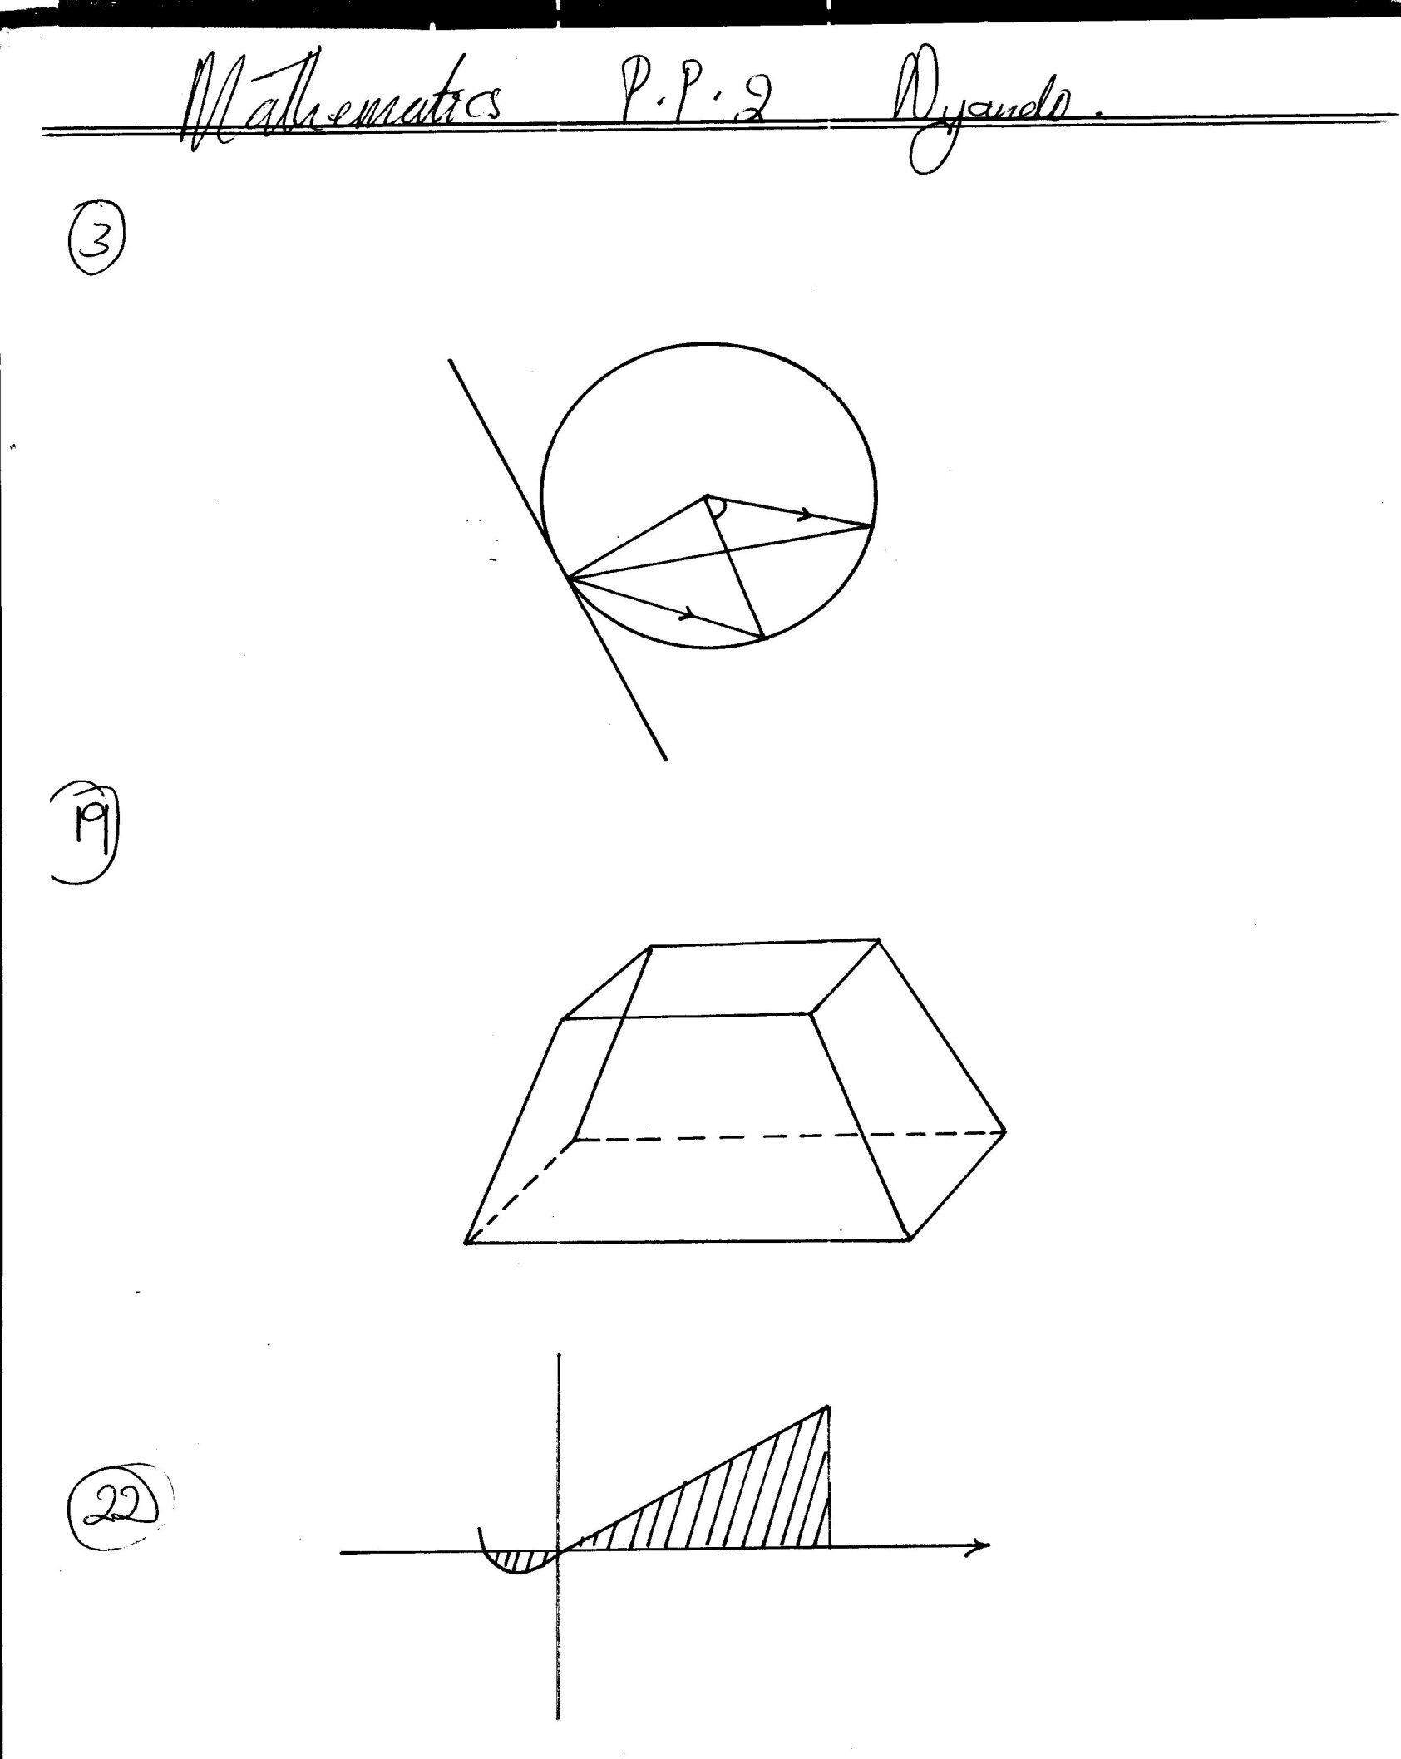

**C’**

**D’**

**A’**

**A**

**D**

**B’**

**B**

**C**

**4cm**

**4cm**

**5cm**

**10cm**

**10cm**

Determine

1. The height of the frustum (2mks)
2. The volume of the frustum (3mks)
3. The total surface area of the frustum (3mks)
4. The angle between AC’ and the base ABCD (2mks)

20. a) Complete the table below for the function: $y=x^{2}+3x-5$

|  |  |  |  |  |  |  |  |  |  |
| --- | --- | --- | --- | --- | --- | --- | --- | --- | --- |
| ***X*** | **-6** | **-5** | **-3** | **-2** | **-1** | **0** | **1** | **2** | **3** |
| ***Y*** |  |  |  |  |  |  |  |  |  |

b) On the grid provided, draw the graph of: $y=x^{2}+3x-5$ for $-6≤x≤3$

(use 1 cm to represent 1 unit on the horizontal axis and 2cm to represent 5 units on the vertical axis.) (3 marks)

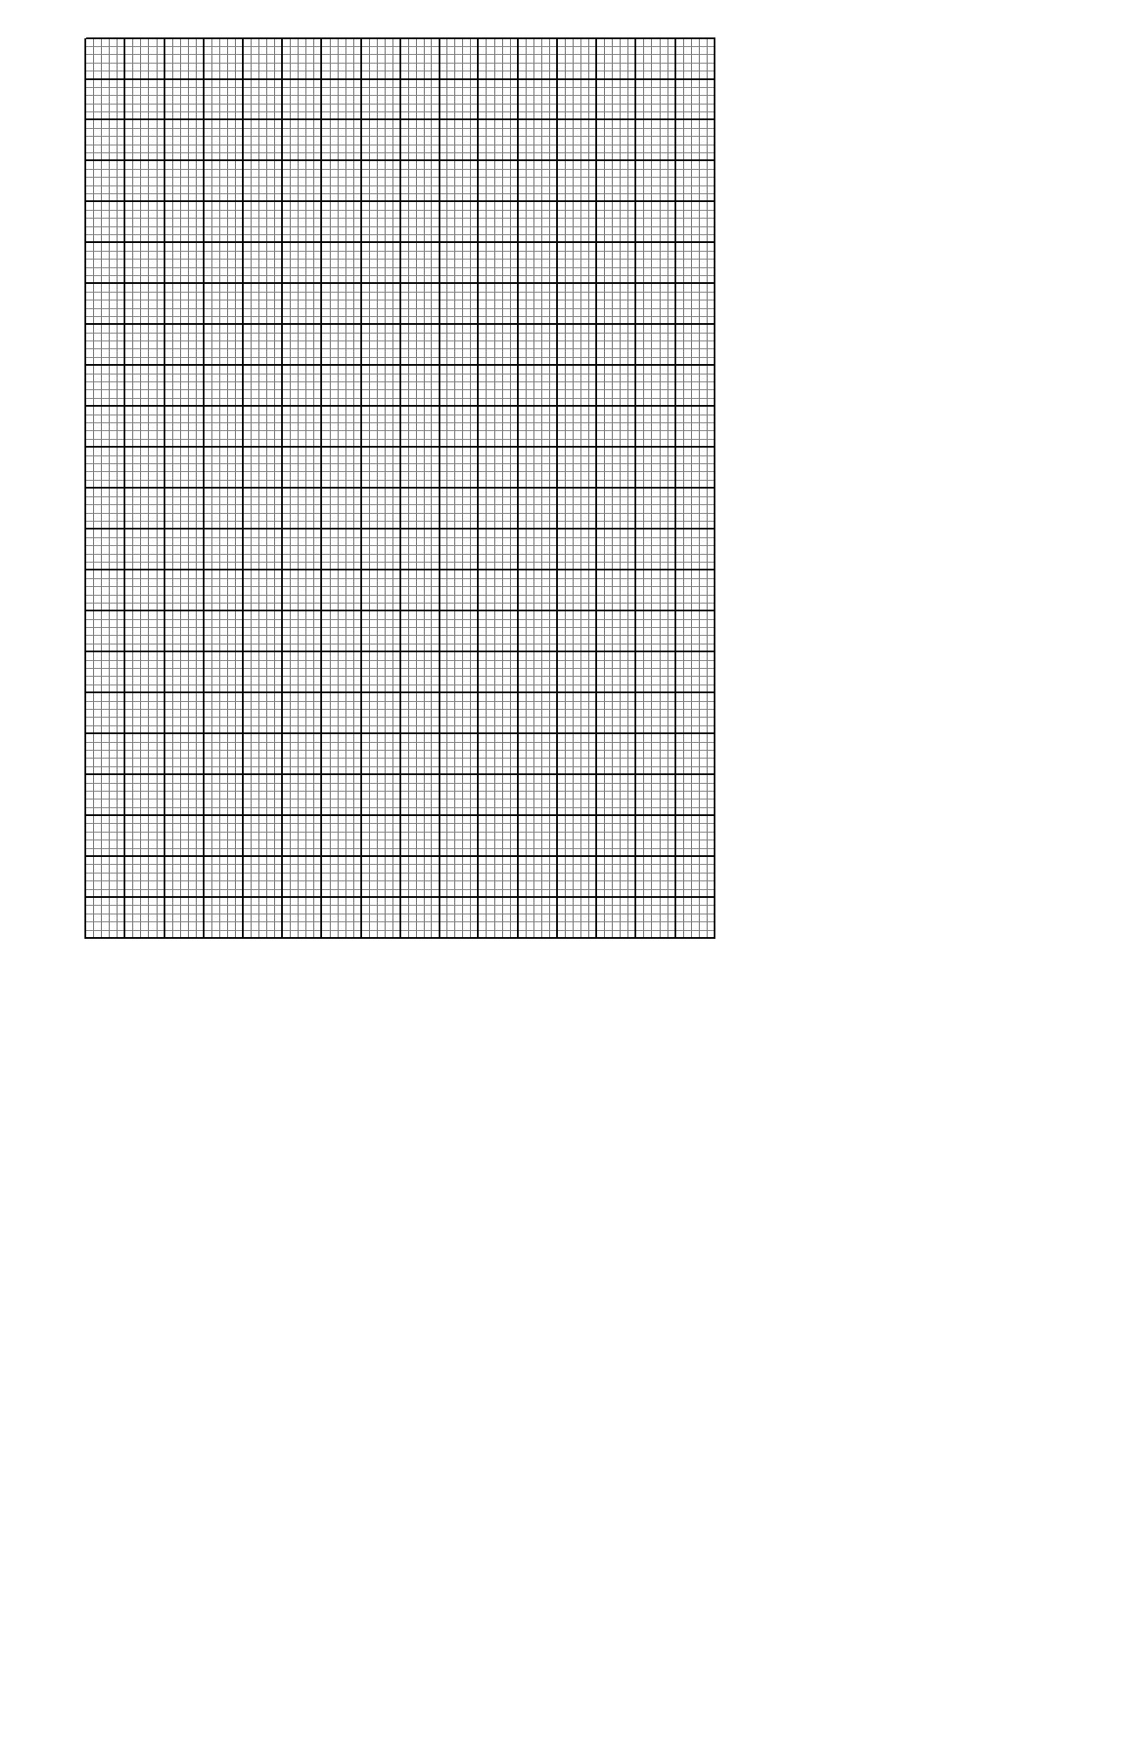c) Using the graph, estimate the values of ***x*** when $y=0$ (2marks)d) On the same axes, draw the line $y=2x+2$ and use it to determine the root of the function

21. (a) A rectangle PQRS has vertices P(1, 2), Q(3, 2), R(3, 5)and S(1, 5). Plot PQRS on the grid provided. (2mk)

(b) Find the co-ordinates of P’, Q’, R’ and S’ the image of PQRS after a translation  and plot rectangle P’Q’R’S’ (3mks)

(c) Rectangle P’Q’R’S’ above is mapped onto rectangle P’’Q’’R’’S’’ under the matrix . Find the co-ordinates of this image and plot on the same axes above. (3mks)

(d) using the diagrams in (b) and (c) determine the centre and angle of rotation that map PQRS 0ntoP’’ Q’’ R’’ S’’. (2mks)

(ii) Describe the transformation that can map PQRS onto P’’Q’’R’’S’’. (2mks)



22. In the figure below ABC is a tangent to the circle at B.DE is a diameter and DEC and BFG are straight lines. BE is parallel to DG. Angle EBC=300 and angle DBG = 500

Find the following angles giving reasons for each answer;

1. < BDE (2mks)
2. < BCE (2mks)
3. < BGD (2mks)
4. < FDG (2mks)
5. < BED (2mks)

23. A body is **s** metres from its starting point O after time t where **s** = 4t3 -3t2 -6t. Find:

1. The value of ***s*** when t = 2 seconds (2 marks)
2. Expressions for velocity and acceleration of the body after t seconds (2 marks)
3. The value of t when the particle is at rest (3 marks)
4. The maximum velocity the particle attains (3 marks)

24. The weigh to the nearest kilogram, of 200 pupils were recorded as shown below;

|  |  |
| --- | --- |
| Mass | Frequency |
| 41-50 | 21 |
| 51-55 | 62 |
| 56-65 | y |
| 66-70 | 50 |
| 71-85 | 12 |

a)Find the value of y (1mk)

b) Estimate the mean weight (2mks)

c) Estimate the median (3mks)

d) Draw a histogram to represent the information above. (4mks)

