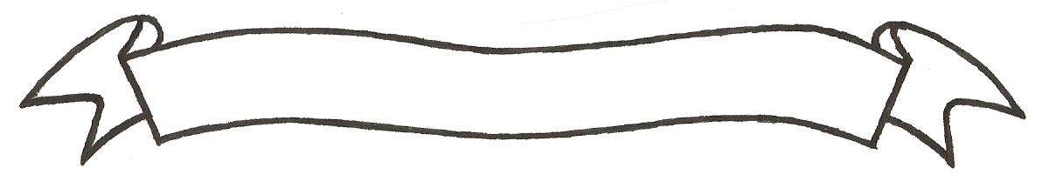

MERU UNIVERSITY OF SCIENCE AND TECHNOLOGY
P.O. Box 972-60200 – Meru-Kenya.
Tel: 020-2069349, 061-2309217. 064-30320 Cell phone: +254 712524293, +254 789151411
Fax: 064-30321
Website: www.must.ac.ke Email: info@must.ac.ke

University Examinations 2015/2016
SECOND YEAR SECOND SEMESTER EXAMINATION FOR DIPLOMA IN ELECTRICAL ENGINEERING
EEE 2255: POWER ELECTRONICS
DATE: NOVEMBER 2015 TIME: 1¹/₂ HOURS
INSTRUCTIONS: Answer question one and any other two questions

QUESTION ONE (30 MARKS)
- Figure 1 shows an initially relaxed circuit. Thyristor T is turned on at t=0 seconds.
Given: L=5 millihenrys.
C= 20 microfarads
Vs=200 volts
Calculate:
- Conduction time and thyristor.
- Voltage across thyrisor.
- Capacitance after SCR is turned off. (7 Marks)

Figure 1
- Figure 2 is structure of the thyrisor device.

Figure 2
- Name the device.
- Explain its operation.
- Construct its symbol. (6 Marks)
- (i) Explain the various modes of operation of a thyristor.
(ii) Discuss conditions which must be satisfied to turn on a thyrisor using gate circuit. (10 Marks)
- (i) What is power electronics? (1 Mark)
(ii) List 2 advantages of power electronics. (2 Marks)
(iii) Figure 3 shows how forward breakover voltage with gate current. Explain the relationship shown in this diagram. (4 Marks)

Figure 3
QUESTION TWO (15 MARKS)
- A two transistor anology of a SCR has the following:
PNP transistor gain = 0.42
NPN transistor gain = 0.54
Rated gate triggering current = 68 mA
- Derive the expression for the anode current.
- Calculate the value of anode current. (4 Marks)
- Explain:
- Forward voltage triggering. (1 Mark)
- Light triggering. (1 Mark)
- Temperature triggering. (1 Mark)
- Define:
- Holding current. (1 Mark)
- Latching current. (1 Mark)
- Figure 4 is a single phase half wave converter.

Figure 4
Construct wave forms of:
- Vs or input signal. (1 Mark)
- Firing signal 1g. (1 Mark)
- Load current i_{o}. (2 Marks)
- Voltage across thyristor (V_{T}) (2 Marks)
Assuming firing angle of
QUESTION THREE (15 MARKS)
- Describe RC filters listed indicating ideal and practical responcer to input signals:
- Bound stop. (2 Marks)
- Low pass. (2 Marks)
- Band stop. (2 Marks)
- High pass. (2 Marks)
- A low pass filter consists of an inductance of 5000 PF. Calculate its:
- Source resistance. (1 Mark)
- Load resistance. (1 Mark)
- Cut-off frequency. (1 Mark)
- Explain a thyristor.
- Hard firing. (1 Mark)
- Forced commutation. (1 Mark)
- Line commutation. (2 Marks)

QUESTION FOUR (15 MARKS)
- You are provided with the following devices:
- SW (Switch)
- L (inductor)
- R (load)
- FD (free wheeling diode)
- VS (source of power)
- Sketch a chopper from above information. (1 Mark)
- State a device used instead of SW. (1 Mark)
- Explain the principle of operation of the sketched device. (1 Mark)
- Draw the expected input and output voltage and current wave for ms. (1 Mark)
- If the input voltage of the device constructed is 50v and duty cycle is 5 milliseconds, calculate output voltage. (3 Marks)
- Explain the following DC choppers:
- Step up. (1¹/₂ Marks)
- Step down. (1¹/₂ Marks)
- Discuss the operation of D in the following circuit figure 5. (5 Marks)

Figure 5

