**Name: …………………………………………………………… Index No. …………………….........**

**Candidate’s Sign. …………............ Date: ………………………………..**

**232/3**

**PHYSICS**

**PRACTICAL**

**PAPER 3**

**JUNE/JULY 2015**

**TIME: 2 ¼ HOURS**

***STAREHE BOYS CENTRE AND SCHOOL***

**INSTRUCTIONS TO THE CANDIDATES:**

* Write your **name** and **index number** in the spaces provided above.
* Answer ***all*** questions in the spaces provided in the question paper.
* You are supposed to spend the first 15 minutes of the 2 ¼ hours allowed for this paper reading the whole paper carefully.
* Marks are given for a clear record of the observation actually made, their suitability, accuracy and the use made of them.
* Candidates are advised to record their observations as soon as they are made.
* Mathematical tables, slide rules and calculators may be used.
* Record your observations as soon as you make them.

**For Examiners’ Use Only**

|  |  |  |  |
| --- | --- | --- | --- |
|  |  |  |  |
|  |  |  |  |
|  |  |  |  |
|  |  |  |  |

*This paper consists of 6 printed pages. Candidates should check to ascertain that all pages are printed as indicated and that no questions are missing.*

**Q. 1 PART 1 15 MARKS**

**Apparatus**

* Two identical 100g masses
* Uniform meter rule
* Liquid **L** in a 250 ml beaker (almost full)
* Vernier calipers
* A string about one meter long

**Method**

1. Take one 100g mass and measure the diameter d and the height h in using vernier calipers.
   1. d = ……………..cm (1mk)
   2. h = ……………..cm (1mk)
   3. Determine the volume **V,** given

V = π(d/2)2h

**V**= (1mks)

* 1. Using the formula **D = M/V**, determine the density of the solid **Ds**

Ds = 100/V

= (1mks)

1. Adjust the meter rule so that it balances at its centre of gravity **G** as the knife edge.

**N/B.** This position should be measured throughout the experiment

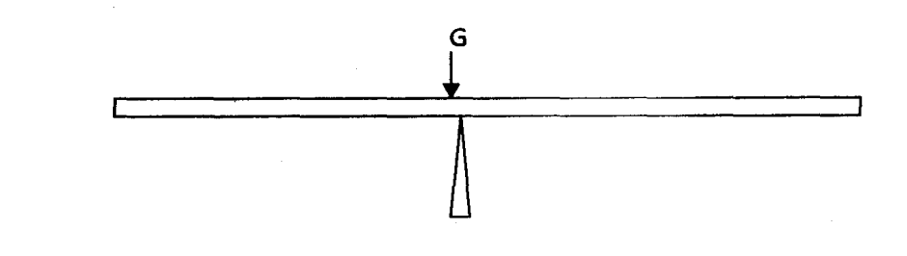 G = ………………………………….cm (1mk)

1. Starting with the distance **X** for the mass in liquid **L** as 48cm, adjust the position of the other mass to obtain a balance condition. Record the corresponding distance y in the table of results.

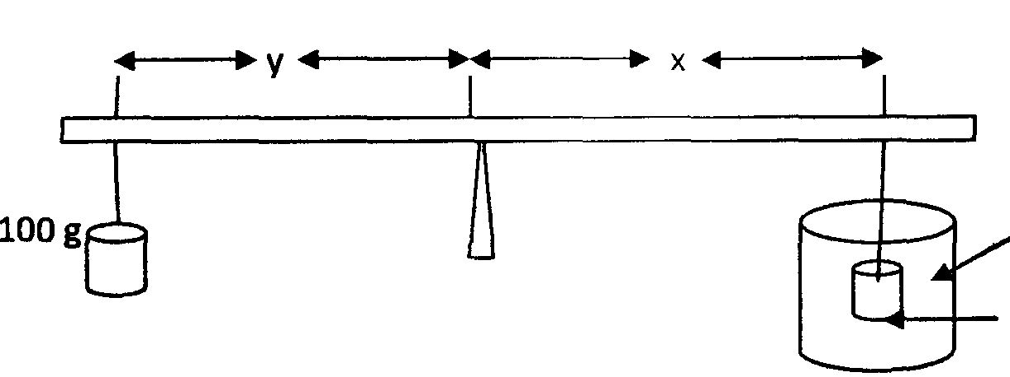

**Liquid L**

**100g**

Repeat the above for the rest of the values of x given in the table below. (3mks)

|  |  |
| --- | --- |
| **DISTANCE (x) cm** | **DISTANCE (y) cm** |
| 48 |  |
| 43 |  |
| 38 |  |
| 33 |  |
| 28 |  |
| 23 |  |

d) Plot a graph of **Y** against **X.** (4mks)

e) Find the slope **S** of the graph. (2mks)

f) Using the expression

Where S is the slope

Find the density **DL** of the liquid. (1mks)

**PART 2 5 MARKS**

(b) You are provided with the following apparatus:

* Candle
* Lens
* Lens holder
* Metre rule
* Cross wire
* Screen
* Vernier calipers

Proceed as follows:

1. Arrange the apparatus as shown in the figure **below**.

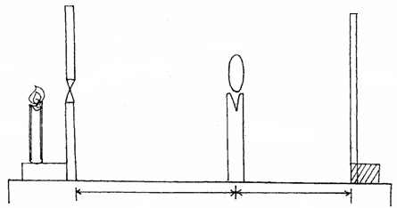

Candle

Cross wire

Lens

Lens holder

White screen

u

v

1. Place the cross-wire before the lens so that U = 28cm. The lit candle should

be placed close to the cross-wire.

1. Adjust the position of the screen until a sharp image is cast on the screen.
2. Measure and record the value of image distance, V, in the table.
3. Repeat the same procedure for the other values in the table.

|  |  |  |  |
| --- | --- | --- | --- |
| U(cm) | V(cm) |  |  |
| 30 |  |  |  |
| 36 |  |  | (2mks) |

(vi) Given that the focal length ƒ of the lens satisfies the equation  determine average value of the focal length, ƒ. (3mks)

**Q2. 20 MARKS**

You are provided with the following apparatus

* Resistance wire fitted on a scale labeled **AB**
* Switch
* Voltmeter
* Ammeter
* Two dry cells
* Six connecting wires

***Proceed as follows:-***

(i) Set up the apparatus as shown below

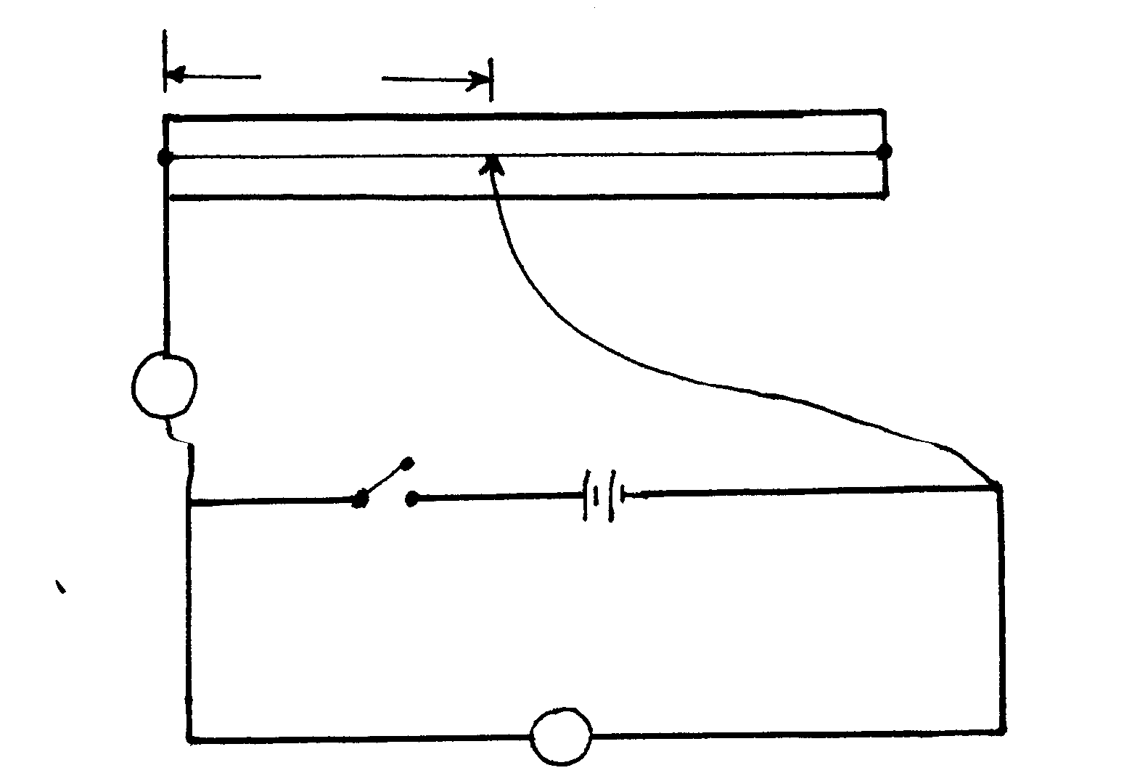

**B**

**L**

**A**

**v**

**A**

(ii)Remove the crocodile clip from resistance wire **AB** and close the switch. Record the voltmeter reading X=___________________volts (1mk)

(iii) Attach the crocodile clip to the resistance wire such that L=10cm

(iv) Record the voltmeter and ammeter reading in the table below

(v) Repeat the procedure in iii and iv for L=20cm, 30cm, 40cm, 50cm,60cm,70c, and 80cm

(vi) Complete the table below

|  |  |  |  |  |  |  |  |  |
| --- | --- | --- | --- | --- | --- | --- | --- | --- |
| **Length L(cm)** | 10 | 20 | 30 | 40 | 50 | 60 | 70 | 80 |
| **Current I (A)** |  |  |  |  |  |  |  |  |
| **p.d V (v)** |  |  |  |  |  |  |  |  |
| **X-V(V)** |  |  |  |  |  |  |  |  |
|  |  |  |  |  |  |  |  |  |
| **V=R(Ω)**  **I** |  |  |  |  |  |  |  |  |

(10mks)

(viii) (a) Plot the graph of against **R** (5mks)

(b) Determine the slope **S** of the graph (3mks)

(c) The graph is given by the equation

  

Determine the value of **m** and **d** (2mks)