NAME: ……………………………………………………………..… ADM …………….
JUJA GIRLS HIGH SCHOOL
END TERM II EXAMINATIONS 2018
FORM THREE

Kenya Certificate of Secondary Education (KCSE)
232/2
Paper 2
Physics (Theory)
July/August 2018
2 Hours

Instructions
- This paper consists of two sections A and B.
- Answer all the questions in sections A and B in the spaces provided.
- All working must be clearly shown.
- Silent non programmable electronic calculators may be used.

For Examiner’s Use Only
Section | Question | Maximum Score | Student’s Score
A | 1-13 | 25
B | 14 | 17
 | 15 | 11
 | 16 | 15
 | 17 | 12
Total Score |  | 80

SECTION A (25MARKS)
- The figure below shows two parallel current carrying conductors A and B cutting through a piece of cardboard.
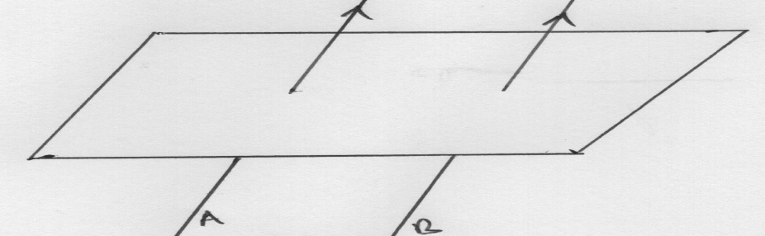

Identify the nature of the force between them (1mk)
………………………………………………………………………………………………….
- An electromagnet is made by winding insulated copper wire on an iron core. State two changes that could be made to increase the strength of the electromagnet. (2mks)
………………………………………………………………………………………………………………………………………………………………………………………………………………………………………………………………………………………………………………………………………………………………………………………………………………………………
- Define the term ‘line of force’ as applied to magnetic fields. (1mk)
……………………………………………………………………………………………………………………………………………………………………………………………………………………………………………………………………………………………..
- A vibrator is sending out 8 ripples per second across a ripple tank. The ripples are observed to be 4cm apart. Calculate the velocity of the ripples. (2mks)
………………………………………………………………………………………………………………………………………………………………………………………………………………………………………………………………………………………………………………………………………………………………………………………………………………………………………………………………………………………………
- The figure below shows a positively charged metal plate with an earthing connection. Using an arrow, show the direction of charges through the earth connection and explain the final charge of the plate. (2mks)
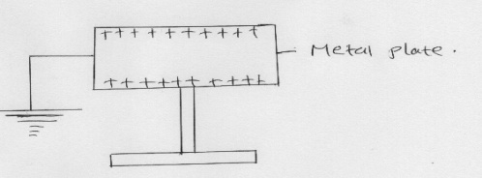
………………………………………………………………………………………………………………………………………………………………………………………………………………………………………………………………………………………………………………………………………………………………………………………………
- State two factors that effect the speed of sound in air. (2 marks)
................................................................................................................................................................................................................................................................................................................................................................................................................................................
- In domestic wiring systems lamps in the lighting circuit are required to be in parallel and not in series. Sate two reasons for this requirement. (2 marks)
……………………………………………………………………………………………………………………………………………………………………………………………………
- Draw a ray diagram to show how a ray of light may be totally internally reflected two times in an isosceles right-angled glass prism. (Assume that the critical angle of glass is 42ºC.) (2 marks)
………………………………………………………………………………………………………………………………………………………………………………………………………………………………………………………………………………………………………………………………………………………………………………………………………………………………………………………………………………………………………………………………………………………………………..

- Given that the velocity of sound in air is 330ms⁻¹. Calculate the wavelength of sound produced by a turning fork rated 0.44 kHz. (2 marks)
………………………………………………………………………………………………………………………………………………………………………………………………………………………………………………………………………………………………………………………………………………………………………………………………………………………………………………………………………………………………
- A student synchronizes his watch with a church bell 2km away. The following morning, there is a wind. .He notes that the church bell sounded 0.15s later. Assuming his watch was correct and bell was sounded at the usual time. Determine the direction and the speed of the wind.(Assuming the speed of sound in still air is 340m/s) (3mks)
………………………………………………………………………………………………………………………………………………………………………………………………………………………………………………………………………………………………………………………………………………………………………………………………………………………………………………………………………………………………………………………………………………………………………………………………
- The figure below shows two bar magnets and soft iron ring placed between the magnets.

Complete the diagram to show the magnetic field pattern through the soft iron ring. (1 mark)
- Explain why the image formed in a pinhole camera gets blurred when the hole is enlarged. (1 mark)
………………………………………………………………………………………………………………………………………………………………………………………………………………………………………………………………………………………………………
- a) A ray of light is incident on a plane mirror as shown in the figure below.
What is the angle of reflection? (1 mark)
……………………………………………………………………………………………………………………………………………………………………………………………………
b) The mirror is then rotated clockwise through 20º. Determine:
i) The angle through which the reflected ray is turned. (1 marks)
……………………………………………………………………………………………………………………………………………………………………………………………………………………………………………………………………………………………………..
ii) The angle between the incident ray and new reflected ray. (2 marks)
…………………………………………………………………………………………………………………………………………………………………………………………………………………………………………………………………………………………………………………………………………………………………………………………………………

SECTION B (55 MARKS)
- a) A glass prism of refractive index 1.5. Calculate the critical angle of this glass prism. (3 marks)
................................................................................................................................................................................................................................................................................................................................................................................................................................................................................................................................................................................................................................................................................................................................................................................................................................................................................................
b) In an experiment to determine refractive index of water, a black line is painted on the bottom of a tall container which is the partially filled with water. The black line appears closer than it really is. The following results were recorded from the experiment.

Real depth (cm) | 4.0 | 5.0 | 6.0 | 7.0 | 8.0 | 9.0 | 10.0
Apparent depth (cm)
Vertical displacement (cm) | 1.22 | 1.53 | 1.83 | 2.14 | 2.44 | 2.75 | 3.06

i) Complete the table for apparent depth row. (2 marks)

ii) Plot a graph of real depth against apparent depth on the grid provided. (5 marks)

iii) Determine the refractive index for the water. (2 marks)
................................................................................................................................................................................................................................................................................................................................................................................................................................................................................................................................................................................................................................................................................................................................................................................................................................................................................................................................
- A ray of light passes from air into a certain liquid at an angle of 50⁰to the normal. The ray is refracted such that the angle of refraction is 35⁰as it enters the liquid. Calculate the refractive index of the liquid (3mks)
……………………………………………………………………………………………………………………………………………………………………………………………………………………………………………………………………………………………………………………………………………………………………………………………………………………………………………………………………………………………………………………………………………………………………………………………………………………………………………………………………………………………….
- State the necessary conditions for total internal reflection to take place. (2mks)
………………………………………………………………………………………………………………………………………………………………………………………………………………………………………………………………………………………………
- a)The figure below shows the image of an object formed by reflection in a converging mirror. C is the centre of curvature of the mirror.

Complete the diagram to show:
- How incident rays are reflected to form the image. (2 marks)
- The object position. (1 mark)
………………………………………………………………………………………………………………………………………………………………………………………………………………………………………………………………………………………………………………………………………………………………………………………………………
b)An object of height 10.5am stands before concave mirror of focal length 20cm and a distance of 10cm from the mirror.
Determine
- The image distance (2mks)
………………………………………………………………………………………………………………………………………………………………………………………………………………………………………………………………………………………………………………………………………………………………………………………………………………………………………………………
- Height of the image (2mks)
………………………………………………………………………………………………………………………………………………………………………………………………………………………………………………………………………………………………………………………………………………………………………………………………………………………………………………………
- Magnification (2mks)
………………………………………………………………………………………………………………………………………………………………………………………………………………………………………………………………………………………………………………………………………………………………………………………………………………………………………………………
c) State two reasons why convex mirrors are usually used as driving mirrors. (2mks)
........................................................................................................................................................................................................................................................................................................................................................................................................................................................................................................................................................................................................................

- (a)State Ohm’s law (1mk)
…………………………………………………………………………………………………………………………………………………………………………………………………………………………………………………………………………………………………………………………………………………………………………………………………………………………………………………............................................................................................................................
b) You are provided with a voltmeter, an ammeter, a variable resistor, a resistive wire coil and a source of emf. With the aid of a diagram ,describe how you would verify ohm’s law. (5mks)
………………………………………………………………………………………………………………………………………………………………………………………………………………………………………………………………………………………………………………………………………………………………………………………………………………………………………………………………………………………………………………………………………………………………………………………………………………………………………………………………………………………………………………………………………………………………………………………………………………………………………………………………………………………………………………………………………………………………………………………………………………………………………………………………………………………………………………………………………………………………………………………………………………………………………………………………………………………………………………………………………………………………………………………………………………………………………………………………………………………………………………………………………………………………………………………………
(c)The figure below shows how a student set up a circuit using 3 identical bulbs X,Y and t each rated 12V,2.0A
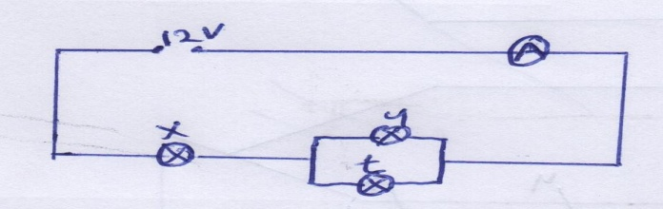
When operating normally, calculate the resistance of each of the bulbs.(2mks)
………………………………………………………………………………………………………………………………………………………………………………………………………………………………………………………………………………………………………………………
(c)When a switch is kept open in the circuit shown below the voltmeter reads 1.5V, when the switch is closed, the reading drops to 1.3V and the current through the resistor is 0.5A.
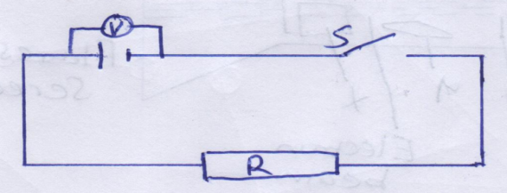
- What is the emf of the cell (1mk)
………………………………………………………………………………………………………………………………………………………………………………
- What is the terminal voltage of the cell (1mk)
………………………………………………………………………………………………………………………………………………………………………………
- Calculate the value of R (2mks)
………………………………………………………………………………………………………………………………………………………………………………………………………………………………………………………………………………………………………………………………………………………………
d) Define: (3mks)
i) Electric current
………………………………………………………………………………………………………………………………………………………………………………………………………………
- Electric potential difference
……………………………………………………………………………………………………………………………………………………………………………………………………………………………………………………………………
- Equipotential points
…………………………………………………………………………………………………………………………………………………………………………………....

- a) When are two particles in a wave motion said to be in phase? (2mks)
……………………………………………………………………………………………………………………………………………………………………………………………………………………………………………………………………………………………………………………………………………………………………………………................
b) State one similarity and one difference between sound waves and water waves. (2mk)
………………………………………………………………………………………………………………………………………………………………………………………………………………………………………………………………………………………………
c) State two differences between sound waves and radio waves. (2mks)
………………………………………………………………………………………………………………………………………………………………………………………………………………
d) The figure below shows waves in a spring travelling along it from one end. The velocity of the wave is 3.2m/s.
Displacement(cm)
4
2
0
20 40 60 80 Distance(cm)
-2
-4

Determine in SI units:
- Wavelength of the wave (1mk)
……………………………………………………………………………………………………………………………………………………………………
- Amplitude of the wave (1mk)
……………………………………………………………………………………………………………………………………………………………………
- Frequency of the wave (2mks)
…………………………………………………………………………………………………………………………………………………………………………………………………………………………………………………………………………………………………………………………………………
- Period of the wave (2mks)
………………………………………………………………………………………………………………………………………………………………………………………………………………………………………………………
End

