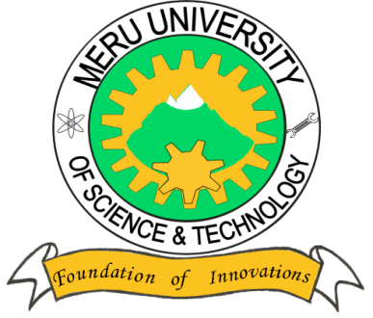

MERU UNIVERSITY OF SCIENCE AND TECHNOLOGY
P.O. Box 972-60200 – Meru-Kenya.
Tel: 020-2069349, 061-2309217. 064-30320 Cell phone: +254 712524293, +254 789151411
Fax: 064-30321
Website: www.mucst.ac.ke Email: info@mucst.ac.ke

University Examinations 2014/2015
THIRD YEAR, SPECIAL/SUPPLEMENTARY EXAMINATIONS FOR THE DEGREE OF BACHELOR OF SCIENCE IN FOOD SCIENCE AND NUTRITION, FOOD SCIENCE AND TECHNOLOGY.
AFS 2306: BEVERAGE TECHNOLOGY
DATE: JULY 2015 TIME: 2 HOURS
INSTRUCTIONS: Answer question one and any other two questions.

QUESTION ONE (30 MARKS)
- List the ingredient used in the manufacture of non-alcoholic carbonated beverages (6 marks)
- Outline the role of carbondioxide in soda soft drinks (4 marks)
- Briefly describe the removal of mucilage from coffee beans by fermentation (8 marks)
- Briefly discuss the main ingredients used in beer manufacture (6 marks)
- Explain the reasons for withering the tea leaf prior to the rolling process (6 marks)

QUESTION TWO (20 MARKS)
- Discuss the factors that influence grading of coffee (10 marks)
- Briefly describe the process of instant coffee manufacture (10 marks)

QUESTION THREE (20 MARKS)
With the aid of a flow diagram describe the process of black tea manufacture (20 marks)
QUESTION FOUR (20 MARKS)
Discuss the main processing steps in beer manufacture (20 marks)

