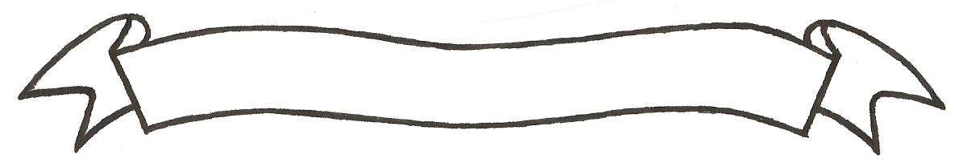

MERU UNIVERSITY OF SCIENCE AND TECHNOLOGY
P.O. Box 972-60200 – Meru-Kenya.
Tel: 020-2069349, 061-2309217. 064-30320 Cell phone: +254 712524293, +254 789151411
Fax: 064-30321
Website: www.must.ac.ke Email: info@must.ac.ke

University Examinations 2014/2015
FOURTH YEAR FIRST SEMESTER EXAMINATION FOR THE DEGREE OF BACHELOR OF COMMERCE
BFB 3433: TECHNOLOGY AND INNOVATION
DATE: AUGUST 2015 TIME: 2 HOURS
INSTRUCTIONS: Answer question one and any other two questions

QUESTION ONE (30 MARKS)
- Discuss the components of technology assessment and show why it is important for business to be involved (10 Marks)
- Using illustrations, explain the process of technology diffusion among businesses (10 Marks)
- Critically, discuss the various enhancers of technology transfer (5 Marks)
- Discuss any five business technology forecasting techniques (5 Marks)

QUESTION TWO (20 MARKS)
- Explain the factors for and against imported business technologies (10 Marks)
- Discuss the historical development of Information Communication Technology in Kenya, highlighting the milestones and impacts since the liberalization of the sector in the 1990’s (10 Marks)

QUESTION THREE (20 MARKS)
- Using illustrations, show how ICT can enhance service delivery in both private and public sector (10 Marks)
- Differentiate between innovation and invention, using illustrations (5 Marks)
- What is appropriate technology? (5 Marks)
QUESTION FOUR (20 MARKS)
- Continuous innovation is inevitable to ensure businesses remain viable and competitive in today’s business environment. Show how managers can encourage innovative practices in their business organizations highlighting the challenges to innovation (15 Marks)
- Identify and discuss the various technology related challenges facing women-preneurs and the physically challenged entrepreneurs (5 Marks)

QUESTION FIVE (20 MARKS)
- Highlight the meaning of technology capability, discuss the three types of technology capability (12 Marks)
- Describe the four generally recognized forms of intellectual property (8 Marks)

