SUNSHINE SECONDARY SCHOOL
442/1
ART & DESIGN
PAPER 1
PRE MOCK 1 – MARCH 2017
1 HOUR 30 MINUTES

NAME: ………………………………………………………..INDEX NO:…………………….
CLASS: ……………………… CANDIDATES SIGNATURE:………………………………..

INSTRUCTIONS

- Write your Name and Index Number in the spaces provided above.
- This paper consists of THREE Sections A, B and C.
- Answer ALL the questions in Section A and B.
- Answer any ONE question from Section C.
- All answers should be written in the spaces provided.
- Where drawings and diagrams are appropriate they should be included within the text of you answer.
For examiner’s use only

SECTION | QUESTION | MAXIMUM SCORE | CANDIDATE’S SCORE
A | 1 | 20
B | 2 | 4
 | 3 | 4
 | 4 | 5
 | 5 | 5
 | 6 | 4
 | 7 | 3
C |  | 15
TOTAL SCORE |  | 60
SECTION A 20 MKS. [Compulsory]
Answer all questions in this section
1.
- Name the technique which is effective for producing marbled effect in tie and dye. [1mk]

- Give the reason why asymmetrical balance is considered active. {1mk]

- Identify two most outstanding elements of art applied in the picture below. [1mk]
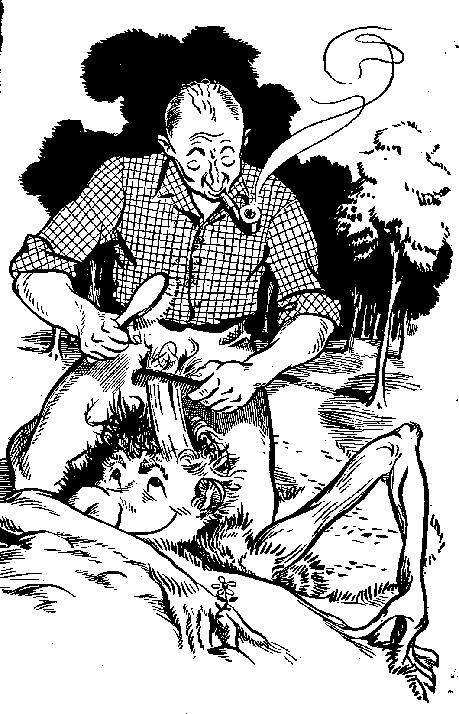

- State two roles of packaging design. [2mks]

- Distinguish between legibility and readability in typography. [2mks]

- Identify the sign below and state its function. [1mk]
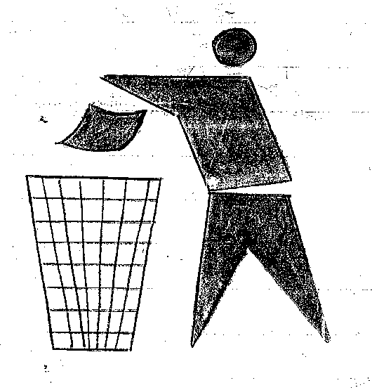

- Identify the part of the material that produces the shape of the design in:

- Serigraphy
- Relief printing [2mks]

- Give the reason why clay is classified as either primary or secondary. [1mk]

- Distinguish between aerial and atmospheric perspective. [2mks]

- “ As the stone wastes, the statue grows”. Name the technique and process suggested by the statement.[2mks]

- State the difference between analogous colours and complementary colours. [2mks]

- Name two specific parts of the human form on which emotions and feelings are displayed.[1mk]

- Distinguish between harmony and unity in a pictorial composition.[2mks]

SECTION B 25MKS (Compulsory)
Answer ALL questions in this section.

- Explain the process of “cire- perdue” [lost wax] in sculpture making. [4mks]

- Explain the function of the following ingredients in clay preparation. [4mks]
- Grog
- Ball clay
- Fire clay
- Kaolin

- In the space provided below, make a drawing of hands fastening a shoe lace. [5mks]

- Explain five factors to consider for effectiveness of a garden sculpture. [5mks]

- “Sorting out, comparing, rethinking, experimenting and re- defining”
- At what stage of the design process does the above activity take place? [1mk]
- Explain your answer. [3mks]

- . Describe the relationship/ activity between the following items in the process of weaving: [3mks]
- Frame
- Warp
- Shuttle
- Weft
- Heddle
- Shed

SECTION C: (15marks)

Answer any ONE question from this section.

- Explain the process of producing a three coloured pictorial wall hanging using a combination of tie & dye and batik. [15mks]

- Using illustrations, describe five techniques of decorating green ware. [15mks]

- i) State two characteristics of organic shapes. [2mks]

ii) Read the following statement carefully and identify four attributes of line conveyed, indicating what part of the statement identifies each of the attributes. [8mks]

“Thinking about line……………….Thick or thin, long or short, straight or curved, line can outline shapes and forms, indicate the contour of a volume and imply direction and movement. Line of sight can connect widely separate parts of a composition. Depending on how it is employed, line can seem extremely intellectual or highly expressive and emotional. It is above all, the artist’ most basic tool.”

iii) Discuss the aspects an artist requires to effectively depict a still life composition under the
following guides: [5mks]
- Subject matter
- Format
- Proportion
- Dominance
- Spatial effects

