NAME: ……………………………………………………………..… ADM …………….
JUJA GIRLS HIGH SCHOOL
TERM I OPENER EXAMINATIONS 2019
FORM FOUR

Kenya Certificate of Secondary Education (KCSE)
232/1/2
Paper 1/2
Physics (Theory)
January 2019
1 Hour 30min

Instructions
- Answer all the questions in the spaces provided.
- All working must be clearly shown.
- Silent non programmable electronic calculators may be used.

For Examiner’s Use Only
Questions | Maximum Score | Student’s Score
1-10 | 50

- Draw a block and tackle system of pulleys with a velocity ratio of 5 such that the effort is applied downwards. (3mks)
………………………………………………………………………………………………………………………………………………………………………………………………………………………………………………………………………………………………………………………………………………………………………………………………………………………………………………………………………………………………………………………………………………………………………………………………………………………………………………………………………………………………………………………………………………………………………………………………………………………………………………………………………………………………
- With reference to a spherical steel ball bearing released to move downwards from the surface of glycerine in a tall glass jar;
- Draw a velocity time graph for the motion of the ball bearing. (2mks)
…………………………………………………………………………………………………………………………………………………………………………………………………………………………………………………………………………………………………………………………………………………………………………………………………………………………………………………………………………………………………………………………………………………………………………………………………………………………………………………………
- What is meant by terminal velocity in this kind of motion? (1mk)
………………………………………………………………………………………………………………………………………………………………………………………………………………………………………………………………………………
- Make a drawing of the ball bearing indicating all the forces acting on it as it moves. [ show direction of each force] (3mks)
……………………………………………………………………………………………………………………………………………………………………………………………………………………………………………………………………………………………………………………………………………………………………………………………………………………………………………………………………………………………………………………………………………………………
- Write an equation relating the forces in (c) above at a time when the terminal velocity is attained. (1mk)
……………………………………………………………………………………………………………………………………………………………………………………
- On the same axes used in (a)draw a velocity – time graph likely to be obtained when water is used instead of glycerine.[label your graphs clearly] (1mk)
- From the statements below, identify the properties of waves under investigation.(5mks)
- Plane water waves made to go past a slit smaller than their wavelength emerge as circular waves.
……………………………………………………………………………………………………………………………………………………………………………………
- A girl standing some distance from a tall rigid wall hears an echo whenever she claps her hands.
……………………………………………………………………………………………………………………………………………………………………………………
- Two coherent sources of light are placed close to each other and an observer some distance away moving along a path parallel to the line joining the two sources sees alternating regions of bright and dark fringes.
……………………………………………………………………………………………………………………………………………………………………………………
- Plane water waves are made to travel from a shallow region to a deep region.
……………………………………………………………………………………………………………………………………………………………………………………
- Two sources of sound connected to the same signal generator produce sound such that an observer moving parallel to the line joining the two sources hears alternating regions of loud and soft sound.
……………………………………………………………………………………………………………………………………………………………………………………
- In 3 (d) above, what happens to the wavelength of the water waves? Explain. (2mks)
………………………………………………………………………………………………………………………………………………………………………………………………………………………………………………………………………………………………………………………………………………………………………………………………………………………………………………………………………………………………
- In 3 (e) above, why are the two sources of sound connected to the same signal generator? (1mk)
………………………………………………………………………………………………………………………………………………………………………………………………
- In an experiment, plane water waves were generated in a ripple tank such that the distance between the first and the fourth ripples is 24cm. Given that speed of the waves is 0.3ms⁻¹, determine the frequency of the waves. (3mks)
………………………………………………………………………………………………………………………………………………………………………………………………………………………………………………………………………………………………………………………………………………………………………………………………………………………………………………………………………………………………………………………………………………………………………………………………
- An old man believes that a train has a magnet with which it pulls people standing near the rails when the train is passing. Suggest to him a scientific explanation that would prove his belief otherwise. (2mks)
………………………………………………………………………………………………………………………………………………………………………………………………………………………………………………………………………………………………………………………………………………………………………………………………

- The famous historic Titanic ship is believed to have capsized after colliding with an ice berg. Give two reasons why ice bergs are such dangerous to navigators. (2mks)
………………………………………………………………………………………………………………………………………………………………………………………………………………………………………………………………………………………………………………………………………………………………………………………………
- a) State the differences between temperature measured in Kelvin scale and Celsius scale. (1mk)
………………………………………………………………………………………………………………………………………………………………………………………………
b) The figure below shows a simple set up for pressure law apparatus.
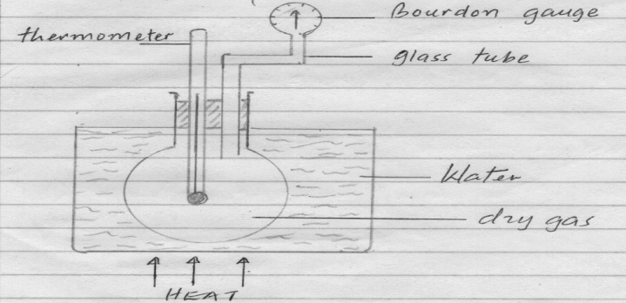
Fig 14
- State two measurements that can be recorded using the above apparatus (2mk)
……………………………………………………………………………………………………………………………………………………………………………………..
- Explain how the measurement above in (i) may be used to verify pressure law. (3mks)
……………………………………………………………………………………………………………………………………………………………………………………………………………………………………………………………………………………………………………………………………………………………………………………………………………………………………………………………………………………………………………………………………………………………………………………………………………………………………………………………………………………………………………………………………………………….
c) State two assumptions made in this experiment (2mk)
………………………………………………………………………………………………………………………………………………………………………………………………………………

- At 20ºC the pressure of a gas is 50cm of mercury. At what temperature would the pressure of the gas fall to 10cm of mercury. (3mks)
………………………………………………………………………………………………………………………………………………………………………………………………………………………………………………………………………………………………………………………………………………………………………………………………………………………………………………………………………………………………………………………………………………………………………………………………
- a) The distance of separation between the plates of a certain capacitor is reduced. State how this affects the capacitance of the capacitor. (1mk)
……………………………………………………………………………………………………………………………………………………………………………………………………………………………………………………………………………………………..
b) You are provided with the following apparatus used for studying charging of a capacitor; an uncharged capacitor, voltmeter, milliameter, 6v battery, connecting wires, a switch and a load resistor R.
- Draw a circuit diagram that can be used to charge the capacitor. (2mks)

- Use the circuit diagram drawn above to explain how the capacitor gets charged. (3mks)
……………………………………………………………………………………………………………………………………………………………………………………………………………………………………………………………………………………………………………………………………………………………………………………………………………………………………………………………………………………………………………………………………………………………………………………………………………………………………………………………………………………………………………………………………………………………………………………………………………………………………………..
- State the purpose of resistors R. (1mk)
………………………………………………………………………………………………………………………………………………………………………………………………………………………………………………………………………………

c) The zinc plate shown below is connected to a negatively charged electroscope and is exposed to ultra violet radiation.
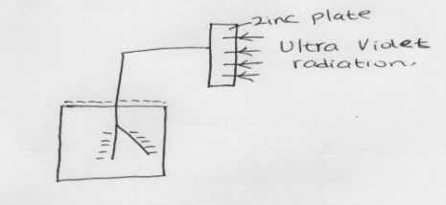
- Explain what happens to the leaf of the charged electroscope. (3mks)
……………………………………………………………………………………………………………………………………………………………………………………………………………………………………………………………………………………………………………………………………………………………………………………………………………………………………………………………………..
- If the same experiment is repeated using a positively charged electroscope, explain the observation (3mk)
……………………………………………………………………………………………………………………………………………………………………………………………………………………………………………………………………………………………………………………………………………………………………………………………………………………………………………………………………

