NAME: ……………………………………………………………..… ADM …………….
JUJA GIRLS HIGH SCHOOL
TERM I OPENER EXAMINATIONS 2019
FORM FOUR

Kenya Certificate of Secondary Education (KCSE)
233/1/2
Paper 1/2
Chemistry (Theory)
January 2019
1 Hour 30min

Instructions
- Answer all the questions in the spaces provided.
- All working must be clearly shown.
- Silent non programmable electronic calculators may be used.

For Examiner’s Use Only
Questions | Maximum Score | Student’s Score
1-7 | 50

- Methane ${CH}_{4}$, is an organic compound. It is the first member of an homologous series of saturated hydrocarbons.
- What is meant by the term hydrocarbon?(1mk)
………………………………………………………………………………………………………………………………………………………………………………………………
- What is meant by the term saturated? (1mk)
……………………………………………………………………………………………………………………………………………………………………………………………………………………………………………………………………………………………..
- Name the homologous series to which methane is the first member.(1mk)
………………………………………………………………………………………………………………………………………………………………………………………………
- Draw the structural formula of the second member of this homologous series.(1mk)
………………………………………………………………………………………………………………………………………………………………………………………………………………………………………………………………………………………………
- Calcium sulphate can be prepared using a precipitation reaction between calcium chloride solution and dilute sulphuric acid.
- Describe the steps that would be followed to produce a pure ,dry sample from the resulting mixture in this reaction. (3mks)
………………………………………………………………………………………………………………………………………………………………………………………………………………………………………………………………………………………………………………………………………………………………………………………………………………………………………………………………………………………………………………………………………………………………………………………………………………
- Write a balanced chemical equation for the reaction.(1mk)
…………………………………………………………………………………………………………………………………………………………………………………………………
- If a 5.55g sample of calcium chloride ( molar mass 111) is dissolved in water to make a solution.
- Calculate the amount, in moles in the sample of calcium chloride.(2mks)
……………………………………………………………………………………………………………………………………………………………………………………………………………………………………………………………………………………………………………………………………………………………………………………………………………………………………………………………………
- What amount, in moles, of sulphuric acid is needed to react completely with the calcium chloride solution. (1mk)
………………………………………………………………………………………………………………………………………………………………………………………………………………………………………………………………………………

- Calculate the mass in grams of calcium sulphate formed.(S=32, Ca=40,O=16) (3mks)
………………………………………………………………………………………………………………………………………………………………………………………………………………………………………………………………………………………………………………………………………………………………………………………………………………………………………………………………………………………………………………………………………………………………
- A sample of copper contains two isotopes.
- What are isotopes? (1mk)
………………………………………………………………………………………………………………………………………………………………………………………………………………………………………………………………………………………………………
- Complete the table for these isotopes of copper. (2mks)
Atomic number | Mass number | Number of protons | Number of neutrons | Percentage of each isotope in sample
29 | 63 |  |  | 69
 |  | 29 | 36 | 31
- Use information in the table in (b) above to calculate the relative atomic mass of this sample of copper. Give your answer to one decimal place. (2mks)
…………………………………………………………………………………………………………………………………………………………………………………………………………………………………………………………………………………………………………………………………………………………………………………………………………
- Why do the two isotopes of copper have the same chemical properties? (1mk)
……………………………………………………………………………………………………………………………………………………………………………………………………
- Copper carbonate, a compound of copper when heated produces copper (II) oxide as one of the products.
- State the colour change observed.(1mk)
……………………………………………………………………………………………………………………………………………………………………………………
- Write a balanced equation for the reaction.(1mk)
……………………………………………………………………………………………………………………………………………………………………………………
- Write the formula of another oxide of copper.(1mk)
……………………………………………………………………………………………………………………………………………………………………………………
- If some dilute hydrochloric acid was added to the copper (II) oxide, write a balanced equation for the reaction that takes place. (1mk)
………………………………………………………………………………………………………………………………………………………………………………………………………………………………………………………………………………

- The figure below represents set up that can be used to prepare and collect oxygen gas.
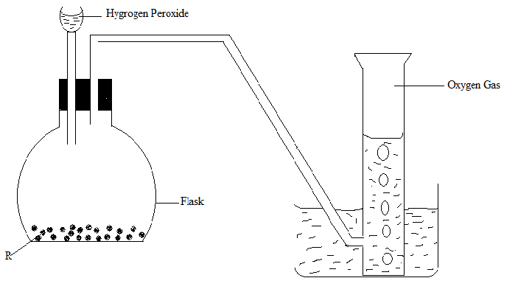
- Name solid R (1mk)
………………………………………………………………………………………………………………………………………………………………………………………………
- What is the role of solid R? (1mk)
……………………………………………………………………………………………………………………………………………………………………………………………..
- Write a word equation for the reaction that takes place. (1mk)
………………………………………………………………………………………………………………………………………………………………………………………………
- Identify the method of gas collection employed. (1mk)
………………………………………………………………………………………………………………………………………………………………………………………………
- Why is the method in (d) above suitable for collecting oxygen?. (1mk)
………………………………………………………………………………………………………………………………………………………………………………………………
- Explain why it is important not to collect any gas for the first few seconds of the experiment. (1mk)
………………………………………………………………………………………………………………………………………………………………………………………………………………………………………………………………………………………………
- State the chemical test for oxygen gas. (1mk)
………………………………………………………………………………………………………………………………………………………………………………………………
- Name a solid which would produce oxygen gas when water is added to it.(1mk)
………………………………………………………………………………………………………………………………………………………………………………………………
- Name any one solids which when heated produces oxygen gas as one of the products. (2mks)
……………………………………………………………………………………………………………………………………………………………………………………………………………………………………………………………………………………………
- a) Define allotropy. (1mk)
…………………………………………………………………………………………………………………………………………………………………………………………………………….
b) Name two allotropes of sulphur. (2mks)
- The flow chart below represents some industrial processes leading to the formation of two nitrogenous fertilizers.
Sulphur
Natural gas
ural gas
Air
Contact process
Process 1
SO₃
Hydrogen
Nitrogen
Process 2
Compound y
H₂SO ₄₍₁₎
Ostwald process
Compound x

Ammonium Nitrate
Ammonium sulphate

- Name the process labeled (2 mks)
- …………………………………………………………………….

2 ………………………………………………………………….....
- Name the catalyst used in (3 mks)
    - a). Process 2
…………………………………………………………………………………………………………………………………………………………………………
    - b). Ostwald’s process
…………………………………………………………………………………………………………………………………………………………………………
    - c). Contact process
…………………………………………………………………………………………………………………………………………………………………………
- Name each of compounds X and Y (1 mk)
X ……………………………………………………………………………………….

Y ………………………………………………………………………………………
- Other than the catalyst named in (b) above, state two optimum conditions for process labeled 2. (1 mk)
………………………………………………………………………………………………………………………………………………………………………………………………………………………………………………………………………………………………………
- Briefly describe process 1 that leads to production of nitrogen from air. (2 mks)
…………………………………………………………………………………………………………………………………………………………………………………………………………………………………………………………………………………………………………………………………………………………………………………………………………
- State one use of ammonium nitrate (1 mks)
……………………………………………………………………………………………………………………………………………………………………………………………………
- The diagram below shows part of the process in the manufacture of suphuric (VI) acid.
- Study it and answer the questions that follow.
i) Write an equation for the formation of sulphur (IV) oxide from sulphur. (1 mark)
…………………………………………………………………………………………………………………………………………………………………………………………………………
ii) What is the role of concentrated sulphuric (VI) acid in chamber A? (1 mark)
…………………………………………………………………………………………………………………………………………………………………………………………………………

iii) Name two catalysts that can be used in the catalytic chamber B. (1 mark)
…………………………………………………………………………………………………………………………………………………………………………………………………………
iv) State one role of the heat exchanger. (2 marks)
…………………………………………………………………………………………………………………………………………………………………………………………………………
c) Explain one way in which sulphur (IV) oxide is a pollutant. (1 mark)
…………………………………………………………………………………………………………………………………………………………………………………………………………
d) What observation will be made when a few drops of concentrated sulphuric (VI) acid are added to crystals of sugar? Explain your answer. (2 marks)
…………………………………………………………………………………………………………………………………………………………………………………………………………………………………………………………………………………………………………………………………………………………………………………………………………………………………………………………………………………………………………………………

